A | Post Details
 | Job Title: | Engineering Contracts Manager |  |  |  |  | Function: |  |  | Engineering (Major Contracts)
 | Location: | 4 More, London |  |  |  |  | Unique Post Number:
 | Reports To: | Head of Fleet Commercials |  |  |  |  | Grade: |  |  | MG2
B | Purpose of the Job
To manage Southeastern’s Engineering Contracts and provide high quality and professional commercial expertise, with a particular focus on Rolling Stock leasing, maintenance and modification Contracts.

To support the business planning process, contract negotiations, and production of new contracts and contract variations, relating to Rolling Stock leasing, maintenance and modifications.

To work with Engineering Managers, Project Managers and Commercial Managers within the Engineering Directorate, providing expert commercial and contractual advice and to be a professional support function to the wider business.

To provide accurate, timely and relevant commercial and financial information on which to base business decisions, with a focus on best practice in contract management.

To manage and supervise the Rolling Stock Contracts Manager, having regular 1 to 1s and check ins.
C | Principal Accountabilities
C1  C2  C3  C4  C5  C6  C7  C8  C9  C10  C11  C12 | To negotiate and prepare all necessary Engineering, Rolling Stock Leases, Lease Amendments, Maintenance Contracts, Modification Contracts and contract amendments required to maintain and enhance the Southeastern fleet of Rolling Stock and to implement Southeastern’s business objectives.  To manage the day-to-day relationships with ROSCOs and Engineering suppliers and follow up all required lease and contract review actions.  To provide support to the Head of Major Contracts for any contract management task related to the management and performance of Southeastern’s Engineering Contracts.  To identify risks and opportunities through a sound understanding of Southeastern’s Engineering Contracts, making recommendations to maximise profitability and mitigate key risks within these constraints.  To work closely with other colleagues in Finance, in particular the Finance Business Partners and the Financial Accounting team to enable accurate business plans and budgeting and to answer questions raised by the financial accountants.  To be a trusted source of insight for engineering commercial and contractual advice.  To support wider company projects and provide Project Managers with commercial expertise.  To ensure Southeastern’s Contracts Library and Contracts Database are maintained, updated and accurate.  To manage the necessary Oracle POs (Purchase Requisitions and Receipts) and necessary Sales Orders, ensuring accurate and timely financial controls surround Southeastern’s Engineering Contracts.  Advise the responsible Engineering Managers on the commercial and contractual framework applicable to their roles including in regard to warranty and performance regimes.  Provide the key commercial point of liaison between the Engineering Directorate and the Finance Directorate.  Provide the Train Services Directorate with contract negotiation and commercial expertise in relation to Train Crew and other trading Agreements.
D | Safety Responsibilities
D1 | This post is required to undertake SAFETY CRITICAL WORK |  |  |  |  |  |  |  |  | Yes |  |  | No
D2 | This is a KEY SAFETY POST |  |  |  |  |  |  |  |  | Yes |  |  | No
D3 | This post requires SECURITY CLEARANCE |  |  |  |  |  |  |  |  | Yes |  |  | No
D4 | The job requires competence in PERSONAL TRACK SAFETY |  |  |  |  |  |  |  |  | Yes |  |  | No
D5 | This job has SPECIFIC SAFETY RESPONSIBILITIES (if Yes see section D6 below) |  |  |  |  |  |  |  |  | Yes |  |  | No
D6 | The post holder has the following specific safety responsibilities:
Carrying out Planned General Inspections of the following locations:
- n/a

Acting as Fire Precautions Manager for the following locations:
- n/a

E | Decision making Authority
E1  E2  E3  E4 | Implement and manage the existing contractual relationships within the guidelines set by the Head of Major Contracts.  Authorised to review and recommend changes to contracts and contract variations, in conjunction with Southeastern’s legal advisors.  Provide business case justification for any new contract.  Authorised to attend meetings with external companies and organisations and represent Southeastern’s interests at those meetings within the guidelines set by the Head of Major Contracts.
F | Most Challenging and/or Difficult parts of the role
F1  F2  F3 | Managing conflicting business requirements.  Delivery to tight deadlines and reviewing large and complex contacts.  Understanding the technical aspects of Southeastern’s Engineering, Rolling Stock and maintenance practises to ensure that the contracts are fit for purpose and provide safe, reliable Rolling Stock that meets customer expectations.
G | Person Specification

Southeastern aims to recruit people not just for jobs but for long term careers. We want good quality, talented people with the right attitude who will stay with us.

For these reasons we look for evidence of Southeastern values and behaviours in all potential staff and our existing staff looking for promotion along with the particular experience/knowledge, skills and behaviours relevant to the position applied for. These are

We care passionately about our people and passengers
  - we put ourselves in our passengers’ shoes to do what’s right for them
  - we support our colleagues to be, feel and do their best
  - we love the places we serve and do our bit for our communities and environment

We aim to be the best
  - we move with pace, we’re agile and learn from everything
  - we relentlessly strive to be the best
  - we are professionals with personalities

We make the difference together
  - we are answerable to each other and our passengers
  - we trust each other and do what we say we will
  - we are stronger together than we are as individuals

We also have identified behaviours required to be successful in leading Southeastern.

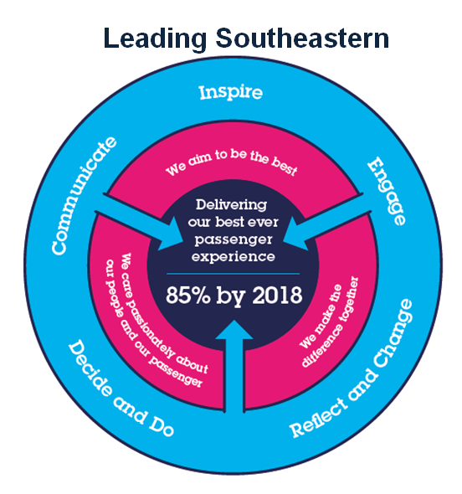
The Leading Southeastern framework details how we should be behaving in order to drive up performance to deliver 85 by 18.

All shortlisted candidates seeking promotion will be assessed against this framework.

The job demands the following blend of experience/knowledge, skills and behaviours (all are essential , unless otherwise shown and will be assessed by application and/ or interview/assessment) :

G1 | Experience, Knowledge & Qualifications  Educated to degree standard or equivalent level of experience.  Qualified or working towards a recognised Engineering or Contract Management professional qualification.  Strong commercial and financial awareness.  Knowledge and understanding of contractual frameworks, preferably with knowledge of Railway Industry.  Min. 5 to 7 years experience in an Engineering or Commercial environment.  Experience of rail or similar transport / franchise industry (desirable).
G2 | Skills (including any specific safety critical competencies)  Negotiation & influencing skills – influences, convinces or impresses others in a way that results in acceptance, agreement or behaviour change.  Communication – presents information and ideas confidently and effectively. Is friendly and engages others across the business in open, honest and productive conversations.  Commercial Awareness – understands and applies commercial and financial principles. Exploits opportunities to improve results and add value to the business.  Thinking & Problem Solving – analyses issues and breaks them into component parts. Makes systematic and rational judgements based on relevant information.  Good attention to detail – careful and thorough review of documents and figures to ensure accuracy of written and numeric information and commercial objectives are met.  Literacy & Numeracy – comprehends legal and business documents, expresses complex issues clearly in writing together with the ability to analyse and process complex calculations.
G3 | Behaviours  Professionalism – Aims to be the best they can be through their attitude & respect for others, customer focussed, delivery focussed and having a “can do” approach.  Honesty & Integrity – Is transparent and honest taking full responsibility for actions. Demonstrates confidence and courage, dealing effectively with difficult situations.  Team work, Sharing and Supportive – Aligns with others to deliver common goals. Shares ideas and information in a collaborative manner. Supports colleagues and works effectively and effectively with others.  Adding Value – Demonstrates readiness to make decisions, take initiatives and drive action, contributing to a culture of continuous business improvement.  Empathetic – Is empathetic to the needs of colleagues, earning their trust and respect.  Taking a Broader view - Champions change and considers the long-term impact of decisions across the business.  Flexibility – successfully adapts to changing demands, conditions and scenarios, and enacts decisions reached even if not their own.
G4 | Other
H | Dimensions of role
H1 | Financial – Direct: |  |  | c. £ 180m pa Rolling Stock leasing charges  c. £ 50m pa Rolling Stock maintenance contracts  c. £ 10m pa Rolling Stock modification contracts (varies from year to year)  c. £ 1m pa Engineering Sales derived from maintenance and modification activities carried out for 3rd parties such as ROSCOs (varies from year to year)
H2 | Financial – Other: |  |  | c. £0.3m pa external legal advice relating to Rolling Stock
H3 | Staff Responsibilities – Direct: |  |  | 1 x Rolling Stock Contracts Manager
H4 | Staff Responsibilities – Other: |  |  | Support and advice to various posts in Engineering, including Contract Managers, Technical Managers and Project Managers. Close liaison role with Finance Business Partners
H5 | Any Other Statistical Data: |  |  | Southeastern currently leases over 1,500 Rolling Stock Vehicles from three ROSCOs and procures light and heavy maintenance from two major industry suppliers.
I | Acknowledgement
I1 | Prepared By: |  | Dev Sumboo |  |  |  |  | Date: | July 2025
I2 | Approved By (Head of Department): |  | Mark Johnson |  |  |  |  | Date: | July 2025
J | Job Description Briefing
 | The post holder has been briefed on and understands the requirements of this Job Description and other related documents:
 | Name of post holder: |  |  |  | Signature: |  |  |  |  |  | Date:
 | Name of briefing manager: |  |  |  | Signature: |  |  |  |  |  | Date:
K | Nominated Deputy for Safety requirements
 | If this is a KEY SAFETY POST (D2 in Safety Details above is YES) at least one nominated deputy must be identified. The Job Holder must ensure that the Nominated Deputy(ies) receives a copy of and is briefed on this Job Description. If there are more nominated deputies, they should sign further copies of this Job Description.
 | The nominated deputy has been briefed on and understands the requirements of this Job Description and other related documents:
 | Name of nominated deputy: |  |  |  | Signature: |  |  |  |  |  | Date:
 | Name of briefing manager: |  |  |  | Signature: |  |  |  |  |  | Date:

