A | Post Details
 | Job Title: | Quality & Standards Manager | Function: |  |  | Engineering
 | Location: | Slade Green Engineering Depot, other locations as required | Unique Post Number:
 | Reports To: | Fleet Operations Manager | Grade: |  |  | MG2
B | Purpose of the Job
 | Provide professional and technical leadership for quality, engineering competence, fleet safety, rail vehicle certification, regulatory compliance within the Engineering Directorate.
C | Principal Accountabilities
C1  C2  C3  C4  C5  C6  C7  C8  C9  C10  C11  C12  C13  C14 | Act as ‘Competent Person’ for Engineering Changes, scrutinising proposed changes against requirements and issuing new Design, Maintenance and Engineering Acceptance Certificates as required  Ensure processes are in place to assure the operational safety of Southeastern’s fleet (including Concessions, Engineering Change Control, Risk Review and National Incident Reports (NIRs)). Oversee fleet safety performance by monitoring and ensuring incidents are investigated; report to Directors and Senior Managers recommending corrective actions if required.  Establish and maintain an Engineering Change Control process to assure that design and maintenance changes are safe and meet requirements, including industry standards and Legislation. Facilitate the Engineering Change Board meeting and provide guidance / interpretation relating to the process to internal and external stakeholders.  Ensure that a comprehensive and coherent Quality Management System is implemented within Engineering that meets the requirements of Southeastern’s Railway Safety Management System, Legislation, Industry Standards and business needs.  Implement a documented Competence Management System (CMS) for Engineering activities and roles that meets the requirements of the ROGS regulations and aligns with guidance provided by ORR. Oversee the apprenticeship scheme.  Schedule assessments, competence reviews and verification checks. Publish a plan of assessments for CDS and other assessors to follow. Track progress against the plan and escalate performance issues. Carry out assessments if required.  Drive process improvement, challenging and supporting functional managers through a PDCA-cycle of continual improvement. Establish focus groups or process improvement workshops if required. Highlight areas of concern or where there is potential for further improvement; raise corrective / preventive actions and recommend closure of these when completed.  Act as point of contact for the Office of Rail Regulation and Rail Accident Investigation Branch as required.  Produce reports relating to the above areas of accountability.  Following training, attend incidents, provide advice and carry out investigations as on-call Manager.  Act as ‘Internal Quality Assurance Auditor’ for the Competence Management System. Audit the CMS and associated records, and raise Corrective Actions as required. Verify the effectiveness of Corrective Actions.  Accountable for ensuring that any areas where competence is not achieved, a robust development programme is initiated and followed to redress the shortfall in competence.  Accountable / Responsible to produce and maintain accurate and up to date and auditable records to demonstrate competence and training have been conducted in accordance with the appropriate processes.  Establish competence standards for engineering roles across engineering and the processes required for operation and review of the CMS. Ensure the CMS is documented in Company Standards and local QMS procedures.
D | Safety Responsibilities
D1 | This post is required to undertake SAFETY CRITICAL WORK |  |  | Yes |  |  | No | P
D2 | This is a KEY SAFETY POST |  |  | Yes |  |  | No | P
D3 | This post requires SECURITY CLEARANCE |  |  | Yes |  |  | No | P
D4 | The job requires competence in PERSONAL TRACK SAFETY |  |  | Yes | P |  | No
D5 | This job has SPECIFIC SAFETY RESPONSIBILITIES (if Yes see section D6 below) |  |  | Yes | P |  | No
D6 | The post holder has the following specific safety responsibilities:
 | - ‘Competent Person’ for Engineering Change
E | Decision making Authority
E1  E2  E3  E4  E5 | Authority to raise Corrective Actions and recommend closure of these.  Authority to assess risks relating to fleet quality and safety.  Authority to approve and certify Engineering Changes as ‘Competent Person’  Authority to assess compliance of processes and management systems with requirements and approve documentation  Authority to set team members’ objectives and evaluate performance against these
F | Most Challenging and/or Difficult parts of the role
F1  F2 | Engaging with and challenging colleagues to comply or improve while breaking down barriers and remaining part of the team.  Working and communicating at all levels in the organisation.

G | Person Specification

Southeastern aims to recruit people not just for jobs but for long term careers. We want good quality, talented people with the right attitude who will stay with us.

For these reasons we look for evidence of Southeastern values and behaviours in all potential staff and our existing staff looking for promotion along with the particular experience/knowledge, skills and behaviours relevant to the position applied for. These are

We care passionately about our people and passengers
  - we put ourselves in our passengers’ shoes to do what’s right for them
  - we support our colleagues to be, feel and do their best
  - we love the places we serve and do our bit for our communities and environment

We aim to be the best
  - we move with pace, we’re agile and learn from everything
  - we relentlessly strive to be the best
  - we are professionals with personalities

We make the difference together
  - we are answerable to each other and our passengers
  - we trust each other and do what we say we will
  - we are stronger together than we are as individuals

We also have identified behaviours required to be successful in leading Southeastern.

The Leading Southeastern framework details how we should be behaving in order to drive up performance to deliver 85%.

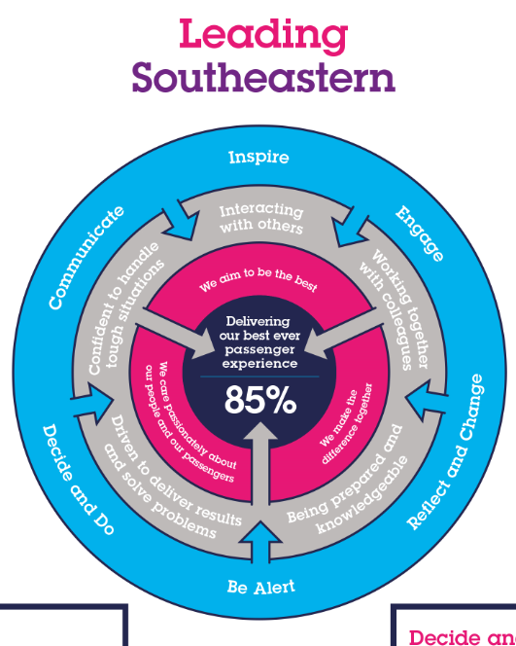

All shortlisted candidates seeking promotion will be assessed against this framework.

The job demands the following blend of experience/knowledge, skills and behaviours (all are essential , unless otherwise shown and will be assessed by application and/ or interview/assessment) :

G1 | Experience, Knowledge & Qualifications  Qualified in an engineer discipline preferred, with rolling stock engineering expertise  3+ years experience in maintenance engineering or asset intensive operational environment (rail, nuclear, marine, aviation, utilities, process plant, armed forces)  5+ years experience in quality / safety assurance in above environment  Demonstrable Continued Professional Development (CPD) through membership of professional institutions (such as the IMechE, IET or CQI)  Hold, or working towards TAQA Level 4 qualification.
G2 | Skills (including any specific safety critical competencies)  Excellent managerial skill and knowledge demonstrated through above requirements.  Good communication skills and assertiveness to engage with colleagues; working at all levels in the organisation.  Good thinking and problem solving skills  Planning and organising skills  Strong analytical skills  Excellent computing skills. Understanding of Computerised Maintenance Management Systems (CMMS) and ability to use Microsoft Office computer applications.
G3 | Behaviours  Professional and business focussed outlook.  Able to balance the long term and strategic with the short term and tactical.  Aware of surroundings, naturally inquisitive and questioning.
G4 | Other  Membership of IMechE, IET or other professional institution.

H | Dimensions of role
H1 | Financial – Direct: |  |  |  | None
H2 | Financial – Other: |  |  |  | As defined by the Head of Engineering Complaince. In practice control of the Engineering training, audit and some consultancy budget.
H3 | Staff Responsibilities – Direct: |  |  |  | 3 Managers
H4 | Staff Responsibilities – Other:
H5 | Any Other Statistical Data:
I | Acknowledgement
I1 | Prepared By: |  | _______________ |  |  |  | Date: | ______________
I2 | Approved By (Head of Department): |  | _______________ |  |  |  | Date: | ______________
J | Job Description Briefing
 | The post holder has been briefed on and understands the requirements of this Job Description and other related documents:
 | Name of post holder: |  |  | Signature: |  |  |  |  | Date:
 | Name of briefing manager: |  |  | Signature: |  |  |  |  | Date:
K | Nominated Deputy for Safety requirements
 | If this is a KEY SAFETY POST (D2 in Safety Details above is YES) at least one nominated deputy must be identified. The Job Holder must ensure that the Nominated Deputy(ies) receives a copy of, and is briefed on this Job Description. If there are more nominated deputies, they should sign further copies of this Job Description.
 | The nominated deputy has been briefed on and understands the requirements of this Job Description and other related documents:
 | Name of nominated deputy: |  |  | Signature: |  |  |  |  | Date:
 | Name of briefing manager: |  |  | Signature: |  |  |  |  | Date:

