A | Post Details
 | Job Title: | Oracle Finance Systems Manager | Function: | Finance
 | Location: | 4ML | Unique Post Number:
 | Reports To: | Head of Finance | Grade: | MG2
B | Purpose of the Job
We have a requirement for an Application Systems Manager (Oracle), and this role is to:

- Provide systems support, guidance and training to users of the Oracle Financials/Procurement systems;
- Support the Oracle control environment around key external audit controls including change management, privileged access, password parameters and user access review;
- Support and extend the use of the Oracle Financials/Procurement systems to maximise benefit to SET;
- Identify process and systems improvements to the Oracle Financials/Procurement systems including discrete systems improvements projects;
- Share knowledge gained to other members of the team.

In addition to the core Oracle support activity the role will support the Finance and Business Planning teams in the development of their financial reporting and forecasting models/tools.

C | Principal Accountabilities
- Manage and direct Oracle Financials/Procurement support requests;
- Lead on the testing and documentation of the change management process for systems upgrades (functional and technical) and liaise with SET IT.
- Oversee and manage the Oracle Workflow mailer;
- Provide daily support to the Oracle Financials/Procurement user community;
- Liaise with our managed services providers for incident management and bug fixing;
- Create and undertake thorough testing regimes as appropriate
- Recommend and undertake Systems and efficiency improvements within the Oracle service;
- Manage the supplier creation function in Oracle and the relationship with the Procurement function and the internal controls around this;
- Support and report information to both internal and external audits (systems and finance), including starters and leavers;
- Support and advise on PC/local installation issues with the Oracle client application
- Identification of key risks and opportunities through a sound understanding of the financial profile of the business/projects and key drivers of business value, making recommendations to maximise value and mitigate key risks within these constraints;
- Liaise closely with the Financial Business Partner, Financial Accounting and Procurement teams to ensure reliability, accuracy and timeliness of financial and procurement information; and
- Provide guidance on Oracle matters within relevant business area.

D | Safety Responsibilities
 | This post is required to undertake SAFETY CRITICAL WORK |  |  |  | Yes |  | No
 | This is a KEY SAFETY POST |  |  |  | Yes |  | No
 | This post requires SECURITY CLEARANCE |  |  |  | Yes |  | No
 | The job requires competence in PERSONAL TRACK SAFETY |  |  |  | Yes |  | No
 | This job has SPECIFIC SAFETY RESPONSIBILITIES (if Yes see section D6 below) |  |  |  | Yes |  | No
 | The post holder has the following specific safety responsibilities:
 | - None
E | Decision making Authority
- The role provides the key link point of contact between all financial systems end users and the internal support function. This will entail problem resolution and enhancement suggestions to improve end user experience and best practice;
- Authorised to review and recommend changes to business systems, practices, processes and new projects; and
- Authorised to attend meetings with external companies and organisations and represent Southeastern’s interests at those meetings.

F | Most Challenging and/or Difficult parts of the role
- Ensuring best practice is advised and adopted by the user community;
- Dealing with managed services providers for incident management and bug fixing;
- Managing to tight deadlines.

G | Person Specification

Southeastern aims to recruit people not just for jobs but for long term careers. We want good quality, talented people with the right attitude who will stay with us.

For these reasons we look for evidence of Southeastern values and behaviours in all potential staff and our existing staff looking for promotion along with the particular experience/knowledge, skills and behaviours relevant to the position applied for. These are

We care passionately about our people and passengers
  - we put ourselves in our passengers’ shoes to do what’s right for them
  - we support our colleagues to be, feel and do their best
  - we love the places we serve and do our bit for our communities and environment

We aim to be the best
  - we move with pace, we’re agile and learn from everything
  - we relentlessly strive to be the best
  - we are professionals with personalities

We make the difference together
  - we are answerable to each other and our passengers
  - we trust each other and do what we say we will
  - we are stronger together than we are as individuals

We also have identified behaviours required to be successful in leading Southeastern.

The Leading Southeastern framework details how we should be behaving in order to drive up performance to deliver 85 by 18.

Leading Southeastern

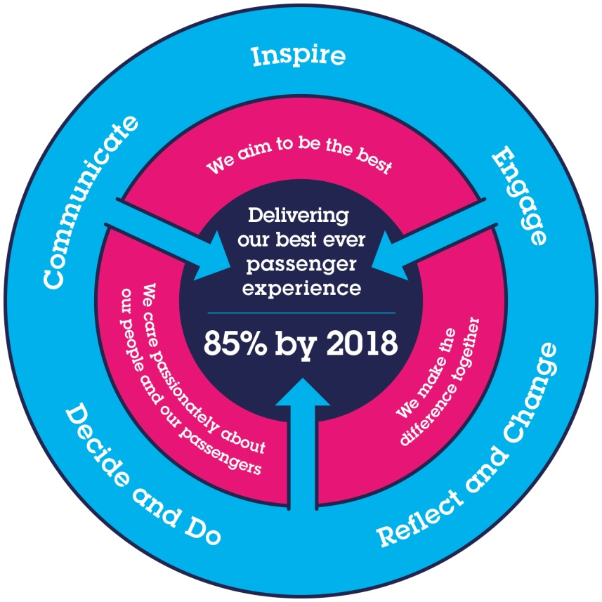
All shortlisted candidates seeking promotion will be assessed against this framework.

The job demands the following blend of experience/knowledge, skills and behaviours (all are essential, unless otherwise shown and will be assessed by application and/ or interview/assessment).

G1 | Experience, Knowledge & Qualifications
  Attributes | Essential | Desirable
  Education & Qualifications | - Educated to A level or equivalent | - Educated to Degree level or equivalent  - ITIL for IT service management
  Specialist Knowledge, Skills and Experience | - Previous experience of providing technical IT support of core financial systems  - Understanding of reporting systems linked to Oracle Financials to include: Spreadsheet Server, TM1, More 4 Apps  - Ability to facilitate and implement changes (systems and/or processes)  - Finance background  - Understanding of all Oracle Financials modules  - Knowledge of systems that will interface or provide inputs to financial systems (Equinox, Maximo etc.)  - Good work prioritisation and time management  - Good organisational skills.  - Excellent attention to detail  - Experience of working as part of a team and autonomously  - Effective communication skills  - Ability to prioritise own workload  - Ability to work under pressure and to tight timescales  - Ability to be flexible, and travel to various sites as appropriate  - Understanding of confidentiality and data protection legislation including information governance | - Knowledge of Oracle E-Business Tax configuration  - Detailed knowledge of the configuration of Oracle interfaces with feeder systems
H | Dimensions of role
H1 | Financial – Direct: |  |  | 0
H2 | Financial – Other: |  |  | 0
H3 | Staff Responsibilities – Direct: |  |  | 0
H4 | Staff Responsibilities – Other: |  |  | 0
H5 | Any Other Statistical Data: |  |  | 0
I | Job Description Briefing
 | The post holder has been briefed on and understands the requirements of this Job Description and other related documents:
 | Name of post holder: |  | Signature: |  |  | Date:
 | Name of briefing manager: |  | Signature: |  |  | Date:

