A | Post Details
 | Job Title: | Permanent Timetable Specialist | Function: | Train Services
 | Location: | Four More London | Unique Post Number:
 | Reports To: | Permanent Timetable Manager | Grade: | MG1
B | Purpose of the Job
 | To assist the Permanent Timetable Manager with the compilation and production of permanent timetables, taking into account long term planning and commercial requirements, to defined production schedules.
C | Principal Accountabilities
C1  C2  C3  C4  C5  C6  C7  C8  C9 | Production of permanent timetables and updating of associated contingency timetables in connection with all long-term specification and business changes, in accordance with laid down production schedules.  Production of other plans such as blockades or future service scenarios as required from time to time  Ensure the correct presentation of permanent timetables on behalf of the company to Network Rail as laid down in the Network Rail Operational Planning Production Schedule and Network Code Part D.  Proactive in learning other disciplines within the Train Planning Department, and assisting where necessary under the direction of the Permanent Timetable Manager.  Ensure that appropriate work records of the work process are maintained for future retrieval in accordance with legal, business and quality assurance requirements.  Establish effective liaison channels with the Permanent Resources Team to ensure that alterations to the train plan are accurately documented and communicated throughout the Train Planning process.  Build and maintain strong working relationships with Network Rail and other Train Operators’ planning teams.  Assist with the ongoing development of Train Planning IT systems to meet business needs.  Deputise for the Permanent Timetable Manager as necessary.

D | Safety Responsibilities
D1 | This post is required to undertake SAFETY CRITICAL WORK | Yes |  | No
D2 | This is a KEY SAFETY POST or nominated deputy | Yes |  | No
D3 | The holder of this post is identified as a KEY SAFETY MANAGER | Yes |  | No
D4 | The job requires competence in PERSONAL TRACK SAFETY | Yes |  | No
D5 | This job has SPECIFIC SAFETY RESPONSIBILITIES (if Yes see section D6 below) | Yes |  | No
D6 | The post holder has the following specific safety responsibilities:
 | - None
E | Decision making Authority
E1 | Planning / re-planning of train services to meet the specification agreed with the Permanent Timetable Manager.
F | Most Challenging and/or Difficult parts of the role
F1  F2 | Compilation and delivery of robust timetables, which will impact on the performance and business growth of Southeastern.  Maintaining strong working relationships with planning teams at Network Rail and other Train Operators.

G | Person Specification

Southeastern aims to recruit people not just for jobs but for long term careers. We want good quality, talented people with the right attitude who will stay with us.

For these reasons we look for evidence of Southeastern values and behaviours in all potential staff and our existing staff looking for promotion along with the particular experience/knowledge, skills and behaviours relevant to the position applied for. These are

We care passionately about our people and passengers
  - we put ourselves in our passengers’ shoes to do what’s right for them
  - we support our colleagues to be, feel and do their best
  - we love the places we serve and do our bit for our communities and environment

We aim to be the best
  - we move with pace, we’re agile and learn from everything
  - we relentlessly strive to be the best
  - we are professionals with personalities

We make the difference together
  - we are answerable to each other and our passengers
  - we trust each other and do what we say we will
  - we are stronger together than we are as individuals

We also have identified behaviours required to be successful in leading Southeastern.

The Leading Southeastern framework details how we should be behaving in order to drive up performance to deliver 85.

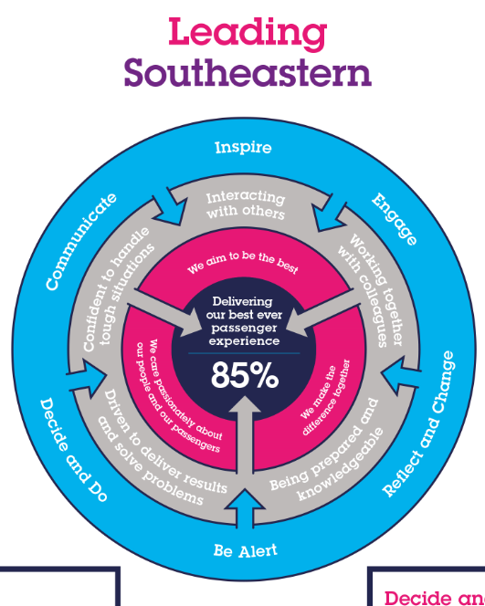

All shortlisted candidates seeking promotion will be assessed against this framework.

The job demands the following blend of experience/knowledge, skills and behaviours (all are essential, unless otherwise shown and will be assessed by application and/ or interview/assessment):

G1 | Experience, Knowledge & Qualifications (including any specific safety training requirements)  Solid Train Planning experience, with a good understanding of Timing Principles used in the timing of train services, including the structure of Train Planning Rules and the Network Code Part D.  Comprehensive knowledge of Southeastern train service pattern and Network Rail geography.  Good education and ability to evaluate and solve complex planning scenarios
G2 | Skills (including any specific safety critical competencies)  Excellent attention to detail.  Problem solving skills.  Commercial awareness.  Planning and organising – organises and schedules events, activities and resources.  Good communication skills.  Honesty and integrity
G3 | Behaviours  Flexible approach to working hours to ensure deadlines can be met.  Willingness to support other parts of the team and business.  Tenacious approach to solving complex logical problems.
G4 | Other

H | Dimensions of role
H1 | Financial – Direct: |  | None
H2 | Financial – Other: |  | Franchise Punctuality and Performance Targets
H3 | Staff Responsibilities – Direct: |  | None
H4 | Staff Responsibilities – Other: |  | None
H5 | Any Other Statistical Data: |  | None
I | Acknowledgement
I1 | Prepared By: | M Wittekopf |  | Date: | 04/12/20
I2 | Approved By (Head of Department): | G Horstmann |  | Date: | 04/12/20

J | Job Description Briefing
 | The post holder has been briefed on and understands the requirements of this Job Description and other related documents:
 | Name of post holder: |  | Signature: |  | Date:
 | Name of briefing manager: |  | Signature: |  | Date:
K | Nominated Deputy for Safety requirements
 | If this is a KEY SAFETY POST (D2 in Safety Details above is YES) at least one nominated deputy must be identified. The Job Holder must ensure that the Nominated Deputy(ies) receives a copy of and is briefed on this Job Description. If there are more nominated deputies, they should sign further copies of this Job Description.
 | The nominated deputy has been briefed on and understands the requirements of this Job Description and other related documents:
 | Name of nominated deputy: |  | Signature: |  | Date:
 | Name of briefing manager: |  | Signature: |  | Date:

