A | Post Details
 | Job Title: | Recruitment & Assessment Officer | Function: |  | Human Resources
 | Location: | Tonbridge | Unique Post Number:
 | Reports To: | Senior Recruitment & Assessment Officer | Grade: |  | MG1
B | Purpose of the Job
Responsible for the delivery of an efficient and trusted recruitment & selection service to Southeastern which meets the business needs.

Attract and recruit competent, confident, customer focussed employees whilst delivering an exceptional customer and candidate experience.

Support the recruitment team in the achievement of KPI’s and Diversity targets.

C | Principal Accountabilities
C1  C2  C3  C4  C5  C6  C7  C8  C9  C10  C11  C12  C13  C14  C15 | Attract, recruit and select the best people who reflect our values and will continue to make Southeastern a successful business, taking responsibility for allocated internal and external recruitment campaigns.  Produce, develop and enhance the full use of all recruitment advertising methods, reviewing success of campaigns and processing applications in a timely fashion.  Responsible for conducting assessment centres using psychometric tests, interpersonal skills analysis, safety related tests and role plays. Interpret and decide on assessment centre results and give meaningful feedback to candidates undergoing testing.  Produce candidate profiles and feedback reports for recruiting managers, ensuring a clear understanding of candidate performance.  Arrange and support selection interviews for both internal and external candidates, ensuring that recruiting managers are complying with best practice techniques. Identifying skills gaps with recruiting managers highlighting areas of improvement to the Senior Recruitment Officer.  Working with recruiting managers, develop, review and enhance the structured interviewing templates to ensure they always identify the appropriate competencies and behaviours and select the best people for the job.  Confirm offers of employment ensuring that the candidate meets the correct medical standards.  Issue contracts of employment, coordinating the arrangements for new entrant induction and ensuring that all new entrant paperwork is completed and correct with particular attention to “right to work in the UK” status and criminal record checks.  Ensure all candidates receive appropriate feedback at all stages of the process. Provide regular communication and deliver a good experience throughout the recruitment process.  Maintain accuracy of data on Applicant Tracking System.  Delivery of in-house recruitment and selection training, ensuring managers are competent and confident to make selection decisions.  Delivery of interview skills workshops to support and upskill our internal colleagues.  Participate in recruitment activities i.e. job fairs, open days and seminars as appropriate.  Comply with HR policies and procedures relating to recruitment & selection, including Equality Act, GDRR and Company Data Protection Policy.  Assist the Senior Recruitment Officer and Resourcing Manager and undertake any projects as required
D | Safety Responsibilities
D1 | This post is required to undertake SAFETY CRITICAL WORK |  |  | Yes |  |  | No
D2 | This is a KEY SAFETY POST or nominated deputy |  |  | Yes |  |  | No
D3 | The holder of this post is identified as a KEY SAFETY MANAGER |  |  | Yes |  |  | No
D4 | The job requires competence in PERSONAL TRACK SAFETY |  |  | Yes |  |  | No
D5 | This job has SPECIFIC SAFETY RESPONSIBILITIES (if Yes see section D6 below) |  |  | Yes |  |  | No
D6 | The post holder has the following specific safety responsibilities:
 | None
E | Decision making Authority
E1  E2  E3 | Interpretation of government legislation and the equality act.  Interpretation of policies and relevant practices, trends and data, making recommendations for action.  Give recommendations on the selection of both internal and external candidates.
F | Most Challenging and/or Difficult parts of the role
F1  F2  F3 | Dealing sensitively and empathetically when providing feedback to applicants.  Influencing recruiting managers regarding selection decisions.  Coaching recruiting managers and candidates to improve their skills
G | Person Specification

Southeastern aims to recruit people not just for jobs but for long term careers. We want good quality, talented people with the right attitude who will stay with us.

For these reasons we look for evidence of Southeastern values and behaviours in all potential staff and our existing staff looking for promotion along with the particular experience/knowledge, skills and behaviours relevant to the position applied for. These are

We care passionately about our people and passengers
  - we put ourselves in our passengers’ shoes to do what’s right for them
  - we support our colleagues to be, feel and do their best
  - we love the places we serve and do our bit for our communities and environment

We aim to be the best
  - we move with pace, we’re agile and learn from everything
  - we relentlessly strive to be the best
  - we are professionals with personalities

We make the difference together
  - we are answerable to each other and our passengers
  - we trust each other and do what we say we will
  - we are stronger together than we are as individuals

We also have identified behaviours required to be successful in leading Southeastern.

The Leading Southeastern framework details how we should be behaving in order to drive up performance to deliver 85 by 18.

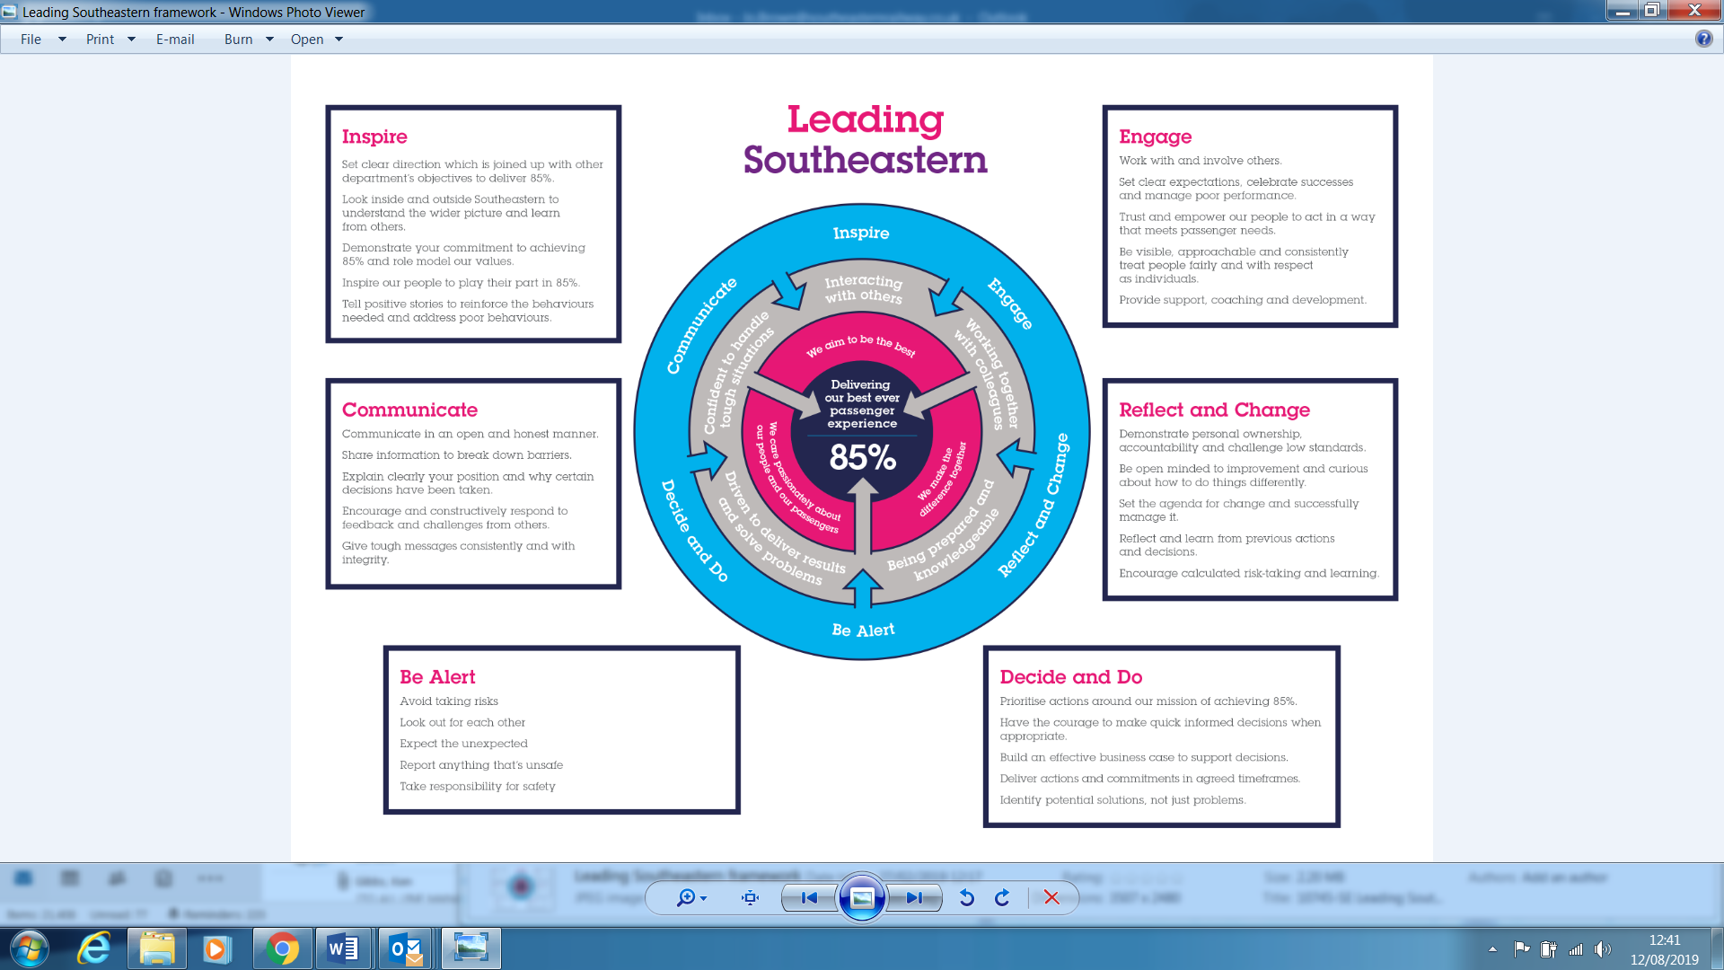

All shortlisted candidates seeking promotion will be assessed against this framework.

G1 | The job demands the following blend of experience/knowledge, skills and behaviours (all are essential , unless otherwise shown and will be assessed by application and/ or interview/assessment) :  Experience, Knowledge & Qualifications (including any specific safety training requirements)  - Proven experience/success working in a recruitment role (preferably in- house).  - Application and knowledge of best practice and legislation relating to recruitment & assessment techniques and labour legislation  - Knowledge of candidate attraction techniques.  - Experience of building effective working relationships.  - A relevant qualification or working towards, e.g. Certificate in HR Practice.  - You will ideally be Level A qualified in Occupational Testing and be on the current Register of the British Psychological Society’s Qualifications in Test Use (RQTU).  - Ideally be certificated to administer and interpret train driver psychometric selection processes, complying with RIS-3751-TOM Train Driver Selection
G2 | Skills (including any specific safety critical competencies)  - High standard of communication, both written and verbal, with the ability to communicate and influence with all levels of the organisation.  - Able to critically evaluate behaviours and interpersonal skills  - Excellent attention to detail  - Experience of working to tight deadlines under pressure with little supervision  - Excellent time management and prioritising skills  - Able to work independently and achieve individual goals  - Excellent team working skills and flexibility in approach to work.  - Computer literate with experience of using Applicant Tracking Systems.
G3 | Behaviours  - Motivated  - Confident  - Determined  - Resilient  - Integrity  - Customer focussed

H | Dimensions of role
H1 | Financial – Direct: |  |  |  | none
H2 | Financial – Other: |  |  |  | Organisational impact
H3 | Staff Responsibilities – Direct: |  |  |  | none
H4 | Staff Responsibilities – Other: |  |  |  | Organisational impact
H5 | Any Other Statistical Data:
I | Acknowledgement
I1 | Prepared By: |  | ___Paul Hayler__ |  |  |  | Date: | _August 2019 __
I2 | Approved By (Head of Department): |  | _______________ |  |  |  | Date: | ______________
J | Job Description Briefing
 | The post holder has been briefed on and understands the requirements of this Job Description and other related documents:
 | Name of post holder: |  |  | Signature: |  |  |  |  | Date:
 | Name of briefing manager: |  |  | Signature: |  |  |  |  | Date:
K | Nominated Deputy for Safety requirements
 | If this is a KEY SAFETY POST (D2 in Safety Details above is YES) at least one nominated deputy must be identified. The Job Holder must ensure that the Nominated Deputy(ies) receives a copy of, and is briefed on this Job Description. If there are more nominated deputies, they should sign further copies of this Job Description.
 | The nominated deputy has been briefed on and understands the requirements of this Job Description and other related documents:
 | Name of nominated deputy: |  |  | Signature: |  |  |  |  | Date:
 | Name of briefing manager: |  |  | Signature: |  |  |  |  | Date:

