A | Post Details
 | Job Title: | Senior Campaigns Manager | Function: | Commercial
 | Location: | More London | Unique Post Number:
 | Reports To: | Head of Marketing and Commercial Partnerships | Grade: | MG1
B | Purpose of the Job
Working as part of the Marketing and Commercial Partnerships team plan to manage and execute marketing campaigns and promotional activity to help drive rail recovery, generate revenue and grow the Back to Work (Commuter), Business and Leisure segments.

Lead and manage in house Graphic Designer and external agency resource.

C

C1  C2  C3  C4  C5  C6  C7  C8  C9  C10  C11  C12  C13  C14  C15  C16  C17  C18  C19  C20  C21  C22 | In line with the Annual Business and Marketing Plans, devise integrated marketing campaigns with the aim of acquiring and retaining customers, driving revenue and achieving strategic goals.  Ensure all campaigns deliver on time and to budget.  To be the day-to-day contact for relevant agencies (media, creative, econometrics and research) with responsibility for briefing in and overseeing campaigns.  Ensure best practice execution of all Marketing campaigns, complying with internal approvals procedure and industry guidelines and where relevant work to make sure campaigns adhere to CAP/ASA/BCAP/RACC guidelines.  Manage campaign budgeting and forecasting, raising purchase orders, receipting to ensure timely payment of suppliers, and reconciling costs to ensure efficient use of budget.  Develop and implement organic Instagram social media strategy., Create content and ensuring all social posts are approved on time and in line with brand guidelines. Monitor posts and report on any potential issues or problems. Liaise with Information Delivery team to schedule campaign posts to Twitter platform.  Working with the Head of Marketing and Commercial Partnerships, Finance Business Partner and Marketing team to manage the marketing budget and PO tracker.  Responsible for creative briefing, oversee and manage development of creative assets, writing, editing and proofing creative content to ensure accuracy. In collaboration with in-house Graphic Designer and external creative agency.  Manage Graphic Designer providing day to day management and guidance and any other contract design resource/briefs as needed, setting direction to ensure effective output that is on brand and adheres to internal and external guidelines.  Work closely with Econometrics agency and internal insight teams to forecast campaign ROIs and track activity.  Manage the implementation, tracking, measurement, and post campaign analysis of marketing campaigns, paying close attention to ROI and evolve learnings to optimise future activity.  Ensure that Southeastern’s brand and identity is adhered to across all campaigns, promotions, and marketing communications.  Working closely with Marketing Executive to ensure the timely design, print, distribution and booking of marketing posters and collateral.  Collaborate with the eCRM Manager to maximise use of customer database and customer segmentation.  Collaborate with relevant partners and sister TOCs to secure and promote specific partner offers during campaign periods and to run contra-marketing activity to increase reach of Southeastern campaigns.  Close liaison with the External Communications team to support PR, enhance reputation and achieve campaign coverage.  Liaise with Internal Communications and Retail teams to ensure colleagues across the business are aware of marketing campaigns and initiatives.  Collaborate with Digital team to create, optimise and analyse web content to enhance campaigns.  Liaise with Engineering team to understand planned engineering works and impact on services, taking this into consideration when planning marketing campaigns.  Collaborate with Promotions agency to run activations at stations with clear objectives, driving key messages to customers at key customer touchpoint.  Create regular reports with marketing activity updates to be presented to Exec Board and Department for Transport
D | Safety Responsibilities
D1 | This post is required to undertake SAFETY CRITICAL WORK |  |  |  | Yes |  | No
D2 | This is a KEY SAFETY POST or nominated deputy |  |  |  | Yes |  | No
D3 | The holder of this post is identified as a KEY SAFETY MANAGER |  |  |  | Yes |  | No
D4 | The job requires competence in PERSONAL TRACK SAFETY |  |  |  | Yes |  | No
D5 | This job has SPECIFIC SAFETY RESPONSIBILITIES (if Yes see section D6 below) |  |  |  | Yes |  | No
D6 | The post holder has the following specific safety responsibilities:
 | - N/A
E | Decision making Authority
E1  E2 | Recommendations for campaign timing, budget and activity based on insight and business needs.  Proposals for marketing creative treatments to meet campaign objectives.
F | Most Challenging and/or Difficult parts of the role
F1  F2 | Ongoing need to remain flexible in planning, budgeting and execution of Marketing campaigns due to industrial action.  Managing changing priorities and delivering campaigns on time and within budget.

G | Person Specification

Southeastern aims to recruit people not just for jobs but for long term careers. We want good quality, talented people with the right attitude who will stay with us.

For these reasons we look for evidence of Southeastern values and behaviours in all potential staff and our existing staff looking for promotion along with the particular experience/knowledge, skills and behaviours relevant to the position applied for. These are

We care passionately about our people and passengers
  - we put ourselves in our passengers’ shoes to do what’s right for them
  - we support our colleagues to be, feel and do their best
  - we love the places we serve and do our bit for our communities and environment

We aim to be the best
  - we move with pace, we’re agile and learn from everything
  - we relentlessly strive to be the best
  - we are professionals with personalities

We make the difference together
  - we are answerable to each other and our passengers
  - we trust each other and do what we say we will
  - we are stronger together than we are as individuals

We also have identified behaviours required to be successful in leading Southeastern.

The Leading Southeastern framework details how we should be behaving in order to drive up performance to deliver 85%.

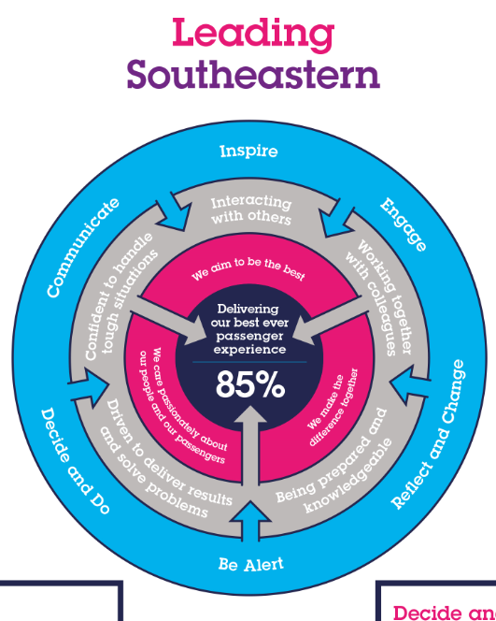

All shortlisted candidates seeking promotion will be assessed against this framework.
The job demands the following blend of experience/knowledge, skills and behaviours (all are essential, unless otherwise shown and will be assessed by application and/ or interview/assessment) :

G1 | Experience, Knowledge & Qualifications (including any specific safety training requirements)  - Educated to degree level or equivalent  - Experience and knowledge of planning and executing marketing campaigns incorporating management of external agencies  - Outstanding commercial knowledge with good understanding and working knowledge of ROI and how to best maximise budgets  - Clear understanding of planning and all aspects of the marketing mix  - Outstanding attention to detail with exceptional copywriting, proofing, and editing skills  - Excellent communication and people skills  - Able to prioritise work on own initiative, working to tight deadlines  Desirable
G2 | Skills (including any specific safety critical competencies)  - Excellent communication and people skills  - Excellent attention to detail with ability to think creatively and strategically  - An understanding of how Marketing fits into Annual Business Planning and process  - Ability to analyse data and draw out actionable insights  - Creative flair and attention to the customer needs
G3 | Behaviours  - Integrity  - Strong team player with the ability to motivate and inspire others  - Proactive and problem solving
G4 | Other  Job Description – Revised April 2022
H | Dimensions of role
H1 | Financial – Direct:
H2 | Financial – Other:
H3 | Staff Responsibilities – Direct:
H4 | Staff Responsibilities – Other:
H5 | Any Other Statistical Data:
I | Acknowledgement
I1 | Prepared By: | Nikki Causer - Head of Marketing & Commercial Partnerships |  | Date: | 04/04/22
I2 | Approved By (Head of Department): |  |  | Date:
J | Job Description Briefing
 | The post holder has been briefed on and understands the requirements of this Job Description and other related documents:
 | Name of post holder: |  | Signature: |  | Date:
 | Name of briefing manager: |  | Signature: | Nikki Causer | Date: | 04/04/22
K | Nominated Deputy for Safety requirements
 | If this is a KEY SAFETY POST (D2 in Safety Details above is YES) at least one nominated deputy must be identified. The Job Holder must ensure that the Nominated Deputy(ies) receives a copy of, and is briefed on this Job Description. If there are more nominated deputies, they should sign further copies of this Job Description.
 | The nominated deputy has been briefed on and understands the requirements of this Job Description and other related documents:
 | Name of nominated deputy: |  | Signature: |  | Date:
 | Name of briefing manager: |  | Signature: |  | Date:

