A | Post Details
 | Job Title: | Area Manager,  South | Function: | Passenger Services
 | Location: |  | Unique Post Number:
 | Reports To: | General Manager, South | Grade: | MG2
B | Purpose of the Job
Manage a group of stations and management team. Ensure the safety and security of customers and team members. Motivate and develop the station teams. Utilise resources to maximise income and meet statutory obligations.

Responsible for delivering safe, secure and professional levels of on board services to customers, focusing on customer satisfaction and revenue collection. Lead, deploy and motivate front line staff so as to encourage and promote professional standards of service, continuous improvement and compliance with all imposed obligations.

C | Principal Accountabilities
C1  C2  C3  C4  C5  C6  C7  C8  C9  C10  C11  C12  C13  C14  C15  C16  C17  C18  C19  C20  C21  C22  C23  C24  C25  C26  C27  C28  C29  C30  C31  C32  C33  C34  C35  C36 | People & Culture – Station Staff  Ensure that daily station reviews are undertaken, and key actions recorded in the station log, to ensure that the station team and infrastructure are presented to the highest possible standard. This includes, but is not limited to, staff presentation and uniform compliance, station cleanliness, customer information systems, posters, leaflets and other marketing collateral. Ensure visible station manager presence to staff and customers including, but not limited to, presence on the platforms, concourse, gateline or in the booking hall of a key station for a minimum of two hours in the weekday morning peaks (i.e. 0700 hours to 0900 hours) and two hours in the weekday evening peaks (i.e. 1700 hours to 1900 hours). Where possible, during these times, no office or administrative work is to be conducted except in exceptional circumstances (which must be recorded in the station log). Customer conversations, leading by example and coaching will be the core activities during these times.  Demonstrate Southeastern values and behaviours.  Lead, coach and develop the teams at all stations within the group and deliver a customer-focused culture.  Conduct Performance Development Reviews twice per year with every member of the team. Assess training needs of team members and ensure that agreed needs are met through the provision of appropriate courses, coaching and self development.  Develop effective communication systems that ensure regular face-to-face briefings occur with all team members.  Work with trade unions to develop harmonious and effective working relations and provide a safe workplace for all team members, developing and implementing strategies to reduce lost time injuries, sickness and assaults.  Manage manpower levels at stations within the group and arrange recruitment and selection as appropriate to ensure effective resource use of staff to minimise overtime and rest-day working.  Ensure the rapid and effective response to incidents affecting customers, particularly with the KICC to implement the Service Disruption Procedure.  Develop and maintain productive working relationships, both internally and externally with customers and other external stakeholders. Ensure Southeastern brand and values are professionally represented at all times.  Support where required, the production of rosters for ticket office, platform and gateline staff at all stations in the group.  Open ticket offices as required by Schedule 17 and deliver ticket vending machine availability to ensure customer queuing times within Charter targets.  Deliver ticket office internal control scores at or above agreed level.  Operate gatelines as required.  Comply with the requirements of the Safety Responsibility Statement, Company Safety Manual and other industry safety standards.  Achieve all agreed objectives and franchise commitments.  Compile, control and deliver through regular reviews, the delegated expenditure budget.  Carry out regular financial and business reviews and implement improvement plans where performance is not in line with objectives.  Deliver delay minutes within agreed forecast.  Ensure compliance to company Service Quality Standards at all locations.  Work with the Station Access Manager to ensure that stations where Southeastern are not the SFO, provide value for money.  People & Culture - On Board Services  Lead, coach, mentor and performance manage the on train team to ensure cost effective utilisation of resources without detriment to customer satisfaction and revenue performance.  Ensure comprehensive training in conducting and customer service standards is delivered to create a thriving and customer focussed on board sales environment.  Follow the manpower plan at all depots under the control of this post and arrange recruitment and selection as appropriate to ensure proper resourcing and rostering utilisation of on board staffing requirements.  Ensure as directed that actions are identified and instigated in the changing customer requirements, in conjunction with other departments, to provide a continuously improving on board service quality.  Manage and deliver those issues with robust systems and processes to ensure full compliance with relevant Legal and Industry Safety Standards. Undertake regular audits of Depots to ensure process is being administered correctly.  Ensure that Depot Managers cover early and late shifts to ensure availability to conductors within depots.  As directed by General Manager, deliver effective processes to ensure communication is cascaded quickly to employees and they receive regular robust briefings.  Ensure compliance to Penalty Fares Scheme, Railway Safety Accreditation Scheme and National Conditions of Carriage.  Control level of spending to ensure that costs are managed within agreed budgets.  Provide a safe workplace for staff, developing and implementing strategies to reduce lost time injuries, sickness and staff assaults.  Deliver an efficient station/train interface, driving punctual departures and maintaining service continuity during disruptions.  Develop and maintain productive working relationships, both internally and externally with customers, outside bodies and stakeholders to ensure the effective presentation of the Company at all times.  Ensure full engagement by all staff to Service Quality Standards, ensuring consistent and continually improving delivery.  Deliver required level of NVQs at the depots under your control.  Ensure that all Personal Development Reviews are undertaken and that all agreed actions and development plans are met within agreed timescales by direct reports.  Ensure compliance to maintaining Investors in People accreditation for the passenger services organisation working with your team of Depot Managers.

D | Safety Responsibilities
D1 | This post is required to undertake SAFETY CRITICAL WORK | Yes |  | No
D2 | This is a KEY SAFETY POST | Yes |  | No
D3 | This post requires SECURITY CLEARANCE | Yes |  | No
D4 | The job requires competence in PERSONAL TRACK SAFETY | Yes |  | No
D5 | This job has SPECIFIC SAFETY RESPONSIBILITIES (if Yes see section D6 below) | Yes |  | No
D6 | The post holder has the following specific safety responsibilities:
 | Carry out General Inspections or provide written agreement as to the disposition of activity where locations are shared with other Train Operating Companies, Network Rail or other departments within Southeastern.
 | Act as Fire Precautions Manager at for the relevant areas or provide written agreement as to the disposition of activity where locations are shared with other Train Operating Companies, Network Rail or other departments within Southeastern.
 | Ensure compliance to all company policies, procedures and processes.
 | Carry out on call duties as required.
E | Decision making Authority
E1 | Purchase through the Oracle System within budget and Delegated Financial Authority up to a maximum of £5k.
F | Most Challenging and/or Difficult parts of the role
F1 | To ensure a consistent achievement of company standards and objectives within timescales.

G | Person Specification

Southeastern aims to recruit people not just for jobs but for long term careers. We want good quality, talented people with the right attitude who will stay with us.

For these reasons we look for evidence of Southeastern values and behaviours in all potential staff and our existing staff looking for promotion along with the particular experience/knowledge, skills and behaviours relevant to the position applied for. These are

We care passionately about our people and passengers
  - we put ourselves in our passengers’ shoes to do what’s right for them
  - we support our colleagues to be, feel and do their best
  - we love the places we serve and do our bit for our communities and environment

We aim to be the best
  - we move with pace, we’re agile and learn from everything
  - we relentlessly strive to be the best
  - we are professionals with personalities

We make the difference together
  - we are answerable to each other and our passengers
  - we trust each other and do what we say we will
  - we are stronger together than we are as individuals

We also have identified behaviours required to be successful in leading Southeastern.

The Leading Southeastern framework details how we should be behaving in order to drive up performance to deliver 85 by 18.

Leading Southeastern
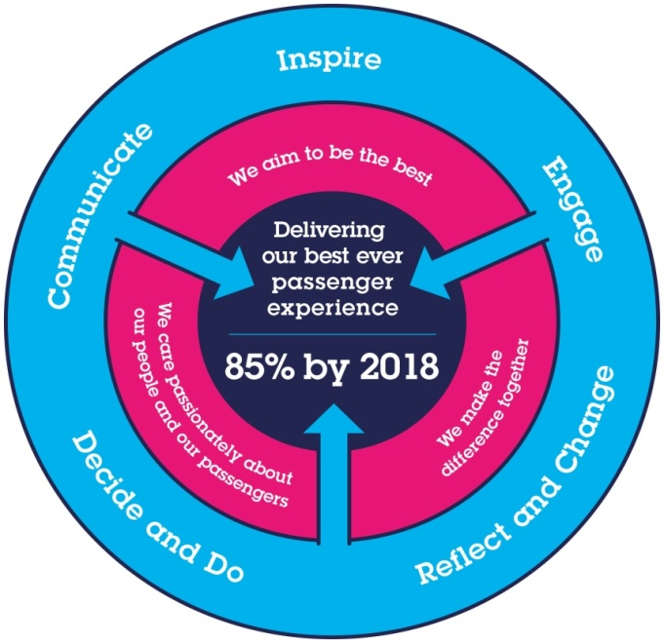

All shortlisted candidates seeking promotion will be assessed against this framework.

The job demands the following blend of experience/knowledge, skills and behaviours (all are essential , unless otherwise shown and will be assessed by application and/ or interview/assessment) :

G1 | \
G2 | Skills (including any specific safety critical competencies)  Influencing – Gains commitment to deliver the desired result, through the use of a range of interpersonal skills, focussing on persuasion and negotiation.  Customer focused with strong commercial awareness – Uses understanding of Southeastern and its position within the marketplace to grow the business.  Leadership – Sets direction and inspires commitment to achieve common goals. Coaches to improve performance.  Professionalism – Aims to be the very best they can be through their attitude & respect of others, always leading by example.  Quality Orientation – Shows awareness of goals and standards, ensuring that quality and productivity standards are met.  Innovative, creative and highly motivated.  Excellent communicator both written and verbally.
G3 | Behaviours  Persuasiveness – Presents the key points of an argument persuasively. Negotiates and convinces others, changes people’s views and influences decisions.  Communication - Expresses oneself confidently and effectively. Is friendly and engages others in open, honest and productive conversations.  Commercial Awareness - Understands and applies commercial and financial principles. Views issues in terms of costs, profits, markets and added value.  Leadership – Motivates and empowers others in order to reach organisational goals.  Professionalism – Interacts with others in a sensitive and effective way. Respects and works well with others. Quickly builds rapport and easily establishes relationships with different types of customers and stakeholders.  Adding Value – Exploits opportunities to improve results and add value to the business.
G4 | Other  It is desirable but not essential that you hold a Train Despatch Licence. You must attend a Safety Critical Medical upon appointment to determine your ability to do so.  Deputise for the General Manager as required.

I | Dimensions of role
I1 | Financial – Direct: |  |  |  | As per budget and DFA
I2 | Financial – Other: |  |  |  | Up to £3000 Refund authorisation.
I3 | Staff Responsibilities – Direct:
I4 | Staff Responsibilities – Other: |  |  |  | As detailed by
I5 | Any Other Statistical Data: |  |  |  | stations.
J | Acknowledgement
J1 | Prepared By: |  |  |  |  |  | Date:
J2 | Approved By (Head of Department): |  |  |  |  |  | Date:
K | Job Description Briefing
 | The post holder has been briefed on and understands the requirements of this Job Description and other related documents:
 | Name of post holder: |  |  | Signature: |  |  |  |  | Date:
 | Name of briefing manager: |  |  | Signature: |  |  |  |  | Date:
L | Nominated Deputy for Safety requirements
 | If this is a KEY SAFETY POST (D2 in Safety Details above is YES) at least one nominated deputy must be identified. The Job Holder must ensure that the Nominated Deputy(ies) receives a copy of, and is briefed on this Job Description. If there are more nominated deputies, they should sign further copies of this Job Description.
 | The nominated deputy has been briefed on and understands the requirements of this Job Description and other related documents:
 | Name of nominated deputy: |  |  | Signature: |  |  |  |  | Date:
 | Name of briefing manager: |  |  | Signature: |  |  |  |  | Date:

