A | Post Details
 | Job Title: | Service Engineer Level 5 (PDE) | Function: | Engineering
 | Location: | All Engineering Depot | Unique Post Number:
 | Reports To: | Shift Production Manager or Depot  Delivery Manger | Grade: | SE5
B | Purpose of the Job
This is a wide ranging role, providing both technical expertise and team leadership. As a Production Delivery Engineer (PDE), you will be leading a team of engineering staff, whilst being responsible for primary defect management to in service units, including, defect troubleshooting, defect diagnosis, work scope creation and defect rectification.

Report directing to the SPM/DDM, the SE5 will manage a team, covering all engineering activities, including exams, defects rectification, modifications, time based maintenance packages and repair. SE5s will report to the SPM/DDM in a fixed team structure.

The SE5 is also responsible for in service defect control, including liaising with external stakeholders, re railing engineers, despatch/notification of engineering support staff.

Key tasks will include technical expertise and defect management, leading and motivating a team of staff to ensure that they work together safely and effectively to the required standards and specifications. Co-ordinating the effective deployment of staff to ensure production and operational deadlines targets are met.

C | Principal Accountabilities
C1  C2  C3  C4  C5  C6  C7  C8  C9  C10  C11  C12  C13  C14  C15  C16  C17  C18  C19 | Motivate and lead an engineering team on and off site  Provide technical expertise for the team and SPM, including, troubleshooting and defect rectification and raising the scope of work.  Supervision, training/coaching, competence assessments, document writing, train bourne software/IT support, tooling issues and calibration.  Prioritise and manage workloads, liaising with other departments as necessary  Have a sound knowledge of Engineering’s Quality and Competency Management Systems  Responsible for creating required work scopes for investigation and repair based on the information provided and the use of on-train monitoring systems such as but not limited to XDM, TDS, Transient Downloads, BCU analysis, CCTV, LIM fault diagnosis, OTMR and Traction Fault Logs etc.  Provide assistance to technical department for technical documentation and fault finding guides to assist production personnel. Promote and share best practice procedures for Engineering by means of feed back loops (WIKI)  A systems and component level knowledge of rolling stock so as to carry out system testing and failure modes analysis. Able to monitor and react to defect trends and process management issues.  Required to find innovative ways to continuously improve production processes and the reliability of the rolling stock and implement these changes.  Responsible for carrying out failure mode component testing of faulty or suspect electronic hardware both on and off rolling stock.  Able to follow high level technical documentation including hardware/software schematics and engineering drawings and complete all necessary supporting paperwork, in conjunction with Engineering’s Quality Management System  Able to deputise for the SPM or DDM as required, for periods of absence and other occasions as directed by the Senior Management.  Project manage packages of work to steady business state  In line with the conditions of service section 2.7 Engineering grades will be required to undertake any work for which they are trained and competent.  In addition to this additional training will be supplied where required to meet the operational needs of the business  Operate plant, machinery as competent or licensed to use  Responsible for maintaining unit record documents, information and ensuring they are stored in compliance with our engineering management system  Attend all production related meetings and reviews as required  Hold and Maintain a full UK driving license and adhere to Southeastern use of company vehicles policy

D | Safety Responsibilities
D1 | This post is required to undertake SAFETY CRITICAL WORK | Yes | X | No
D2 | This is a KEY SAFETY POST | Yes |  | No | X
D3 | This post requires SECURITY CLEARANCE | Yes | X | No
D4 | The job requires competence in PERSONAL TRACK SAFETY | Yes | X | No
D5 | This job has SPECIFIC SAFETY RESPONSIBILITIES (if Yes see section D6 below) | Yes | X | No
D6 | The post holder has the following specific safety responsibilities:
 | Competent to pass as first aider
Perform HSE checks for both SE Staff and Contractors in conjunction with Engineering’s Quality Management System
Perform Finish work inspections and in process checks
A1 Competence assessor
Ensure local depot and on track safety is adhered to
Key specific SPM safety duties as and when covering

E | Decision making Authority
E1  E2  E3 | As defined by the Shift Production Manager or Depot Deliver Manager, but primarily responsible for the day to day supervision of the team, the allocation of work, the technical management of the team and the rolling stock tasks assigned to the team and shift.  As defined by defective on train and equipment list, if a unit is fit for or to continue in passenger service  Communicate with relevant stakeholders to ensure the reliability of the rolling stock is kept to an optimum for passenger service
F | Most Challenging and/or Difficult parts of the role
F1  F2  F3 | Ensuring the shift output and resource is maintained to the desired productivity level.  Ensuring defects are repaired effectively and that unit engineering reliability is not affected as a result of maintenance/repair intervention  Ensuring long term plans retain integrity  Ensure quality standards are kept at a standard expected by our customers

G | Person Specification

Southeastern aims to recruit people not just for jobs but for long term careers. We want good quality, talented people with the right attitude who will stay with us.

For these reasons we look for evidence of Southeastern values and professional behaviours in all potential staff and our existing staff looking for promotion along with the particular experience/knowledge, skills and behaviours relevant to the position applied for. These are

We care passionately about our people and passengers
  - we put ourselves in our passengers’ shoes to do what’s right for them
  - we support our colleagues to be, feel and do their best
  - we love the places we serve and do our bit for our communities and environment

We aim to be the best
  - we move with pace, we’re agile and learn from everything
  - we relentlessly strive to be the best
  - we are professionals with personalities

We make the difference together
  - we are answerable to each other and our passengers
  - we trust each other and do what we say we will
  - we are stronger together than we are as individuals

We also have identified behaviours required to be successful in leading Southeastern.

The Leading Southeastern framework details how we should be behaving in order to drive up performance to deliver 85 by 18.

Leading Southeastern
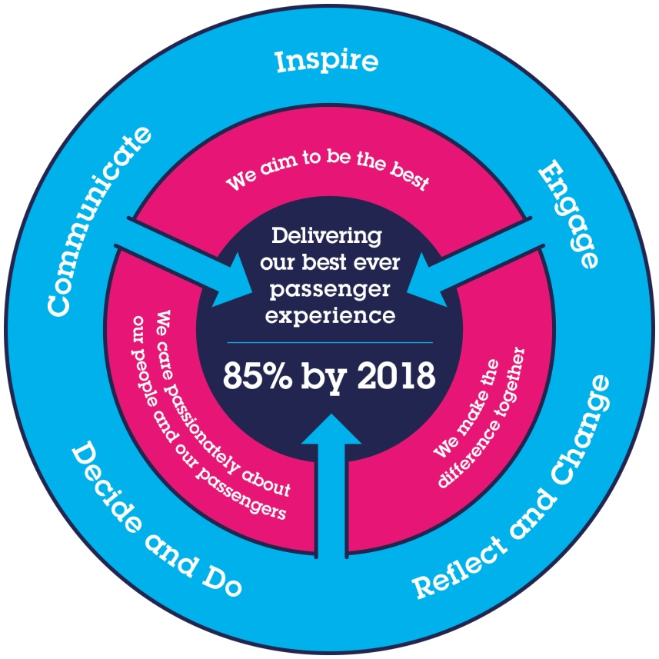

All shortlisted candidates seeking promotion will be assessed against this framework.

G1 | Experience, Knowledge & Qualifications – Essential  5 years experience of Engineering, NVQ level 3 in Rail Engineering, Core Management and Leadership training, Intermediate IT skills (Excel, word etc), Accredited with certificate in Engineering (BTEC/ONC) or equivalent.  Hold and Maintain a full UK driving license  1A assessor desirable
G2 | Competencies – Essential  Core Mechanical Skills 1 (Confirm compliance with Specification) and 2 (Remove and refit components), Core Electrical Skills 1 (confirm compliance with specification) and 2 (remove and refit complex components)  Physically fit and able to pass a medical to engineering standard  Competencies – Essential  Schematic and fault finding, Line of Route and DOTEL  Experience, Knowledge & Qualifications – Desirable  HNC in Engineering or Higher, Advanced IT skills (Excel, Word etc), NVQ Level 4 in supervision/team management, quality & safety systems training.
G3 | Behaviours  As set out above in core value and codes of conduct.
G4 | Report Preparation  Utilising the complaint engineering management system and process ensure all stake holders are informed in a concise manner of any incidents or defects that have occurred.  Responsible for communicating shift issues and information to following shift and relevant stakeholders, including but not limited to ie handovers callovers and defect logs
Activity specific

General reports in Microsoft Word, Excel, and PowerPoint format, as defined by the Shift Production Manager/Depot delivery manager

G5 | Contact With Others
 | This is a wide ranging role with contacts across the organisation, including Senior and Depot Managers, the Technical Team, Planning Team, Material Team and Warranty Team. Suppliers, contractors and other support and external staff.

I | Dimensions of role
I1 | Financial – Direct: |  | None
I2 | Financial – Other: |  | As defined by the Senior management
I3 | Staff Responsibilities – Direct: |  | Performance development reviews on staff attributed to them by Shift production manager
I4 | Staff Responsibilities – Other: |  | All other Engineering grades as defined by senior management
I5 | Any Other Statistical Data: |  | None
J | Acknowledgement
J1 | Prepared By: | _______________ |  | Date: | ______________
J2 | Approved By (Head of Department): | _______________ |  | Date: | ______________

K | Job Description Briefing
 | The post holder has been briefed on and understands the requirements of this Job Description and other related documents:
 | Name of post holder: |  | Signature: |  | Date:
 | Name of briefing manager: |  | Signature: |  | Date:
L | Nominated Deputy for Safety requirements
 | If this is a KEY SAFETY POST (D2 in Safety Details above is YES) at least one nominated deputy must be identified. The Job Holder must ensure that the Nominated Deputy(ies) receives a copy of, and is briefed on this Job Description. If there are more nominated deputies, they should sign further copies of this Job Description.
 | The nominated deputy has been briefed on and understands the requirements of this Job Description and other related documents:
 | Name of nominated deputy: |  | Signature: |  | Date:
 | Name of briefing manager: |  | Signature: |  | Date:

