A | Post Details
 | Job Title: Retail Contracts Manager |  | Function: Commercial
 | Location: 4 More London |  | Unique Post Number:
 | Reports To: Head of Retail Operations |  | Grade: MG2
B | Purpose of the Job  This position plays an important role within the Retail Operations team, providing specialist commercial and contractual management to drive value and compliance within the eight figure Retail contract portfolio.
The purpose of this role is to work with business stakeholders and third-party suppliers to ensure that contractual commitments are monitored, relevant and aligned with business objectives, and proactively managed to build better relationships and performance growth. As such, this role will have a significant bearing on the output and value achieved by the team and will play a major part in ensuring that third-party contracts add value to Southeastern and its customers.

Southeastern are currently in the process of retendering and extending a number of Retail Contracts, with the expectation that the contracts will take effect within 6-9 months. The successful applicant will use their expertise to assist the team with the tender process and ensure that our new contracts maximise and deliver the most value for the business over the lifetime of the contract.

The role may also be required to assist with establishing or renegotiating additional contracts within the Commercial function, to ensure the department is maximising value from the supply chain.

C | Principal Accountabilities
C1  C2  C3  C4  C5  C6  C7  C8  C9  C10  C11  C12  C13  C14  C15  C16  C17 | Ensuring that suppliers adhere to their contractual responsibilities, and delivering the value achieved in the procurement process whilst also focusing on continuous improvement via performance improvements, and driving efficiency via savings and cost avoidance.  Managing change and negotiating best value on contracts, working with supply chain partners to seek opportunities for innovation whilst also ensuring that any proposed changes represent value for money, are justified and ensure continuous improvement throughout the contract lifecycle.  Providing contractual expertise to proactively manage any arising issues and being familiar with relevant procurement and contract regulations including the Procurement Act 2023 to ensure that Southeastern remains compliant with any contract management and reporting requirements  Administering the contract to ensure compliance with deliverables and both Southeastern and the supplier’s obligations  Assessing and validating payment applications to ensure cost accuracy  Developing optimised supplier relationships including using SRM tools and approaches which aim to lead to better collaboration, improved service quality and favourable pricing; as well as minimising disputed charges.  Mitigating supply chain risks by monitoring supplier performance, health and market conditions – proactively taking action to avoid disruption and ensure business continuity  Standardising data capture to allow increased market analysis and opportunity assessment, as well as supporting reporting and transparency requirements.  Liaising with the Procurement team throughout the sourcing process to ensure that business requirements are agreed and technical specifications and performance regimes are representative of business priorities and focus.  Maximising and managing social value generation in third-party contracts, including monitoring contractual commitments and net zero progress.  Liaising with Finance Business Partners to manage contract and project budgets.  Providing ad hoc support of associated business/industry initiatives such as cross-organisation or industry initiatives, supplier relationship management, contract negotiations or supply chain management.  Ensuring that all contracts which involve suppliers working on Southeastern sites have appropriate contractual health and safety documentation which is actively monitored.  Managing the contracts in life, monitoring and reporting that the supplier is delivering their Service Level Agreements. Organise and manage regular service reviews and follow up actions to ensure timely close out.  Be the point of escalation to resolve any issues related to the Supplier and the service provided by the Supplier. Liaise with relevant Southeastern departments and industry bodies to ensure smooth day to day operation.  Explore opportunities internally and with suppliers to enhance the customer offering and ensure Change/Variation Orders are raised accordingly whilst ensuring value for money for new works.  Manage and take ownership for testing of new software releases and other associated developmental items and facilitate deployment into the field in a controlled manner to ensure system integrity. Obtain necessary internal approvals for any rollout as directed via Southeastern change control protocols.
D | Safety Responsibilities
D1 | This post is required to undertake SAFETY CRITICAL WORK |  |  | Yes |  | No | x
D2 | This is a KEY SAFETY POST or nominated deputy |  |  | Yes |  | No | x
D3 | The holder of this post is identified as a KEY SAFETY MANAGER |  |  | Yes |  | No | x
D4 | The job requires competence in PERSONAL TRACK SAFETY |  |  | Yes |  | No | x
D5 | This job has SPECIFIC SAFETY RESPONSIBILITIES (if Yes see section D6 below) |  |  | Yes |  | No | x
D6 | The post holder has no specific safety responsibilities.
E | Decision making Authority
E1  E2  E3  E4 | Recommendation of Southeastern contract strategies and contract amendments to the Head of Retail Operations, Commercial Director, Head of Procurement and Finance & Contracts Director for final approval.  Negotiating with suppliers on behalf of Southeastern up to unlimited values.  Respect corporate governance protocols, ensuring that permissions are sought at a level appropriate to the respective contractual/financial impact of a decision/agreement  Give expert advice to the Head of Retail Operations with the formal evaluation of tender responses in line with business requirements and recommendation of a preferred contractor

F |  | Person Specification

Southeastern aims to recruit people not just for jobs but for long term careers. We want good quality, talented people with the right attitude who will stay with us.

For these reasons we look for evidence of Southeastern values and behaviours in all potential staff and our existing staff looking for promotion along with the particular experience/knowledge, skills and behaviours relevant to the position applied for. These are

We care passionately about our people and passengers
  - we put ourselves in our passengers’ shoes to do what’s right for them
  - we support our colleagues to be, feel and do their best
  - we love the places we serve and do our bit for our communities and environment

We aim to be the best
  - we move with pace, we’re agile and learn from everything
  - we relentlessly strive to be the best
  - we are professionals with personalities

We make the difference together
  - we are answerable to each other and our passengers
  - we trust each other and do what we say we will
  - we are stronger together than we are as individuals

We also require more than competent performance against our Leadership & Management Competency Framework.
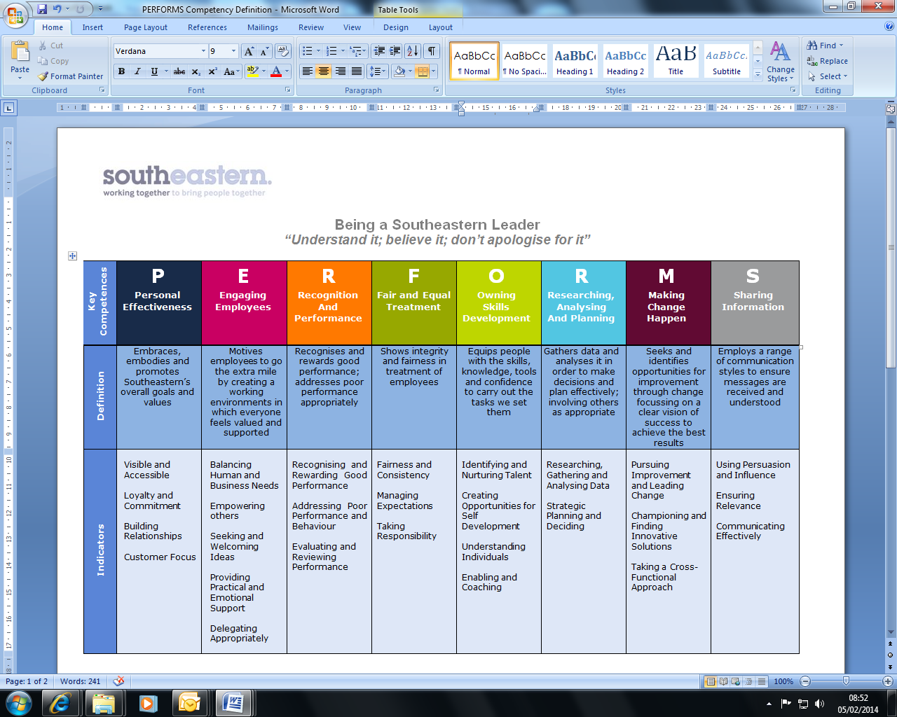
All shortlisted candidates seeking promotion will be assessed against this framework.

The job demands the following blend of experience/knowledge, skills and behaviours (all are essential, unless otherwise shown and will be assessed by application and/ or interview/assessment).

F1 |  | Experience, Knowledge & Qualifications (including any specific safety training requirements)  - Good stakeholder management skills and experience  - Knowledge and experience of working with retail and or EPOS systems contracts in a Railway or equivalent environment is desirable  - Experience of preparing and managing large budgets with good numeracy and analytical skills - Essential  - Experience in writing, building and supporting business case submissions.  - Experience in evaluating bidder submissions in a tender process and negotiating improved value in contract extensions - Essential  - Experience in managing suppliers within an in-life contract - Essential  - Experience in setting up a new supplier within a business and working with different departments, including IT, to deliver the contract. - Desirable  - Working knowledge of contract law, government legislation and Procurement Act 2023 regulations- Essential
F2 |  | Skills (including any specific safety critical competencies)  - Ability to work effectively at management level within Southeastern, liaising with senior managers and across directorates effectively.  - Ability to express oneself confidently, honestly and effectively.  - Proven influencing and problem-solving skills.  - Commercial awareness.  - Good IT skills including use of Microsoft suite (Excel, Word & Powerpoint)  - Well-developed report writing skills  - Able to analyse data and make decisions from the information provided.
F3 |  | Behaviours  - Professionalism - reliable, setting your own high standards, and showing that you care about every aspect of your job. Being industrious and organized, and holding yourself accountable for your thoughts, words and actions  - Honesty and Integrity – is transparent and honest and takes full responsibility for actions. Confidence and courage to challenge the business and deal effectively with difficult situations.  - Teamwork, Sharing and Supportive – aligns with others both within and outside Southeastern to deliver common goals. Shares ideas and information. Supports colleagues and works effectively with others.  - Flexibility – successfully adapts to changing demands, conditions and scenarios.
H | Dimensions of role
H1 | Financial – Direct:
H2 | Financial – Other: n/a
H3 | Staff Responsibilities – Direct:
H4 | Staff Responsibilities – Other: none
H5 | Any Other Statistical Data: Procurement KPIs
I | Acknowledgement
I1 | Prepared By (Head of Department): |  | _______________ |  | Date: | ______________

J | Job Description Briefing
 | The post holder has been briefed on and understands the requirements of this Job Description and other related documents:
 | Name of post holder: |  | Signature: |  | Date:
 | Name of briefing manager: |  | Signature: |  | Date:
K | Nominated Deputy for Safety requirements
 | If this is a KEY SAFETY POST (D2 in Safety Details above is YES) at least one nominated deputy must be identified. The Job Holder must ensure that the Nominated Deputy(ies) receives a copy of, and is briefed on this Job Description. If there are more nominated deputies, they should sign further copies of this Job Description.
 | The nominated deputy has been briefed on and understands the requirements of this Job Description and other related documents:
 | Name of nominated deputy: |  | Signature: |  | Date:
 | Name of briefing manager: |  | Signature: |  | Date:

