A | Post Details
 | Job Title: | Fleet Manager Mainline |  |  |  |  |  | Function: |  |  |  |  | Engineering
 | Location: | Ramsgate |  |  |  |  |  | Unique Post Number:
 | Reports To: | Head of Fleet Engineering |  |  |  |  |  | Grade: |  |  |  |  | MG2
B | Purpose of the Job
The Fleet Manager Mainline leads and manages a team of Fleet Engineers to develop and continually improve Southeastern rolling stock. The team principally leads identification, development and implementation of a range of fleet development initiatives across all fleets to improve safety, reliability, passenger experience, profit and environmental impact. Typically improvements are achieved through process, specification or component/system modification.

The team also provide technical support for business-critical projects. The team shall provide support to the Major Programmes team from the initial outline specification through to design, development, approval and implementation.

The role shall ensure the team is providing the correct development initiatives to meet the business objectives and Business Plan Commitments. It shall ensure that all initiatives are clearly reported, deadlines are met, and any changes are progressed through the Engineering Change process. The role shall report on the team progress and the status of Engineering Change to the business.

The role shall also, along with the Fleet Engineers, look outside the business to identify improvement opportunities, innovations and best practice that Southeastern can benefit from. This will require representing Southeastern at industry working groups, as well as looking outside the rail industry in other applicable fields.

C | Principal Accountabilities
C1  C2  C3  C4  C5  C6  C7  C8  C9  C10  C11 | Responsible for managing the Mainline fleet portfolio of development initiatives, ensuring all workstreams are correctly prioritised, and that deadlines are met.  Responsible for managing Engineering Changes via the Engineering Change tracker and chair regular meetings, ensuring business critical changes are being progressed within agreed timescales.  Responsible for managing the outstanding actions and caveats raised by Engineering Changes and ensure these are all closed in acceptable timescales.  Lead or attend regular meetings where fleet development is an agenda item. This shall include representing Southeastern at RoSCo and Supplier meetings as required.  Act as Competent Person and approve Engineering Changes, part of Southeastern’s Safety Management System (SMS).  Responsible for ensuring fleet development that could affect Safety, Performance and Reliability are managed effectively to reduce potential risks to acceptably low levels. Must be able to assess and manage risk using recognised processes.  Support Materials with technical investigations to determine root cause and failure analysis. Where possible, fleet development initiatives shall improve reliability by identifying modern replacement materials, which in turn will provide improved performance.  Accountable for regularly reporting to the business on fleet development and demonstrate the progress of each initiative. Where targets are compromised these must be effectively communicated to the business, including an appropriate recovery strategy.  As required, lead technical investigations and provide technical reports with structured recommendations as necessary.  Provide on call cover by supporting the Fleet Technical Officer Roster.  The post-holder shall deputise for the Fleet Manager High Speed, or Fleet Manager Metro, as required.
D | Safety Responsibilities
D1 | This post is required to undertake SAFETY CRITICAL WORK |  |  |  |  |  |  |  |  |  | Yes |  |  | No
D2 | This is a KEY SAFETY POST or nominated deputy |  |  |  |  |  |  |  |  |  | Yes |  |  | No
D3 | The holder of this post is identified as a KEY SAFETY MANAGER |  |  |  |  |  |  |  |  |  | Yes |  |  | No
D4 | The job requires competence in PERSONAL TRACK SAFETY |  |  |  |  |  |  |  |  |  | Yes |  |  | No
D5 | This job has SPECIFIC SAFETY RESPONSIBILITIES (if Yes see section D6 below) |  |  |  |  |  |  |  |  |  | Yes |  |  | No
D6 | The post holder has the following specific safety responsibilities:  - N/A
E | Decision making Authority
E1  E2  E3 | Approval of Engineering Changes as a Competent Person.  Complete and approve Risk Assessments and make the necessary decisions to manage the risk within acceptable levels, whistle causing the minimum amount of disruption to business operations.  Prioritisation of development initiatives to meet business objectives to agreed deadlines.
F | Most Challenging and/or Difficult parts of the role
F1  F2  F3 | Management of a diverse workload with a large team of qualified Fleet Engineers.  Providing support to all Mainline rolling stock that are in different stages of their lifecycle and being maintained in difference locations.  Direct liaison with Alstom to ensure correct levels of technical support is being provided under the terms of the TSSSA.
G | Person Specification

Southeastern aims to recruit people not just for jobs but for long term careers. We want good quality, talented people with the right attitude who will stay with us.

For these reasons we look for evidence of Southeastern values and behaviours in all potential staff and our existing staff looking for promotion along with the particular experience/ knowledge, skills and behaviours relevant to the position applied for. These are

Take personal responsibility for our actions

Support our colleagues

Take care of our customers

Work collaboratively with stakeholders

Operate in a socially and environmentally responsible way

The Leading Southeastern framework details how we should be behaving in order to drive up performance to deliver 85%.

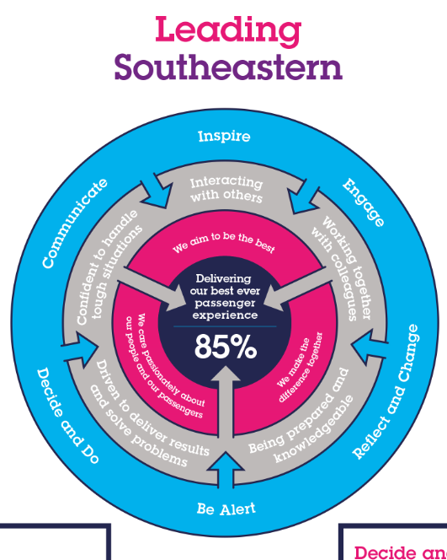

All shortlisted candidates seeking promotion will be assessed against this framework.

The job demands the following blend of experience/knowledge, skills and behaviours (all are essential , unless otherwise shown and will be assessed by application and/ or interview/assessment).

G1 | Experience, Knowledge & Qualifications (including any specific safety training requirements)  At least 4 years experience in an engineering environment.  Degree or HND/ HNC in an Engineering Discipline.  Knowledge of reliability growth models and techniques together with experience and application in a technical or operational environment. Particular skills in structure problem solving using recognised process such as FMEA, RCM, RAMS or FRACAS.  Desirable to have technical knowledge of Traction and Rolling Stock systems and operation. It is also desirable to have knowledge of Traction and Rolling Stock maintenance management, maintenance plan and maintenance documentation.  Proven leadership and management experience, communication and interpersonal skills.  Experience in project management particularly structured time management and planning, resource identification and utilisation and prioritising. Proven leadership experience, communication and interpersonal skills. Articulate in written and oral communication.  Practical application knowledge of IT systems, including Windows, Word, Excel and MS Project or equivalent.  Good knowledge of Railway Group Standards, ROGS and other relevant rail related standards. Knowledge of Interoperability (RIR) and Technical Standards for Interoperability.  Working knowledge of the Network Rail operational rule book including those applicable to DC EMU rolling stock.  The post holder must be able to attain Personal Track Safety Certification.
G2 | Skills (including any specific safety critical competencies)  Must be able to interpret technical standards and applicable legislation.  Must be able to make sound engineering judgments in relation to material selection.  Must be able to effectively prioritise workload.  Must be a logical thinker with good planning and organising skills to ensure targets are met, trackers are updated, and progress is communicated.
G3  G4 | Behaviours  Take ownership and responsibility for issues and work in structured way to deliver to target.  Lead and motivate other team members to deliver objectives.  Lead by example and go the extra mile when required by the business.  Excellent team working qualities by assisting/supporting others with technical problems and working with others to gain a rich understanding of the problems surrounding an issue.  Other  The post holder will be based at Ramsgate Depot; however, will be expected to work closely with suppliers, which may include travel to other depots or work sites, including Southeastern HQ at ML in central London.
H | Dimensions of role
H1 | Financial – Direct:
H2 | Financial – Other: |  |  |  |  | As directed by Head of Fleet Engineering
H3 | Staff Responsibilities – Direct: |  |  |  |  | 5 x Fleet Engineers
H4 | Staff Responsibilities – Other: |  |  |  |  | Alstom TSSSA staff based at Ramsgate
H5 | Any Other Statistical Data:
I | Acknowledgement
I1 | Prepared By: |  |  | _______________ |  |  |  |  | Date: | ______________
I2 | Approved By (Head of Department): |  |  | _______________ |  |  |  |  | Date: | ______________
J | Job Description Briefing
 | The post holder has been briefed on and understands the requirements of this Job Description and other related documents:
 | Name of post holder: |  |  |  | Signature: |  |  |  |  |  |  |  | Date:
 | Name of briefing manager: |  |  |  | Signature: |  |  |  |  |  |  |  | Date:
K | Nominated Deputy for Safety requirements
 | If this is a KEY SAFETY POST (D2 in Safety Details above is YES) at least one nominated deputy must be identified. The Job Holder must ensure that the Nominated Deputy(ies) receives a copy of, and is briefed on, this Job Description. If there are more nominated deputies, they should sign further copies of this Job Description.
 | The nominated deputy has been briefed on and understands the requirements of this Job Description and other related documents:
 | Name of nominated deputy: |  |  |  | Signature: |  |  |  |  |  |  |  | Date:
 | Name of briefing manager: |  |  |  | Signature: |  |  |  |  |  |  |  | Date:

