A | Post Details
 | Job Title: | Fire Safety & Emergency Planning Manager | Function: | Safety & Environment
 | Location: | 4 More London | Unique Post Number:
 | Reports To: | Head of Security & Business Continuity | Grade: | MG2
B | Purpose of the Job
Act as Contract Manager for the maintenance and replacement of portable fire fighting equipment. Lead the development of fire risk assessments, the inspection of premises and the provision of professional advice and the supply of fire safety training across the company.
Support the Head of Security & Business Continuity with all aspects of emergency planning including assurance checks, tabletop and live exercises.

C | Principal Accountabilities
C1  C2  C3  C4  C5  C6  C7  C8  C9  C10  C11 | Ensure that appropriate portable fire fighting equipment (including hose reels)  is provided and undertake an annual maintenance programme to include  maintenance, replacement and recharging in accordance with current Railway  Group Standards.  Lead the development of fire risk assessments across all Southeastern premises, maintaining a database and completing reviews as required either directly or via Key Safety Leaders.  Conduct full, compliant fire risk assessments on new or modified premises.  Provide competent fire safety support and advice to any new projects or alterations to Southeastern premises.  Ensure that all legal requirements in respect of fire safety are being adequately observed within Southeastern.  Lead emergency planning arrangements for stations, depots and office locations across the Southeastern network.  Act as the lead for tabletop and live emergency exercises for Southeastern.  Maintain detailed records for each premises showing locations of firefighting equipment, equipment type and size.  Deliver initial and refresher Fire Precautions Manager (FPM) training for Key Safety Leaders.  Carry out initial routine inspections of all Southeastern premises, including tenancies.  Submit comprehensive reports to the Head of Health, Safety & Environment as necessary.
D | Safety Responsibilities
D1 | This post is required to undertake SAFETY CRITICAL WORK |  |  |  | Yes |  | No
D2 | This is a KEY SAFETY POST |  |  |  | Yes |  | No
D3 | This post requires SECURITY CLEARANCE |  |  |  | Yes |  | No
D4 | The job requires competence in PERSONAL TRACK SAFETY |  |  |  | Yes |  | No
D5 | This job has SPECIFIC SAFETY RESPONSIBILITIES (if Yes see section D6 below) |  |  |  | Yes |  | No
D6 | The post holder has the following specific safety responsibilities:
- Responsible Manager for Fire Safety specification
- Responsible Manager for Fire Precautions Manager Specification
- Responsible Manager for Local emergency planning specification

E | Decision making Authority
E1 | Able to make decisions relating to fire safety and local emergency planning
F | Most Challenging and/or Difficult parts of the Job
F1 | Maintaining compliance to fire regulations, railway industry standards and Southeastern health and safety management system.
G | Person Specification:

Southeastern aims to recruit people not just for jobs but for long term careers. We want good quality, talented people with the right attitude who will stay with us.

For these reasons we look for evidence of Southeastern values and behaviours in all potential staff and our existing staff looking for promotion along with the particular experience/knowledge, skills and behaviours relevant to the position applied for. These are

We care passionately about our people and passengers
  - we put ourselves in our passengers’ shoes to do what’s right for them
  - we support our colleagues to be, feel and do their best
  - we love the places we serve and do our bit for our communities and environment

We aim to be the best
  - we move with pace, we’re agile and learn from everything
  - we relentlessly strive to be the best
  - we are professionals with personalities

We make the difference together
  - we are answerable to each other and our passengers
  - we trust each other and do what we say we will
  - we are stronger together than we are as individuals

We also have identified behaviours required to be successful in leading Southeastern.

The Leading Southeastern framework details how we should be behaving in order to drive up performance to deliver 85%.

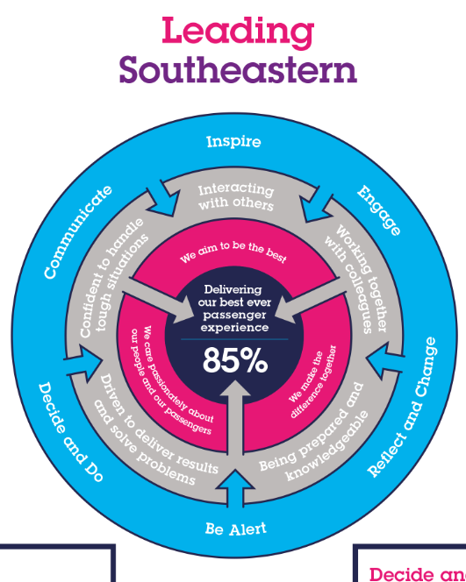

All shortlisted candidates seeking promotion will be assessed against this framework.

The job demands the following blend of experience/knowledge, skills and behaviours (all are essential , unless otherwise shown and will be assessed by application and/ or interview/assessment) :

G1 | Experience, Knowledge & Qualifications – Essential  Good education with passes in English Language and Mathematics.  Fire Precautions Manager module.  Comprehensive knowledge of fire safety legislation.  Must have fire prevention experience in a local authority fire brigade or have equivalent experience within the railway industry.
G2 | Experience, Knowledge & Qualifications – Desirable
G3 | Behaviours and Skills – Essential  Proactive and able to work without immediate supervision.  Communication- Expresses oneself confidently and effectively. Is friendly and engages others in open, honest and productive conversations.  Good attention to detail.  Honesty and Integrity- Is transparent and honest and takes full responsibility for actions.  Professionalism- Interacts with others in a sensitive and effective way.  Good planning and organisational skills.
G4 | Behaviours and Skills – Desirable

H | Dimensions of the Job
H1 | Financial – Direct:
H2 | Financial – Other:
H3 | Staff Responsibilities – Direct:
H4 | Staff Responsibilities – Other:
H5 | Any Other Statistical Data:
K | Acknowledgement
K1 | Prepared By: |  | _______________ |  |  |  | Date: | ______________
K2 | Approved by (Head of Department): |  | _______________ |  |  |  | Date: | ______________
J | Job Description Briefing
 | The post holder has been briefed on and understands the requirements of this Job Description and other related documents:
 | Name of post holder: |  |  | Signature: |  |  |  |  | Date:
 | Name of briefing manager: |  |  | Signature: |  |  |  |  | Date:
K | Nominated Deputy for Safety requirements
 | If this is a KEY SAFETY POST (D2 in Safety Details above is YES) at least one nominated deputy must be identified. The Job Holder must ensure that the Nominated Deputy(ies) receives a copy of, and is briefed on this Job Description. If there are more nominated deputies, they should sign further copies of this Job Description.
 | The nominated deputy has been briefed on and understands the requirements of this Job Description and other related documents:
 | Name of nominated deputy: |  |  | Signature: |  |  |  |  | Date:
 | Name of briefing manager: |  |  | Signature: |  |  |  |  | Date:

