A | Post Details
 | Job Title: | Depot Manager | Function: | Passenger Services
 | Location: |  | Unique Post Number:
 | Reports To: | Area Manager | Grade: | MG1
B | Purpose of the Job
 | Lead and direct employees who work in the on board services environment to provide excellent customer service, effective collection of revenues and a safe, punctual and reliable train service.
C | Principal Accountabilities
C1  C2  C3  C4  C5  C6  C7  C8  C9  C10  C11  C12  C13  C14  C15  C16  C17 | Lead, develop and motivate designated teams of on board services employees to ensure they are equipped, trained and competent to undertake their required duties to the agreed retail standards.  In conjunction with the Operations Inspectors maintain competence standards through periodic assessments and maintain robust records to ensure continuous compliance to the relevant safety requirements.  Manage manpower levels at the depot and arrange recruitment and selection as appropriate to ensure proper resourcing and rostering utilisation of on board staffing requirements.  Assess training needs of staff and ensure that agreed needs are met through the provision of appropriate courses, coaching and self development.  Manage the consistent performance delivery of employees through on board staff key performance indicators and announced/unannounced ride standard forms.  Develop effective communication processes to ensure employees receive regular robust briefings.  Maintain staff performance records, ensuring that all revenues and associated documentation are properly and efficiently accounted for, and that all internal controls required are carried out to the correct frequency, ensuring full use is made of Company analysis tools and identified weak areas are addressed quickly.  Assist in delivering an efficient station/train interface, driving punctual departures and maintaining service continuity during disruptions.  Ensure compliance against the procedures detailed in the HR Policies & Procedures Manual.  Compile and deliver agreed Action Plans which reduce Staff Sickness/Absenteeism and that they are managed and maintained at an agreed level.  Monitor contractors providing on board services and ensure compliance with Company standards and contract terms.  Ensure that appropriate depot standards are maintained including signing on and off arrangements, notice board contents etc.  Operate safety management systems to ensure compliance with Industry and Company Safety Standards.  Ensure compliance to company Service Quality Standards at all locations.  Control and deliver through regular reviews, the delegated expenditure budget.  Manage consistent and successful performance of employees by measuring them against the Company’s key objectives on a regular basis.  Work with trade Unions to develop harmonious and effective working relations
D | Safety Responsibilities
D1 | This post is required to undertake SAFETY CRITICAL WORK |  |  |  | Yes |  | No
D2 | This is a KEY SAFETY POST |  |  |  | Yes |  | No
D3 | This post requires SECURITY CLEARANCE |  |  |  | Yes |  | No
D4 | The job requires competence in PERSONAL TRACK SAFETY |  |  |  | Yes |  | No
D5 | This job has SPECIFIC SAFETY RESPONSIBILITIES (if Yes see section D6 below) |  |  |  | Yes |  | No
D6 | The post holder has the following specific safety responsibilities:
Carrying out Planned General Inspections of the following locations:
- Conductor Depot or provide written evidence of agreement as to who will carry out this duty with Operations.

Acting as Fire Precautions Manager for the following locations:
- Conductor Depot or provide written evidence of agreement as to who will carry out this duty with Operations.

 | - Ensure compliance to all company standards, processes and procedures.
 | - Carry out On Call Duties as required.
E | Decision making Authority
E1
F | Most Challenging and/or Difficult parts of the role
F1 | Ensuring compliance to company standards on a consistent basis.

G | Person Specification

Southeastern aims to recruit people not just for jobs but for long term careers. We want good quality, talented people with the right attitude who will stay with us.

For these reasons we look for evidence of Southeastern values and behaviours in all potential staff and our existing staff looking for promotion along with the particular experience/knowledge, skills and behaviours relevant to the position applied for. These are

We care passionately about our people and passengers
  - we put ourselves in our passengers’ shoes to do what’s right for them
  - we support our colleagues to be, feel and do their best
  - we love the places we serve and do our bit for our communities and environment

We aim to be the best
  - we move with pace, we’re agile and learn from everything
  - we relentlessly strive to be the best
  - we are professionals with personalities

We make the difference together
  - we are answerable to each other and our passengers
  - we trust each other and do what we say we will
  - we are stronger together than we are as individuals

We also have identified behaviours required to be successful in leading Southeastern.

The Leading Southeastern framework details how we should be behaving in order to drive up performance to deliver 85%.

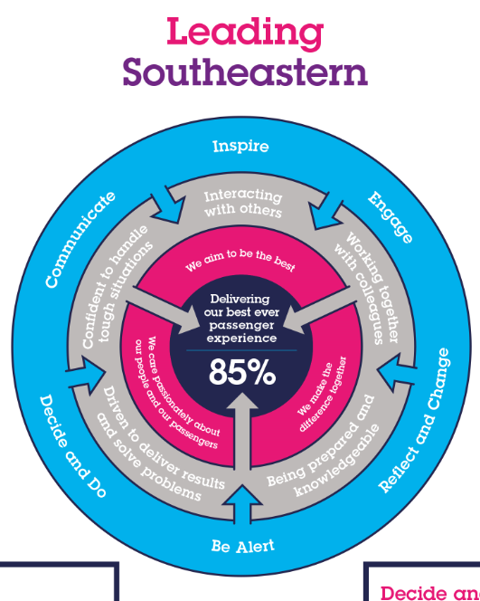

All shortlisted candidates seeking promotion will be assessed against this framework.

The job demands the following blend of experience/knowledge, skills and behaviours (all are essential , unless otherwise shown and will be assessed by application and/ or interview/assessment) :

G1 | Experience, Knowledge & Qualifications  Proven success in meeting demanding budgetary and workforce productivity targets.  Proven track record of line management experience in a transport environment.  Strong interpersonal skills and experienced negotiator.  Innovative and creative, highly motivated.  Ability to interpret financial statements.
G2 | Skills (including any specific safety critical competencies)  Persuasiveness – Presents the key points of an argument persuasively. Negotiates and convinces others, changes people’s views and influences decisions.  Communication - Expresses oneself confidently and effectively. Is friendly and engages others in open, honest and productive conversations.  Commercial Awareness - Understands and applies commercial and financial principles. Views issues in terms of costs, profits, markets and added value.  Leadership – Motivates and empowers others in order to reach organisational goals.
G3 | Behaviours  Professionalism – Interacts with others in a sensitive and effective way. Respects and works well with others. Quickly builds rapport and easily establishes relationships with different types of customers.  Adding Value – Exploits opportunities to improve results and add value to the business.  Honesty and Integrity – Is transparent and honest and takes full responsibility for actions. Demonstrates confidence and courage and deals effectively with difficult situations.  Flexibility – Successfully adapts to changing demands and conditions.  Planning and Organising – Organises and schedules events, activities and resources. Sets up and monitors timescales and plans. Organises own time effectively and creates own work schedules. Prioritised and prepares in advance and sets realistic timescales.  Teamwork, Sharing and Supportive – Aligns with others to deliver common goals. Shares ideas and information. Supports colleagues and works effectively with others.
G4 | Other  It is desirable although not essential that you hold Conductor or Train Despatch Licence Competency (training can be provided). You should attend a Safety Critical Medical prior to appointment to determine your ability to do so.  Deputise for the Depot Manager Mainline South as required.
H | Dimensions of role
H1 | Financial – Direct: |  | Budget within DFA
H2 | Financial – Other:
H3 | Staff Responsibilities – Direct: |  | Staff at Depot
H4 | Staff Responsibilities – Other: |  | Staff at Depot
H5 | Any Other Statistical Data: |  | 1 depot
I | Acknowledgement
I1 | Prepared By: |  |  | Date:
I2 | Approved By (Head of Department): |  |  | Date:

K | Job Description Briefing
 | The post holder has been briefed on and understands the requirements of this Job Description and other related documents:
 | Name of post holder: |  | Signature: |  | Date:
 | Name of briefing manager: |  | Signature: |  | Date:
L | Nominated Deputy for Safety requirements
 | If this is a KEY SAFETY POST (D2 in Safety Details above is YES) at least one nominated deputy must be identified. The Job Holder must ensure that the Nominated Deputy(ies) receives a copy of, and is briefed on this Job Description. If there are more nominated deputies, they should sign further copies of this Job Description.
 | The nominated deputy has been briefed on and understands the requirements of this Job Description and other related documents:
 | Name of nominated deputy: |  | Signature: |  | Date:
 | Name of briefing manager: |  | Signature: |  | Date:

