A | Post Details
 | Job Title: | Area HR Manager | Function: | Human Resources
 | Location: | Ashford/Kent/London | Unique Post Number:
 | Reports To: | Senior HR Manager | Grade: | MG2
B | Purpose of the Job
 | Provide professional advice and guidance to Departmental Managers and their management teams on local Human Resource issues within the geographical area served, in a manner as to encourage unity of purpose towards achieving the company’s business objectives.
C | Principal Accountabilities
C1  C2  C3  C4  C5  C6  C7  C8  C9  C10  C11  C12  C13 | Provide professional advice and support to departmental managers and their management teams on Human Resource issues in order to promote the proper application of the Company’s policies and procedures.  Provide accurate and timely advice on employment legislation issues including discipline, equal opportunities, harassment and grievance claims, maintaining fair treatment of all staff and protecting the Company from risk of legislation.  Lead on local ER issues and resolution and ensure the ER Manager is aware of emerging issues that have potential to impact on collective bargaining and / or matters of dispute.  Build and maintain good relations with local union representatives.  Support the constant review of policies and procedures and the creation of a suite that can be operated across the business.  Offer telephone assistance on recruitment, selection, induction, discipline, promotion, re-deployment, resignations, retirement and other people related issues.  Attend, where possible Gross Misconduct, Stage 3 AAW and medical/performance Capability hearings to provide procedural advice and guidance.  Ensure that policies, procedures and employee initiatives are effectively communicated to departmental managers and their management teams.  Attend, where possible management welfare meetings to advise on AAW issues, long term sickness, placement of medically restricted staff and progression of ill health retirements, where appropriate.  Ensure that HR systems, processes and services that support the management teams are aligned to meet the business requirements in a cost effective and efficient manner.  Assist the Training & Development Department to identify, develop and deliver appropriate training in HR policies and procedures.  Ensure employees who wish to retire from the Company are informed of their pension benefits, including any Company benefits to which they may be entitled.  Help resource the HR Hotline as and when required by the Senior HR Manager
D | Safety Responsibilities
D1 | This post is required to undertake SAFETY CRITICAL WORK |  |  |  | Yes |  | No
D2 | This is a KEY SAFETY POST or nominated deputy |  |  |  | Yes |  | No
D3 | The holder of this post is identified as a KEY SAFETY MANAGER |  |  |  | Yes |  | No
D4 | The job requires competence in PERSONAL TRACK SAFETY |  |  |  | Yes |  | No
D5 | This job has SPECIFIC SAFETY RESPONSIBILITIES (if Yes see section D6 below) |  |  |  | Yes |  | No
D6 | The post holder has the following specific safety responsibilities:
 | None
E | Decision making Authority
E1  E2  E3  E4 | Interpretation and advice on HR Policies and Procedures.  Interpretation of Collective Bargaining procedures and working arrangements.  Interpretation of Employment Law and Equal Opportunities legislation.  Interpretation of Terms and Conditions of Employment.
F | Most Challenging and/or Difficult parts of the role
F1 | Advising/influencing managers at Gross Misconduct, AAW Stage 3 and Capability hearings.

G | Person Specification

Southeastern aims to recruit people not just for jobs but for long term careers. We want good quality, talented people with the right attitude who will stay with us.

For these reasons we look for evidence of Southeastern values and behaviours in all potential staff and our existing staff looking for promotion along with the particular experience/knowledge, skills and behaviours relevant to the position applied for. These are

We care passionately about our people and passengers
  - we put ourselves in our passengers’ shoes to do what’s right for them
  - we support our colleagues to be, feel and do their best
  - we love the places we serve and do our bit for our communities and environment

We aim to be the best
  - we move with pace, we’re agile and learn from everything
  - we relentlessly strive to be the best
  - we are professionals with personalities

We make the difference together
  - we are answerable to each other and our passengers
  - we trust each other and do what we say we will
  - we are stronger together than we are as individuals

We also have identified behaviours required to be successful in leading Southeastern.

The Leading Southeastern framework details how we should be behaving in order to drive up performance to deliver 85 by 18.
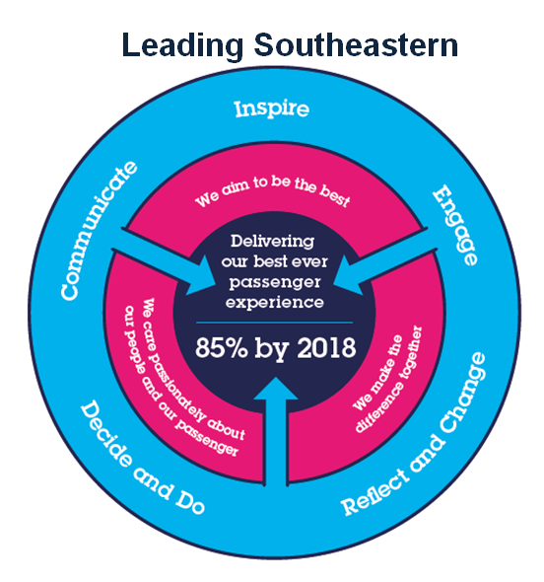

All shortlisted candidates seeking promotion will be assessed against this framework.

The job demands the following blend of experience/knowledge, skills and behaviours (all are essential , unless otherwise shown and will be assessed by application and/ or interview/assessment) :

G1 | Experience, Knowledge & Qualifications (including any specific safety training requirements)  Minimum Part qualified CIPD or substantial experience gained in a managerial position within an HR environment.  In depth knowledge of current Employment Legislation.  Understanding of HR Policies and Procedures.  Ability to use persuasive arguments to influence others.  Desirable  CIPD Qualified.  Degree standard education.
G2 | Skills (including any specific safety critical competencies)  Excellent written and oral communication skills and the ability to communicate at all levels.  Strong interpersonal skills.  Good organisational and planning skills.  Self starter and highly motivated.
G3 | Behaviours  Professionalism.  Honesty and integrity.  Commercial Awareness.  Team Player.  Persuasiveness- Influences and convinces others in a way that results in acceptance, agreement or behaviour change.
G4 | Other

H | Dimensions of role
H1 | Financial – Direct:
H2 | Financial – Other:
H3 | Staff Responsibilities – Direct:
H4 | Staff Responsibilities – Other:
H5 | Any Other Statistical Data:
I | Acknowledgement
I1 | Prepared By: | _______________ |  | Date: | ______________
I2 | Approved By (Head of Department): | _______________ |  | Date: | ______________

J | Job Description Briefing
 | The post holder has been briefed on and understands the requirements of this Job Description and other related documents:
 | Name of post holder: |  | Signature: |  | Date:
 | Name of briefing manager: |  | Signature: |  | Date:
K | Nominated Deputy for Safety requirements
 | If this is a KEY SAFETY POST (D2 in Safety Details above is YES) at least one nominated deputy must be identified. The Job Holder must ensure that the Nominated Deputy(ies) receives a copy of, and is briefed on this Job Description. If there are more nominated deputies, they should sign further copies of this Job Description.
 | The nominated deputy has been briefed on and understands the requirements of this Job Description and other related documents:
 | Name of nominated deputy: |  | Signature: |  | Date:
 | Name of briefing manager: |  | Signature: |  | Date:

