A | Post Details
 | Job Title: | Admin Support Officer | Function: | Human Resources
 | Location: | Ashford | Unique Post Number: | FML/H/118
 | Reports To: | Training Support Manager | Grade: | ASG
B | Purpose of the Job
 | To provide an effective administration service for the Training and Apprenticeship teams.
C | Principal Accountabilities
C1  C2  C3  C4  C5  C6  C7  C8  C9  C10  C11  C12  C13 | Provide administrative support duties for the Training and Apprenticeship teams.  Responsible for scheduling of courses, producing Joining Instructions and recording attendance of delegates.  Adhere to procedures to ensure that all persons attending Safety Critical courses have the correct medical certificates and assessment profiles in accordance with company safety requirements prior to being trained.  Assist with the preparation of relevant course material, ensuring that the delivery environment is ready and fit for purpose.  Arranging meetings and minute taking.  Assist with the production of reports as required.  Maintain databases as required.  Responsible for ordering and controlling office supplies.  Maintain electronic and hard copy filing systems in accordance with the GDPR policy.  Manage purchase orders and invoices as applicable.  Reception duties (receiving and assisting visitors at the centres).  Assist with all localised projects as required.  Liaise with external stakeholders and manage end to end training provision when required.

D | Safety Responsibilities
D1 | This post is required to undertake SAFETY CRITICAL WORK |  |  |  |  |  |  |  | Yes |  |  | No
D2 | This is a KEY SAFETY POST |  |  |  |  |  |  |  | Yes |  |  | No
D3 | This post requires SECURITY CLEARANCE |  |  |  |  |  |  |  | Yes |  |  | No
D4 | The job requires competence in PERSONAL TRACK SAFETY |  |  |  |  |  |  |  | Yes |  |  | No
D5 | This job has SPECIFIC SAFETY RESPONSIBILITIES (if Yes see section D6 below) |  |  |  |  |  |  |  | Yes |  |  | No
D6 | The post holder has the following specific safety responsibilities: None
E | Decision making Authority
E1 | As defined by the Training Team Co-Ordinator
F | Most Challenging and/or Difficult parts of the Job
F1 | To be able to work on own initiative and to deadlines, whilst providing accuracy at all times.
G | Person Specification

Southeastern aims to recruit people not just for jobs but for long term careers. We want good quality, talented people with the right attitude who will stay with us.

For these reasons we look for evidence of Southeastern values in all potential staff and our existing staff looking for promotion along with the particular experience/knowledge, skills and behaviours relevant to the position applied for. These are

We care passionately about people
  - we put ourselves in our passengers’ shoes to do what’s right for them
  - we support our colleagues to be, feel and do their best
  - we love the places we serve and do our bit for our communities and environment

We aim to be the best
  - we move with pace, we’re agile and learn from everything
  - we relentlessly strive to be the best
  - we are professionals with personalities

We make the difference together
  - we are answerable to each other and our passengers
  - we trust each other and do what we say we will
  - we are stronger together than we are as individuals

The job demands the following blend of experience/knowledge, skills and behaviours (all are essential , unless otherwise shown and will be assessed by application and/ or interview/assessment) :

G1 | Experience, Knowledge & Qualifications  Must be computer literate (PowerPoint/Excel) with good typing skills and highly organised, the ability to work under pressure for a large team. Must be a good communicator. Ideally with previous administration experience.  Must be able to work on own initiative and to deadlines whilst providing accuracy at all times.
G2 | Behaviours and Skills  We also have identified behaviours required to be successful in our Professional People Framework.  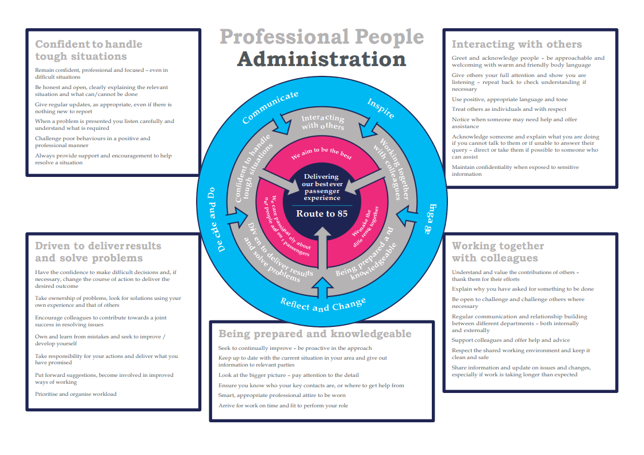
H | Dimensions of role
H1 | Financial – Direct: |  |  |  | None
H2 | Financial – Other: |  |  |  | None
H3 | Staff Responsibilities – Direct: |  |  |  | None
H4 | Staff Responsibilities – Other: |  |  |  | None
H5 | Any Other Statistical Data: |  |  |  | None
I | Acknowledgement
I1 | Prepared By: |  | _______________ |  |  |  | Date: | ______________
I2 | Approved By (Head of Department): |  | _______________ |  |  |  | Date: | ______________
L | Job Description Briefing
 | The post holder has been briefed on and understands the requirements of this Job Description and other related documents:
 | Name of post holder: |  |  | Signature: |  |  |  |  |  |  | Date:
 | Name of briefing manager: |  |  | Signature: |  |  |  |  |  |  | Date:
M | Nominated Deputy for Safety requirements
 | If this is a KEY SAFETY POST (D2 in Safety Details above is YES) at least one nominated deputy must be identified. The Job Holder must ensure that the Nominated Deputy(ies) receives a copy of and is briefed on this Job Description. If there are more nominated deputies, they should sign further copies of this Job Description.
 | The nominated deputy has been briefed on and understands the requirements of this Job Description and other related documents:
 | Name of nominated deputy: |  |  | Signature: |  |  |  |  |  |  | Date:
 | Name of briefing manager: |  |  | Signature: |  |  |  |  |  |  | Date:

