A | Post Details
 | Job Title: | Head of External Communications |  |  | Function: |  | Communications & Stakeholder
 | Location: | 4 More London |  |  | Unique Post Number:
 | Reports To: | Communications and Stakeholder Director |  |  | Grade: |  | SMG
B | Purpose of the Job
Lead the development and delivery of a multi-faceted external communications strategy to build a positive reputation for Southeastern; communicating the company’s strategic projects, achievements and joint projects with partners including Network Rail.

The role encompasses building plans for communications with external audiences involving public relations, passenger campaigns, digital and social media engagement and wider external communications.

An essential part of the role is to lead, mentor, manage and inspire a team comprising campaigns, communications and press office specialists to ensure the delivery of the integrated communications strategy and protect the company’s reputation during a crisis.

C | Principal Accountabilities
C1  C2  C3  C4  C5  C6  C7  C8  C9  C10  C11  C12  C13  C14  C15  C16 | Develop and lead an integrated communications strategy to build and enhance the company’s reputation with passengers, generate positive press coverage and social media engagement, and ensure passenger awareness for major business priorities including service changes and projects.  Work with business partners, industry partners and other departments including Marketing and Internal Communications to develop, deliver and measure integrated communications strategies and associated plans for major programmes  Work in partnership with Network Rail and other industry partners to ensure strategic alignment of communications activity and development and delivery of communications plans for major programmes.  Develop, deliver and measure the effectiveness of industry-leading, multi-channel campaign activity to deliver non-revenue generating business benefits, including enhanced trust and improving passenger information. Undertake campaign review and measurement to ensure value for money and effectiveness.  Procure, manage the relationship with, and the performance of specialist communications, and PR agencies to deliver elements of the strategic communications programme and support the activities of the in-house team.  Lead, mentor, inspire and manage a high-performing team of direct reports to ensure the delivery of integrated communications plans for ‘business as usual’ activities and strategic projects.  Represent Southeastern as a company spokesperson with the media.  Develop and deliver a programme of events and activities to build a positive reputation  In the event of a crisis, lead the external communications team response and provide expert advice and develop messaging to protect the company’s reputation. Ensure well-developed crisis communications plans are in place, and regularly tested through exercises and training.  Ensure the delivery of relevant franchise committed obligations as required  Undertake business planning and manage the external communications budget, identify and forecast team budget requirements, and ongoing monitoring.  Take insights of lessons learnt and drive continuous improvements as part of the reviews.  Maintain and update the company’s strategic messaging document on a monthly basis and cascade to teams  Maintain, coordinate and participate in on an on-call rota to deliver 24-hour on-call service for media and stakeholders such as Members of Parliament and Government departments, and provide communications advice and support to operational colleagues.  Deputise for the Communications and Stakeholder Director, attending Board meetings, giving internal presentations in front of a large audience, and leading a busy and dynamic department.  Develop a group of colleagues who have been appropriately trained to act as spokespeople for the company, and manage the professional development of communications team members to ensure the team maintains its position as a centre of excellence in communications
D | Safety Responsibilities
D1 | This post is required to undertake SAFETY CRITICAL WORK |  |  |  |  |  |  |  | Yes |  | No
D2 | This is a KEY SAFETY POST or nominated deputy |  |  |  |  |  |  |  | Yes |  | No
D3 | The holder of this post is identified as a KEY SAFETY MANAGER |  |  |  |  |  |  |  | Yes |  | No
D4 | The job requires competence in PERSONAL TRACK SAFETY |  |  |  |  |  |  |  | Yes |  | No
D5 | This job has SPECIFIC SAFETY RESPONSIBILITIES (if Yes see section D6 below) |  |  |  |  |  |  |  | Yes |  | No
D6 | The post holder has the following specific safety responsibilities:
 | - N/A
E | Decision making Authority
E1  E2  E3 | Budget allocation and spend within delegated authority limits  Strategic communications and events  Approval of tactics and messages
F | Most Challenging and/or Difficult parts of the role
F1  F2  F3  F4  F5 | Leading and managing a team of direct reports  Working in a fast paced, challenging environment  Managing competing priorities  Planning and delivery of projects  Managing reputation in a crisis, responding and reacting quickly to unforeseen issues
G | Person Specification

Southeastern aims to recruit people not just for jobs but for long term careers. We want good quality, talented people with the right attitude who will stay with us.

For these reasons we look for evidence of Southeastern values and behaviours in all potential staff and our existing staff looking for promotion along with the particular experience/knowledge, skills and behaviours relevant to the position applied for. These are

We care passionately about our people and passengers
  - we put ourselves in our passengers’ shoes to do what’s right for them
  - we support our colleagues to be, feel and do their best
  - we love the places we serve and do our bit for our communities and environment

We aim to be the best
  - we move with pace, we’re agile and learn from everything
  - we relentlessly strive to be the best
  - we are professionals with personalities

We make the difference together
  - we are answerable to each other and our passengers
  - we trust each other and do what we say we will
  - we are stronger together than we are as individuals

We also have identified behaviours required to be successful in leading Southeastern.

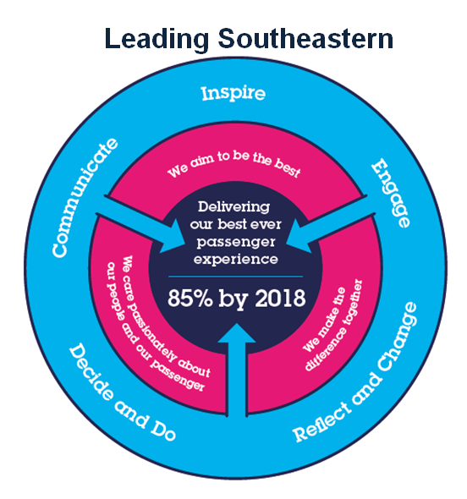
The Leading Southeastern framework details how we should be behaving in order to drive up performance to deliver 85 by 18.

All shortlisted candidates seeking promotion will be assessed against this framework.

The job demands the following blend of experience/knowledge, skills and behaviours (all are essential , unless otherwise shown and will be assessed by application and/ or interview/assessment) :

G1 | Experience, Knowledge & Qualifications (including any specific safety training requirements)  People management: a passion for leading and managing a team, with proven experience in line management and mentoring, and developing and managing team performance  At least 10 years communications experience, preferably with Agency and in-house background  Proven ability to develop, deliver and measure an ambitious multi-channel communications strategy for a large high profile organisation  Proven experience in developing a PR strategy, leading a press team and managing a media/reputational crisis  Proven experience in identifying stories (positive and potential crises), and PR opportunities  A driven individual, with proven experience developing key relationships with stakeholders and influencing senior executives  Experience of project management, time management and meeting deadlines  Proven experience forecasting, managing a budget  Experience of briefing and managing external agencies and suppliers  Experience of public speaking/presenting to stakeholders both internal and external  Experience making decisions in a high pressure, reactive environment  A planner, with exceptional organisational skills  Experience of allocating and managing tasks across a team  Experience preparing briefing notes for senior executives  A degree qualification or equivalent.
G2 | Skills (including any specific safety critical competencies)  Strategic thinking skills, to define and deliver a well thought out strategy  Outstanding interpersonal and communications skills  Excellent copy writing and professional writing skills  Communications project management  Publishing experience, including planning, design and delivery  Visual presentation skills – PowerPoint  Proof reading and attention to detail  Public speaking
G3 | Behaviours  Professional  Impactful  Thoughtful/considerate  Hard working  Influencing and negotiating  Planning and organising  Authentic  Team work, sharing and supportive  Resilient  Attention to detail  Adding value
G4 | Other
H | Dimensions of role
H1 | Financial – Direct: |  |  | Budget management and approval of spend of approx. £1.2 million
H2 | Financial – Other: |  |  | Budget planning, and influence of staff budget for team, and wider department
H3 | Staff Responsibilities – Direct: |  |  | Five direct reports (all managers at MG2 and MG1 grade) with responsibility for media relations, PR, public affairs and stakeholder engagement, campaigns and communications for major programmes
H4 | Staff Responsibilities – Other: |  |  | Mentoring to other communications team members, and advisor to wider business on external communications and reputation management
H5 | Any Other Statistical Data: |  |  | N/A
I | Acknowledgement
I1 | Prepared By: |  | Alison Nolan |  |  | Date: |  | May 2020
I2 | Approved By (Head of Department): |  | Alison Nolan |  |  | Date: |  | May 2020

J | Job Description Briefing
 | The post holder has been briefed on and understands the requirements of this Job Description and other related documents:
 | Name of post holder: |  | Signature: |  | Date:
 | Name of briefing manager: |  | Signature: |  | Date:
K | Nominated Deputy for Safety requirements
 | If this is a KEY SAFETY POST (D2 in Safety Details above is YES) at least one nominated deputy must be identified. The Job Holder must ensure that the Nominated Deputy(ies) receives a copy of, and is briefed on this Job Description. If there are more nominated deputies, they should sign further copies of this Job Description.
 | The nominated deputy has been briefed on and understands the requirements of this Job Description and other related documents:
 | Name of nominated deputy: |  | Signature: |  | Date:
 | Name of briefing manager: |  | Signature: |  | Date:

