 | A |  |  |  |  | Post Details
 |  |  |  |  |  | Job Title: |  | Safety Delivery Manager |  |  |  | Function: |  |  | Engineering
 |  |  |  |  |  | Location: |  | Depot and delivery locations |  |  |  | Unique Post Number:
 |  |  |  |  |  | Reports To: |  | Head of Engineering Delivery North and South. Dotted line to the Head of Occupational Safety |  |  |  | Grade: |  |  | MG2
 | B |  |  |  |  | Purpose of the Job  Provide Health, Safety and Environmental leadership and support within Engineering Delivery function, so that safety objectives are delivered effectively and continuous improvement in both the Safety Management System and safety culture is identified and executed.
Develop, interpret and verify implementation of the Southeastern Health and Safety Management System within Engineering.

Lead environmental initiatives for Engineering Delivery including introduction of an Environmental Management System and energy use reduction schemes.

Develop and maintain close working relationships across the wider Engineering Team, ensuring best practice, continuous improvement and wider initiatives are shared.

 | C |  |  |  |  | Principal Accountabilities
 | C1  C2  C3  C4  C5  C6  C7  C8  C9  C10  C11  C12  C13  C14  C15  C16  C17  C18  C19  C20 |  |  |  |  | Lead on behalf of Engineering Delivery in identifying opportunities for the continuous improvement in HSE in line with legislation, Industry best practices, aligned to company safety plans.  Provide expert advice and support to Engineering Managers in matters relating to environmental issues in line with legislation.  Ensure, in partnership with local KSL that all accidents are investigated to root cause with remedial action agreed and implemented as necessary.  Undertaking accident/ incident learning reviews within engineering depot yards and sidings  Accountable for the provision of Health, Safety and Environment support and guidance to Engineering Managers in respect of all premises activities and equipment at all engineering locations.  Responsible for supporting Engineering managers in safety and environment documentation including company standards Engineering HSE Manuals and Instructions and local briefings as required.  Analyse, interpret and understand data / reports and be able to identify opportunities for improvement action.  To assist in developing HSE Briefings and Training  Establish function emergency response plans that control and limit risk exposure, maintaining these, testing them as determined by risk and that the business continuity requirements are in line with the company needs.  Accountable for environmental, safety and employee wellbeing initiatives  Accountable for installing and monitoring Engineering HSE audits ensuring findings are reported to the relevant local managers and the maintenance of suitable up to date and auditable records.  Work closely with all internal and third party audit requirements, facilitating, arranging audit assessment points and input into such audits, supporting local depot or other managers.  Accountable for ensuring that Engineering Delivery remain compliant to current environmental legislation and to retain ISO 50001 and 40001  Responsible for managing and improving the depot risk profile, underpinned with ‘Bow Tie’ risk assessments, supporting the KSL and local managers.  Responsible for supporting the KSL and local union safety reps with safety committee meetings that include, but not limited to, risk profile and evaluation, assurance through auditing, safety culture and improvement.  Establishing the level of risk that the Engineering function are willing to accept/take in line with the corporate requirement.  Maintain personal level of competency through continuous professional development.  Conducting policy and compliance audits, in line with the Engineering SMS  Work closely with RSSB and other industry partners.  Responsible for supporting KSL and local Engineering managers in identifying KPI’s  Undertaking accident/ incident Learning Reviews within engineering depot yards and sidings
 | D |  |  |  | Safety Responsibilities
 | D1 |  |  |  | This post is required to undertake SAFETY CRITICAL WORK |  |  |  |  |  |  |  | Yes |  |  | P | No
 | D2 |  |  |  | This is a KEY SAFETY POST or nominated deputy |  |  |  |  |  |  |  | Yes |  |  | P | No
 | D3 |  |  |  | The holder of this post is identified as a KEY SAFETY MANAGER |  |  |  |  |  |  |  | Yes |  |  |  | No | O
 | D4 |  |  |  | The job requires competence in PERSONAL TRACK SAFETY |  |  |  |  |  |  |  | Yes |  |  | P | No
 | D5 |  |  |  | This job has SPECIFIC SAFETY RESPONSIBILITIES (if Yes see section D6 below) |  |  |  |  |  |  |  | Yes |  |  | P | No
 | D6 |  |  |  | The post holder has the following specific safety responsibilities:
 |  |  |  |  | Carrying out Planned General Inspections.
 | E |  |  |  | Decision making Authority
 | E1  E2  E3 |  |  |  | Authority to raise CAR and NCR and to recommend closure
 | F |  |  |  | Most Challenging and/or Difficult parts of the role
 | F1  F2  F3  F4 |  |  |  | Influencing continual improvements in behaviours and culture to bring about HSE improvements in line with wider engineering and company objectives
 |  | G |  | Person Specification

Southeastern aims to recruit people not just for jobs but for long term careers. We want good quality, talented people with the right attitude who will stay with us.

For these reasons we look for evidence of Southeastern values and behaviours in all potential staff and our existing staff looking for promotion along with the particular experience/knowledge, skills and behaviours relevant to the position applied for. These are

Take personal responsibility for our actions

Support our colleagues

Take care of our customers

Work collaboratively with stakeholders

Operate in a socially and environmentally responsible way

We also require more than competent performance against our Leadership & Management Competency Framework.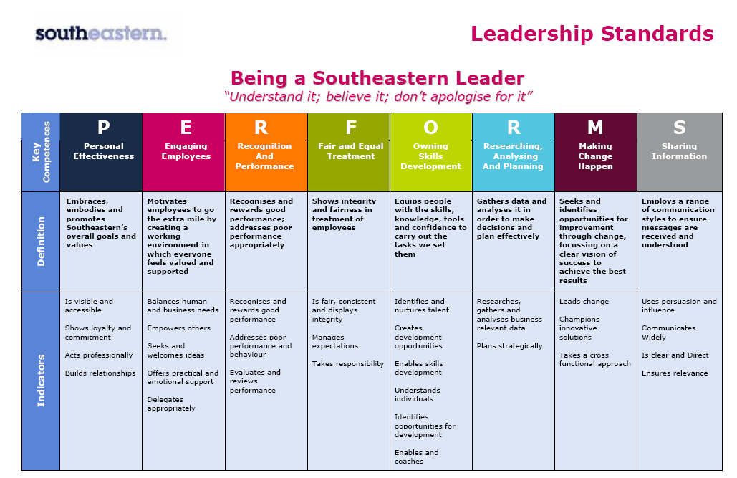
All shortlisted candidates seeking promotion will be assessed against this framework.

The job demands the following blend of experience/knowledge, skills and behaviours (all are essential , unless otherwise shown and will be assessed by application and/ or interview/assessment) :
 |  | G1 |  |  | Experience, Knowledge & Qualifications (including any specific safety training requirements)  - Must have extensive knowledge and experience of Health, Safety and Environment at a Managerial level  - Must be competent as an accident / incident investigator  - Must be competent lead accident / incident investigator  - Must hold NEBOSH Diploma (General Safety)  - Must hold NEBOSH Diploma (Environmental Management) or working towards  - Must be competent in compiling RAMS  - Must be Competent to undertake Safety Compliance Audits
 |  | G2 |  |  | Skills (including any specific safety critical competencies)  - Good numeric skills  - Proven ability to communicate and influence.  - Customer focused with strong business awareness.  - Good personal organisational skills.  - Systems (CMS) and ability to use Microsoft Office computer applications  - Excellent computing skills. Understanding of Computerised Maintenance
 |  | G3 |  |  | Behaviours  Professional and business focussed outlook.  Attention to detail.  Empathetic and approachable, supportive of colleagues.  Resilient and self motivated.
 |  | G4 |  |  |  |  | Other
H |  |  | Dimensions of role
H1 |  |  | Financial – Direct: |  |  |  |  |  | None
H2 |  |  | Financial – Other: |  |  |  |  |  | As defined by Head of Engineering Compliance
H3 |  |  | Staff Responsibilities – Direct: |  |  |  |  |  | 4 MG1 Managers
H4 |  |  | Staff Responsibilities – Other:
H5 |  |  | Any Other Statistical Data: |  |  |  |  |  | Compile data relating to HSE, including the corporate social responsibility data required by Go-Ahead Group.
I |  |  | Acknowledgement
I1 |  |  | Prepared By: |  |  |  |  |  |  | _______________ | Date: |  |  | ______________
I2 |  |  | Approved By (Head of Department): |  |  |  |  |  |  | _______________ | Date: |  |  | ______________

J | Job Description Briefing
 | The post holder has been briefed on and understands the requirements of this Job Description and other related documents:
 | Name of post holder: |  | Signature: |  | Date:
 | Name of briefing manager: |  | Signature: |  | Date:
K | Nominated Deputy for Safety requirements
 | If this is a KEY SAFETY POST (D2 in Safety Details above is YES) at least one nominated deputy must be identified. The Job Holder must ensure that the Nominated Deputy(ies) receives a copy of, and is briefed on this Job Description. If there are more nominated deputies, they should sign further copies of this Job Description.
 | The nominated deputy has been briefed on and understands the requirements of this Job Description and other related documents:
 | Name of nominated deputy: |  | Signature: |  | Date:
 | Name of briefing manager: |  | Signature: |  | Date:

