A | Post Details
 | Job Title: | Chief of Staff | Function: | Executive Team
 | Location: | 4ML
 | Reports To: | Managing Director | Grade: | SMG
B | Purpose of the Job  Reporting to the Managing Director, this role will work closely with other members of the leadership team helping to deliver Southeastern’s strategic priorities. This will be a pivotal role working across all elements of the business, building strong and trusted relationships with the Executive and Senior Leadership teams. The role will act as a central point of co-ordination, ensuring that all functions of the business are aligned and working collaboratively to deliver with transparent, effective and efficient governance.
C | Principal Accountabilities
C1  C2  C3  C4  C5  C6  C7  C8 | To prepare SET Board papers and other related meeting material (e.g. presentations) to ensure the business is represented to the highest standard with its shareholders and stakeholders  To design and oversee the Governance and ‘Operating System’ of the Business (to include meeting hierarchy, frequency, Terms of Reference, and decision-making structure  Develop the associated business reporting pack and KPIs for DOHL and OSC  Act on the authority of the MD to undertake reviews and provide Insight and recommendations for the Executive on issues that typically require cross-functional collaboration. The portfolio of work undertaken will continue to evolve in line with the business change programme  Deliver briefings to MD (and other Exec members as relevant) to ensure that all are sufficiently briefed for key stakeholder meetings, collate information and sense check information being provided by other business areas. Flag up any key issues, and offer suitable suggestions/ mitigations ahead of time  Facilitate and manage the schedule, agenda, content and logistics for Executive and Board meetings throughout the year in collaboration with the PA team, ensuring all relevant content and reports are captured and communicated in an appropriate way.  Attend specific Exec level meetings to ensure that key actions are captured and followed up by the business as required. Offer own advice and suggestions to influence outcomes as appropriate.  Maintain close working relationships with other DOHL or London TOCs to enable best practice sharing in advance of migration towards GBR

D | Safety Responsibilities
D1 | This post is required to undertake SAFETY CRITICAL WORK | Yes |  | No
D2 | This is a KEY SAFETY POST | Yes |  | No
D3 | This post requires SECURITY CLEARANCE | Yes |  | No
D4 | The job requires competence in PERSONAL TRACK SAFETY | Yes |  | No
D5 | This job has SPECIFIC SAFETY RESPONSIBILITIES (if Yes see section D6 below) | Yes |  | No
D6 | The post holder has the following specific safety responsibilities:
E | Decision making Authority
E1

F | Most Challenging and/or Difficult parts of the role
F1

G | Person Specification

Southeastern aims to recruit people not just for jobs but for long term careers. We want good quality, talented people with the right attitude who will stay with us.

For these reasons we look for evidence of Southeastern values and behaviours in all potential staff and our existing staff looking for promotion along with the particular experience/knowledge, skills and behaviours relevant to the position applied for. These are

We care passionately about our people and passengers
  - we put ourselves in our passengers’ shoes to do what’s right for them
  - we support our colleagues to be, feel and do their best
  - we love the places we serve and do our bit for our communities and environment

We aim to be the best
  - we move with pace, we’re agile and learn from everything
  - we relentlessly strive to be the best
  - we are professionals with personalities

We make the difference together
  - we are answerable to each other and our passengers
  - we trust each other and do what we say we will
  - we are stronger together than we are as individuals

We also have identified behaviours required to be successful in leading Southeastern.

The Leading Southeastern framework details how we should be behaving in order to drive up performance to deliver our best ever passenger experience.

Leading Southeastern
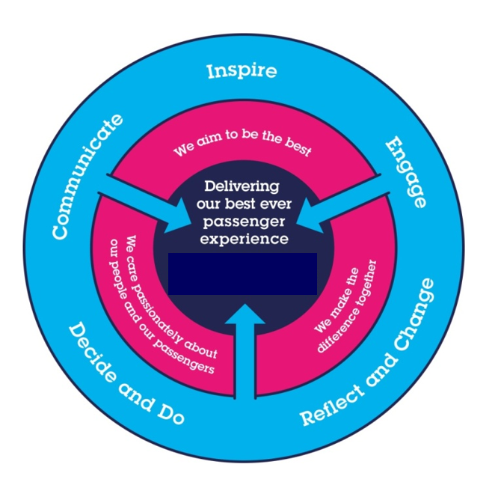

All shortlisted candidates seeking promotion will be assessed against this framework.

The job demands the following blend of experience/knowledge, skills and behaviours (all are essential, unless otherwise shown and will be assessed by application and/ or interview/assessment) :

G1 | Skills & Knowledge
- Experience managing cross-functional projects from inception to execution to close-out
- Ability to multitask and prioritise with changes in scale, scope, and project deadlines
- Smart, empathetic communicator, skilled in written communication, social media, building presentations (Powerpoint) and analysing data (Excel)
- Comfortable interacting with executives and senior-level stakeholders, building effective relationships across the business and working within highly technical, specialised disciplines
- Ability to work in a confidential and discrete manner
- Highly organised with a strong attention for detail
- Curious and energetic, with a positive ‘can do' mindset.
- Knowledge on the effective operation of corporate Governance to drive business success
- Preferably, previous rail industry or Government experience

I | Dimensions of role
I1 | Financial – Direct: |  |  |  | As per budget and DFA
I2 | Financial – Other:
I3 | Staff Responsibilities – Direct:
I4 | Staff Responsibilities – Other:
I5 | Any Other Statistical Data:
J | Acknowledgement
J1 | Prepared By: |  |  |  |  |  | Date:
J2 | Approved By (Head of Department): |  |  |  |  |  | Date:
K | Job Description Briefing
 | The post holder has been briefed on and understands the requirements of this Job Description and other related documents:
 | Name of post holder: |  |  | Signature: |  |  |  |  | Date:
 | Name of briefing manager: |  |  | Signature: |  |  |  |  | Date:
L | Nominated Deputy for Safety requirements
 | If this is a KEY SAFETY POST (D2 in Safety Details above is YES) at least one nominated deputy must be identified. The Job Holder must ensure that the Nominated Deputy(ies) receives a copy of, and is briefed on this Job Description. If there are more nominated deputies, they should sign further copies of this Job Description.
 | The nominated deputy has been briefed on and understands the requirements of this Job Description and other related documents:
 | Name of nominated deputy: |  |  | Signature: |  |  |  |  | Date:
 | Name of briefing manager: |  |  | Signature: |  |  |  |  | Date:

