

Information Pack

Engineering Apprenticeship

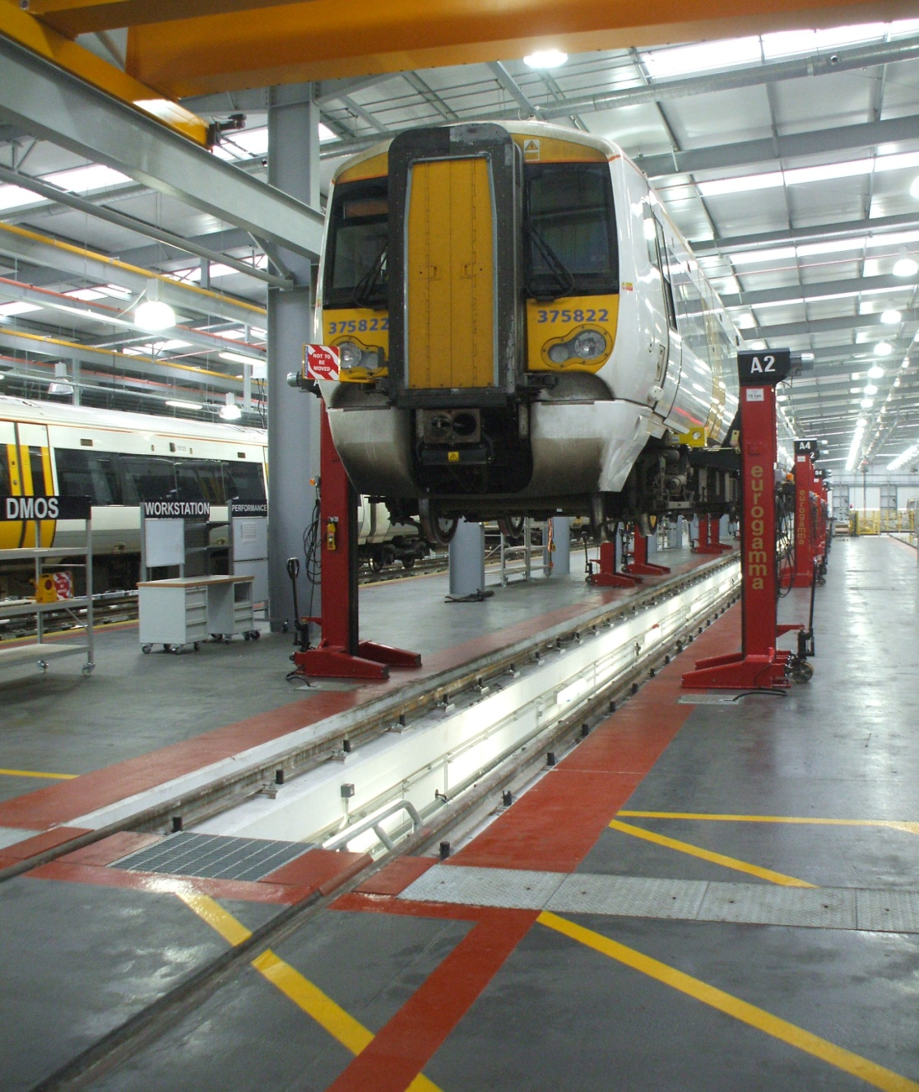
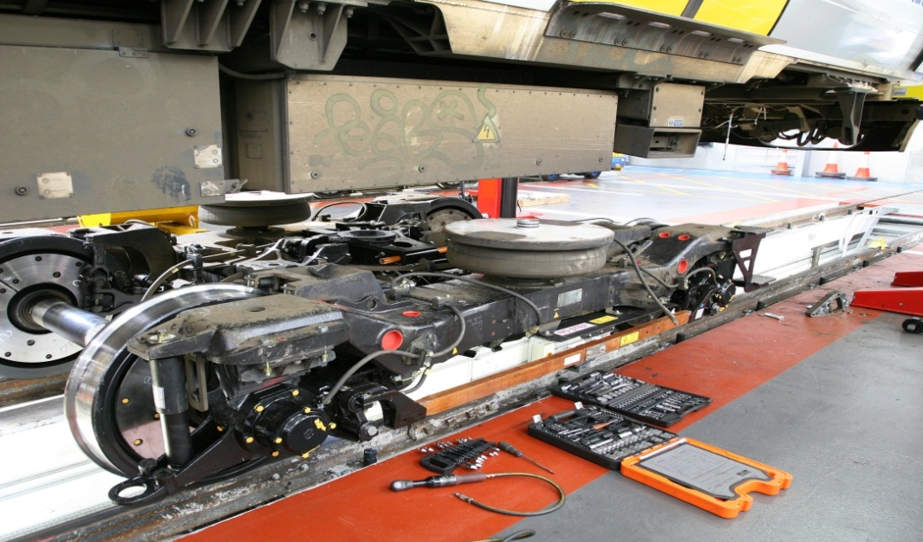

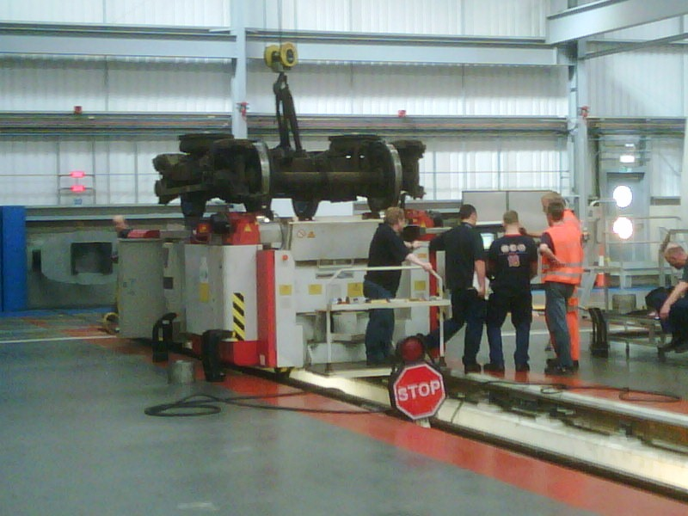

Southeastern Engineering Depots:

Slade Green  Traction Maintenance Depot  Moat Lane  Slade Green, Erith  Kent  DA8 2NJ | Ramsgate  Traction & Rolling Stock Depot  Newington Road  Ramsgate  Kent  CT12 6EE

Engineering Apprentice – Level 3 Rail Engineering Technician

This is a four year scheme designed at providing you with the appropriate qualifications and competencies to become a skilled service engineer with Southeastern. The qualifications you will achieve upon completion will be Level 2 Advanced Manufacturing Engineering (Foundation Competence), Level 3 Diploma in Rail Engineering Competence and Level 3 Rail Engineering Technician Knowledge Qualification. Here is a full breakdown of what you can expect throughout the programme:

Year 1 – Full time college attendance

The training in the first year will give you a broad base of knowledge and understanding of engineering. Your practical training will include the following:
- Working Safely in an Engineering Environment
- Using and Communicating Technical Data
- Carrying out Engineering Activities Efficiently and Effectively
- Wiring and Testing Electrical Equipment and Circuits
- Producing Components using Hand Fitting Techniques
- Maintaining Electrical Devices and Equipment
- Maintaining Mechanical Devices and Equipment
- Programmable Logic Controllers

Years 2-4
The remaining two and a half years of the apprenticeship are based in the workplace with day release at college. You will be the option to gain exposure across various engineering locations and departments on the Southeastern network. These will include:
Locations  Slade Green  Ramsgate  Gillingham  London Terminals | Departments  Production Exam teams  Technical Department  Planning  Materials

Practical and theory training will also be given on all classes of Rolling stock that Southeastern currently operate.

Year 2
During the second year, you will attend college to complete the second and final year of the Rail Engineering Technician Knowledge. You will also begin the Rail Engineering Competence Programme. This programme is work based and requires you to collect job evidence to build a portfolio for presentation to an assessor to prove competence in an engineering discipline.
Practical/Theory training will also be given on all classes of Rolling stock that operate on the Southeastern network area.
Following training, you will be placed in the appropriate department to practice the skills you have learnt.

Year 3 & 4
The placements and training plan will continue as in the year 2 with more advanced system training.
At the end of year 4 you will have completed the Rail Engineering Technical Competency, and therefore completed the Apprenticeship ready to move to final End Point Assessment.
Engineering competence assessments will be periodically undertaken to provide evidence to ensure that all necessary competence and knowledge to progress in the role of Service Engineer has been attained.
The Apprenticeship Scheme prepares a young engineer for a career in Rail Engineering
The programme culminates in End Point Assessment which consists of:
- Occupational Competence Validation Portfolio Collation
- Occupational Competence Validation Interview (Viva)
- Independent Assessment
- Professional Engineering institution validation (EngTech)
- Employer “Final Sign Off”
- Apprenticeship Certification

Personal Specification

Before applying, the applicant should be conscious of the following requirements:

- 4 x GCSE’s (Grade C / 5 minimum) including English, Maths and Science
- Good verbal communication skills
- To be proactive when it comes to problem solving
- Good team working skills
- Should be computer literate with a basic knowledge of information technology.
- Must possess good written and numerical skills.
- Must be prepared to attend college for first year off the job training, and further college on a day release or block programme for additional years of apprenticeship.

Current Rate of Pay

Stage 1 | £17,420
Stage 2 | £20,804
Stage 3 | £25,874
Stage 4 | £29,256
(Next pay review is due April 2019)

Method of payment: 4 - weekly by bank / building society credit transfer.

Hours of Duty

35 hours per week (subject to travelling while attending courses etc). From year 2 onwards you may begin working shifts, which consists of 4 days on and then 4 days off.

Travel Facilities

You will be entitled to free residential leisure travel anywhere on Southeastern, Thameslink & Gatwick Express Rail Services, and will be entitled to a reduced rate for leisure travel on other Train Operating Services.

After 12 months you will be entitled to free and reduced rail travel on European Rail Services (subject to restrictions).

Annual Leave

New entrants will be granted annual leave of 32 days which is inclusive of Bank Holidays in year 1. When you start shift work your annual leave entitlement is 24 days inclusive of Bank Holidays.

Job Description

Principal Tasks

Assist with:-

- Identification of defects on traction units, associated components and equipment.
- Carry out essential maintenance and routine examination work.
- Reporting any defects found to the team leader.
- Fault finding arising from initial / routine inspections.
- Component exchange / heavy lifting.
- Repairs or work arising from examinations (mechanical and electronic).

Recruitment overview for Apprentice Service Engineer

Candidates will need to complete and submit an online application form to www.southeasternrailwaycareers.co.uk. Please register and sign up for job alerts to receive a notification when we advertise. Successfully screened applicants will be progressed through the selection process below.

Stage One - Assessment

Candidates are required to sit assessment tests as part of the selection procedure for all positions within Southeastern. These tests help us decide if someone can learn the skills needed to do the job. They play a vital role in the selection procedure and provide a fair and objective assessment of your abilities. People who do well in the tests do well in the job.

An interview with a Line Manager will be arranged at a later date if you reach the required standard from the assessment day, however your application cannot be processed further if you fail to reach the standard.

Stage Two - Interview

Successful candidates will be required to attend an interview with a line Manager. Interviews last about an hour and you will be advised of the outcome once all interviews have been undertaken.

Stage Three - Medical

You will be required to attend a full medical and drugs screening if you pass the interview stage. You are required to reach the standard set by the Occupational Health Service. All employees in employment of Southeastern are subject to random screening for illegal drugs and alcohol. You should have good eyesight, normal colour vision, good hearing, height and weight in proportion.

Confirmation of any position will be subject to satisfactory medical results and references.

If you require any further information you may contact:

Telephone: - 07817 028614 Email: careers@southeasternrailway.co.uk

Please Note

The Information provided in this pamphlet is subject to changes which may arise from the re-organisation structures within the Company but gives a reasonable indication of all relevant details.

