A | Post Details
 | Job Title: |  | Head of Inclusive Customer Experience |  |  |  | Function: |  |  |  | Commercial
 | Location: |  | 4 More London |  |  |  | Unique Post Number:
 | Reports To: |  | Commercial Director |  |  |  | Grade: |  |  |  | SMG
B | Purpose of the Job  This role is responsible for devising the strategy and establishing the specification of the Customer Experience at Southeastern, incorporating Station, On Board and other settings as directed. The role holder will also lead the organisation strategy and plans to ensure that accessibility and inclusion are at the heart of all customer experiences and that all customers are served appropriately in relation to their needs.  The Head of Customer Experience will build strong relationships with both internal stakeholders and wider industry peers to ensure that the customer is at the forefront of initiatives by acting as the internal “voice of the customer”.
C | Principal Accountabilities
C1  C2  C3  C4  C5  C6  C7  C8  C9  C10  C11  C12 | Develop, communicate and gain approval for customer experience strategy by working collaboratively with other departments to collate specialist inputs into strategy development  Lead the accessibility and inclusion strategy and workstreams for external customers ensuring that strategies are above and beyond compliance and recognise all customers as individuals.  Lead a team of two Customer Experience Managers – ensuring delivery of agreed Customer Experience improvement strategies and roadmaps and providing point of escalation where required  Influence and collaborate with a range of stakeholders across the organisation to communicate the CX vision, identifying areas for improvement and adopting a challenging and supporting approach to drive improvement  Develop the right set of standards, metrics and targets in conjunction with the Head of Insights and with the approval of Commercial Director and Passenger Services Director, to monitor performance and prioritise areas for improvement  Analyse and interpret information from the insight team to help map and understand the current customer experience at each journey touchpoint, identifying the drivers of customer satisfaction and dissatisfaction  In collaboration with relevant stakeholders, lead the review of responses to  customer experience pain-points, and the selection of projects which will ‘go live' and bring the strategy and specification to life.  Cultivate positive relationships with relevant partners at Network Rail and other agreed organisations to ensure that customer experience strategy at Southeastern is developed at a holistic level which encompasses not only the operation of our services but also the infrastructure in which we operate  Responsible for ensuring that customer experience aligns with, and delivers, the brand strategy for Southeastern  Manage the Customer Experience specification budget ensuring compliance with relevant procurement and finance processes  Working with the Passenger Services Directorate leadership, support the strategic development of services offered by Customer Ambassadors.  Monitor and review best practice in CX across other transport providers and the wider consumer services sector to seek opportunities for improvement and lessons learned which can be adopted at Southeastern.
D | Safety Responsibilities
D1 | This post is required to undertake SAFETY CRITICAL WORK |  |  |  |  |  |  |  |  | Yes |  |  |  |  | No
D2 | This is a KEY SAFETY POST or nominated deputy |  |  |  |  |  |  |  |  | Yes |  |  |  |  | No
D3 | The holder of this post is identified as a KEY SAFETY MANAGER |  |  |  |  |  |  |  |  | Yes |  |  |  |  | No
D4 | The job requires competence in PERSONAL TRACK SAFETY |  |  |  |  |  |  |  |  | Yes |  |  |  |  | No
D5 | This job has SPECIFIC SAFETY RESPONSIBILITIES (if Yes see section D6 below) |  |  |  |  |  |  |  |  | Yes |  |  |  |  | No
D6 | The post holder has the following specific safety responsibilities:
 | - N/A
E | Decision Making Authority
E1  E2  E3 | Potential of deputising for the Commercial Director, which involves representing the Commercial team on various Objective Boards.  Supplier contract management  Support the various functional Directors on key policy decisions relating to Customer Experience
F | Most Challenging and/or Difficult Parts of the Role
F1  F2  F3  F4 | Building strong and collaborative relationships with a wide range of internal and external stakeholders to be able to ensure a continuous improvement of the customer experience  Translating insight into meaningful action and ensuring that key stakeholders are involved as part of the improvement journey  Maintaining a keen focus at all times on the improvement of the customer experience whilst balancing the needs and realities of the operational environment  Maintaining current SME and leadership across Southeastern for emerging A & I policy priorities
G | Person Specification

Southeastern aims to recruit people not just for jobs but for long term careers. We want good quality, talented people with the right attitude who will stay with us.

For these reasons we look for evidence of Southeastern values and behaviours in all potential staff and our existing staff looking for promotion along with the particular experience / knowledge, skills and behaviours relevant to the position applied for. These are:

We care passionately about our people and passengers
  - we put ourselves in our passengers’ shoes to do what’s right for them
  - we support our colleagues to be, feel and do their best
  - we love the places we serve and do our bit for our communities and environment

We aim to be the best
  - we move with pace, we’re agile and learn from everything
  - we relentlessly strive to be the best
  - we are professionals with personalities

We make the difference together
  - we are answerable to each other and our passengers
  - we trust each other and do what we say we will
  - we are stronger together than we are as individuals

We also have identified behaviours required to be successful in leading Southeastern.

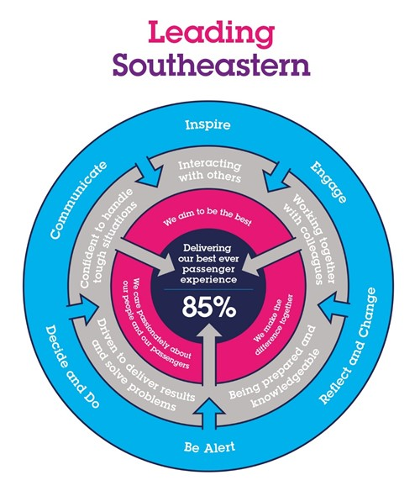

The Leading Southeastern framework details how we should be behaving in order to drive up performance to deliver 85% customer satisfaction.

All shortlisted candidates will be assessed against this framework.

G1 | The job demands the following blend of experience / knowledge, skills and behaviours (all are essential, unless otherwise shown and will be assessed by application and/ or interview / assessment):  Experience, Knowledge & Qualifications  Essential  - Previous management experience in the field of customer experience and/or programme management  - Previous experience of working in a customer service business with a proven track record of delivering a high-quality customer experience– particularly in the transport or retail sector  - Experience of successfully working to deadlines and of delivering change and performance outcomes  - Strong understanding of qualitative and quantitative research methods and analytics  - Experience of working in a setting that manages physical and digital customer experiences holistically.  Desirable  - Experience of working in complex and often pressurised environments  - Transport industry experience  - Experience working with market research, data analytics, journey mapping software or tools  - Experience or exposure to digital user experience design, and ecommerce flows
G2 | Behaviours & Skills  - Organised able to prioritise effectively based on insight and understanding of corporate and broader goals  - Excellent communicator (both verbally and written) with an ability to communicate clearly and coherently with all levels of staff  - A big thinker who can look outside the box for solutions, while still able to stay aligned with the long-term plans and goal  - A systematic thinker who proactively gathers the right data from appropriate sources to make the right decisions with confidence.  - Exceptional stakeholder management skills - able to build effective relationships and influence change at all levels  - Empathy and understanding of alternative viewpoints and ability to demonstrate consideration of these in decision making  - Expert planner with a disciplined approach in turning initiatives into business as usual
G3 | Other
H | Dimensions of Role
H1 | Financial – Direct:
H2 | Financial – Other:
H3 | Staff Responsibilities – Direct:
H4 | Staff Responsibilities – Other:
H5 | Any Other Statistical Data:
I | Acknowledgement
I1 | Prepared By: |  |  | __________________________ |  |  |  |  | Date: |  |  | _________________
I2 | Approved By (Head of Department): |  |  | __________________________ |  |  |  |  | Date: |  |  | _________________
J | Job Description Briefing
 | The post holder has been briefed on and understands the requirements of this Job Description and other related documents:
 | Name of Post Holder: | ___________________ |  |  | Signature: |  |  | _______________ |  |  |  |  |  | Date: |  | ________
 | Name of Briefing Manager: | ___________________ |  |  | Signature: |  |  | _______________ |  |  |  |  |  | Date: |  | ________
K | Nominated Deputy for Safety Requirements
 | If this is a KEY SAFETY POST (D2 in Safety Details above is YES) at least one nominated deputy must be identified. The Job Holder must ensure that the Nominated Deputy(ies) receives a copy of, and is briefed on this Job Description. If there are more nominated deputies, they should sign further copies of this Job Description.
 | The nominated deputy has been briefed on and understands the requirements of this Job Description and other related documents:
 | Name of Nominated Deputy: | __________________ |  |  | Signature: |  |  | _______________ |  |  |  |  |  | Date: |  | ________
 | Name of Briefing Manager: | __________________ |  |  | Signature: |  |  | _______________ |  |  |  |  |  | Date: |  | ________

