A | Post Details
 | Job Title: | Operations Inspector | Function: | Operations Standards
 | Location: | Ashford | Unique Post Number:
 | Reports To: | Senior Operations Inspector | Grade: | MG1
B | Purpose of the Job
Working within the Safety and Environment Organisation, and responsible to the Senior Operations Inspector, for the safe reliable train operation in compliance with Railway Group Standards and the Company Standards within Passenger Services and maintaining the associated safety critical competence assessments of staff.

Investigate accidents/incidents via Root Cause Analysis procedures as directed

Responsible for review and update of local train dispatch plans and Risk Assessments in accordance with Group and Rail Industry Standards, Passenger Train Dispatch and Platform Safety Measures (RIS-3703-TOM Iss4.1) and in conjunction with the PTI Risk Manager, Station Managers, Conductor Managers and Local Safety Representatives.

C | Principal Accountabilities
C1  C2  C3  C4  C5  C6  C7 | Responsible to Senior Operations Inspector for continual competence assessment and certification process of all Passenger Services staff and Managers who carry out Safety Critical work within the Passenger Services department in accordance with SE/WI/OPS/028 – Station Operatives Management and Competence, SE/WI/OPS/029 – Train Guards Management and Competence, SE/WI/OPS/018 – On Board Manager – Management and Competence, Network Rail Rule Book (GE/RT8000) and Train Movement – Medical Fitness Requirements (RIS-3452-TOM Iss1)  Monitor and enforce the compliance of standards regarding persons engaged in Safety Critical work, taking special cognisance of the requirements of the Network Rail Rule Book (GE/RT8000) and Train Movement – Medical Fitness Requirements (RIS-3452-TOM Iss1). DC Electrified Lines Rule Book Module (GE/RT8000-DC).  AC Electrified Lines (GE/RT8000/AC). SE/WI/OPS/028 – Station Operatives Management and Competence, SE/WI/OPS/029 – Train Guards Management and Competence, SE/WI/OPS/018 – On Board Manager – Management and Competence. Incident Response Planning & Management (RIS-3118-TOM Iss2). Accident and Incident Investigation (RIS-3119-TOM Iss2.2)  Responsible for the investigation of safety of the line accident and incidents involving all Safety Critical Passenger Services staff/contractors or members of the public via SE/SP/SAF/008 – Accident and Incident Reporting and Investigation and conducting Learning Reviews.  Introducing resulting Learning Points, recommendations for change and or coaching / mentoring as a consequence to meet Company Standards.  Responsible for the monitoring and upkeep of relevant e-CMS and paper records ensuring that the relevant Mangers receive periodic updates.  Producing draft Safety, PTI and/or Operational Notices and assist in the drafting and preparation of relevant Work Instructions and Competency Standards as and when required.  Responsible for the continual review of Local Train Dispatch Plans for Stations, ensuring Station Managers are co signatories and Conductor Managers are updated.  Delivery of an assurance checks and audits programme for conductor and on-board manager depots.
D | Specific Safety Accountabilities
D1  D2  D3  D4  D5  D6  D7  D8  D9 | You have legal responsibility for yourself and the people you advise, under various items of safety and environmental legislation.  Copies of all health and safety legislation and other safety documentation are kept in the Safety Reference Library.  You are required to undertake duties as directed by the Senior Operations Inspector for the purposes of:  Providing safety advice and guidance over the telephone;  Taking any action necessary to ensure the safety of customers, workforce or contractors following a Safety Of The Line incident or other safety related occurrence, i.e. ‘for cause’ Medscreens, withdrawal of Safety Critical licences, or assisting at major incidents;  Ensuring that the Company Safety Certificate is not put at risk.  Before taking up your post you must meet the standard medical requirements for conductors as described in Train Movement – Medical Fitness Requirements (RIS-3452-TOM Iss1)  This post is defined as safety critical and as such you are subject to drugs and alcohol screening in accordance with the SE/SP/SAF/007 – Drugs and Alcohol.  No Planned General Inspection responsibilities have been identified for this post. However, you must ensure that substandard conditions found by you in Southeastern workplaces are brought to the attention of the appropriate line manager without delay via the Fault Reporting Procedure.  You must take appropriate action to control risks identified in the risk assessment process.  You must assist in the risk assessment process as delegated by your manager for train dispatch, splitting and joining, shunting, and any other operational activity as required.  You must investigate all accidents/incidents in accordance with SE/SP/SAF/008 – Accident and Incident Reporting and Investigation  You must ensure appropriate action is taken as a result of recommendations that arise from investigations and inquiries, where these actions are within your area of control.  You must co-operate with Network Rail or the enforcing authority when formal inquiries are held into accidents and incidents  You must familiarise yourself with the contents of the local safety notice board
E | Decision making Authority
E1  E2 | Issue and withdrawal of Safety Critical Licences for all Passenger Services staff.  Instigation of “For cause Med Screening” of all Passenger Services Safety Critical Staff as required.

F | Most Challenging and/or Difficult parts of the Job
F1  F2 | Driving culture change and awareness of Southeastern Company values.  Forward planning of assessments that can change when rosters or train plans are amended

G | Person Specification

Southeastern aims to recruit people not just for jobs but for long term careers. We want good quality, talented people with the right attitude who will stay with us.

For these reasons we look for evidence of Southeastern values and behaviours in all potential staff and our existing staff looking for promotion along with the particular experience/knowledge, skills and behaviours relevant to the position applied for. These are

We care passionately about our people and passengers
  - we put ourselves in our passengers’ shoes to do what’s right for them
  - we support our colleagues to be, feel and do their best
  - we love the places we serve and do our bit for our communities and environment

We aim to be the best
  - we move with pace, we’re agile and learn from everything
  - we relentlessly strive to be the best
  - we are professionals with personalities

We make the difference together
  - we are answerable to each other and our passengers
  - we trust each other and do what we say we will
  - we are stronger together than we are as individuals

We also have identified behaviours required to be successful in leading Southeastern.

The Leading Southeastern framework details how we should be behaving in order to drive up performance to deliver 85%.
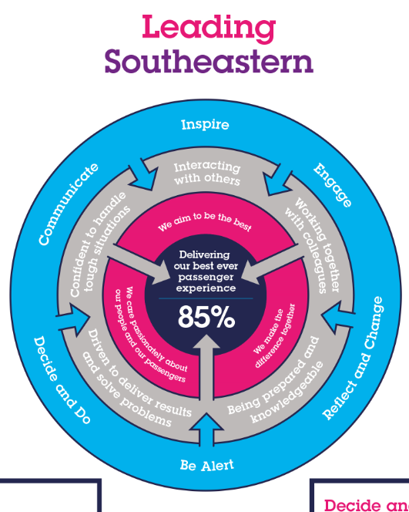

All shortlisted candidates seeking promotion will be assessed against this framework.

The job demands the following blend of experience/knowledge, skills and behaviours (all are essential, unless otherwise shown and will be assessed by application and/ or interview/assessment) :

G1 | Experience, Knowledge & Qualifications  Must be trained in (or working towards) A1, L12, V1 (or equivalent) City and Guilds Training standards.  Comprehensive Knowledge of relevant train working techniques, rules, instructions and Railway Group and Company Safety Standards.  Must have rules competence in the following competencies Personal Track Safety (PTS), SE/WI/OPS/028 – Station Operatives Management and Competence, SE/WI/OPS/029 – Train Guards Management and Competence, SE/WI/OPS/018 – On Board Manager – Management and Competence.  Fully trained in “Accident Investigation and Root Cause Analysis” or working towards.  Competent in Microsoft Office – Word, Excel and Outlook and be familiar with the use Tablets for undertaking Competence assessments and PTI Risk Assessments.  To hold or working towards Practical Risk Assessment qualification.
G2 | Skills (including any specific safety critical competencies)  Ability to work under pressure in a busy and varied environment under own initiative, and successfully adapts to changing demands and conditions.  Communication - Expresses oneself confidently and effectively. Is friendly and engages others in open, honest and productive conversations.  Planning & Organising.  Specialist Knowledge – Understands technical or professional aspects of work and continually maintains technical knowledge.  Problem Solving – Identifies potential difficulties and their causes. Generates workable solutions and makes rational judgements.  Before taking up the responsibilities of the post, your competence must be assessed and certified. The process will be one of continual assessment, proved over a Three-year period and will be carried out by the Senior Operations Inspector, or nominated deputy.  You will be issued with a Southeastern Personal Identification Card, and the following licences following an assessment and a finding of ‘competent’ by a licensed assessor:  - SE/WI/OPS/028 – Station Operatives Management and Competence  - SE/WI/OPS/029 – Train Guards Management and Competence  - SE/WI/OPS/018 – On Board Manager – Management and Competence  These must be carried at all times whilst on duty and must be presented on request to any manager wishing to see them.
G3 | Behaviours  Teamwork, Sharing and Supportive – Aligns with others to deliver common goals. Shares ideas and information. Supports colleagues and works effectively with others.  Honesty and Integrity – Is transparent and honest and takes full responsibility for actions. Demonstrates confidence and courage and deals effectively with difficult situations.
G4 | Other
H | Additional Information
I | Dimensions of the Job
I1 | Financial – Direct: |  | Nil
I2 | Financial – Other: |  | Nil
I3 | Staff Responsibilities – Direct: |  | Average 150 safety critical staff
I4 | Staff Responsibilities – Other: |  | Support/training to all Passenger Services staff
I5 | Any Other Statistical Data: |  | Generation and analysis of management information as required
J | Acknowledgement
J1 | Prepared By: | Alan Gale |  | Date: | ______________
J2 | Approved By (Head of Department): | Colin Campbell |  | Date: | ______________
K | Job Description Briefing
 | I confirm I have been briefed on and understand the requirements of this Job Description and other related documents
 | Name of post holder signature | ……………………………………………………………
 | I confirm I have briefed the Post Holder on the requirements of this Job Description and other related documents
Name of manager ……………………………………………………………
If this is a KEY SAFETY POST (2 in Safety Details above is YES) at least one nominated deputy must be identified. The Job Holder must ensure that the Nominated Deputy(ies) receives a copy of, and is briefed on this Job Description. If there are more nominated deputies, they should sign further copies of this Job Description.
Name of Deputy ……………………………………………………………
Nominated Deputies
I confirm I have briefed the Nominated Deputy on the requirements of this Job Description and other related documents
Signature ……………………………………………………………
As the Nominated Deputy for this post, I confirm I have been briefed on and understand the requirements of this Job
Signature ……………………………………………………………

