A | Post Details
 | Job Title: | Timetable Contingency Development Manager | Function: | Train Services
 | Location: | Friars Bridge Court | Unique Post Number:
 | Reports To: | Head of Train Planning | Grade: | MG2
B | Purpose of the Job
 | Support the Head of Train Planning and the Long Term & Short Term Planning teams with timetable projects, maintaining our suite of contingency plans, monitoring timetable performance, and developing and managing train planning performance schemes.
C | Principal Accountabilities
C1  C2  C3  C4  C5  C6 | Manage timetable related projects that span the Long Term and Short Term timetabling teams, for example fleet introduction that require numerous phases of re-diagramming.  Manage the suite of contingency timetables and ensure they are updated appropriately at timetable changes.  Lead the Train Planning team’s development of performance schemes, tracking their progress to ensure successful close-out of each scheme.  Monitor timetable performance and undertake Train Planning’s delay attribution processes.  Oversee the compilation of Train Planning’s KPIs, ensuring the weekly dashboard is kept up to date.  Represent the train planning team at industry and stakeholder meetings, deputising for the Head of Train Planning where necessary.

D | Safety Responsibilities
D1 | This post is required to undertake SAFETY CRITICAL WORK | Yes |  | No
D2 | This is a KEY SAFETY POST or nominated deputy | Yes |  | No
D3 | The holder of this post is identified as a KEY SAFETY MANAGER | Yes |  | No
D4 | The job requires competence in PERSONAL TRACK SAFETY | Yes |  | No
D5 | This job has SPECIFIC SAFETY RESPONSIBILITIES (if Yes see section D6 below) | Yes |  | No
D6 | The post holder has the following specific safety responsibilities:
 | - None
E | Decision making Authority
E1 | The post-holder will need to make decisions relating to performance (delay attribution), contingency timetable planning and other major timetable schemes, ensuring the appropriate approvals are obtained to maintain compliance with Southeastern’s latest Governance Process.
F | Most Challenging and/or Difficult parts of the role
F1  F2  F3 | The post-holder requires extensive geographic knowledge of the complex railway network used by Southeastern, and the logistics behind the stock and crew plans.  Turning high level scheme descriptions into workable proposals  Understanding Delay Attribution principles and the wider Performance Management System.

G | Person Specification

Southeastern aims to recruit people not just for jobs but for long term careers. We want good quality, talented people with the right attitude who will stay with us.

For these reasons we look for evidence of Southeastern values and behaviours in all potential staff and our existing staff looking for promotion along with the particular experience/knowledge, skills and behaviours relevant to the position applied for. These are

We care passionately about our people and passengers
  - we put ourselves in our passengers’ shoes to do what’s right for them
  - we support our colleagues to be, feel and do their best
  - we love the places we serve and do our bit for our communities and environment

We aim to be the best
  - we move with pace, we’re agile and learn from everything
  - we relentlessly strive to be the best
  - we are professionals with personalities

We make the difference together
  - we are answerable to each other and our passengers
  - we trust each other and do what we say we will
  - we are stronger together than we are as individuals

We also have identified behaviours required to be successful in leading Southeastern.

The Leading Southeastern framework details how we should be behaving in order to drive up performance to deliver 85.

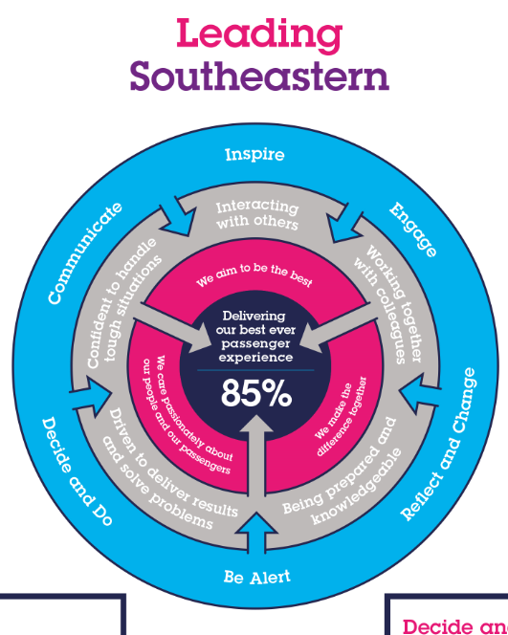

All shortlisted candidates seeking promotion will be assessed against this framework.

The job demands the following blend of experience/knowledge, skills and behaviours (all are essential , unless otherwise shown and will be assessed by application and/ or interview/assessment) :
G1 | Experience, Knowledge & Qualifications (including any specific safety training requirements)  Specialised knowledge in timetable production techniques with at least 3 years Train Planning experience  Comprehensive knowledge of Southeastern train service pattern and Network Rail geography  Understanding of Delay Attribution and Performance Management on UK railways, including experience of using TRUST via WinVV.
G2 | Skills (including any specific safety critical competencies)  Persuasiveness – Presents the key points of an argument persuasively. Negotiates and convinces others, changes people’s views and influences decisions.  Problem Solving – Able to analyse information and identify key decisions to be made. Generates innovative ideas and solutions, identifying potential opportunities and challenging others to think differently and take risks.  Communication - Expresses oneself confidently and effectively, questioning others to establish facts and ensure messages have been understood correctly. Is friendly and engages others in open, honest and productive conversations. Conveys complex information in plain language.  Commercial Awareness – Understands and applies commercial and financial principles. Views issues in terms of costs, profits, markets and added value. Demonstrates a readiness to make decisions, takes the initiative and originates action.  Customer Focus – Finds out the expectation of customers and initiates any improvements to deliver a consistently high quality service. Considers the impact on the customer of all business decisions and responds to competitor service levels appropriately. Will challenge all who fail to achieve the required level of customer service.
G3 | Behaviours  Resilience – Remains calm and self-controlled under pressure. Reacts well to change and stays positive despite setbacks. Keeps difficulties in perspective.  Honesty and Integrity – Is transparent and honest and takes full responsibility for actions. Demonstrates confidence and courage and deals effectively with difficult situations.
G4 | Other

H | Dimensions of role
H1 | Financial – Direct:
H2 | Financial – Other: |  | Company Passenger Revenue, Track Access Costs, Rolling Stock Leasing Charges
H3 | Staff Responsibilities – Direct:
H4 | Staff Responsibilities – Other:
H5 | Any Other Statistical Data:
I | Acknowledgement
I1 | Prepared By: | Guy Horstmann |  | Date: | 6th April 2022
I2 | Approved By (Head of Department): | Guy Horstmann |  | Date: | 6th April 2022

J | Job Description Briefing
 | The post holder has been briefed on and understands the requirements of this Job Description and other related documents:
 | Name of post holder: |  | Signature: |  | Date:
 | Name of briefing manager: |  | Signature: |  | Date:
K | Nominated Deputy for Safety requirements
 | If this is a KEY SAFETY POST (D2 in Safety Details above is YES) at least one nominated deputy must be identified. The Job Holder must ensure that the Nominated Deputy(ies) receives a copy of, and is briefed on this Job Description. If there are more nominated deputies, they should sign further copies of this Job Description.
 | The nominated deputy has been briefed on and understands the requirements of this Job Description and other related documents:
 | Name of nominated deputy: |  | Signature: |  | Date:
 | Name of briefing manager: |  | Signature: |  | Date:

