A | Post Details
 | Job Title: |  | Senior Revenue Protection Manager |  |  |  |  |  |  | Function: |  |  |  |  |  | Passenger Services
 | Location: |  | Area |  |  |  |  |  |  | Unique Post Number:
 | Reports To: |  | General Manager Revenue, Crime & Enforcement |  |  |  |  |  |  | Grade: |  |  |  |  |  | MG2
B | Purpose of the Job  Work in complete collaboration, as part of the wider revenue, crime and enforcement team within passenger services, to deliver the southeastern revenue protection strategy and reduce ticketless travel and revenue at risk.  Ensure delivery of all committed obligations and similar within the passenger services contract  Lead and head up a professional and continuously improving revenue protection team who put the fare paying passenger at the heart of all their activity  Work with the Data Team delivering intelligently led and quantifiable revenue protection activity  Ensure compliance to the Railways (Penalty Fares) Legislation and criminal fare evasion legislation for all southeastern colleagues  Work with internal and external partners to deliver industry best performance in tackling revenue protection, ticket fraud and associated anti-social behaviours
____________________________________________________________________
Principal Accountabilities

Revenue & Enforcement
Manage the revenue protection department in line with the revenue protection strategy including direction to positively impact on ticketless travel and revenue at risk whist not impeding passenger satisfaction

Work with the Railway Enforcement department to positively impact on feelings of safety and security of passengers and staff and reduce low level crime and disorder

Manage OSU team to deliver the business needs for Fraud Investigations

Manage the southeastern Penalty Fares approach and all aspects of fraudulent travel

D | Safety Responsibilities
D1 | This post is required to undertake SAFETY CRITICAL WORK |  |  |  |  |  |  |  |  |  |  |  |  |  | Yes |  |  |  |  | No
D2 | This is a KEY SAFETY POST |  |  |  |  |  |  |  |  |  |  |  |  |  | Yes |  |  |  |  | No
D3 | This post requires SECURITY CLEARANCE |  |  |  |  |  |  |  |  |  |  |  |  |  | Yes |  |  |  |  | No
D4 | The job requires competence in PERSONAL TRACK SAFETY |  |  |  |  |  |  |  |  |  |  |  |  |  | Yes |  |  |  |  | No
D5 | This job has SPECIFIC SAFETY RESPONSIBILITIES (if Yes see section D6 below) |  |  |  |  |  |  |  |  |  |  |  |  |  | Yes |  |  |  |  | No
D6 | The post holder has the following specific safety responsibilities:
- Ensure compliance with relevant sections of the Company Standards relating to revenue protection staff including planned safety audits.

Safety interface (insofar as safety of the staff and public from crime is concerned) with the following external parties:

- British Transport Police
- Others as may be identified from time to time

E | Decision making Authority
E1 | Up to £2000 financial delegated authority within budget
F | Most Challenging and/or Difficult parts of the role
F1  F2  F3  F4 | Ensuring a fair and consistent approach to opportunistic passenger fare evasion and criminal fare evasion  Manage the relationship and importance of revenue protection as a wider activity across the business  Delivering reductions in Ticketless travel  Deliver requirement of the Passenger Services Contract or similar
G | Person Specification

Southeastern aims to recruit people not just for jobs but for long term careers. We want good quality, talented people with the right attitude who will stay with us.

For these reasons we look for evidence of Southeastern values and behaviours in all potential staff and our existing staff looking for promotion along with the particular experience and knowledge, skills and behaviours relevant to the position applied for. These are

We care passionately about our people and passengers
  - we put ourselves in our passengers’ shoes to do what’s right for them
  - we support our colleagues to be, feel and do their best
  - we love the places we serve and do our bit for our communities and environment

We aim to be the best
  - we move with pace, we’re agile and learn from everything
  - we relentlessly strive to be the best
  - we are professionals with personalities

We make the difference together
  - we are answerable to each other and our passengers
  - we trust each other and do what we say we will
  - we are stronger together than we are as individuals

We also require more than competent performance against our Leadership & Management Competency Framework.

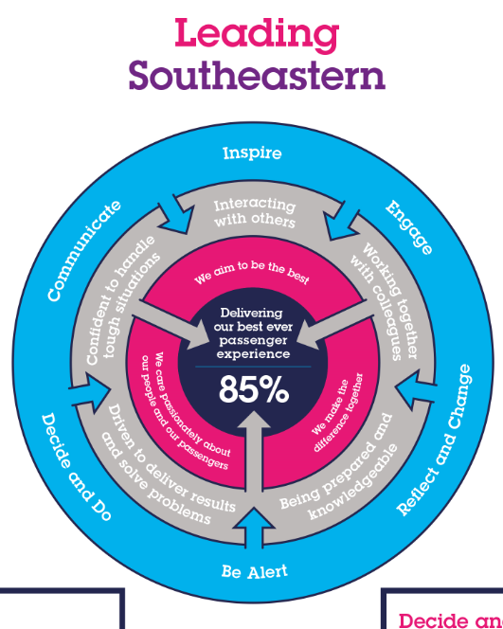

Experience, Knowledge & Qualifications
G1

Essential
Proven track record of achievement in terms of managing a large mobile workforce over a wide geographical area.

Demonstrable experience of using intelligence and data in order to deliver consistent improvement

Proven success in a customer service/results orientated environment

Strong interpersonal skills with experience of leading and directing customer focused teams.

Good knowledge of Railway legislation or willingness to undertake training

May also need to apply for and attain level 2 vetting

Desirable
Knowledge of Penalty Fares and relevant legislation

G2 | Skills (including any specific safety critical competencies)  Influencing – Gains commitment to deliver the desired result, through the use of a range of interpersonal skills, focussing on persuasion and negotiation.  Customer focused with strong commercial awareness – Uses understanding of Southeastern and its position within the marketplace to grow the business.  Leadership – Sets direction and inspires commitment to achieve common goals. Coaches to improve performance.  Professionalism – Aims to be the very best they can be through their attitude & respect of others, always leading by example.  Quality Orientation – Shows awareness of goals and standards, ensuring that quality and productivity standards are met.  Excellent communicator both written and verbally and ability to communicate at all levels.  Persuasiveness = presents the key points of an argument persuasively. Negotiates and convinces others..  Planning, organising and innovative problem solving – identifies potential difficulties and causes, generating workable solutions and making rational judgements.
G3 | Behaviours  Honesty and Integrity – Is transparent and honest and takes full responsibility for actions.  Innovative, creative and highly motivated.  Flexibility – Successfully adapts to changing demands and conditions.  Professionalism – interacts with others in a sensitive and effective way. Respects and works well with others. Quickly builds rapport and easily establishes relationships with different types of customers and stakeholders.  Demonstrates confidence and courage and deals effectively with difficult situations.  Resilience – remains calm and self-controlled under pressure.
G4 | Other – N/A
H | Dimensions of role
H1 | Financial – Direct: |  |  |  |  |  |  | COSTS: TBC INCOME:£TBC
H2 | Financial – Other: |  |  |  |  |  |  | TBC
H3 | Staff Responsibilities – Direct: |  |  |  |  |  |  | 7
H4 | Staff Responsibilities – Other: |  |  |  |  |  |  | 150 approx
H5 | Any Other Statistical Data:
I | Acknowledgement
I1 | Prepared By: |  |  |  |  | Siobhan Bradshaw |  |  |  |  |  | Date:
I2 | Approved By (Head of Department): |  |  |  |  | Siobhan Bradshaw,  Passenger Services Director |  |  |  |  |  | Date:
J | Job Description Briefing
 | The post holder has been briefed on and understands the requirements of this Job Description and other related documents:
 | Name of post holder: |  |  | Richard Cummings |  |  |  |  | Signature: |  |  |  |  |  |  |  |  | Date:
 | Briefing manager: |  |  |  | Siobhan Bradshaw |  |  |  | Signature: |  |  |  |  |  |  |  | Date:
K | Nominated Deputy for Safety requirements
 | If this is a KEY SAFETY POST (If D2 in Safety Details above is YES) at least one nominated deputy must be identified. The Job Holder must ensure that the Nominated Deputy(ies) receives a copy of, and is briefed on this Job Description. If there are more nominated deputies, they should sign further copies of this Job Description.
 | The nominated deputy has been briefed on and understands the requirements of this Job Description and other related documents:
 | Name of nominated deputy: | Steve Ells |  |  |  |  | Signature: |  |  |  |  |  |  |  |  |  |  |  | Date:
 | Name of briefing manager: | Richard Cummings |  |  |  |  | Signature: |  |  |  |  |  |  |  |  |  |  |  | Date:

