A | Post Details
 | Job Title: | Marketing  Executive | Function: | Commercial Directorate
 | Location: | More London | Unique Post Number: | FML/D/048
 | Reports To: | Marketing Manager | Grade: | MG1
B | Purpose of the Job
- Responsible for creation and delivery of marketing collateral for owned channels such as Station information posters, timetables and engineering works.
- Maintain collateral and promotional materials inventory.
- Provide support for the Marketing team on campaigns and projects.

C | Principal Accountabilities
C1  C2  C3  C4  C5  C6  C7  C8  C9  C10 | Create and develop relationships with key staff and departments such as Facilities and Customer Services and the Communications Team in order to understand their requirements and deliver required assets and collateral.  Work closely with the in-house designer taking responsibility for briefing in required collateral and assets, creative and copy.  Manage the approval process of collateral and assets.  Ensure timely delivery through close working with suppliers (printers and distributors) so all deadlines are met.  Efficient management of given budget and the purchase order system to cover the costs of all activity.  Work with internal teams to understand and deliver on all requirements for Department for Transport compliance with regards to station and passenger information and collateral.  Gain a full understanding of Southeastern brand guidelines, ensuring all collateral is compliant. Support and advice other departments and colleagues when required to ensure their work is also compliant with the guidelines.  Take responsibility for regular processing of station orders for replenishment of posters and leaflets as requested by station teams.  Work with the Marketing team when required on revenue generating or reputation building activity and campaigns. Such as logging and supplying travel passes to press or partners or helping to source passenger rewards from brands across our network.  Undertake other activities and projects as requested by the Marketing Manager.
D | Safety Responsibilities
D1 | This post is required to undertake SAFETY CRITICAL WORK |  |  |  | Yes |  | No | 
D2 | This is a KEY SAFETY POST |  |  |  | Yes |  | No | 
D3 | This post requires SECURITY CLEARANCE |  |  |  | Yes |  | No | 
D4 | The job requires competence in PERSONAL TRACK SAFETY |  |  |  | Yes |  | No | 
D5 | This job has SPECIFIC SAFETY RESPONSIBILITIES (if Yes see section D6 below) |  |  |  | Yes |  | No | 
D6 | The post holder has the following specific safety responsibilities:
 | - N/A
E | Decision making authority
E1  E2 | Taking appropriate action to meet deadlines  Approval of artwork as per the sign off and approvals process
F | Most Challenging and/or Difficult parts of the Job
F1  F2  F3 | Working to deadlines and managing multiple projects.  Translating often complex information from other teams into appropriate language for collateral.  Managing priorities and delivery of requirements within budget.
G | Person Specification

Southeastern aims to recruit people not just for jobs but for long term careers. We want good quality, talented people with the right attitude who will stay with us.

For these reasons we look for evidence of Southeastern values in all potential staff and our existing staff looking for promotion along with the particular experience/knowledge, skills and behaviours relevant to the position applied for. These are
- We care passionately about people
  - we put ourselves in our passengers’ shoes to do what’s right for them
  - we support our colleagues to be, feel and do their best
  - we love the places we serve and do our bit for our communities and environment
- We aim to be the best
  - we move with pace, we’re agile and learn from everything
  - we relentlessly strive to be the best
  - we are professionals with personalities
- We make the difference together
  - we are answerable to each other and our passengers
  - we trust each other and do what we say we will
  - we are stronger together than we are as individuals

We also have identified behaviours required to be successful in leading Southeastern.

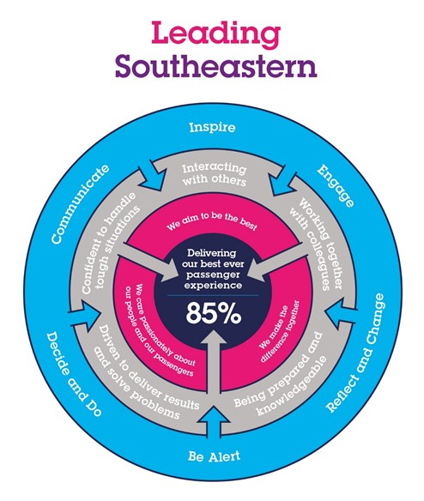

The Leading Southeastern framework details how we should be behaving in order to drive up performance to deliver 85 by 18.

All shortlisted candidates seeking promotion will be assessed against this framework.

The job demands the following blend of experience/knowledge, skills and behaviours (all are essential, unless otherwise shown and will be assessed by application and/ or interview/assessment):

G1 | Experience, Knowledge & Qualifications – Essential  - Excellent communication and interpersonal skills  - Outstanding attention to detail  - The ability to manage budgets  - Able to prioritise and work on own initiative, working to tight deadlines  - Be able to think quickly and manage multiple projects  - Marketing qualification e.g. CIM Dip / Degree
G2 | Experience, Knowledge & Qualifications – Desirable  - Previous experience working within a marketing team or agency
G3 | Behaviours and Skills – Essential  - Professionalism  - Planning and organising  - Integrity  - Friendly and approachable  - Can do attitude  - Attention to detail  - A willingness to learn new skills

H | Dimensions of role
H1 | Financial – Direct:
H2 | Financial – Other:
H3 | Staff Responsibilities – Direct:
H4 | Staff Responsibilities – Other:
H5 | Any Other Statistical Data:
I | Acknowledgement
I1 | Prepared By: | _______________ |  | Date: | ______________
I2 | Approved By (Head of Department): | _______________ |  | Date: | ______________

