A | Post Details
 | Job Title: Procurement Manager – Indirect Projects (12mth FTC) |  | Function: Finance & Contracts
 | Location: London Bridge and Remote |  | Unique Post Number: n/a
 | Reports To: Indirect Lead |  | Grade: TBC
B | Purpose of the Job  This role is an important component of the Southeastern Procurement team. The team are responsible for all purchasing requirements for the organisation and support a wide range of functions from purchase order creation, supplier management, tendering, contract and commercial support and delivering value through savings, improved contracts and supply chain efficiencies.
The purpose of this role is to provide support to deliver UCR compliant procurement projects across Southeastern’s indirect categories, including IT, retail/website and HR. The role will focus on delivery of defined projects to advance the business and meet specific deadlines in the IT transition from our previous owning Group into an autonomous environment.

This will include understanding contractual obligations, proactively planning and delivering high quality tenders, leasing with key stakeholders contract and offering support in delivering framework call-offs and RFPs/RFQs, as required.

C | Principal Accountabilities
C1  C2  C3  C4  C5  C6  C7  C8  C9  C10  C11 | Responsible for entire tender process for specified projects whilst complying with UCR16.  Proposing appropriate terms and conditions and drafting amendment to Southeastern or standard form terms and conditions for purchasing/procurement requirements.  Ensuring project risks related to safety, information security and GDPR are mitigated by proposing appropriate terms and conditions based on Southeastern templates.  To regularly update the Procurement Information Manager with project progress, contract status and submitting signed documentation/contracts for archiving.  Working with internal stakeholders to ensure goods & services are appropriately specified and KPIs are developed for key contracts.  Effectively communicating and engaging stakeholders throughout the procurement process.  Advising and assisting stakeholders on procurement procedures, processes and governance in achieving project objectives.  Undertaking market research and developing new or existing suppliers to meet the operational needs of the business.  Liaising with Finance Business Partners to ascertain project budgets and authorisations for new contracts.  Ensuring that all contracts which involve supplier’s working on Southeastern sites have appropriate contractual health and safety documentation.  Assisting the Procurement team in developing and delivering necessary Forums to share knowledge, information or best practice with the organisation – specifically across the IT and Indirect category.
D | Safety Responsibilities
D1 | This post is required to undertake SAFETY CRITICAL WORK |  |  | Yes |  | No | x
D2 | This is a KEY SAFETY POST or nominated deputy |  |  | Yes |  | No | x
D3 | The holder of this post is identified as a KEY SAFETY MANAGER |  |  | Yes |  | No | x
D4 | The job requires competence in PERSONAL TRACK SAFETY |  |  | Yes |  | No | x
D5 | This job has SPECIFIC SAFETY RESPONSIBILITIES (if Yes see section D6 below) |  |  | Yes |  | No | x
D6 | The post holder has no specific safety responsibilities.
E | Decision making Authority
E1  E2 | Recommendation of Southeastern procurement strategies and contract awards to the Indirect Lead/Head of Procurement, Department Director and Finance & Contracts Director for final approval.  Negotiating with suppliers and drafting contracts on behalf of Southeastern.
F | Most Challenging and/or Difficult parts of the role
F1  F2  F3 | Ensuring the local and procurement culture and processes are applied throughout Southeastern.  Ensuring UCR adherence throughout supplier negotiations, tenders and transactions.  Simultaneously managing multiple stakeholders to align objectives.

G | Person Specification

Southeastern look for values and behaviours in all potential staff and our existing staff looking for promotion along with the particular experience/knowledge, skills and behaviours relevant to the position applied for. These are:

We care passionately about our people and passengers
  - we put ourselves in our passengers’ shoes to do what’s right for them
  - we support our colleagues to be, feel and do their best
  - we love the places we serve and do our bit for our communities and environment

We aim to be the best
  - we move with pace, we’re agile and learn from everything
  - we relentlessly strive to be the best
  - we are professionals with personalities

We make the difference together
  - we are answerable to each other and our passengers
  - we trust each other and do what we say we will
  - we are stronger together than we are as individuals

We also require more than competent performance against our Leadership & Management Competency Framework.
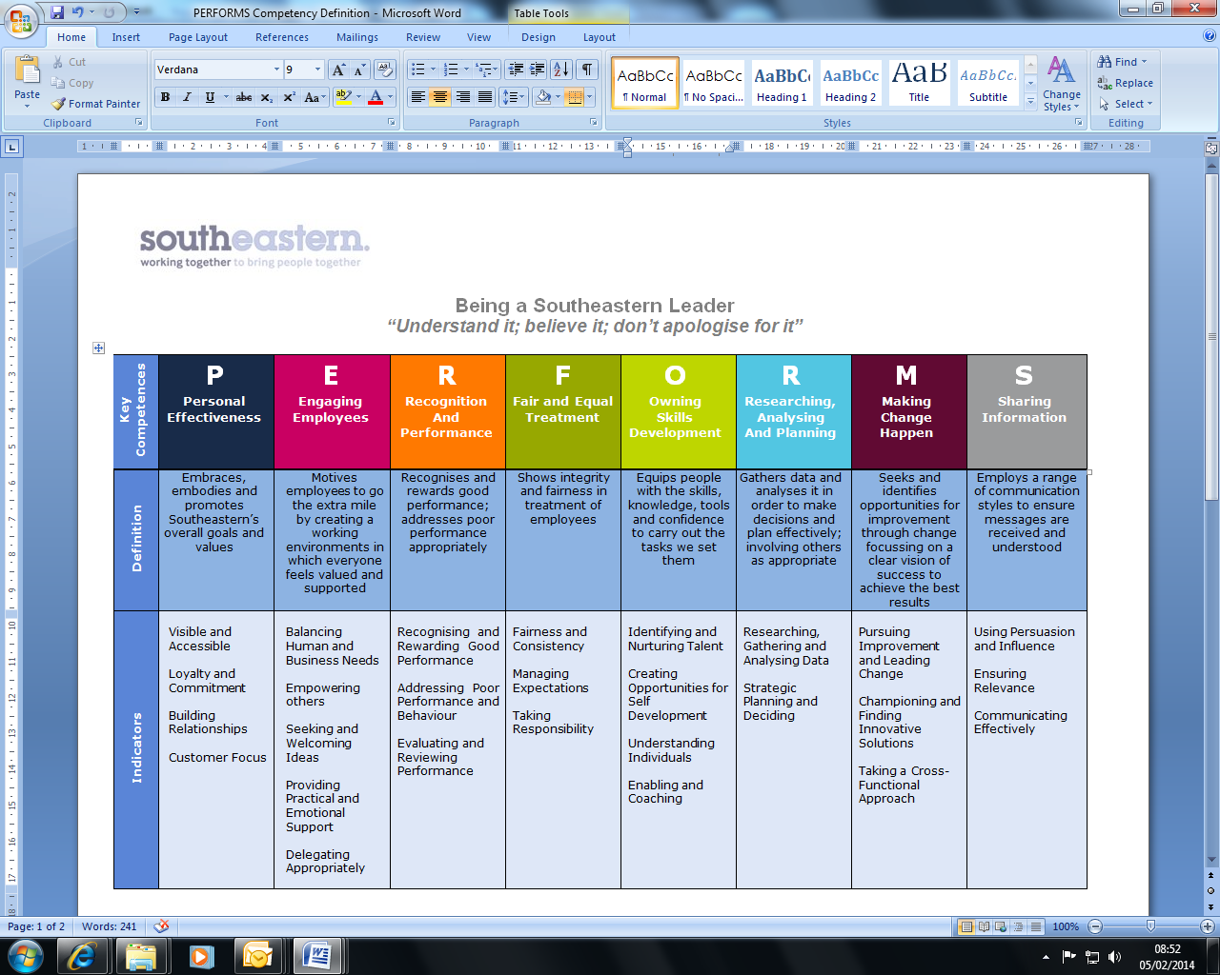
All shortlisted candidates seeking promotion will be assessed against this framework.

The job demands the following blend of experience/knowledge, skills and behaviours (all are essential, unless otherwise shown and will be assessed by application and/ or interview/assessment).

G1 | Experience, Knowledge & Qualifications (including any specific safety training requirements)  - Qualified member of the Chartered Institute of Purchasing and Supply (MCIPS) – or equivalent transferrable degree or professional qualification.  - A minimum of four (4) years of working in an accountable role in either a procurement, commercial or contract management within an Indirect/IT environment.  - Working knowledge of contract law, GDPR and UCR16 regulations.  - Good understanding and experience of procure to pay (P2P) systems and processes  - Some experience of contract management (i.e. post contract)  - Good understanding of contractual documentation and governance requirements  - Good understand of e-tendering systems/tools  - Excellent stakeholder management skills and experience  - Proficient experience of supply chain planning, engagement and producing associated reports.  - Good experience of market engagement
G2 | Skills (including any specific safety critical competencies)  - Ability to work effectively at management level within Southeastern, liaising with senior managers and across supplier directors.  - Ability to express oneself confidently, honestly and effectively.  - Proven influencing and problem-solving skills.  - Commercial awareness.  - Good IT skills including use of Microsoft suite (Excel, Word & Powerpoint)  - Well-developed report writing skills
G3 | Behaviours  - Professionalism  - Honesty and Integrity – is transparent and honest and takes full responsibility for actions. Confidence and courage to challenge the business and deal effectively with difficult situations.  - Teamwork, Sharing and Supportive – aligns with others both within and outside Southeastern to deliver common goals. Shares ideas and information. Supports colleagues and works effectively with others.  - Flexibility – successfully adapts to changing demands, conditions and scenarios.

H | Dimensions of role
H1 | Financial – Direct: n/a
H2 | Financial – Other: n/a
H3 | Staff Responsibilities – Direct: None
H4 | Staff Responsibilities – Other: None
H5 | Any Other Statistical Data: Procurement KPIs
I | Acknowledgement
I1 | Prepared By (Head of Department): | _______________ |  | Date: | ______________

J | Job Description Briefing
 | The post holder has been briefed on and understands the requirements of this Job Description and other related documents:
 | Name of post holder: |  | Signature: |  | Date:
 | Name of briefing manager: |  | Signature: |  | Date:
K | Nominated Deputy for Safety requirements
 | If this is a KEY SAFETY POST (D2 in Safety Details above is YES) at least one nominated deputy must be identified. The Job Holder must ensure that the Nominated Deputy(ies) receives a copy of, and is briefed on this Job Description. If there are more nominated deputies, they should sign further copies of this Job Description.
 | The nominated deputy has been briefed on and understands the requirements of this Job Description and other related documents:
 | Name of nominated deputy: |  | Signature: |  | Date:
 | Name of briefing manager: |  | Signature: |  | Date:

