A | Post Details
 | Job Title: | Operational Communications Manager (OCM) | Function: | Train Services
 | Location: | Puddle Dock (KICC) | Unique Post Number:
 | Reports To: | Passenger Experience Delivery Manager (PEDM) | Grade: | MG1
B | Purpose of the Job
 | Manage the timely provision of information to staff on the current status of Southeastern train services. Ensuring that the frequency and quality of information provided supports the Passengers Services organisation in delivering excellent customer service. Co-ordinate the provision of alternative transport, Southeastern on-call / response staff and initiate the “Chain of Care” when required in response to incidents.
C | Principal Accountabilities
C1  C2  C3  C4  C5  C6  C7  C8  C9  C10  C11  C12  C13  C14  C15  C16  C17  C18 | Monitor the performance of Southeastern services.  Provide regular summaries on the current state of Southeastern services to internal customers. Ensuring all information is appropriate to the audience and delivery channel.  During times of disruption promptly provide regular fit for purpose information to Southeastern members of staff, to ensure they can assist customers to make informed decisions on travel based on the reason and likely duration of a delay and alternate transport arrangements.  As required, implement the introduction of replacement bus services, including the determination of the appropriate level / frequency of service, when there is train service disruption.  When a replacement bus service is in operation, manage services by liaising with local coordinators to ensure the required service is being delivered. This includes determining the most appropriate time to terminate the replacement service.  Initiate the process for investigation of incidents and accidents as specified in the Southeastern Safety Manual.  Manage Southeastern on-call roster in real time for on call managers & disruption agents to attend incidents, as required.  In conjunction with the Information Delivery Manager, implement the communication plan element of the Southeastern’s Service Disruption Procedure in the event of a service disrupting incident occurring  Liaise with other travel organisations in sharing service information so that Southeastern customers can be regularly updated about potential onward journey travel information  Ensure that adequate documentation is maintained to address legislation, regulations, group standards and Southeastern’s internal requirements  Liaise with Transport for London / Docklands Light Railway as required, to arrange the mutual acceptance of Southeastern passengers on their services & vice versa.  Liaise with the Oyster Control Centre as required, to inform them of ticket gate failures / closures.  Provide an out of office hours contact point for reporting station infrastructure faults.  Communicate messages regarding closed ticket offices and failed ticket vending machines  Calculate and publish performance statistics throughout the day as per agreed process.  Process Passenger Accident information ensuring details are recorded in the KICC daily log, according to procedures in the Southeastern Safety Manual.  Assist the Passenger Experience Delivery Manager in the KICC as required.  Communication with the Safety & Executive teams in relation to operational & safety related incidents.
D | Safety Responsibilities
D1 | This post is required to undertake SAFETY CRITICAL WORK |  |  |  | Yes |  | No | √
D2 | This is a KEY SAFETY POST |  |  |  | Yes |  | No | √
D3 | This post requires SECURITY CLEARANCE |  |  |  | Yes |  | No | √
D4 | The job requires competence in PERSONAL TRACK SAFETY |  |  |  | Yes |  | No | √
D5 | This job has SPECIFIC SAFETY RESPONSIBILITIES (if Yes see section D6 below) |  |  |  | Yes |  | No | √
D6 | The post holder has the following specific safety responsibilities:
 | None
E | Decision making Authority
E1  E2 | Management of the Passenger Services response when the train service is disrupted  Evaluate information provided by Train Service Managers and other sources and process in accordance with the agreed standard.
F | Most Challenging and/or Difficult parts of the role
F1 | Working many hours at unsociable times in a busy demanding office.  Making decisions, which will not be approved by everyone but are to the benefit of the majority of Southeastern passengers and objectives?

G | Person Specification

Southeastern aims to recruit people not just for jobs but for long term careers. We want good quality, talented people with the right attitude who will stay with us.

For these reasons we look for evidence of Southeastern values and behaviours in all potential staff and our existing staff looking for promotion along with the particular experience/knowledge, skills and behaviours relevant to the position applied for. These are

We care passionately about our people and passengers
  - we put ourselves in our passengers’ shoes to do what’s right for them
  - we support our colleagues to be, feel and do their best
  - we love the places we serve and do our bit for our communities and environment

We aim to be the best
  - we move with pace, we’re agile and learn from everything
  - we relentlessly strive to be the best
  - we are professionals with personalities

We make the difference together
  - we are answerable to each other and our passengers
  - we trust each other and do what we say we will
  - we are stronger together than we are as individuals

We also have identified behaviours required to be successful in leading Southeastern.

The Leading Southeastern framework details how we should be behaving in order to drive up performance to deliver 85.

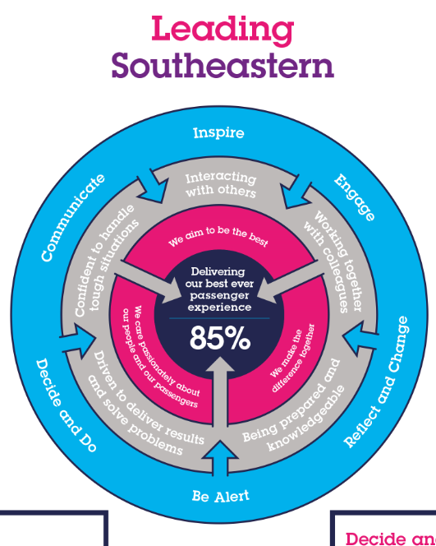

All shortlisted candidates seeking promotion will be assessed against this framework.

The job demands the following blend of experience/knowledge, skills and behaviours (all are essential , unless otherwise shown and will be assessed by application and/ or interview/assessment) :

G1 | Experience, Knowledge & Qualifications  Knowledge services operated by Southeastern.  Good knowledge of generally available and bespoke IT systems.  Good general knowledge of Southeastern Passenger Services organisation structure.  Good general education with passes in English Language and Mathematics.  Previous experience in a Customer Information role preferable.  Ability to create own inputs and influence at a number of levels in the organisation
G2 | Skills (including any specific safety critical competencies)  Excellent communication skills.  Passenger awareness- Understands the needs of the Passenger
G3 | Behaviours  Resilience- Remains calm and self-controlled under pressure. Reacts well to change and stays positive despite setbacks.  Professionalism- Interacts with others in a sensitive and effective way. Respects and works well with others.
G4 | Other

I | Dimensions of role
I1 | Financial – Direct:
I2 | Financial – Other: |  | Provision of emergency replacement buses, approx £0.5 million
I3 | Staff Responsibilities – Direct:
I4 | Staff Responsibilities – Other:
I5 | Any Other Statistical Data:
J | Acknowledgement
J1 | Prepared By: | John Till / Kevin Morris |  | Date: | 28/06/11
J2 | Approved By (Head of Department): | Andy Toplis |  | Date: | 28/06/11

K | Job Description Briefing
 | The post holder has been briefed on and understands the requirements of this Job Description and other related documents:
 | Name of post holder: |  | Signature: |  | Date:
 | Name of briefing manager: |  | Signature: |  | Date:
L | Nominated Deputy for Safety requirements
 | If this is a KEY SAFETY POST (D2 in Safety Details above is YES) at least one nominated deputy must be identified. The Job Holder must ensure that the Nominated Deputy(ies) receives a copy of, and is briefed on this Job Description. If there are more nominated deputies, they should sign further copies of this Job Description.
 | The nominated deputy has been briefed on and understands the requirements of this Job Description and other related documents:
 | Name of nominated deputy: |  | Signature: |  | Date:
 | Name of briefing manager: |  | Signature: |  | Date:

