Department | People & Culture
Grade | MG1
Reports to | Planning, Implementation and Reporting Manager
Location | Four More London (4ML) 3 x a week, one day in Ashford, one flexible day

Our Purpose
Working together to secure a thriving future for the railway and for the communities we serve
Your Role: Implementation Manager
Your Purpose
In this role you will lead the delivery of key People & Culture projects, ensuring initiatives are delivered on time, on budget and with clear outcomes for colleagues.
You will provide structure, challenge and pace across the People Team, improving how we plan, track and deliver work. You will continually question how things are done, helping implement better ways of working that improve the experience of colleagues across Southeastern.

Your Talent’s
- Experience working in HR and/or people change projects
- Strong project management experience with proven ability to track progress and manage delivery plans
- Experience in risk management, governance and reporting
- Process improvement experience, Lean qualification desirable
- Experience working in a train operating company or similar regulated environment advantageous
- Strong reporting and dashboard writing skills
- Ability to manage multiple priorities and work across teams
- Confident critical thinker who constructively challenges the status quo
- Collaborative style with the ability to influence without direct line management authority

Your Responsibilities & Accountabilities
- Support project initiation by helping scope objectives, requirements and assumptions
- Develop, maintain and track project plans and documentation
- Proactively follow up with managers and suppliers to ensure delivery milestones are met
- Identify internal and external best practice to improve the colleague experience
- Participate in GBR working groups and communities of practice as required
- Support Heads of HR to ensure BAU activity is tracked and aligned with strategic priorities
- Contribute to period reports and dashboards, ensuring insight highlights future risks and deliverables, not just past activity
- Act as a trusted critical friend to a nominated Head of HR and their team, supporting risk management and control frameworks
- Support contract and supplier management activity
- Ensure cyclical external reporting and accreditations are delivered on time, including Gender Pay Gap reporting and Investors in People audits
- Partner with Internal Communications and People Team colleagues to project manage key events such as Gold Awards, Long Service Awards and Pride-related activity
- Upskill the People Team and Colleague Network Groups in project and risk management principles
- Act as the People Team AI champion, identifying opportunities to streamline and improve processes
What we trust you to do – (Authority to Act)
- OwnMake clear, evidence-based recommendations to Heads of HR on project risks, priorities and delivery decisions
- Challenge working groups constructively on behalf of colleagues
- Escalate delivery risks where appropriate
- Shape and influence project direction through insight and governance oversight
- Represent the People Team in cross-functional forums

Our ways of working
- We think what if
We Listen, We Learn, We Improve.
- We show we care
We look out for people. We do what we can to help.
- We make great things happen
Whilst keeping it simple.
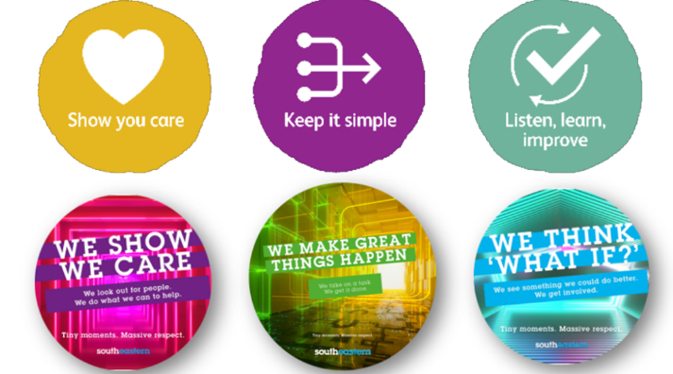
Date created | XX/XX/XXXXX
Approved by | APPROVER NAME HERE

