A | Post Details
 | Job Title: Procurement Information Manager |  | Function: Finance & Contracts
 | Location: London Bridge and/or Remote |  | Unique Post Number: n/a
 | Reports To: Indirect Procurement Lead |  | Grade: TBC
B | Purpose of the Job  This role is an important component of the Southeastern Procurement team, helping bring business information, reporting and intelligence to the forefront of our departmental strategy and, in turn, delivering on legal, contractual and governance obligations. This role will lead on reporting progress/project status, manage business-wide stakeholder communications, own and proactively manage our contract database, signatures, governance approvals and other associated documentation. In addition, the role will provide supplier intelligence, risk management and due diligence, supplier development (for key bottleneck/constrained areas) and helping deliver supply chain sustainability and tracking contractual CSR KPIs.  Core elements of the role will involve regularly seeking information, problem solving and finding solutions, generating usable information for the Procurement team and wider stakeholders to use.
C | Principal Accountabilities
C1  C2  C3  C4  C5  C6  C7  C8  C9  C10  C11  C12 | Proactive and timely maintenance/management of Southeastern’s contract database (including information accuracy), hard and soft version contract archives and associated procurement/governance documentation, ensuring that all activities are captured and up to date at all times (within 2 Business Days) – including chasing progress and ensuring timescales are achieved.  Managing contract and governance approvals, consents and information requests from internal or external stakeholders.  Creation and maintenance of compliance/project tracker/s, including obtaining regular updates from the wider team, in order to disseminate across the business as required.  Producing KPI/spend/purchasing reports, as required by the Procurement team.  Implementation of supplier risk assessments, due diligence and credit checks – ensuring accurate records are kept.  Assessing/auditing our UCR compliance against our contract database, highlighting risks and areas of focus for the procurement pipeline.  Advising and assisting internal stakeholders on/with procurement procedures, processes, business cases and governance.  To regularly report and effectively communicate to the Procurement team and wider stakeholders.  Working with the Head of Procurement and Procurement Leads to issue UCR compliant Prior Indication Notices (PIN) for known goods, works and services within the procurement pipeline.  Supporting the collection and invoicing of any contractual rebates due to Southeastern.  Undertaking analysis of our spend data, including tailspend and associated systems (e.g. Amazon Business) to highlight opportunities to the Procurement team and ensuring gaps/leakage are identified.  Liaising with internal stakeholders, suppliers and external stakeholders to perform benchmarking exercises.
D | Safety Responsibilities
D1 | This post is required to undertake SAFETY CRITICAL WORK |  |  | Yes |  | No | x
D2 | This is a KEY SAFETY POST or nominated deputy |  |  | Yes |  | No | x
D3 | The holder of this post is identified as a KEY SAFETY MANAGER |  |  | Yes |  | No | x
D4 | The job requires competence in PERSONAL TRACK SAFETY |  |  | Yes |  | No | x
D5 | This job has SPECIFIC SAFETY RESPONSIBILITIES (if Yes see section D6 below) |  |  | Yes |  | No | x
D6 | The post holder has no specific safety responsibilities.
E | Decision making Authority
E1 | n/a
F | Most Challenging and/or Difficult parts of the role
F1  F2  F3  F4 | Consistently ensuring a good level of understanding of team activities in order to provide accurate and credible information to the team and business.  Helping to ensure that Southeastern’s contracts are compliant with UCR.  Simultaneously liaising with a wide range of stakeholders and activities  Ensuring clear systems/processes are developed to ensure that information is updated as quickly as possible

G | Person Specification

Southeastern look for values and behaviours in all potential staff and our existing staff looking for promotion along with the particular experience/knowledge, skills and behaviours relevant to the position applied for. These are:

We care passionately about our people and passengers
  - we put ourselves in our passengers’ shoes to do what’s right for them
  - we support our colleagues to be, feel and do their best
  - we love the places we serve and do our bit for our communities and environment

We aim to be the best
  - we move with pace, we’re agile and learn from everything
  - we relentlessly strive to be the best
  - we are professionals with personalities

We make the difference together
  - we are answerable to each other and our passengers
  - we trust each other and do what we say we will
  - we are stronger together than we are as individuals

We also require more than competent performance against our Leadership & Management Competency Framework.
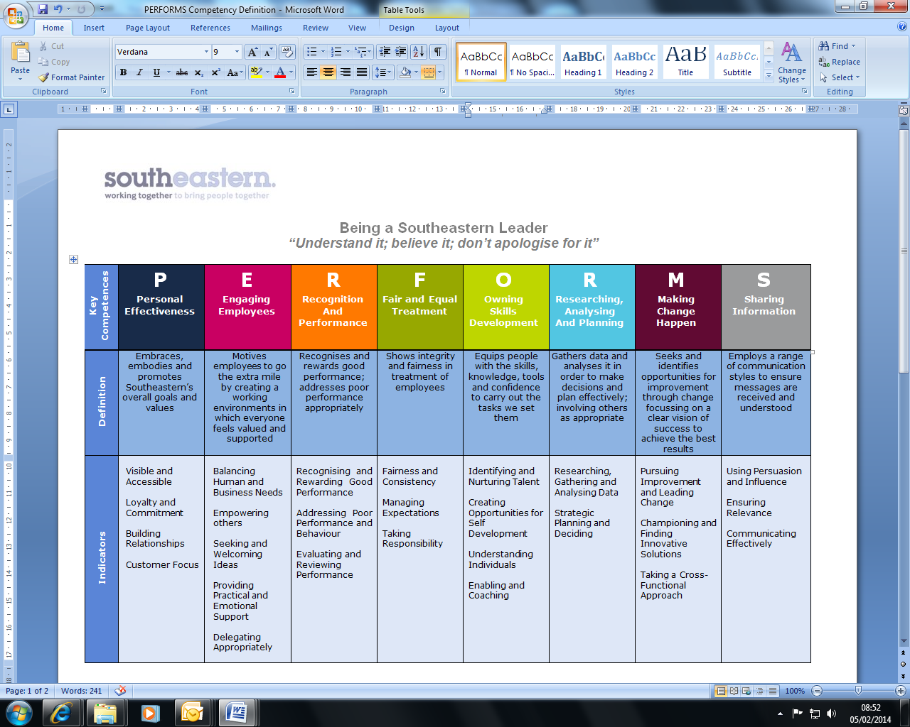
All shortlisted candidates seeking promotion will be assessed against this framework.

The job demands the following blend of experience/knowledge, skills and behaviours (all are essential, unless otherwise shown and will be assessed by application and/ or interview/assessment).
G1 | Experience, Knowledge & Qualifications (including any specific safety training requirements)  - A transferrable degree, professional qualification or accreditation  - A detailed knowledge of the procurement process, contractual compliances and auditing  - Good/Excellent understanding and experience of procure to pay (P2P) systems and processes  - Good/Excellent understanding of contractual documentation and governance requirements  - Good/Excellent working knowledge of contract law, safety and GDPR requirements  - Good/Excellent stakeholder management skills and experience  - Good/Excellent experience of producing reports for senior management and board levels  - Knowledge of the rail industry is advantageous but not mandatory
G2 | Skills (including any specific safety critical competencies)  - Ability to work effectively at management level within Southeastern, liaising with senior managers and external clients.  - Ability to express oneself confidently, honestly and effectively.  - Proven influencing and problem-solving skills.  - Commercial awareness.  - Good/Excellent IT skills including use of Microsoft suite (Excel, Word & Powerpoint)  - Well-developed report and letter writing skills
G3 | Behaviours  - Professionalism  - Honesty and Integrity – is transparent and honest and takes full responsibility for actions. Confidence and courage to challenge the business and deal effectively with difficult situations.  - Teamwork, Sharing and Supportive – aligns with others both within and outside Southeastern to deliver common goals. Shares ideas and information. Supports colleagues and works effectively with others.  - Flexibility – successfully adapts to changing demands, conditions and scenarios.

H | Dimensions of role
H1 | Financial – Direct: n/a
H2 | Financial – Other: n/a
H3 | Staff Responsibilities – Direct: None
H4 | Staff Responsibilities – Other: None
H5 | Any Other Statistical Data: Procurement KPIs
I | Acknowledgement
I1 | Prepared By (Head of Department): | _______________ |  | Date: | ______________

J | Job Description Briefing
 | The post holder has been briefed on and understands the requirements of this Job Description and other related documents:
 | Name of post holder: |  | Signature: |  | Date:
 | Name of briefing manager: |  | Signature: |  | Date:
K | Nominated Deputy for Safety requirements
 | If this is a KEY SAFETY POST (D2 in Safety Details above is YES) at least one nominated deputy must be identified. The Job Holder must ensure that the Nominated Deputy(ies) receives a copy of, and is briefed on this Job Description. If there are more nominated deputies, they should sign further copies of this Job Description.
 | The nominated deputy has been briefed on and understands the requirements of this Job Description and other related documents:
 | Name of nominated deputy: |  | Signature: |  | Date:
 | Name of briefing manager: |  | Signature: |  | Date:

