A | Post Details
 | Job Title: | Station Manager | Function: | Passenger Services
 | Location: | TBC | Unique Post Number:
 | Reports To: | Area Manager | Grade: | MG1
B | Purpose of the Job
Manage all Commercial staff on a day-to-day basis at defined stations to provide a thriving sales environment, excellent customer service, safe stations, efficient train service performance and accurate and timely information for customers.

Ensuring visible station manager presence to staff and customers including, but not limited to, presence on the platforms, concourse, gateline or in the booking hall of a key station for a minimum of two hours in the weekday morning peaks (i.e. 0700 hours to 0900 hours) and two hours in the weekday evening peaks (i.e. 1700 hours to 1900 hours). During these times no office or administrative work is to be conducted except in exceptional circumstances (which must be recorded in the station log). Customer conversations, leading by example and coaching will be the core activities during these times.

C | Principal Accountabilities
C1  C2  C3  C4  C5  C6  C7  C8  C9  C10  C11  C12  C13  C14  C15  C16  C17  C18  C19 | Direct daily working arrangements, ensuring that all station staff are fully equipped and competent to fulfill their roles.  Control the delegated expenses budget with regard to payroll and non-payroll costs.  Manage the internal controls associated with ticket office procedures and delegated authorities ensuring compliance and taking corrective action.  Ensure that current legislation and the requirements of the Safety Manual is complied with and understood at all levels including contractor activities on stations premises.  Implement communication plans to ensure customers are always informed about current performance and any delays.  With direction from the Area Manager ensure that all training needs of staff are identified and delivered in accordance with a properly constructed Action/Improvement Plan.  Ensure efficient operation of the retailing activity by maintaining trained competent and motivated sales force, complying with customer service and ATOC standards and actively seeking ways of maximising sales and revenue protection.  Lead and direct all station activity in connection with trains service delivery and performance with particular regard to the management of delay and attribution of lost minutes and the prevention of cancellations.  Ensure all staff that undertake safety critical duties are assessed and proved competent at the prescribed intervals as set down in the Company Safety Management System.  Monitor and carry out split/attach and despatch duties as required.  Ensure the production of timely roster that are cost effective and compliant with all policies relating to working time regulations and Hidden 18.  Ensure compliance to company Service Quality Standards.  Undertake assessment and selection interviews  Effectively communicate with local teams including regular monthly team briefs.  Ensure all station teams are trained and deliver adequate revenue protection and are competent in manning of gatelines.  Ensure that promotional offers are current and correctly displayed.  Ensure budgetary targets are met and creative initiatives are developed to meet the Company’s aims and business objectives.  Work with Trade Unions to develop effective working relationships  With direction from the Station Manager London liaise and coordinate retail and travel matters with TfL and Network Rail to ensure value for money delivery of station services at Network Rail Major Stations where required.

D | Safety Responsibilities
D1 | This post is required to undertake SAFETY CRITICAL WORK | Yes |  | No
D2 | This is a KEY SAFETY POST | Yes |  | No
D3 | This post requires SECURITY CLEARANCE | Yes |  | No
D4 | The job requires competence in PERSONAL TRACK SAFETY | Yes |  | No
D5 | This job has SPECIFIC SAFETY RESPONSIBILITIES (if Yes see section D6 below) | Yes |  | No
D6 | The post holder has the following specific safety responsibilities:
 | - Ensure compliance to all company standards, processes and procedures.
 | - Carry out On Call Duties as required.
E | Decision making Authority
E1 | N/A
F | Most Challenging and/or Difficult parts of the role
F1 | Ensuring compliance to company standards on a consistent basis.

G | Person Specification

Southeastern aims to recruit people not just for jobs but for long term careers. We want good quality, talented people with the right attitude who will stay with us.

For these reasons we look for evidence of Southeastern values and behaviours in all potential staff and our existing staff looking for promotion along with the particular experience/knowledge, skills and behaviours relevant to the position applied for. These are

We care passionately about our people and passengers
  - we put ourselves in our passengers’ shoes to do what’s right for them
  - we support our colleagues to be, feel and do their best
  - we love the places we serve and do our bit for our communities and environment

We aim to be the best
  - we move with pace, we’re agile and learn from everything
  - we relentlessly strive to be the best
  - we are professionals with personalities

We make the difference together
  - we are answerable to each other and our passengers
  - we trust each other and do what we say we will
  - we are stronger together than we are as individuals

We also have identified behaviours required to be successful in leading Southeastern.

The Leading Southeastern framework details how we should be behaving in order to drive up performance to deliver 85%.

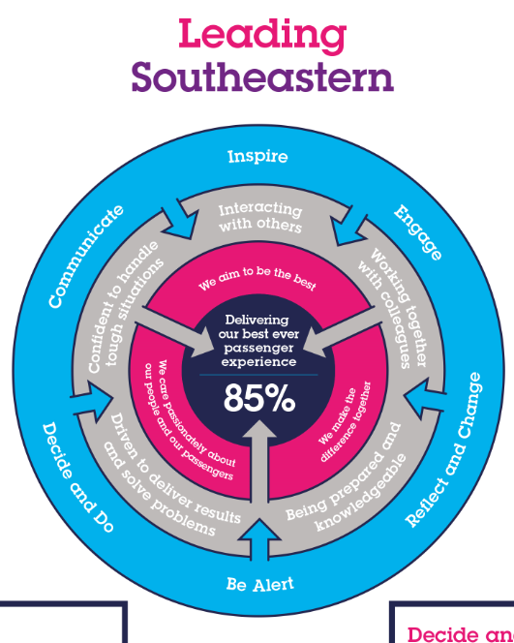

All shortlisted candidates seeking promotion will be assessed against this framework.

The job demands the following blend of experience/knowledge, skills and behaviours (all are essential , unless otherwise shown and will be assessed by application and/ or interview/assessment) :

G1 | Experience, Knowledge & Qualifications  Proven success in meeting workforce productivity targets.  Proven track record of line management experience in a transport environment.  Strong interpersonal skills and experienced negotiator.  Innovative and creative, highly motivated.  Knowledge and understanding of relevant parts of Ticketing and Settlement.
G2 | Skills (including any specific safety critical competencies)  Persuasiveness – Presents the key points of an argument persuasively. Negotiates and convinces others, changes people’s views and influences decisions.  Communication - Expresses oneself confidently and effectively. Is friendly and engages others in open, honest and productive conversations.  Commercial Awareness - Understands and applies commercial and financial principles. Views issues in terms of costs, profits, markets and added value.  Leadership – Motivates and empowers others in order to reach organisational goals.  Innovative, creative and highly motivated.  Knowledge of relevant HR procedures
G3 | Behaviours  Taking personal responsibility for our actions – Is transparent and honest taking full responsibility for actions. Demonstrates confidence and courage, dealing effectively with difficult situations  Problem Solving – Identifies potential difficulties and causes, generating workable solutions and making rational judgements.  Flexibility – Successfully adapts to changing demands and conditions.
G4 | Other  Deputise for the Area Manager as required.  Undertake On-Call duties as required.  Working shifts or weekends where required

I | Dimensions of role
I1 | Financial – Direct:
I2 | Financial – Other:
I3 | Staff Responsibilities – Direct: |  |  |  | Line manage station teams
I4 | Staff Responsibilities – Other:
I5 | Any Other Statistical Data:
J | Acknowledgement
J1 | Prepared By: |  |  |  |  |  | Date:
J2 | Approved By ( Department): |  |  |  |  |  | Date:
K | Job Description Briefing
 | The post holder has been briefed on and understands the requirements of this Job Description and other related documents:
 | Name of post holder: |  |  | Signature: |  |  |  |  | Date:
 | Name of briefing manager: |  |  | Signature: |  |  |  |  | Date:
L | Nominated Deputy for Safety requirements
 | If this is a KEY SAFETY POST (D2 in Safety Details above is YES) at least one nominated deputy must be identified. The Job Holder must ensure that the Nominated Deputy(ies) receives a copy of, and is briefed on this Job Description. If there are more nominated deputies, they should sign further copies of this Job Description.
 | The nominated deputy has been briefed on and understands the requirements of this Job Description and other related documents:
 | Name of nominated deputy: |  |  | Signature: |  |  |  |  | Date:
 | Name of briefing manager: |  |  | Signature: |  |  |  |  | Date:

