A | Post Details
 | Job Title: | Graduate Project Manager | Function: | HR
 | Location: | 4 More London | Unique Post Number:
 | Reports To: | Organisational Development Partner | Grade: | ASG
B | Purpose of the Job
 | The Project Management Graduate Scheme is a two year programme that is designed to give participants the skills and experience needed to become a successful project manager. Participants will work on real life projects across Southeastern, covering a broad range of topics, in order to develop technical knowledge and hands on practical experience of working on projects. Time will also be spent across the wider Southeastern business, gaining broad knowledge and understanding of how a train operating company works. The two year scheme will be based around four different six month placements.
C | Principal Accountabilities  Accountabilities will vary depending on the placement, but will include:
C1  C2  C3  C4  C5  C6  C7  C8  C9  C10 | Managing and coordinating small projects, or key workstreams within larger projects  Owning and upkeeping key project documentation, such as risk registers and scope documents  Building relationships with key stakeholders across the business  Assisting with managing and tracking project budgets  Helping to run project team meetings, taking notes and actions  Helping to draft and maintain project schedules and milestones  Producing project reports and dashboards  Managing external suppliers to ensure tasks are completed on time  Spending time on location at depots, offices and sites, to work with project team members and track progress  Spending time with colleagues right across the business – from the front line to the boardroom – to better understand the different areas of the organisation
D | Safety Responsibilities
D1 | This post is required to undertake SAFETY CRITICAL WORK |  |  |  | Yes |  | No
D2 | This is a KEY SAFETY POST |  |  |  | Yes |  | No
D3 | This post requires SECURITY CLEARANCE |  |  |  | Yes |  | No
D4 | The job requires competence in PERSONAL TRACK SAFETY |  |  |  | Yes |  | No
D5 | This job has SPECIFIC SAFETY RESPONSIBILITIES (if Yes see section D6 below) |  |  |  | Yes |  | No
D6 | The post holder has the following specific safety responsibilities:
E | Decision-making Authority
E1 | None
F | Most Challenging and/or Difficult parts of the role
F1  F2  F3 | Working across multiple different activities in parallel, ensuring items are coordinated and communicated effectively.  Understanding the impacts operationally, commercially and technically that project activities might have on the wider business.  Building good rapport and relationships with stakeholders; being able to influence and communicate with others who deliver things for your project but who you don’t manage directly.

G | Person Specification

Southeastern aims to recruit people not just for jobs but for long term careers. We want good quality, talented people with the right attitude who will stay with us.

For these reasons we look for evidence of Southeastern values and behaviours in all potential staff and our existing staff looking for promotion along with the particular experience/knowledge, skills and behaviours relevant to the position applied for. These are

We care passionately about our people and passengers
  - we put ourselves in our passengers’ shoes to do what’s right for them
  - we support our colleagues to be, feel and do their best
  - we love the places we serve and do our bit for our communities and environment

We aim to be the best
  - we move with pace, we’re agile and learn from everything
  - we relentlessly strive to be the best
  - we are professionals with personalities

We make the difference together
  - we are answerable to each other and our passengers
  - we trust each other and do what we say we will
  - we are stronger together than we are as individuals

We also have identified behaviours required to be successful in leading Southeastern.

The Leading Southeastern framework details how we should be behaving in order to drive up performance to deliver 85%.

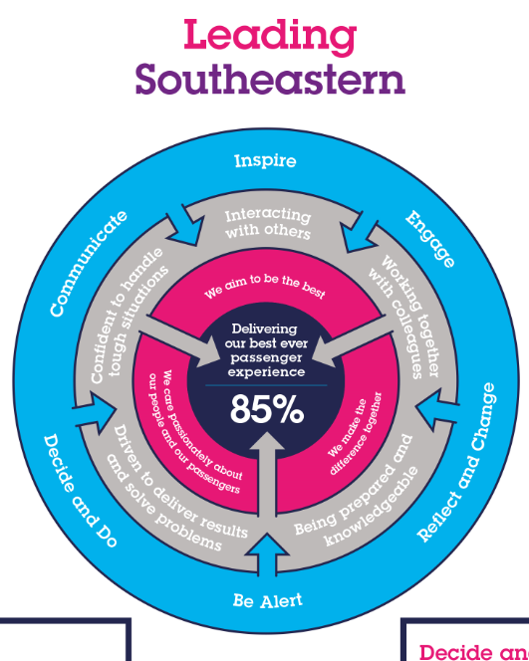

All shortlisted candidates seeking promotion will be assessed against this framework.

G1  G2  G3 | Experience, Knowledge & Qualifications  A bachelor’s degree from a UK university or equivalent; in any discipline, of at least 2:2 grade  A passion for enhancing people’s lives through public transport and putting the customer at the heart of everything we do  Skills (including any specific safety critical competencies)  An ability to lead others, as well as work as part of a team  Excellent communication and presentation abilities  Good oral and written communication skills  Good planning and organisational skills, with an eye for detail  Being proactive  Critical thinking in order to solve problems and make decisions  Behaviours  Willingness to learn and perform in a fast-changing environment  Ability to work efficiently, effectively and collaboratively as part of a team, contributing to a culture of continuous business improvement
G4 | Other
H | Dimensions of role
H1 | Financial – Direct: |  | 0
H2 | Financial – Other: |  | 0
H3 | Staff Responsibilities – Direct: |  | 0
H4 | Staff Responsibilities – Other: |  | 0
H5 | Any Other Statistical Data:
I | Acknowledgement
I1 | Prepared By: | Emily Florio |  | Date: | 10/05/2023
I2 | Approved By (Head of Department): | Sophie Barker |  | Date: | 25/05/2023

K | Job Description Briefing
 | The post holder has been briefed on and understands the requirements of this Job Description and other related documents:
 | Name of post holder: |  | Signature: |  | Date:
 | Name of briefing manager: |  | Signature: |  | Date:
L | Nominated Deputy for Safety requirements
 | If this is a KEY SAFETY POST (D2 in Safety Details above is YES) at least one nominated deputy must be identified. The Job Holder must ensure that the Nominated Deputy(ies) receives a copy of, and is briefed on this Job Description. If there are more nominated deputies, they should sign further copies of this Job Description.
 | The nominated deputy has been briefed on and understands the requirements of this Job Description and other related documents:
 | Name of nominated deputy: |  | Signature: |  | Date:
 | Name of briefing manager: |  | Signature: |  | Date:

