A | Post Details
 | Job Title: Procurement Manager -Infrastructure |  | Function: Finance & Contracts
 | Location: London Bridge and/or Remote |  | Unique Post Number: TBC
 | Reports To: Deputy Head of Procurement / Direct Procurement Lead |  | Grade: TBC
B | Purpose of the Job  This role is an important component of the Southeastern Procurement team. The team are responsible for all purchasing requirements for the organisation and support a wide range of functions from purchase order creation, supplier management, tendering, contract and commercial support and delivering value through savings, improved contracts and supply chain efficiencies.
The purpose of this role is to provide support to deliver UCR compliant procurement activities within the direct category of Infrastructure (Civils, buildings, maintenance and construction) across the entire business, plus ad hoc support for Engineering. This will include utilising bespoke and standard form contracts (e.g. NEC/JCT) to deliver high quality tenders, stakeholder contract and commercial support, supplier management and delivering value through savings, improved contracts and supply chain efficiencies.

The role incorporates managing 1-2 Assistant Procurement Managers, as well as any planned or ad hoc cover. In addition, there may be some ad hoc responsibilities in deputising for the Direct Procurement Lead.

C | Principal Accountabilities
C1  C2  C3  C4  C5  C6  C7  C8  C9  C10  C11  C12  C13 | Responsible for entire tender process with the Infrastructure category for new requirements, negotiating extensions or renegotiations whilst complying with UCR16.  Proposing appropriate terms and conditions and drafting amendment to Southeastern or standard form terms and conditions for purchasing/procurement requirements.  To work with contract managers to develop procurement strategies and 12-24 month project pipelines across the Infrastructure category and determine technical specifications.  Working with internal stakeholders to ensure goods & services are appropriately specified and KPIs are developed for contracts.  To regularly update the Procurement Information Manager with project progress, contract status and submitting signed documentation/contracts for archiving.  Managing the Assistant Procurement Manager/s performance and delivery to agreed timescales.  Effectively communicating and engaging stakeholders throughout the procurement process.  Advising and assisting internal stakeholders on the procurement procedures, processes, business cases and governance.  Undertaking market research and developing new or existing suppliers to better meet the operational needs of the business in the Infrastructure area, including promotion of sustainable organisations and small/medium sizes enterprises.  Liaising with Finance Business Partners to ascertain project budgets and authorisations for new contracts.  Ad hoc support of associated business/industry initiatives such as cross-organisation tendering, contract negotiations or supply chain management.  Assisting the Procurement team in developing and delivering necessary Forums to share knowledge, information or best practice with the organisation – specifically across the Infastructure category.  Ensuring that all contracts which involve supplier’s working on Southeastern sites have appropriate contractual health and safety documentation.
D | Safety Responsibilities
D1 | This post is required to undertake SAFETY CRITICAL WORK |  |  | Yes |  | No | x
D2 | This is a KEY SAFETY POST or nominated deputy |  |  | Yes |  | No | x
D3 | The holder of this post is identified as a KEY SAFETY MANAGER |  |  | Yes |  | No | x
D4 | The job requires competence in PERSONAL TRACK SAFETY |  |  | Yes |  | No | x
D5 | This job has SPECIFIC SAFETY RESPONSIBILITIES (if Yes see section D6 below) |  |  | Yes |  | No | x
D6 | The post holder has no specific safety responsibilities.
E | Decision making Authority
E1  E2 | Recommendation of Southeastern procurement strategies and contract awards to the Direct Lead/Head of Procurement, Department Director and Finance & Contracts Director for final approval.  Negotiating with suppliers on behalf of Southeastern up to unlimited values.
F | Most Challenging and/or Difficult parts of the role
F1  F2  F3 | Ensuring the local procurement culture and processes are applied throughout Southeastern.  Ensuring UCR adherence throughout supplier negotiations, tenders and transactions  Simultaneously managing multiple stakeholders and direct reports to align objectives

G | Person Specification

Southeastern aims to recruit people not just for jobs but for long term careers. We want good quality, talented people with the right attitude who will stay with us.

For these reasons we look for evidence of Southeastern values and behaviours in all potential staff and our existing staff looking for promotion along with the particular experience/knowledge, skills and behaviours relevant to the position applied for. These are

We care passionately about our people and passengers
  - we put ourselves in our passengers’ shoes to do what’s right for them
  - we support our colleagues to be, feel and do their best
  - we love the places we serve and do our bit for our communities and environment

We aim to be the best
  - we move with pace, we’re agile and learn from everything
  - we relentlessly strive to be the best
  - we are professionals with personalities

We make the difference together
  - we are answerable to each other and our passengers
  - we trust each other and do what we say we will
  - we are stronger together than we are as individuals

We also require more than competent performance against our Leadership & Management Competency Framework.
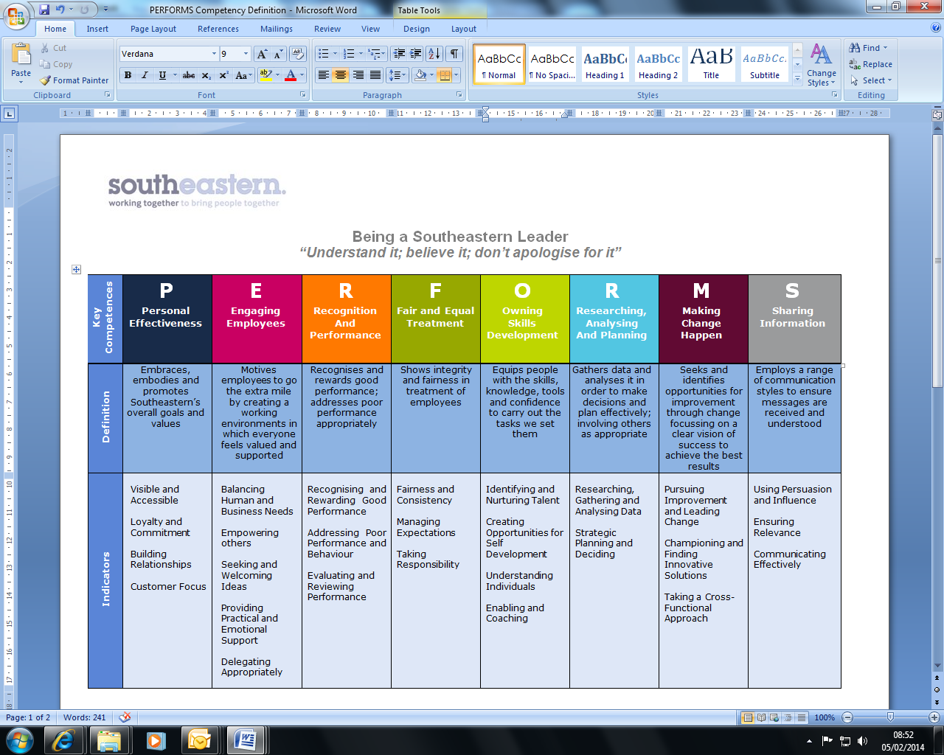
All shortlisted candidates seeking promotion will be assessed against this framework.

The job demands the following blend of experience/knowledge, skills and behaviours (all are essential, unless otherwise shown and will be assessed by application and/ or interview/assessment).

G1 | Experience, Knowledge & Qualifications (including any specific safety training requirements)  Qualified member of the Chartered Institute of Purchasing and Supply (MCIPS) – or equivalent transferrable degree or professional qualification.  A minimum of four years of working in an accountable role in either a procurement, commercial or contract management environment.  Working knowledge of contract law, government legislation and OJEU regulations.  Comprehensive understanding and experience of procure to pay (P2P) systems and processes  Some experience of contract management (i.e. post contract)  Good understanding of contractual documentation and governance requirements  Good understand of e-tendering systems/tools  Good stakeholder management skills and experience  Proficient experience of supply chain planning and producing associated reports.  E-tendering tools experience and knowledge.
G2 | Skills (including any specific safety critical competencies)  Ability to work effectively at management level within Southeastern, liaising with senior managers and across supplier directors.  Ability to express oneself confidently, honestly and effectively.  Proven influencing and problem-solving skills.  Commercial awareness.  Good IT skills including use of Microsoft suite (Excel, Word & Powerpoint)  Well developed report writing skills
G3 | Behaviours  Professionalism  Honesty and Integrity – is transparent and honest and takes full responsibility for actions. Confidence and courage to challenge the business and deal effectively with difficult situations.  Teamwork, Sharing and Supportive – aligns with others both within and outside Southeastern to deliver common goals. Shares ideas and information. Supports colleagues and works effectively with others.  Flexibility – successfully adapts to changing demands, conditions and scenarios.

H | Dimensions of role
H1 | Financial – Direct: n/a
H2 | Financial – Other: n/a
H3 | Staff Responsibilities – Direct: up to 2
H4 | Staff Responsibilities – Other: none
H5 | Any Other Statistical Data: Procurement KPIs
I | Acknowledgement
I1 | Prepared By (Head of Department): | _______________ |  | Date: | ______________

J | Job Description Briefing
 | The post holder has been briefed on and understands the requirements of this Job Description and other related documents:
 | Name of post holder: |  | Signature: |  | Date:
 | Name of briefing manager: |  | Signature: |  | Date:
K | Nominated Deputy for Safety requirements
 | If this is a KEY SAFETY POST (D2 in Safety Details above is YES) at least one nominated deputy must be identified. The Job Holder must ensure that the Nominated Deputy(ies) receives a copy of, and is briefed on this Job Description. If there are more nominated deputies, they should sign further copies of this Job Description.
 | The nominated deputy has been briefed on and understands the requirements of this Job Description and other related documents:
 | Name of nominated deputy: |  | Signature: |  | Date:
 | Name of briefing manager: |  | Signature: |  | Date:

