A | Post Details
 | Job Title: Assistant Procurement Manager |  | Function: Finance & Contracts
 | Location: London Bridge/Hybrid |  | Unique Post Number: n/a
 | Reports To: Procurement Manager |  | Grade: MG1
B | Purpose of the Job  This role is an important component of the Southeastern Procurement team. The team are responsible for all purchasing requirements for the organisation and support a wide range of functions from purchase order creation, supplier management, tendering, contract and commercial support and delivering value through savings, improved contracts and supply chain efficiencies.  The purpose of this role is to support the Procurement Manager/s and wider team across all direct categories, including Infrastructure, Operations and Engineering, delivering framework mini-competitions across all directorates, RFPs, RFQs and tenders under UCR16 thresholds, while meeting important milestones, ensuring quality and maintaining spend within defined budgets. An important element of these activities will be ensuring that sustainable contracts are delivered with a view for on-going management and smooth transition into operations.  The role will also be responsible for managing the Minor & Intermediate Works, Rail Services and Professional Services Frameworks and collating supplier feedback and calculating annual rebate values..  Where required, the role may require supporting the administration team for any emergency cover. In addition, there may be some ad hoc responsibilities in deputising for the Procurement Manager/s.
C | Principal Accountabilities
C1  C2  C3  C4  C5  C6  C7  C8  C9  C10  C11 | Responsible for the pre-contract process for delegated requirements under UCR16 thresholds and the occasional requirements above the UCR16 thresholds under the supervision of the Procurement Manager, always ensuring compliance with Southeastern’s governance requirements.  Delivering effective framework mini-competitions, RFPs and RFQs in order to meet business/project requirements, ensuring compliance with Southeastern’s governance requirements.  Managing the Minor & Intermediate Works, Rail Services and Professional Services Frameworks, including maintenance of an up to date briefing pack, stakeholder communications regular supplier liaison, providing feedback and monitoring accrued rebates.  Ensuring project risks related to safety, information security and GDPR are escalated to the Procurement Manager - Infrastructure for appropriate resolution.  To work with contract managers and the Procurement Manager/s in developing and supporting the delivery of agreed procurement strategies.  Working with internal stakeholders to ensure goods & services are appropriately specified and KPIs are developed for call-offs and contracts.  To regularly report and effectively communicate to the Procurement team and wider stakeholders.  Supporting the Procurement Manager/s and wider team in assisting stakeholders on procurement procedures, processes and governance in achieving project objectives.  Undertaking market engagement, research and developing new or existing suppliers to meet the operational needs of the business.  Regularly liaising with Finance Business Partners to ascertain project budgets and authorisations for new contracts.  Ensuring that all contracts which involve supplier’s working on Southeastern sites have appropriate contractual health and safety documentation.
D | Safety Responsibilities
D1 | This post is required to undertake SAFETY CRITICAL WORK |  |  | Yes |  | No | x
D2 | This is a KEY SAFETY POST or nominated deputy |  |  | Yes |  | No | x
D3 | The holder of this post is identified as a KEY SAFETY MANAGER |  |  | Yes |  | No | x
D4 | The job requires competence in PERSONAL TRACK SAFETY |  |  | Yes |  | No | x
D5 | This job has SPECIFIC SAFETY RESPONSIBILITIES (if Yes see section D6 below) |  |  | Yes |  | No | x
D6 | The post holder has no specific safety responsibilities.
E | Decision making Authority
E1  E2 | Drafting Southeastern procurement strategies and contract awards to the Direct Lead/Head of Procurement, relevant Operational Director and Finance & Contracts Director for final approval.  Negotiating with suppliers and drafting contracts on behalf of Southeastern.
F | Most Challenging and/or Difficult parts of the role
F1  F2  F3 | Ensuring the local procurement culture, governance and processes are applied throughout all projects  Managing a range projects and requirements while meeting milestones and objectives  Managing multiple stakeholders to align objectives

G | Person Specification

Southeastern look for values and behaviours in all potential staff and our existing staff looking for promotion along with the particular experience/knowledge, skills and behaviours relevant to the position applied for. These are:

We care passionately about our people and passengers
  - we put ourselves in our passengers’ shoes to do what’s right for them
  - we support our colleagues to be, feel and do their best
  - we love the places we serve and do our bit for our communities and environment

We aim to be the best
  - we move with pace, we’re agile and learn from everything
  - we relentlessly strive to be the best
  - we are professionals with personalities

We make the difference together
  - we are answerable to each other and our passengers
  - we trust each other and do what we say we will
  - we are stronger together than we are as individuals

We also require more than competent performance against our Leadership & Management Competency Framework.
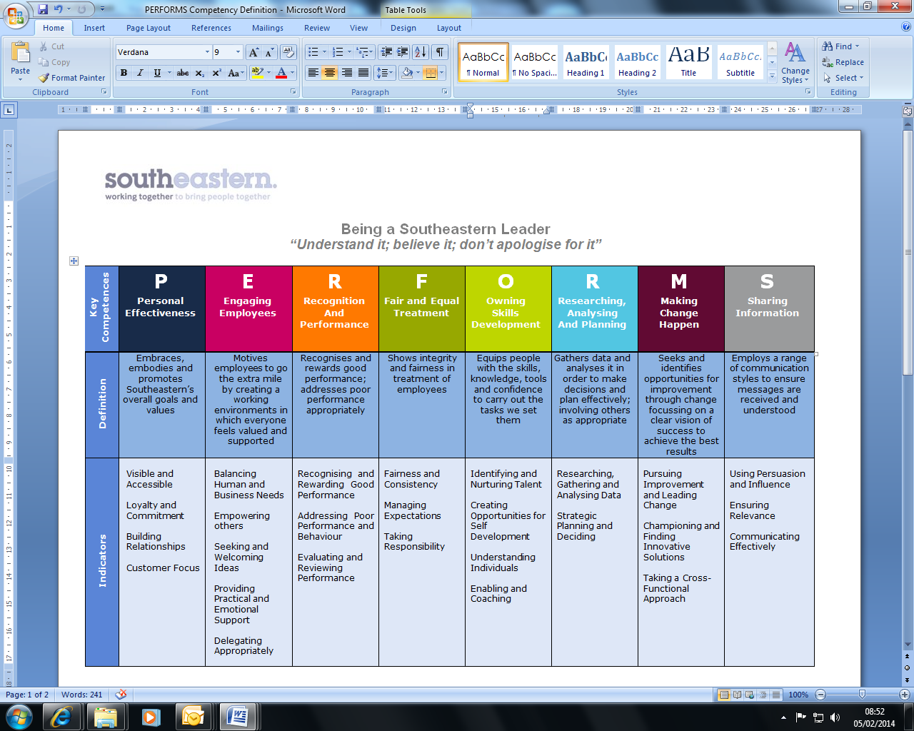
All shortlisted candidates seeking promotion will be assessed against this framework.

The job demands the following blend of experience/knowledge, skills and behaviours (all are essential, unless otherwise shown and will be assessed by application and/ or interview/assessment).

G1 | Experience, Knowledge & Qualifications (including any specific safety training requirements)  - Member of the Chartered Institute of Purchasing and Supply (MCIPS) – or equivalent transferrable degree or professional qualification  - A minimum of two (2) years of working in a direct procurement, commercial or contract management environment.  - Good understanding and experience of procure to pay (P2P) systems and processes  - Good understanding of contractual documentation and governance requirements  - Good understand of e-tendering systems/tools  - Good stakeholder management skills and experience  - Proficient in producing reports.  - Good experience of market engagement
G2 | Skills (including any specific safety critical competencies)  - Ability to work closely and collaboratively with other team members.  - Ability to work effectively with various stakeholders within Southeastern and liaising with senior managers.  - Ability to express oneself confidently, honestly and effectively.  - Developing influencing and problem-solving skills.  - Commercial awareness of the industry and markets.  - Good IT skills including use of Microsoft suite (Excel, Word & Powerpoint)  - Developing report writing skills
G3 | Behaviours  - Professionalism  - Honesty and Integrity – is transparent and honest and takes full responsibility for actions. Confidence and courage to challenge the business and deal effectively with difficult situations.  - Teamwork, Sharing and Supportive – aligns with others both within and outside Southeastern to deliver common goals. Shares ideas and information. Supports colleagues and works effectively with others.  - Flexibility – successfully adapts to changing demands, conditions and scenarios.

H | Dimensions of role
H1 | Financial – Direct: n/a
H2 | Financial – Other: n/a
H3 | Staff Responsibilities – Direct: None
H4 | Staff Responsibilities – Other: None
H5 | Any Other Statistical Data: None
I | Acknowledgement
I1 | Prepared By (Head of Department): | _______________ |  | Date: | ______________

J | Job Description Briefing
 | The post holder has been briefed on and understands the requirements of this Job Description and other related documents:
 | Name of post holder: |  | Signature: |  | Date:
 | Name of briefing manager: |  | Signature: |  | Date:
K | Nominated Deputy for Safety requirements
 | If this is a KEY SAFETY POST (D2 in Safety Details above is YES) at least one nominated deputy must be identified. The Job Holder must ensure that the Nominated Deputy(ies) receives a copy of, and is briefed on this Job Description. If there are more nominated deputies, they should sign further copies of this Job Description.
 | The nominated deputy has been briefed on and understands the requirements of this Job Description and other related documents:
 | Name of nominated deputy: |  | Signature: |  | Date:
 | Name of briefing manager: |  | Signature: |  | Date:

