A | Post Details
 | Job Title: | Fleet Engineer | Function: | Engineering
 | Location: | Slade Green Depot | Unique Post Number:
 | Reports To: | Metro/Mainline Fleet Manager | Grade: | MG1
B | Purpose of the Job
The Fleet Engineer leads the development and implementation of reliability growth initiatives, business led development engineering and customer driven modifications across all Southeastern rolling stock.

Each Fleet Engineer will develop and utilise systematic and structured processes to address reliability, availability, maintainability and safety issues. Fleet Engineers will develop cost effective technical solutions as well as process improvements to solve problems and improve the performance of Southeastern Rolling Stock and the wider business. Fleet Engineers will lead on component or system modifications, improvements in specifications, maintenance plan improvements, whilst also recommending maintenance or operational process improvements where applicable.

The Fleet Engineer will ensure adequate communication across Southeastern Engineering and Operations departments, recognising that a large part of reliability growth can be derived from continued improvements to communication and management process. The Fleet Engineer will support reliability growth through development of initiatives with train leasing companies and external suppliers.

Critical to the Fleet Engineer role is the ability to provide an effective technical support service, through effective problem solving, reliability growth initiatives and safety improvement initiatives.

C | Principal Accountabilities
C1  C2  C3  C4  C5  C6  C7  C8  C9  C10  C11  C12  C13 | Provide technical leadership and develop and enhance technical system knowledge across all rolling stock. In particular being conversant with performance issues, emerging technical trends, reliability problems and safety risks. Provide other engineers and stakeholders with support in developing their understanding of train systems.  Communicate reliability issues within the depot environment and actively engage in reliability meetings to ensure all stakeholders are aware of current issues and trends.  Responsible for the identification, development and implementation of reliability growth initiatives utilising reliability growth techniques such as RCM, FMECA, RAMS or MSG3 where applicable.  Develop and implement reliability initiatives depending on emerging trends and customer or business driven needs. Initiatives must identify resource needs (labour, material, specification, Business Case) and be developed in conjunction with the Planning and Materials teams. Initiatives must be planned, prioritised and delivered to agreed timescales based upon business-driven needs.  Lead technical investigations and provide technical reports with root cause analysis and structured recommendations. Where required, act as a liaison with RoSCos and train and supplier OEMs for specific technical matters.  Provide support to Engineering Production, Materials and Planning teams to review scope for maintenance and defect priority extensions using the Concession process.  Develop Engineering Specifications that can be used for the development of modifications and improvements to Rolling Stock.  Continually review best practice to suggest and implement improvements to maintenance processes including maintenance optimisation activities.  Produce and develop all Engineering Change documentation where required to ensure a complete and robust process is followed. Support colleagues within the Engineering directorate with the Engineering Change process and the implementation of modifications.  Accountable for ensuring systems across all fleets remain compliant with Engineering Acceptance Certification, Network Rail Route Certification as well as providing guidance to Production to maintain component modification or configuration control.  Responsible for, and aware of, the need for continued application of the Engineering Quality Management System (QMS). This includes developing or improving engineering quality procedures, or engineering technical procedures, as required to maintain compliance with QMS.  The Fleet Engineer is required to provide an on-call Fleet Technical Officer (FTO) incident response service. Where necessary, this may require attendance at-site for incident investigations or representation of Southeastern interests. The post holder will carry out formal investigations and report on incidents and findings, together with recommendations.  Deputise for the Metro/Mainline/High Speed Fleet Manager if/when required.

D | Safety Responsibilities
D1 | This post is required to undertake SAFETY CRITICAL WORK | Yes |  | No
D2 | This is a KEY SAFETY POST or nominated deputy | Yes |  | No
D3 | The holder of this post is identified as a KEY SAFETY MANAGER | Yes |  | No
D4 | The job requires competence in PERSONAL TRACK SAFETY | Yes |  | No
D5 | This job has SPECIFIC SAFETY RESPONSIBILITIES (if Yes see section D6 below) | Yes |  | No
D6 | The post holder has the following specific safety responsibilities:
 | Investigation of incidents occurring at Southeastern locations or on Southeastern rolling stock.
E | Decision making Authority
E1  E2 | The Fleet Engineer will be the key point of contact for the RoSCo where technical liaison is required for a project they are the nominated as the technical lead.  The Fleet Engineer will be required to attend and represent Southeastern at meetings regarding issues where they are the nominated technical lead.
F | Most Challenging and/or Difficult parts of the role
F1  F2  F3  F4  F5 | Identifying and reacting to system issues affecting safety or performance at the earliest possible opportunity, providing immediate and longer-term mitigations to provide closure.  Progressing reliability growth and development engineering initiatives in line with the targets set and maintaining regular progress reporting to stakeholders.  The post holder will have a good understanding of all the applicable standards (from the point of view of maintaining compliance).  The post holder is responsible for advising and investigating NIR system related issues and managing these safety issues through to conclusion.  The post holder will be the point of contact with the defect controller as the Fleet Technical Officer, on-call in a rota for in service safety failures.

G | Person Specification

Southeastern aims to recruit people not just for jobs but for long term careers. We want good quality, talented people with the right attitude who will stay with us.

For these reasons we look for evidence of Southeastern values and behaviours in all potential staff and our existing staff looking for promotion along with the particular experience/knowledge, skills and behaviours relevant to the position applied for. These are

We care passionately about our people and passengers
  - we put ourselves in our passengers’ shoes to do what’s right for them
  - we support our colleagues to be, feel and do their best
  - we love the places we serve and do our bit for our communities and environment

We aim to be the best
  - we move with pace, we’re agile and learn from everything
  - we relentlessly strive to be the best
  - we are professionals with personalities

We make the difference together
  - we are answerable to each other and our passengers
  - we trust each other and do what we say we will
  - we are stronger together than we are as individuals

We also have identified behaviours required to be successful in leading Southeastern.

The Leading Southeastern framework details how we should be behaving in order to drive up performance to deliver the route to 85.

Leading Southeastern

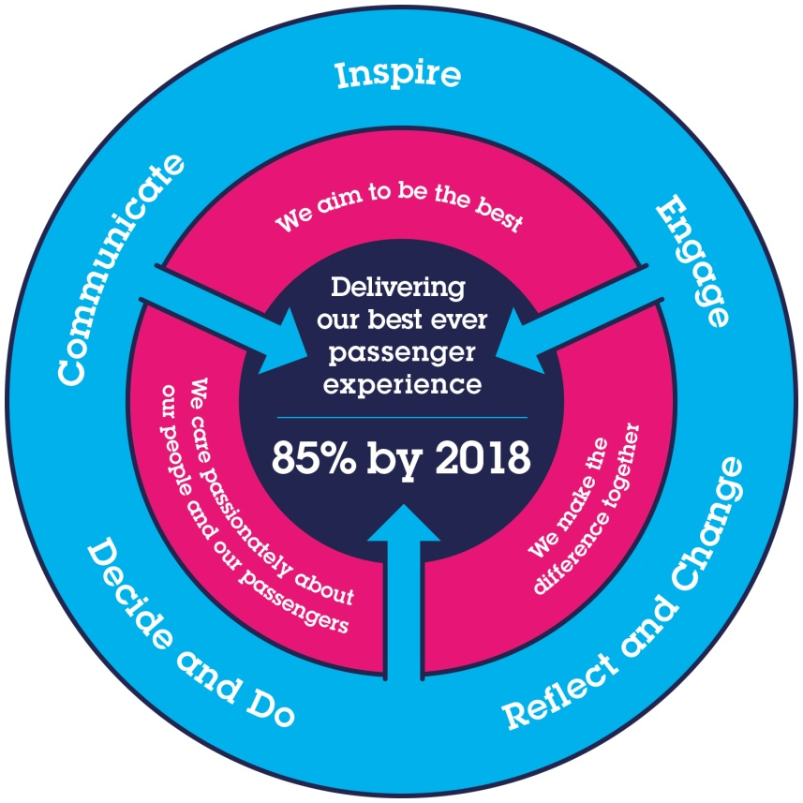
All shortlisted candidates seeking promotion will be assessed against this framework.

The job demands the following blend of experience/knowledge, skills and behaviours (all are essential , unless otherwise shown and will be assessed by application and/ or interview/assessment) :

G1 | Experience, Knowledge & Qualifications (including any specific safety training requirements)  At least 4 years’ experience in a T&RS engineering environment.  Degree or HNC / HND in an Engineering Discipline.  Ideally working toward or holding professional registration.  Knowledge of reliability growth models and techniques together with experience and application in a technical or operational environment. Particular skills in structure problem solving using recognised process such as FMEA, RCM, RAMS or FRACAS.  Technical knowledge of Rolling Stock systems and operation, software and Diagnostic Tools. As well as good knowledge of rolling stock Maintenance Management structure and systems and as well as all associated maintenance documentation.  Experience in project management particularly structured time management and planning, resource identification and utilisation and prioritising. Proven leadership experience, communication and interpersonal skills. Articulate in written and oral communication.  Practical application knowledge of IT systems, including Windows, Word, Excel and MS Project or equivalent.  Good knowledge of Railway Group Standards and ROGS and relevant rail related standards.  The post holder must be able to attain Personal Track Safety Certification.
G2 | Skills (including any specific safety critical competencies).  Must be able to interpret technical standards and applicable legislation.  Must be able to make sound engineering judgments in relation to Rolling Stock defects (acting in accordance with Southeastern documentation).  Strong level of organisation skills & multi-tasking.  Must be a logical thinker with good planning and organising skills to ensure targets are met, trackers are updated and progress is communicated.
G3  G4 | Behaviours  Take ownership and responsibility for issues and work in structured way to deliver to target.  Excellent team working qualities by assisting/supporting others with technical problems and working with others to gain a rich understanding of the problems surrounding an issue.  Able to work well both independently with minimal support and collaboratively in a team.  Other  Will be required to attend and complete formal training as required.  This role encompasses a degree of hybrid working with the expectation that Fleet Engineers are on depot a minimum of 60% of the time.  The post holder will be expected to attend depot when required.
H | Dimensions of role
H1 | Financial – Direct: |  | None
H2 | Financial – Other: |  | None
H3 | Staff Responsibilities – Direct: |  | None
H4 | Staff Responsibilities – Other: |  | None
H5 | Any Other Statistical Data: |  | The post holder is responsible for ensuring and maintaining the compliance of all Southeastern’s Rolling Stock vehicles with all applicable standards and legislation.
I | Acknowledgement
I1 | Prepared By: | _______________ |  | Date: | ______________
I2 | Approved By (Head of Department): | _______________ |  | Date: | ______________

J | Job Description Briefing
 | The post holder has been briefed on and understands the requirements of this Job Description and other related documents:
 | Name of post holder: |  | Signature: |  | Date:
 | Name of briefing manager: |  | Signature: |  | Date:
K | Nominated Deputy for Safety requirements
 | If this is a KEY SAFETY POST (D2 in Safety Details above is YES) at least one nominated deputy must be identified. The Job Holder must ensure that the Nominated Deputy(ies) receives a copy of, and is briefed on, this Job Description. If there are more nominated deputies, they should sign further copies of this Job Description.
 | The nominated deputy has been briefed on and understands the requirements of this Job Description and other related documents:
 | Name of nominated deputy: |  | Signature: |  | Date:
 | Name of briefing manager: |  | Signature: |  | Date:

