A | Post Details
 | Job Title: |  | Resource Manager |  |  |  | Function: |  |  | Train Services
 | Location: |  | Puddle Dock |  |  |  | Unique Post Number:
 | Reports To: |  | Passenger Experience Delivery Manager |  |  |  | Grade: |  |  | MG1
B | Purpose of the Job
 | To manage the day-to-day operational activities of train crew, supporting the delivery of a safe, reliable and Customer Focused train service, achieved through efficient forward planning of resources, close collaboration with the Train service Manager (TSM), proactive monitoring of the train service throughout the day, timely and accurate communication with relevant stakeholders and effective administrative and reporting processes.
C | Principal Accountabilities
C1  C2  C3  C4  C5  C6  C7  C8  C9  C10  C11  C12  C13  C14 | Manage train crew throughout operating periods and execute informed decisions to ensure coverage of all duties.  Initiate and conclude investigations into cancellations and delays in Bugle and ensure the investigation results are communicated to the Performance team, Station team and the Local Operations Managers.  Keeping accurate and reliable records, including the RM log, and ensure the full handover of key information with other RMs as required.  Accountable for booking on all train crew, ensuring that they are fit for duty and that they meet the required standards for work.  Distribute relevant information and notices to train crew as required, via local admin staff or management as required.  Maintain system records for sign on, duty changes and spare & cover usage.  Monitor relevant systems for information regarding the train service and take appropriate proactive actions.  Closely liaise with the TSMs regarding all aspects of the train service but in particular during times of disruption to facilitate a safe and efficient service recovery.  Ensure the station staff, as well as the Train Crews are kept informed of any potential impact on the train service.  Introduce and liaise with disruption staff during times of disruption.  Assist in station team delivery regarding performance, customer and service delivery during disruption.  Assist the Driver Managers as required during investigations.  Update and maintain all tracking registers, to include but not be limited to sickness, attendance, AWOL, poor or non reporting, Safety of the line, rest day working costs etc.  Report all equipment faults to appropriate department and maintain fault log
D | Safety Responsibilities
D1 | This post is required to undertake SAFETY CRITICAL WORK |  |  |  |  |  |  |  |  |  |  | Yes |  |  | No
D2 | This is a KEY SAFETY POST |  |  |  |  |  |  |  |  |  |  | Yes |  |  | No
D3 | This post requires SECURITY CLEARANCE |  |  |  |  |  |  |  |  |  |  | Yes |  |  | No
D4 | The job requires competence in PERSONAL TRACK SAFETY |  |  |  |  |  |  |  |  |  |  | Yes |  |  | No
D5 | This job has SPECIFIC SAFETY RESPONSIBILITIES (if Yes see section D6 below) |  |  |  |  |  |  |  |  |  |  | Yes |  |  | No
D6 | The post holder has the following specific safety responsibilities:
 | - None
E | Decision making Authority
F | Most Challenging and/or Difficult parts of the Job
F1  F2 | Meeting train service requirements within cost constraint  Managing conflicting priorities
G | Person Specification:  Southeastern aims to recruit people not just for jobs but for long term careers. We want good quality, talented people with the right attitude who will stay with us.  For these reasons we look for evidence of Southeastern values and behaviours in all potential staff and our existing staff looking for promotion along with the particular experience/knowledge, skills and behaviours relevant to the position applied for. These are  We care passionately about our people and passengers  - we put ourselves in our passengers’ shoes to do what’s right for them  - we support our colleagues to be, feel and do their best  - we love the places we serve and do our bit for our communities and environment  We aim to be the best  - we move with pace, we’re agile and learn from everything  - we relentlessly strive to be the best  - we are professionals with personalities  We make the difference together  - we are answerable to each other and our passengers  - we trust each other and do what we say we will  - we are stronger together than we are as individuals  We also have identified behaviours required to be successful in leading Southeastern.  The Leading Southeastern framework details how we should be behaving in order to drive up performance to deliver 85.  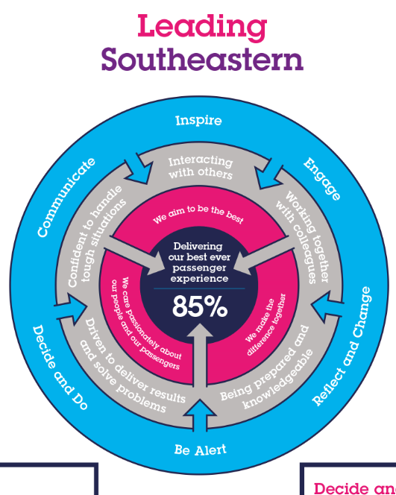  All shortlisted candidates seeking promotion will be assessed against this framework.  The job demands the following blend of experience/knowledge, skills and behaviours (all are essential , unless otherwise shown and will be assessed by application and/ or interview/assessment) :
G1 | Experience, Knowledge & Qualifications – Essential  Ability to conduct investigations and develop meaningful recommendations  Questioning techniques.  Ability to obtain Vocational Qualification in management.  Good level of Computer literacy.  Good knowledge of rostering process.
G2 | Experience, Knowledge & Qualifications – Desirable  Thorough knowledge of conditions of service applicable to train crew.  Vocational Qualification in management.  Good knowledge of relevant IRMA functionality.  Thorough knowledge of relevant Southeastern train service patterns coupled with a good understanding of Network Rail and/or HS1 geography.  Awareness of train driving techniques, rules, instructions and Railway Group and Company standards.  Supervisory or Management Experience.
G3 | Behaviours and Skills – Essential  Excellent attention to detail  Sound decision making skills  Flexible approach to working  Report and letter writing skills  Customer awareness and focus  Planning and organising  Excellent team working  Good communication, negotiation, motivational skills
G4 | Behaviours and Skills – Desirable
H | Dimensions of the Job
H1 | Financial – Direct:
H2 | Financial – Other:
H3 | Staff Responsibilities – Direct:
H4 | Staff Responsibilities – Other:
H5 | Any Other Statistical Data:
I | Acknowledgement
I1 | Prepared By: |  |  | ______________ |  |  |  |  | Date: |  | ______________
I2 | Approved by (Head of Department): |  |  | ______________ |  |  |  |  | Date: |  | ______________
J | Job Description Briefing
 | The post holder has been briefed on and understands the requirements of this Job Description and other related documents:
 | Name of post holder: |  |  |  | Signature: |  |  |  |  |  |  | Date:
 | Name of briefing manager: |  |  |  | Signature: |  |  |  |  |  |  | Date:
K | Nominated Deputy for Safety requirements
 | If this is a KEY SAFETY POST (D2 in Safety Details above is YES) at least one nominated deputy must be identified. The Job Holder must ensure that the Nominated Deputy(ies) receives a copy of, and is briefed on this Job Description. If there are more nominated deputies, they should sign further copies of this Job Description.
 | The nominated deputy has been briefed on and understands the requirements of this Job Description and other related documents:
 | Name of nominated deputy: |  |  |  | Signature: |  |  |  |  |  |  | Date:
 | Name of briefing manager: |  |  |  | Signature: |  |  |  |  |  |  | Date:

