A | Post Details
 | Job Title: | Environment & Carbon Manager | Function: | Safety & Environment
 | Location: | 4 More London | Unique Post Number:
 | Reports To: | Head of Safety & Environment | Grade: | MG2
B | Purpose of the Job
 | To develop environmental policies, strategies and processes that improve environmental performance. To provide assurance to the Executive team that Southeastern is managing environmental risks effectively to avoid contravening legal requirements or creating potential liabilities. Support line managers to improve Southeastern’s environmental performance.
C | Principal Accountabilities
C1  C2  C3  C4  C5  C6  C7  C8  C9  C10  C11  C12  C13  C14 | Develop and implement environmental policies, strategies, objectives, targets and processes.  Ensure that environmental risks are understood, and effective mitigations are in place to reduce incidents and the company’s potential exposure to litigation and reputational damage to as low as reasonably practicable.  Develop and lead initiatives to reduce Southeastern’s environmental impacts. Creating business cases where funding is required.  Develop Southesastern’s approach to climate change adaptation and support reporting to Climate Related Financial Disclosure Regulations 2021.  Support the management and improvement of Environmental Management Systems for Southeastern that enable the company to maintain ISO 14001 and ISO 50001 accreditation on a company-wide basis.  Review our green estate and develop a biodiversity strategy.  Lead the development and implementation of Southeastern’s environmental competence strategy, identifying requirements for all employees from induction onwards and ensuring that appropriate training is developed and implemented.  Monitor existing and proposed legislation, ensuring that impacts on Southeastern are identified, that representations are made where appropriate, that processes are put into place to deliver compliance as required and that suitable measurement and auditing is undertaken to confirm that compliance is satisfactory.  Engage with industry environmental groups, representing Southeastern’s business interests as required and actively seeking good practices which can be implemented by Southeastern.  Work with regulatory bodies to identify and rectify issues in an effective manner, delivering compliance whilst protecting Southeastern’s business interests.  Provide managers and employees throughout the business with expert environmental advice and support.  Monitor and analyse environmental incidents involving Southeastern. Prepare reports and identify remedial action as necessary.  Develop procedures, standards and guidance notes related to environmental management.  Plan, develop and submit internal, external and regulatory reports.
D | Safety Responsibilities
D1 | This post is required to undertake SAFETY CRITICAL WORK |  |  |  | Yes |  | No
D2 | This is a KEY SAFETY POST or nominated deputy |  |  |  | Yes |  | No
D3 | The holder of this post is identified as a KEY SAFETY MANAGER |  |  |  | Yes |  | No
D4 | The job requires competence in PERSONAL TRACK SAFETY |  |  |  | Yes |  | No
D5 | This job has SPECIFIC SAFETY RESPONSIBILITIES (if Yes see section D6 below) |  |  |  | Yes |  | No
D6 | The post holder has the following specific safety responsibilities:
 | - N/A
E | Decision making Authority
E1  E2  E3 | Development of environmental policies, objectives, targets and strategies subject to ratification by SEMG.  Engagement of environmental consultancies and auditors.  Agreement of action plans with line managers and enforcing authorities.
F | Most Challenging and/or Difficult parts of the role
F1  F2 | Required to work through line managers to deliver environmental excellence across the business. This will require both excellent facilitation and inter-personal skills and an acute understanding of business goals.  Delivering environmental excellence and ISO accreditation at a corporate level in a complex customer-focused business with many competing demands for managerial attention.
G | Person Specification

Southeastern aims to recruit people not just for jobs but for long term careers. We want good quality, talented people with the right attitude who will stay with us.

For these reasons we look for evidence of Southeastern values and behaviours in all potential staff and our existing staff looking for promotion along with the particular experience/knowledge, skills and behaviours relevant to the position applied for. These are

We care passionately about our people and passengers
  - we put ourselves in our passengers’ shoes to do what’s right for them
  - we support our colleagues to be, feel and do their best
  - we love the places we serve and do our bit for our communities and environment

We aim to be the best
  - we move with pace, we’re agile and learn from everything
  - we relentlessly strive to be the best
  - we are professionals with personalities

We make the difference together
  - we are answerable to each other and our passengers
  - we trust each other and do what we say we will
  - we are stronger together than we are as individuals

We also have identified behaviours required to be successful in leading Southeastern.

The Leading Southeastern framework details how we should be behaving in order to drive up performance to deliver 85%.

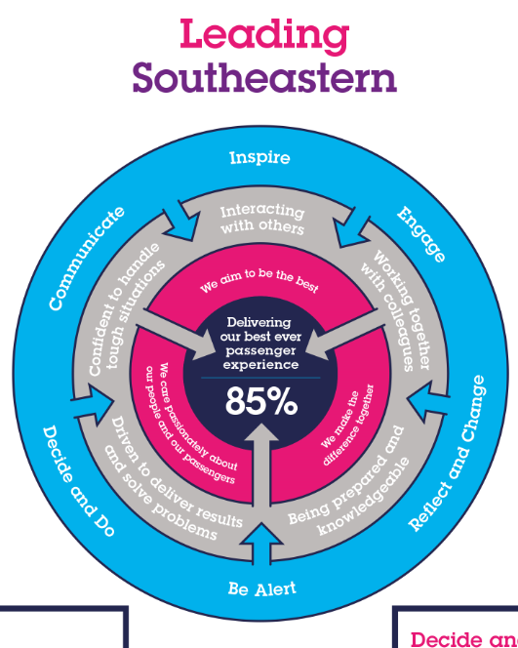

All shortlisted candidates seeking promotion will be assessed against this framework.

The job demands the following blend of experience/knowledge, skills and behaviours (all are essential , unless otherwise shown and will be assessed by application and/ or interview/assessment) :

G1 | Experience, Knowledge & Qualifications (including any specific safety training requirements)  - Educated to degree level or equivalent in environment or directly related subject  - Working towards membership of a relevant industry institute such as IEMA (desirable)  - Good knowledge of UK environmental law  - Good business awareness, including understanding of business cases and the principles of ALARP and/or BATNEEC  - Excellent standard of written and spoken English
G2 | Skills (including any specific safety critical competencies)  - Influencing  - Planning and organising  - Commercial awareness  - Adding value  - Honesty and integrity  - Taking a broader view  - Communication
G3 | Behaviours  Leading by example  Team working  Coaching  Attention to detail and accuracy
G4 | Other

H | Dimensions of role
H1 | Financial – Direct: |  | None
H2 | Financial – Other: |  | Breaches of environmental legislation can expose the company to fines and significant reputational damage. This role is key in reducing the risks of such breaches.  Promoting effective energy and waste management has potential cost reduction benefits.
H3 | Staff Responsibilities – Direct: |  | None
H4 | Staff Responsibilities – Other: |  | Required to influence managers at all levels across the business.
H5 | Any Other Statistical Data: |  | None
I | Acknowledgement
I1 | Prepared By: | _______________ |  | Date: | ______________
I2 | Approved By (Head of Department): | _______________ |  | Date: | ______________

J | Job Description Briefing
 | The post holder has been briefed on and understands the requirements of this Job Description and other related documents:
 | Name of post holder: |  | Signature: |  | Date:
 | Name of briefing manager: |  | Signature: |  | Date:
K | Nominated Deputy for Safety requirements
 | If this is a KEY SAFETY POST (D2 in Safety Details above is YES) at least one nominated deputy must be identified. The Job Holder must ensure that the Nominated Deputy(ies) receives a copy of, and is briefed on this Job Description. If there are more nominated deputies, they should sign further copies of this Job Description.
 | The nominated deputy has been briefed on and understands the requirements of this Job Description and other related documents:
 | Name of nominated deputy: |  | Signature: |  | Date:
 | Name of briefing manager: |  | Signature: |  | Date:

