A | Post Details
 | Job Title: Commercial Lawyer |  | Function: Finance & Legal
 | Location: London Bridge / York / hybrid |  | Unique Post Number:
 | Reports To: Head of Legal |  | Grade: MG2
B | Purpose of the Job  To provide input and support to the Head of Legal on the oversight, management and control of all legal matters that involves SE Trains Limited (“Southeastern”) and London & North Eastern Railway Limited (“LNER”). The role holder will play a critical supporting role in safeguarding the reputation of the business and will provide assistance to ensure that the company strictly follows all relevant legislation. To also provide commercially focused internal legal advice to relevant stakeholders in Southeastern, LNER and across DfT OLR Holdings Limited (“DOHL TOCs” or “DOHL”).  The role will provide integral support to the procurement, marketing, HR, commercial, passenger services, engineering, and finance directorates and will work closely with both the contract managers and operational stakeholders across Southeastern and LNER.  To provide legal advice to stakeholders at various levels of each of the organisation on commercial agreements, intellectual property, data protection, freedom of information, small claims and other compliance matters to protect the company’s commercial interest.
C | Principal Accountabilities
C1  C2  C3  C4  C5  C6  C7  C8  C9  C10  C11  C12  C16  C17  C18  C19  C20  C21  C22  C23 | Drafting and advising on commercial contracts across all areas of the business supported by the procurement team.  Building relationships with stakeholders across Southeastern, LNER and DOHL group (as required).  Proactively support in negotiations and finalising a range of agreements with suppliers on behalf of Southeastern and LNER and relevant business stakeholders across the DOHL group (as required).  Provide legal advice to the business regarding the compliance of proposed GDPR contractual terms with the requirements of GDPR legislation,  Support in reviewing and escalating all County Court (small claims / money claims online) made against Southeastern and LNER and providing assistance as requested.  Proactively collaborate and advise on matters relating to Freedom of Information and other areas of public law such as Public Sector Equality Duty (PSED).  Effectively communicating and engaging with stakeholders throughout Southeastern, LNER and DOHL group (where required) .  Researching and preparing advise on a variety of matters to support the Heads of Legal at Southeastern, LNER and DOHL group (as required), including but not limited to, consumer rights, railway regulations, public sector equality duty, UCR, and competition law.  Advising on the protection of IP and licensing of IP and putting in place the appropriate contractual agreements.  Contributing to, guidance, processes and initiatives (such as training, development, working groups), including training and development to stakeholders across Southeastern, LNER and DOHL group.  Engagement across multiple senior stakeholders, including Director Group / Board when Head of Legal unavailable at Southeastern and LNER.  Support the Head of Legal for all legal matters involving Southeastern and LNER.  Assist in the safeguarding of Southeastern’s and LNER’s reputation in relation to relevant regulatory and legislative requirements.  Provide accurate and timely advice as requested by all the DOHL TOCs Heads of Legal (as required).  Provide professional advice with quality decision making.  To support the Head of Legal at Southeastern and LN ER to ensure the business stays ahead of issues and that it operates with a no surprise culture.  Delivering best practice for Southeastern and LNER.  Conduct all work openly, honestly, with integrity, responsibly and ethically; provide appropriate challenge of others.  Maintain appropriate legal competency and knowledge, including by staying up-to-date with changes to legislation, particularly in relation to laws, rules and regulations that directly affect the business and the rail industry.  Competently analyse complex legal issues and risks and communicate them in a manner that non-legal colleagues can readily understand.
D | Safety Responsibilities
D1 | This post is required to undertake SAFETY CRITICAL WORK |  |  | Yes |  | No | x
D2 | This is a KEY SAFETY POST or nominated deputy |  |  | Yes |  | No | x
D3 | The holder of this post is identified as a KEY SAFETY MANAGER |  |  | Yes |  | No | x
D4 | The job requires competence in PERSONAL TRACK SAFETY |  |  | Yes |  | No | x
D5 | This job has SPECIFIC SAFETY RESPONSIBILITIES (if Yes see section D6 below) |  |  | Yes |  | No | x
D6 | The post holder has no specific safety responsibilities.
E | Decision making Authority
E1 | Providing support to the Head of Legal, at Southeastern, LNER and to DOHL group to ensure effective decision making is achieved by providing expert legal advice. From time to time, support the legal teams at LNER, TPT and Northern and work collaboratively to encourage best practice across the DOHL TOCs
F | Most Challenging and/or Difficult parts of the role
F1 | Managing multiple complex requirements simultaneously.
G | Person Specification

Southeastern aims to recruit people not just for jobs but for long term careers. We want good quality, talented people with the right attitude who will stay with us.

For these reasons we look for evidence of Southeastern values and behaviours in all potential staff and our existing staff looking for promotion along with the particular experience/knowledge, skills and behaviours relevant to the position applied for. These are:

We care passionately about our people and passengers
  - we put ourselves in our passengers’ shoes to do what’s right for them
  - we support our colleagues to be, feel and do their best
  - we love the places we serve and do our bit for our communities and environment

We aim to be the best
  - we move with pace, we’re agile and learn from everything
  - we relentlessly strive to be the best
  - we are professionals with personalities

We make the difference together
  - we are answerable to each other and our passengers
  - we trust each other and do what we say we will
  - we are stronger together than we are as individuals

We also require more than competent performance against our Leadership & Management Competency Framework.
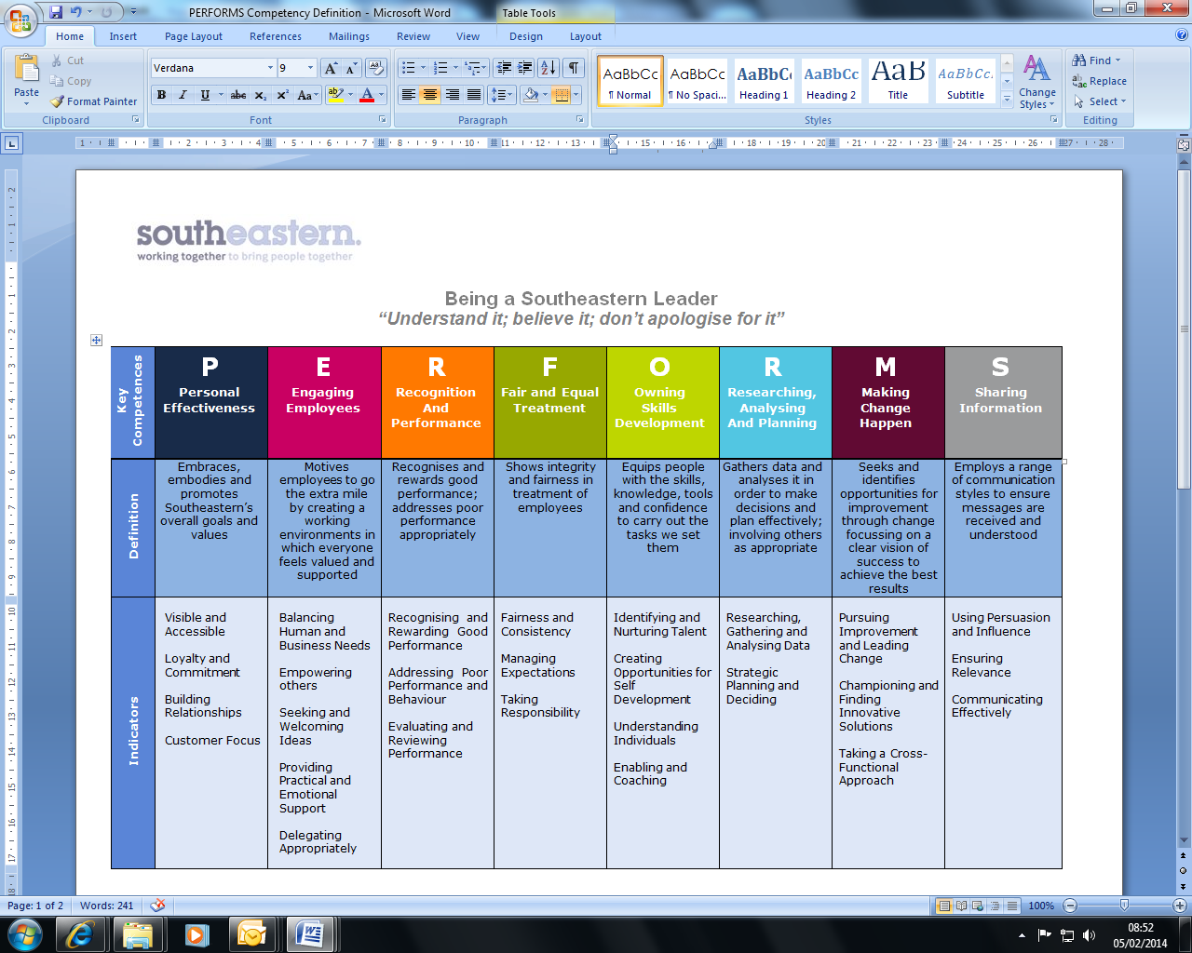
All shortlisted candidates seeking promotion will be assessed against this framework.
The job demands the following blend of experience/knowledge, skills and behaviours (all are essential, unless otherwise shown and will be assessed by application and/ or interview/assessment).

G1 | Experience, Knowledge & Qualifications (including any specific safety training requirements)  - Educated to degree level or higher.  - Solicitor admitted to practice in England & Wales with at least 2-years PQE with a reputable law firm / in house organisation.  - Ability to explain complex legal and risk issues in accessible, plain English terms.  - Ability to produce high quality, accurate and effective contractual drafting with limited support.  - Ability to demonstrate strong legal analytical skills.  - Ability to demonstrate effective persuasion and influencing skills.  - Accurate and methodical.  - The ability to work independently and as part of a team.  - Willingness and ability to learn new areas of law is essential.  - Strong interpersonal skills.  - Clear communicator with excellent verbal and written communication skills  - Ability to effectively adapt communications to the recipient audience  - Ability to express, both in writing and verbally, complex legal concepts and commercial problems in a simplified manner without the loss of important nuance  - A proven track record of working with a wide range of commercial agreements.  - Assisting with enquiries made by both the business and other Heads of Legal or General Counsel.  - Providing legal advice to the business, including but not limited to key support functions such as procurement, HR, IT, marketing, finance, engineering, customer services, facilities on key contracting issues and risks.  - Expert understanding of contracts and commercial law. Ideally some experience in procurement and/or public procurement law.  - Excellent communication (written and oral), negotiation, drafting and organisation skills.  - A strong team player, with a professional and collaborative approach, with the ability to build and maintain strong professional relationships across the businesses and with key external stakeholders (including the Government and Network Rail).  - Ability to research effectively using trusted platforms such as PLC/Lexis Nexis or other trusted sources.  - Excellent attention to detail.  - Ability to manage a varied workload and prioritise competing demands.  - Proactive approach to work and willing to ask for help and support as required.  - Excellent problem solving skills with a proven track record of delivering excellence.  - Ability to build broad knowledge and understanding of all functions across the business, with in-depth commercial awareness.  - Adept at responding promptly and juggling deadlines and actively looks to build relationships based on trust and confidence.  - Ability to work in a highly autonomous role.
G2 | Skills (including any specific safety critical competencies)  - Collaborative with ability to quickly build relationships with a wide range of stakeholders.  - Proven problem-solving skills.  - Excellent IT skills including use of Microsoft suite (Excel, Word & Powerpoint).
G3 | Behaviours  Professionalism  Honesty and Integrity – is transparent and honest and takes full responsibility for actions. Confidence and courage to challenge the business and deal effectively with difficult situations.  Teamwork, Sharing and Supportive – aligns with others both within and outside Southeastern and LNER to deliver common goals. Shares ideas and information. Supports colleagues and works effectively with others.  Flexibility – successfully adapts to changing demands, conditions and scenarios.

H | Dimensions of role
H1 | Financial – Direct: n/a
H2 | Financial – Other: n/a
H3 | Staff Responsibilities – Direct: None
H4 | Staff Responsibilities – Other: None
H5 | Any Other Statistical Data: Project/Income KPIs
I | Acknowledgement
I1 | Prepared By (Head of Department): | _______________ |  | Date: | ______________

J | Job Description Briefing
 | The post holder has been briefed on and understands the requirements of this Job Description and other related documents:
 | Name of post holder: |  | Signature: |  | Date:
 | Name of briefing manager: |  | Signature: |  | Date:
K | Nominated Deputy for Safety requirements
 | If this is a KEY SAFETY POST (D2 in Safety Details above is YES) at least one nominated deputy must be identified. The Job Holder must ensure that the Nominated Deputy(ies) receives a copy of, and is briefed on this Job Description. If there are more nominated deputies, they should sign further copies of this Job Description.
 | The nominated deputy has been briefed on and understands the requirements of this Job Description and other related documents:
 | Name of nominated deputy: |  | Signature: |  | Date:
 | Name of briefing manager: |  | Signature: |  | Date:

