A | Post Details
 | Job Title: | Engineering Systems Data Analyst | Function: | Engineering
 | Location: | Engineering Depots / Remote | Unique Post Number:
 | Reports To: | Engineering Systems Manager | Grade: | MG1
B | Purpose of the Job
The post holder will work under the Engineering Systems Manager to assist in the development, delivery and maintenance of Information Technology tools to Engineering users, wherever they work.

The purpose of the job is to transform data into information, information into insight and insight into business decisions.

Responsibilities include requirements data discovery, data gathering, data systems development, data analysis and reporting capabilities together with continuously performance monitoring and establishing mechanisms to identify improvements, measure business benefits and undertake gap analysis

Working with external and internal data to reveal patterns and relationships to support Southeastern’s business objectives.

C | Principal Accountabilities
C1  C2  C3  C4  C5  C6  C7  C8  C9  C10  C11  C12 | Ability to creatively apply the most appropriate analytical methods to address business questions  Identify, analyse, and interpret trends or patterns in complex data sets  Acquire data from primary or secondary data sources and maintain databases/data systems  Ability to work across the business with a wide range of stakeholders asking the right questions to solve problems and to communicate the data in a timely, relevant and stakeholder-centric manner  Interpret data, analyse results using statistical techniques and provide ongoing performance reports  Ability to understand and be able to take account of the ‘big picture’ (the business, the market and our strategy), including short and long-term goals  Interact with different business functions to ensure that they are provided with the necessary information to enhance the delivery of customer excellence  Responsible for adherence to Engineering Software System Management, Access and Change Control processes, and reporting structure.  Ability to create, enhance and present reports and data in a jargon-free and digestible form using analytical tools (such as Power BI) and creating interactive end-user dashboards for data visualisation  Utilisation of tools and systems to automate the collection, retention, and dissemination of information.  Identify technology needs for the business and work with Engineering Systems Manager to develop viable solutions that deliver benefit for the user and the business.  Assist the Engineering Systems Manager in maintenance and development of Engineering specific IT systems as required.
D | Safety Responsibilities
D1 | This post is required to undertake SAFETY CRITICAL WORK |  |  |  | Yes |  | No
D2 | This is a KEY SAFETY POST |  |  |  | Yes |  | No
D3 | This post requires SECURITY CLEARANCE |  |  |  | Yes |  | No
D4 | The job requires competence in PERSONAL TRACK SAFETY |  |  |  | Yes |  | No
D5 | This job has SPECIFIC SAFETY RESPONSIBILITIES (if Yes see section D6 below) |  |  |  | Yes |  | No
D6 | The post holder has the following specific safety responsibilities:
 | N/A
E | Decision making Authority
E1  E2 | Determine data storage and data management requirements  Design and visualisation of data via effective dashboards within analytical tools such as Power Bi
F | Most Challenging and/or Difficult parts of the role
F1  F2  F3  F4  F5 | High degree of organisational skills and a methodical approach, to apply best practise project management processes  Strong people skills are required – this role has a strong element of interaction with others throughout the organisation  Maintaining perspective to see both the short- and long-term business needs – and to balance this in the day to day workload  Gaining participation from other areas of the business, without having direct influence over the priority or objectives of those people, so as to ensure deliverables are maintained and met.  Identifying the most appropriate project tools and methodologies to effect delivery

G | Person Specification

Southeastern aims to recruit people not just for jobs but for long term careers. We want good quality, talented people with the right attitude who will stay with us.

For these reasons we look for evidence of Southeastern values and behaviours in all potential staff and our existing staff looking for promotion along with the particular experience/knowledge, skills and behaviours relevant to the position applied for. These are

We care passionately about our people and passengers
  - we put ourselves in our passengers’ shoes to do what’s right for them
  - we support our colleagues to be, feel and do their best
  - we love the places we serve and do our bit for our communities and environment

We aim to be the best
  - we move with pace, we’re agile and learn from everything
  - we relentlessly strive to be the best
  - we are professionals with personalities

We make the difference together
  - we are answerable to each other and our passengers
  - we trust each other and do what we say we will
  - we are stronger together than we are as individuals

We also have identified behaviours required to be successful in leading Southeastern.

The Leading Southeastern framework details how we should be behaving in order to drive up performance to deliver 85 by 18.

Leading Southeastern

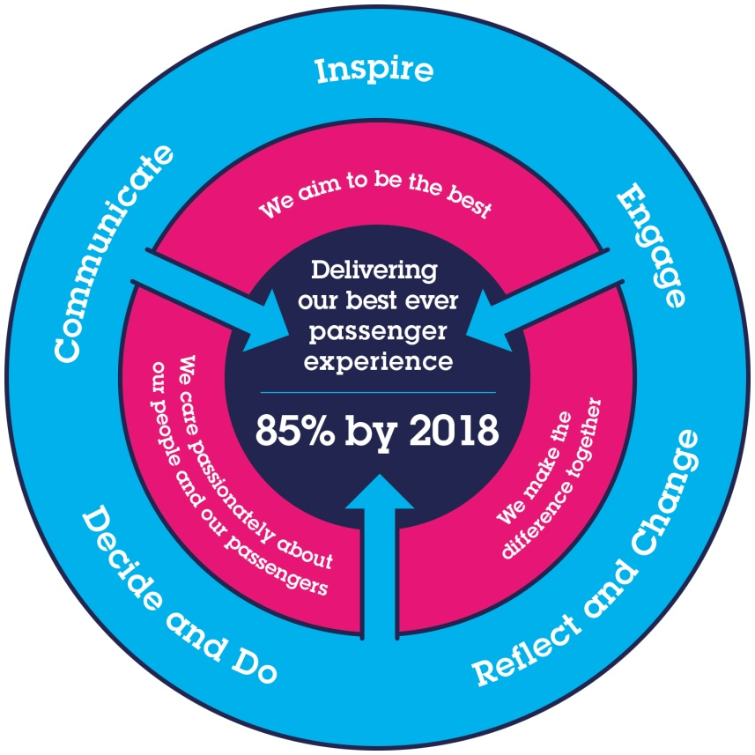
All shortlisted candidates seeking promotion will be assessed against this framework.

The job demands the following blend of experience/knowledge, skills and behaviours (all are essential, unless otherwise shown and will be assessed by application and/ or interview/assessment):

G1 | Experience, Knowledge & Qualifications - Essential  Degree qualified – Sciences or Social Sciences, Mathematics, Economics, Computer Science, Information Management, Statistics  Power user of Excel and analytical tools such as Power BI, proficient in Word, PowerPoint & Outlook  Solid understanding of structured data sources, specifically SQL databases.  Excellent communication skills and the ability to engage with people at all levels of the organisation.  Strong analytical skills with the ability to collect, organise, analyse, and disseminate significant amounts of information with attention to detail and accuracy  Strong desire and willingness to undertake a regime of self-learning (via training courses and in practise) for developing skills in the use of a variety of software (e.g. Power BI, SQL, Azure tools etc)  Experience, Knowledge & Qualifications - Desirable  Proven working experience as a data analyst is desirable, however there is a considerable scope for personal growth and skills development within the role.  Knowledge of statistics and experience undertaking statistical analysis is desired
G2 | Skills  IT literacy would be required to prepare reports and presentation materials suitable for senior manager review.  Analytical skills to understand and articulate the business needs in an objective and compelling manner.  An ability to work successfully to deadlines and timescales.  Coaching and influencing skills  Good communication skills  Good thinking and problem-solving skills.  Forward thinking and organised.
G3 | Behaviours  Energy, enthusiasm, willingness to learn & evolve, a tireless quest for understanding and most importantly a strong desire for continuous improvement & self-development
G4 | Other
H | Dimensions of role
H1 | Financial – Direct:
H2 | Financial – Other:
H3 | Staff Responsibilities – Direct:
H4 | Staff Responsibilities – Other: |  |  |  | No
H5 | Any Other Statistical Data:
I | Acknowledgement
I1 | Prepared By: |  | _Rangel Hristov__ |  |  |  | Date: | _31st January 2022_
I2 | Approved By (Head of Department): |  | _______________ |  |  |  | Date: | ______________
J | Job Description Briefing
 | The post holder has been briefed on and understands the requirements of this Job Description and other related documents:
 | Name of post holder: |  |  | Signature: |  |  |  |  | Date:
 | Name of briefing manager: |  |  | Signature: |  |  |  |  | Date:
K | Nominated Deputy for Safety requirements
 | If this is a KEY SAFETY POST (D2 in Safety Details above is YES) at least one nominated deputy must be identified. The Job Holder must ensure that the Nominated Deputy(ies) receives a copy of and is briefed on this Job Description. If there are more nominated deputies, they should sign further copies of this Job Description.
 | The nominated deputy has been briefed on and understands the requirements of this Job Description and other related documents:
 | Name of nominated deputy: |  |  | Signature: |  |  |  |  | Date:
 | Name of briefing manager: |  |  | Signature: |  |  |  |  | Date:

