A | Post Details
 | Job Title: | Engineering Systems Development Manager | Function: | Engineering Systems
 | Location: | Engineering Depots / Remote | Unique Post Number:
 | Reports To: | Engineering Systems Manager | Grade: | MG2
B | Purpose of the Job
The post holder will work under the Engineering Systems Manager to assist in the development, delivery and maintenance of Information Technology tools to Engineering users, wherever they work.

The purpose of the job to perform Line Management and guidance functions for the Engineering Systems Development team, ensuring that high quality software systems are developed and implemented in line with the agreed specifications.

The role will support the Engineering Systems Manager in ensuring that the right business processes and capabilities exist/are developed within the Engineering Systems Development team, establishing mechanisms and continuously monitoring these to identify improvements, measure business benefits and undertake gap analysis.

Key aspect of the role is to provide an effective interface between the software development team (technical) and the Engineering Systems Support team, converting technical specifications into software development workstreams, coordinating the development team members, allocating resources, and streamlining processes.

C | Principal Accountabilities
C1  C2  C3  C4  C5  C6  C7  C8  C9  C10  C10  C12  C13  C14  C15  C16  C17  C18  C19  C20  C21 | Responsible for the development and line management of the Engineering Systems Development Team. Be the technical and people leader for software developers of various experience levels  Responsible for providing technical leadership, expertise and support the Engineering Systems Development Team, helping to maintain a healthy relationship between the team and stakeholders  Responsible for identifying the skills and resources needed, allocation of tasks within the development team and production of road map documentation for each development project.  Support the Engineering Systems Manager in ensuring the right team members are recruited. Manage the day-to-day activities of a distributed development team.  Responsible for the provision, implementation, control and management of the software development tools used by the Engineering Systems Development team.  Responsible for the design, implementation, and management of the software development lifecycle of all systems and interfaces within the Engineering Systems Development portfolio.  Responsible for the design, implementation, and management of the software development quality assurance process for all systems within the Engineering Systems Development portfolio, providing QA guidelines for the team, inclusive but not exhaustive of what to QA and how to QA.  Responsible for making key architecture recommendations, ensuring scalable and flexible architecture designs are adopted, creating smart architecture choices for the business.  Responsible for identifying the core features and requirements for development projects, recommending the right method and system of development, maintaining project updates and documentation, especially in Agile projects  Responsible for being the product expert, providing key input in the product roadmap, coordinating with all parties involved during the development lifecycle.  Guide technical documentation ensuring high quality document library is maintained.  Help and support the Development Team in prioritising and writing the correct software code.  Able to communicate between technical and non-technical audiences, effectively articulating complex technical information into language simple and accessible for non-technical audiences, facilitating effective dialog with a wide range of stakeholders in a relevant, stakeholder-centric manner.  Capture and convert non-technical business requirements into technical specifications  Understand and be able to take account of the ‘big picture’ (the business, the market and our strategy), including short and long-term goals.  Analyse complex business problems and assess and prescribe workable automation/system or process changes can be implemented to solve them.  Ensure technical compatibility of existing and proposed software and hardware solutions  Show an awareness of advances in digital tools and data manipulation products and keeping the knowledge within the team up to date.  Assist in formulating and designing business objectives and scope for system implementations.  Responsible for the delivery of the Engineering Software System Management, Access and Change Control processes, and reporting structure. Understanding, complying with and providing input into the Data Governance model.  Identify technology needs for the business and work with Engineering Systems Manager and the wider stakeholders within the Engineering Systems Team to develop viable solutions that deliver benefit for the user and the business. Assist the Engineering Systems Manager in maintenance and development of Engineering specific IT systems as required.
D | Safety Responsibilities
D1 | This post is required to undertake SAFETY CRITICAL WORK |  |  |  | Yes |  | No
D2 | This is a KEY SAFETY POST |  |  |  | Yes |  | No
D3 | This post requires SECURITY CLEARANCE |  |  |  | Yes |  | No
D4 | The job requires competence in PERSONAL TRACK SAFETY |  |  |  | Yes |  | No
D5 | This job has SPECIFIC SAFETY RESPONSIBILITIES (if Yes see section D6 below) |  |  |  | Yes |  | No
D6 | The post holder has the following specific safety responsibilities:
 | N/A
E | Decision making Authority
E1  E2  E3  E4  E5  E6  E7  E8  E9  E10 | Authority to deliver and manage of the Engineering Systems Development process  Authority to deliver and manage of Engineering Systems Source Code control process  Accountable for ensuring application developments meet business requirements  Authority to perform Line Management and development functions for the Engineering Systems Development team  Determine and authorise Engineering Systems Development and configuration management documentation  Determine and recommend key architecture decisions, ensuring scalable and flexible architecture designs are adopted  Provide authorisation input for System Changes and implementations  Determine and authorise systems maintenance  Deputise for the Engineering Systems Manager when nominated  Provide deputy cover for: Engineering Systems Support Manager and Engineering Systems Insights Manager
F | Most Challenging and/or Difficult parts of the role
F1  F2  F3  F4  F5  F6  F7 | The role requires high degree of understanding and confidence in applying variety of programming languages, database structures, software interfaces, and systems, linking these with advanced understanding of business process analysis in order to reach optimal solutions  Able to write high quality software code as well as lead team of developers in writing high quality code.  High degree of organisational skills and a methodical approach in order to effectively to apply best practices in data analysis whilst maintaining compliance with data governance processes  Strong people skills are required – this role has a strong element of interaction with others throughout the organisation  Maintaining perspective to see both the short- and long-term business needs – and to balance this in the day-to-day workload  Gaining participation from other areas of the business, without having direct influence over the priority or objectives of those people, so as to ensure deliverables are maintained and met.  Identifying the most appropriate approach/methodology to affect delivery of a suitable and workable solutions that meet the business needs

G | Person Specification

Southeastern aims to recruit people not just for jobs but for long term careers. We want good quality, talented people with the right attitude who will stay with us.

For these reasons we look for evidence of Southeastern values and behaviours in all potential staff and our existing staff looking for promotion along with the particular experience/knowledge, skills and behaviours relevant to the position applied for. These are

We care passionately about our people and passengers
  - we put ourselves in our passengers’ shoes to do what’s right for them
  - we support our colleagues to be, feel and do their best
  - we love the places we serve and do our bit for our communities and environment

We aim to be the best
  - we move with pace, we’re agile and learn from everything
  - we relentlessly strive to be the best
  - we are professionals with personalities

We make the difference together
  - we are answerable to each other and our passengers
  - we trust each other and do what we say we will
  - we are stronger together than we are as individuals

We also have identified behaviours required to be successful in leading Southeastern.

The Leading Southeastern framework details how we should be behaving in order to drive up performance to deliver 85 by 18.

Leading Southeastern

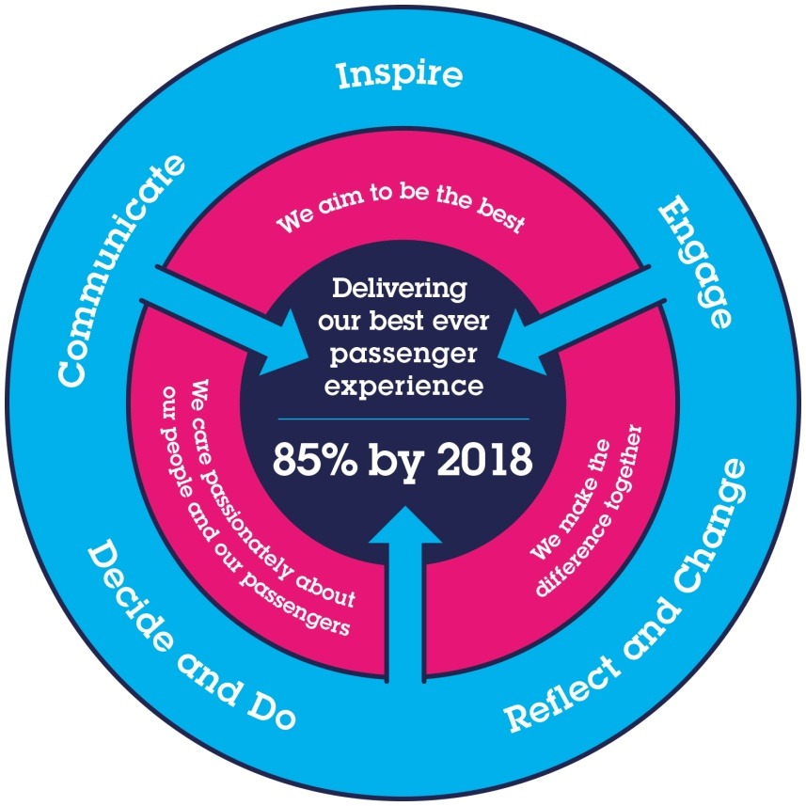
All shortlisted candidates seeking promotion will be assessed against this framework.

The job demands the following blend of experience/knowledge, skills and behaviours (all are essential, unless otherwise shown and will be assessed by application and/ or interview/assessment):

G1 | Experience, Knowledge & Qualifications - Essential  Degree in business, computer science, engineering, information systems or information technology, or equivalent experience  Proven practical experience in software development, ideally in PHP, Laravel, MySql, REST and SOAP-based web services.  Strong background and understanding of high-level programming languages, software, and systems.  Solid understanding of structured data sources, specifically SQL databases.  Solid understanding of Linux operating systems and container-based software deployment.  Proven track record in the area of Data management, Data Analytics and Automation.  Practical experience in managing software development team.  Practical experience in Data Innovation, showing an awareness of opportunities for innovation with new tools and uses of data.  Excellent communication skills and the ability to engage with people at all levels of the organisation.  Proven track record of in the area of business analysis, root cause analysis (systems hardware and software problems) and development of workable and achievable technical specifications for solutions.  Strong analytical skills with the ability to collect, organise, analyse, and disseminate significant amounts of information with attention to detail and accuracy  Experience, Knowledge & Qualifications - Desirable  Previous experience in leading software development teams, and/or full-stack LAMP software development roles is desirable.
G2 | Skills  Web development skills. Solid understanding of PHP, HTML, CSS.  Good understanding of JavaScript.  Solid Database management skills, specifically MySQL.  Solid understanding of OOP, MVC concepts and back-end PHP frameworks.  Practical understanding of front-end development frameworks.  Woking understanding of Project Management frameworks (Agile/Scrum/Waterfall).  Experience working with version control systems, such as Git.  Team management, coaching and influencing skills.  Able to turn business problem into a workable and achievable systems functionality design.  Communicating between the technical and non-technical, able to make complex and technical information and language simple and accessible for non-technical audiences  Critical-thinking and problem-solving skills – able to effectively and efficiently log, analyse and manage problems, identify and implement the appropriate solution  Able to effectively involve team members in analysis of issues/identification of opportunities, and in turn - design and delivery, increase consensus and constructively challenge assumptions.  Able to understand business needs, construct and perform data analysis corresponding to the requirement, and communicate the outcomes of such analysis in an objective, compelling and suitable for the audience manner.  An ability to prioritise and work successfully to deadlines and tight timescales.  Able to maintain focus and perspective during challenging situations, such as system failure and critical system issues, communicating calmly and confidently with a wide range of stakeholders.
G3 | Behaviours  Professional and business focussed outlook.  Attention to detail.  Empathetic and approachable, supportive of colleagues.  Resilient and self-motivated.  Aware of surroundings, naturally inquisitive and questioning
G4 | Other
H | Dimensions of role
H1 | Financial – Direct: |  |  |  | None
H2 | Financial – Other: |  |  |  | None
H3 | Staff Responsibilities – Direct: |  |  |  | User Experience Specialist
H4 | Staff Responsibilities – Other: |  |  |  | Indirectly, organise teams of up to 12
H5 | Any Other Statistical Data: |  |  |  | All static, dynamic and configuration data held across Engineering Systems
I | Acknowledgement
I1 | Prepared By: |  | _Rangel Hristov__ |  |  |  | Date: | _23rd January 2023_
I2 | Approved By (Head of Department): |  | _______________ |  |  |  | Date: | ______________
J | Job Description Briefing
 | The post holder has been briefed on and understands the requirements of this Job Description and other related documents:
 | Name of post holder: |  |  | Signature: |  |  |  |  | Date:
 | Name of briefing manager: |  |  | Signature: |  |  |  |  | Date:
K | Nominated Deputy for Safety requirements
 | If this is a KEY SAFETY POST (D2 in Safety Details above is YES) at least one nominated deputy must be identified. The Job Holder must ensure that the Nominated Deputy(ies) receives a copy of and is briefed on this Job Description. If there are more nominated deputies, they should sign further copies of this Job Description.
 | The nominated deputy has been briefed on and understands the requirements of this Job Description and other related documents:
 | Name of nominated deputy: |  |  | Signature: |  |  |  |  | Date:
 | Name of briefing manager: |  |  | Signature: |  |  |  |  | Date:

