A | Post Details
 | Job Title: |  | Deputy Head of Retail |  |  |  | Function: |  |  |  | Commercial
 | Location: |  | 4 More London |  |  |  | Unique Post Number: |  |  |  | MAT LEAVE COVER
 | Reports To: |  | Commercial Director |  |  |  | Grade: |  |  |  | MG2
B | Purpose of the Job
The Retail team plays a key role in growing Southeastern’s business and helping to create a sustainable railway post Pandemic. It oversees all the selling channels for passenger revenue, both at station and online. The systems managed and supported facilitate the collection of around £700m in farebox revenue.
The Deputy Head of Retail is a maternity cover position for between 9 and 12 months. At a pivotal time, for rail retailing this person will be accountable for the day-to-day delivery of high quality, reliable and customer-friendly retail channels for Southeastern, for embedding significant fares and retail change into day-to-day operations and supporting the business with its revenue growth targets and customer satisfaction objectives. The role oversees the retail support team and contract management of retail system suppliers, as well as managing our digital ticketing offerings.
Working closely with the Heads of Retail Strategy, Digital and Marketing this role will help to manage strategic change and increase revenue for the business by seeking out new opportunities for the development of our retail operations. The role holder will manage a team of 4 who are responsible for a complex estate of in person and unattended retailing systems.
The role is also the sponsor and scheme manager of the Southeastern smartcard The Key, will guide the roll out of eTickets and drive a Mag Zero agenda across the business.
C | Principal Accountabilities
C1  C2  C3  C4  C5  C6  C7  C8  C9  C10  C11  C12 | Specifying and delivering ongoing development and improvements to our retail systems and digital channels  Proposing, evaluating and tracking effectiveness of incremental revenue opportunities  Managing and developing The Key smart ticketing scheme and overseeing our relationship with TfL in respect of the CPAY and Oyster smart ticketing scheme.  Running highly reliable ticket retail systems to support the collection of revenue and income growth.  Maintaining compliance with RDG accreditation across all retail channels.  Achieving and maintain PCI-DSS certification across all retail channels.  Continuing the roll out of eTickets including retailing capabilities, supporting the operational elements of the Project Oval scheme.  Covering for the Head of Retail Strategy and support retail development and digital enhancement projects.  Building and sustaining strong relationships with other parts of the business including Passenger Services, Communications, Major Programmes and Finance.  Representing Southeastern at industry forums such as RDG committees overseeing retailing and ticketing.  Working closely with DOHL Group and other Group TOCs on shared retail projects.  Reporting progress on projects to key stakeholders
D | Safety Responsibilities
D1 | This post is required to undertake SAFETY CRITICAL WORK |  |  |  |  |  |  |  |  | Yes |  |  |  |  | No
D2 | This is a KEY SAFETY POST or nominated deputy |  |  |  |  |  |  |  |  | Yes |  |  |  |  | No
D3 | The holder of this post is identified as a KEY SAFETY MANAGER |  |  |  |  |  |  |  |  | Yes |  |  |  |  | No
D4 | The job requires competence in PERSONAL TRACK SAFETY |  |  |  |  |  |  |  |  | Yes |  |  |  |  | No
D5 | This job has SPECIFIC SAFETY RESPONSIBILITIES (if Yes see section D6 below) |  |  |  |  |  |  |  |  | Yes |  |  |  |  | No
D6 | The post holder has the following specific safety responsibilities:
 | - N/A
E | Decision Making Authority
E1  E2  E3  E4 | Attending RDG decision making committees on behalf of Southeastern  Supplier contract management  Supporting the Head of Retail Strategy and Commercial Director on key policy decisions
F | Most Challenging and/or Difficult Parts of the Role
F1  F2  F3  F4 | Managing a complex portfolio with tight budgets and competing demands for time  Liaising with a wide range of internal and external stakeholders  Developing retail systems to keep pace with customer expectations whilst being constrained by industry supplier capabilities and regulatory structures  Managing change, aligning to central GBRTT policy and WSPfR goals
G | Person Specification

Southeastern aims to recruit people not just for jobs but for long term careers. We want good quality, talented people with the right attitude who will stay with us.

For these reasons we look for evidence of Southeastern values and behaviours in all potential staff and our existing staff looking for promotion along with the particular experience / knowledge, skills and behaviours relevant to the position applied for. These are:

We care passionately about our people and passengers
  - we put ourselves in our passengers’ shoes to do what’s right for them
  - we support our colleagues to be, feel and do their best
  - we love the places we serve and do our bit for our communities and environment

We aim to be the best
  - we move with pace, we’re agile and learn from everything
  - we relentlessly strive to be the best
  - we are professionals with personalities

We make the difference together
  - we are answerable to each other and our passengers
  - we trust each other and do what we say we will
  - we are stronger together than we are as individuals

We also have identified behaviours required to be successful in leading Southeastern.

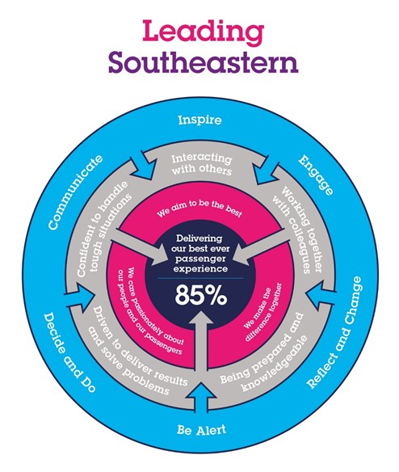

The Leading Southeastern framework details how we should be behaving in order to drive up performance to deliver 85% customer satisfaction.

All shortlisted candidates will be assessed against this framework.

G1 | The job demands the following blend of experience / knowledge, skills and behaviours (all are essential, unless otherwise shown and will be assessed by application and/ or interview / assessment):  Experience, Knowledge & Qualifications  Essential  - Significant experience of rail ticketing, particularly ITSO and eTickets, and an understanding of the technical workings of this type of ticketing in rail.  - Significant understanding of the rail industry structure and the various organisations and systems that play a role in the retail space.  - Demonstrable knowledge of rail fares and ticketing regulations and compliance requirements.  - Astute and commercially driven, with a focus on revenue development and profitable income growth.  - Strong understanding of the importance of customer experienc, focus on process excellence and operational delivery.  - Ability to build good relationships with key stakeholders, both internally and externally.  - Leadership and management skills, able to lead effectively through complex change  - Skilled at managing budgets and high value specialist contracts.  - Experience of project management and project delivery.  Desirable  - Past experience of revenue management/generation in a leisure/transport or hospitality context.  - Ability to forge new partnerships with tourism providers, building new revenue opportunities through fares promotions.
G2 | Behaviours & Skills  - Organised  - Detailed  - Strong planning, prioritising and time management skills  - Excellent communication and people skills  - Enthusiastic  - Able to see the bigger picture  - Strong influencer and negotiator  - Supportive  - Good team worker  - Strong analytical skills  - Thinking and problem solving  - Professional  - Honest  - Resilient
G3 | Other
H | Dimensions of Role
H1 | Financial – Direct:
H2 | Financial – Other:
H3 | Staff Responsibilities – Direct:
H4 | Staff Responsibilities – Other:
H5 | Any Other Statistical Data:
I | Acknowledgement
I1 | Prepared By: |  |  | __________________________ |  |  |  |  | Date: |  |  | _________________
I2 | Approved By (Head of Department): |  |  | __________________________ |  |  |  |  | Date: |  |  | _________________
J | Job Description Briefing
 | The post holder has been briefed on and understands the requirements of this Job Description and other related documents:
 | Name of Post Holder: | ___________________ |  |  | Signature: |  |  | _______________ |  |  |  |  |  | Date: |  | ________
 | Name of Briefing Manager: | ___________________ |  |  | Signature: |  |  | _______________ |  |  |  |  |  | Date: |  | ________
K | Nominated Deputy for Safety Requirements
 | If this is a KEY SAFETY POST (D2 in Safety Details above is YES) at least one nominated deputy must be identified. The Job Holder must ensure that the Nominated Deputy(ies) receives a copy of, and is briefed on this Job Description. If there are more nominated deputies, they should sign further copies of this Job Description.
 | The nominated deputy has been briefed on and understands the requirements of this Job Description and other related documents:
 | Name of Nominated Deputy: | __________________ |  |  | Signature: |  |  | _______________ |  |  |  |  |  | Date: |  | ________
 | Name of Briefing Manager: | __________________ |  |  | Signature: |  |  | _______________ |  |  |  |  |  | Date: |  | ________

