A | Post Details
 | Job Title: | 707 Fleet Engineering Manager | Function: | Engineering
 | Location: | Slade Green | Unique Post Number:
 | Reports To: | Head of Engineering Support Services | Grade: | MG2
B | Purpose of the Job
To oversee all class 707 technical investigations that are required following an operational issue to ensure root cause is established and actions are put in place to grow the reliability of the 707 fleet.

Act as the initial point of contact within Southeastern to ensure all Engineering changes proposed for class 707 units are reviewed and gain the correct authorisation before implementation.

Review all Damage and Vandalism work requests to ensure that they are correctly classified as Damage and/or Vandalism and that the costs are appropriate for the repairs undertaken.

C | Principal Accountabilities
C1  C2  C3  C4  C5  C6  C7 | Accountable for the provision of technical expertise and advice to all departments within Southeastern in respect to class 707 units. Ensure that technical information provided is up-to-date and accurate.  Accountable for the provision of clear, engineering based decisions for the resolution of rolling stock defects and delays.  Collate accurate records of all technical failures and agree attribution with Siemens to allow Southeastern to raise invoices for liquidated damages where appropriate.  Accountable to ensure all Engineering changes proposed for class 707 units are reviewed and gain the correct internal authorisation before implementation.  Accountable for reviewing all Damage and Vandalism work requests to ensure that they are correctly classified as Damage and/or Vandalism and that the costs are appropriate for the repairs undertaken.  Lead regular performance reviews with Siemens and our train services team to develop and agree ways of improving the delivery of the 707 fleet.  Responsible for investigating and resolving class 707 delay disputes in conjunction with the Fleet Management team.
D | Safety Responsibilities
D1 | This post is required to undertake SAFETY CRITICAL WORK |  |  |  | Yes |  | No
D2 | This is a KEY SAFETY POST |  |  |  | Yes |  | No | 
D3 | This post requires SECURITY CLEARANCE |  |  |  | Yes |  | No | 
D4 | The job requires competence in PERSONAL TRACK SAFETY |  |  |  | Yes |  | No
D5 | This job has SPECIFIC SAFETY RESPONSIBILITIES (if Yes see section D6 below) |  |  |  | Yes |  | No | 
D6 | The post holder has the following specific safety responsibilities.  - N/A
E | Decision making Authority
E1 | Authorised to agree the daily attribution of service failures with Siemens based upon professional judgement and evidence provided.
F | Most Challenging and/or Difficult parts of the role
F1  F2 | Establishing root cause of incidents with information provided and then reaching agreement with either Siemens or Southeastern colleagues.  Developing effective working relationships with a wide variety of stakeholders with differing needs.

G | Person Specification

Southeastern aims to recruit people not just for jobs but for long term careers. We want good quality, talented people with the right attitude who will stay with us.

For these reasons we look for evidence of Southeastern values and behaviours in all potential staff and our existing staff looking for promotion along with the particular experience/knowledge, skills and behaviours relevant to the position applied for. These are

We care passionately about our people and passengers
  - we put ourselves in our passengers’ shoes to do what’s right for them
  - we support our colleagues to be, feel and do their best
  - we love the places we serve and do our bit for our communities and environment

We aim to be the best
  - we move with pace, we’re agile and learn from everything
  - we relentlessly strive to be the best
  - we are professionals with personalities

We make the difference together
  - we are answerable to each other and our passengers
  - we trust each other and do what we say we will
  - we are stronger together than we are as individuals

We also have identified behaviours required to be successful in leading Southeastern.

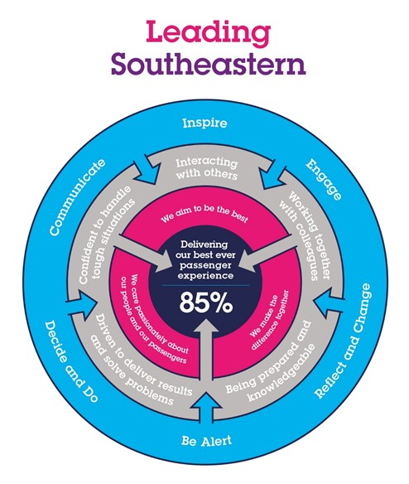

The Leading Southeastern framework details how we should be behaving in order to drive up performance to deliver 85 by 18.

All shortlisted candidates seeking promotion will be assessed against this framework.

The job demands the following blend of experience, knowledge, skills and behaviours (all are essential, unless otherwise shown and will be assessed by application and/ or interview/assessment):

G1 | Experience, Knowledge & Qualifications  Essential  - Customer focussed with strong business awareness.  - Good statistical analysis and numeric skills.  - Must have a good understanding of the principles of Loss Control and Modern Safety Management.  - Proven ability to communicate and influence.  - Good personal organisational skills.  - Must have a good level of knowledge of T&RS Engineering and standards.  - Must have a minimum of 3 years railway technical/management experience.  - NVQ Level 3 or equivalent.  - Must hold current PTS Certificate.  Desirable  - NVQ Level 4/5.  - Knowledge of Operational Procedures and Standards.
G2 | Skills (including any specific safety critical competencies)  - Ability to negotiate and develop robust contractual working relationships.
G3 | Behaviours  - Enthusiastic self-starter, comfortable with making decisions with minimal supervision.
G4 | Other

I | Dimensions of role
I1 | Financial – Direct: |  | none
I2 | Financial – Other: |  | Circa £500K – Based on Damage & Vandalism costs for 707 units and Liquidated Damages claims
I3 | Staff Responsibilities – Direct: |  | none
I4 | Staff Responsibilities – Other: |  | none
I5 | Any Other Statistical Data: |  | This is a key post managing a multi million pound contract with Siemens
J | Acknowledgement
J1 | Prepared By: | _______________ |  | Date: | ______________
J2 | Approved By (Head of Department): | _______________ |  | Date: | ______________

K | Job Description Briefing
 | The post holder has been briefed on and understands the requirements of this Job Description and other related documents:
 | Name of post holder: |  | Signature: |  | Date:
 | Name of briefing manager: |  | Signature: |  | Date:
L | Nominated Deputy for Safety requirements
 | If this is a KEY SAFETY POST (D2 in Safety Details above is YES) at least one nominated deputy must be identified. The Job Holder must ensure that the Nominated Deputy(ies) receives a copy of, and is briefed on, this Job Description. If there are more nominated deputies, they should sign further copies of this Job Description.
 | The nominated deputy has been briefed on and understands the requirements of this Job Description and other related documents:
 | Name of nominated deputy: |  | Signature: |  | Date:
 | Name of briefing manager: |  | Signature: |  | Date:

