A | Post Details
 | Job Title: | Network Engineer L2 | Function: | IT Department
 | Location: | More London | Unique Post Number:
 | Reports To: | IT Network Manager | Grade: | MG1
B | Purpose of the Job  The purpose of the role is to:  Monitor, support, maintain and develop the network infrastructure and architecture for Southeastern, including operational security and service improvement activity.  Work with the organisations’ network delivery and support partners to ensure uptime is maximised, integrity is maintained, and performance is optimised.  Participate in IT projects to ensure the networking impact is understood, that capacity requirements are factored into the technical delivery plan and budgets and ensure that introduction to service is successfully completed.
C | Principal Accountabilities
C1 | Pro-actively monitor the whole network estate, provide support, identify risks, and recommend long term fixes and remediations. Develop secure solutions and improvements for the operation of the overall network and architecture.
C2 | Pro-actively review and monitor network capacity across the organisation. Identify performance constraints and create secure solutions to improve utilisation or increase capacity when required.
C3 | Monitor, support and improve the switching estate. Review and continually improve the implementation to ensure optimal performance. Implement changes to switch configurations as needed and develop secure solutions and improvement plans.
C4 | Monitor, support and improve the security appliance estate. Review/audit policies and configurations to continually secure the implementation to ensure optimal performance. Implement changes to configurations as needed and develop secure solutions and improvements, working in conjunction with the support partner where necessary.
C5 | Monitor, support and improve the wireless implementation. Review configurations to continually secure the implementation. Implement changes to configurations as needed and design secure solutions and improvements, working in conjunction with the support partner where necessary.
C6 | Work in parallel with the WAN Network support partner, to ensure that project/change requirements are accurately communicated, implementations are to standard, and that incidents are handled correctly and resolved promptly.
C7 | Participate in projects: Understand requirements, design, manage and/or deliver solutions to support the project, incorporating adequate capacity planning to ensure existing services are  not adversely affected.
C8 | Work as a team and where necessary work autonomously, lead projects and produce design documentation to meet change review and project requirements, including HLD, LLD and test plans.
C9 | Participate in an on-call escalation rota out of hours.
C10 | Undertake any other activity that is commensurate with the role, as requested by management

D | Safety Responsibilities
D1 | This post is required to undertake SAFETY CRITICAL WORK | Yes |  | No | X
D2 | This is a KEY SAFETY POST or nominated deputy | Yes |  | No | X
D3 | The holder of this post is identified as a KEY SAFETY MANAGER | Yes |  | No | X
D4 | The job requires competence in PERSONAL TRACK SAFETY | Yes |  | No | X
D5 | This job has SPECIFIC SAFETY RESPONSIBILITIES (if Yes see section D6 below) | Yes |  | No | X
D6 | The post holder has the following specific safety responsibilities:
Carrying out Planned General Inspections of the following locations:
- N/A

Acting as Fire Precautions Manager for the following locations:
- N/A

Safety Interface with the following external parties:
- N/A

Investigation of accidents occurring at the following locations or as requested by Safety & Environment:
- N/A

E | Decision making Authority
E1 | N/A
F | Most Challenging and/or Difficult parts of the role
F1 | Understanding how LSER’s network interfaces with third party environments (Multi-VRF operations, BGP route policy)
F2 | Understanding the network integration with remote supplier systems, which are predominantly IPSec based

G | Person Specification

Southeastern aims to recruit people not just for jobs but for long term careers. We want good quality, talented people with the right attitude who will stay with us.

For these reasons we look for evidence of Southeastern values and behaviours in all potential staff and our existing staff looking for promotion along with the experience/knowledge, skills and behaviours relevant to the position applied for. These are

We care passionately about our people and passengers
  - we put ourselves in our passengers’ shoes to do what’s right for them
  - we support our colleagues to be, feel and do their best
  - we love the places we serve and do our bit for our communities and environment

We aim to be the best
  - we move with pace, we’re agile and learn from everything
  - we relentlessly strive to be the best
  - we are professionals with personalities

We make the difference together
  - we are answerable to each other and our passengers
  - we trust each other and do what we say we will
  - we are stronger together than we are as individuals

We also have identified behaviours required to be successful in leading Southeastern.

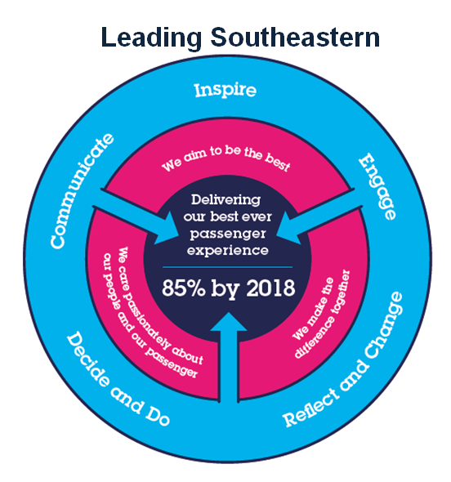
The Leading Southeastern framework details how we should be behaving in order to drive up performance to deliver 85 by 18.

All shortlisted candidates seeking promotion will be assessed against this framework.

The job demands the following blend of experience/knowledge, skills and behaviours (all are essential, unless otherwise shown and will be assessed by application and/or interview/assessment) :

G1 | Experience, Knowledge & Qualifications (including any specific safety training requirements)  - CCNP Enterprise (R+S/Wireless) / Security accreditation or equivalent (essential)  - SD-WAN deployment experience (any product) (essential)  - Experience working with service providers (essential)  - Experience working with suppliers (essential)  - F5 Certified BIG-IP Administrator (desirable)
G2 | Skills (including any specific safety critical competencies)  - Cisco routing/switching configuration and management  - Must have good understanding of MPLS CE router configuration and network operations  - Must have good understanding of enterprise routing protocols (BGP/OSPF)  - Must have experience with QOS design, implementation, and management  - Aruba / HPE switching configuration and management  - Cisco ASA configuration and management  - Cisco Nexus configuration and management  - Cisco NGFW configuration and management  - Cisco WLC configuration and management  - ZScaler Internet Access (ZIA) management  - F5 BIG-IP configuration and management (APM / LTM)  - Fortinet / FortiGate  - SD-WAN deployments, migrations configuration and management
G3 | Behaviours  - Passion, enthusiasm, and expertise.  - Understanding of the wider context around their work  - Good written and verbal communication skills  - Quality and transparency  - Good prioritising skills and the ability to meet targets  - Pragmatism
G4 | Other

H | Dimensions of role
H1 | Financial – Direct:
H2 | Financial – Other:
H3 | Staff Responsibilities – Direct:
H4 | Staff Responsibilities – Other:
H5 | Any Other Statistical Data:
I | Acknowledgement
I1 | Prepared By: | _______________ |  | Date: | ______________
I2 | Approved By (Head of Department): | _______________ |  | Date: | ______________

J | Job Description Briefing
 | The post holder has been briefed on and understands the requirements of this Job Description and other related documents:
 | Name of post holder: |  | Signature: |  | Date:
 | Name of briefing manager: |  | Signature: |  | Date:
K | Nominated Deputy for Safety requirements
 | If this is a KEY SAFETY POST (D2 in Safety Details above is YES) at least one nominated deputy must be identified. The Job Holder must ensure that the Nominated Deputy(ies) receives a copy of, and is briefed on this Job Description. If there are more nominated deputies, they should sign further copies of this Job Description.
 | The nominated deputy has been briefed on and understands the requirements of this Job Description and other related documents:
 | Name of nominated deputy: |  | Signature: |  | Date:
 | Name of briefing manager: |  | Signature: |  | Date:

