A | Post Details
 | Job Title: | Senior Internal Auditor | Function: | Finance
 | Location: | 4 More London | Unique Post Number:
 | Reports To: | Audit & Compliance Manager | Grade: | MG2
B | Purpose of the Job
To provide independent assurance on the adequacy of financial and operational controls and risk mitigations over Southeastern’s business processes.

In conjunction with the Audit & Compliance Manager develop and complete the programme of Internal Audit work for Southeastern and the report on activity to relevant stakeholders, including the Southeastern Audit & Risk Committee.

To support delivery of Southeastern’s compliance obligations for relevant legislation.

C | Principal Accountabilities
C1  C2  C3  C4  C5  C6  C7  C8  C9  C10 | To be a key part of an effective team, whilst encouraging cross functional working.  Planning, managing, conducting and controlling risk based internal audit and business assurance reviews plus requests received from management and assurance activities relating to major business projects, in accordance with the agreed plans in an effective manner. This includes the follow up of agreed management actions.  To ensure that all reports following work completed have sufficient clarity and quality to elicit appropriate management responses and agreed action plans within given timescales.  To support the Audit & Compliance Manager in preparation for Audit Committee meetings (including the tracking of agreed audit actions through to resolution) and communicating the activities of Internal Audit to the wider business.  To support the Audit & Compliance Manager in improving Southeastern’s s Risk Management capability.  To ensure findings and risk ratings are evaluated in line with the governance process endorsed by the business.  To identify opportunities for self-assessment within the business and the mechanisms required to place reliance on this as a source of assurance.  Support the Audit & Compliance Manager in considering compliance with key legislative requirements such as GDPR, FOIA, Bribery Act and the Ticketing Settlement Agreement.  To stay abreast of industry developments and updates to technical standards and policies through continuing education/networking and be the conduit for establishing those practices within the company.  To support the Audit & Compliance Manager in helping the business to influence the behaviours and financial controls frameworks of our third-party service providers, to ensure that their processes and people do not increase our exposure to loss of revenue through fraud or error and that these arrangements do not have an adverse impact on statutory and regulatory requirements.

D | Safety Responsibilities
D1 | This post is required to undertake SAFETY CRITICAL WORK | Yes |  | No
D2 | This is a KEY SAFETY POST or nominated deputy | Yes |  | No
D3 | The holder of this post is identified as a KEY SAFETY MANAGER | Yes |  | No
D4 | The job requires competence in PERSONAL TRACK SAFETY | Yes |  | No
D5 | This job has SPECIFIC SAFETY RESPONSIBILITIES (if Yes see section D6 below) | Yes |  | No
D6 | The post holder has the following specific safety responsibilities:
Carrying out Planned General Inspections of the following locations:
- N/A

Acting as Fire Precautions Manager for the following locations:
- N/A

Safety Interface with the following external parties:
- N/A

Investigation of accidents occurring at the following locations or as requested by Safety & Environment:
- N/A

E | Decision making Authority
E1 | No formal decision making authority.
F | Most Challenging and/or Difficult parts of the role
F1 | The role covers a wide range of diverse activities that require complex judgements and solutions based on conceptual thought and strategic vision and analysis.  To be a convincing and persuasive communicator that represents a directorate and influences strategic decisions at board level.

G | Person Specification

Southeastern aims to recruit people not just for jobs but for long term careers. We want good quality, talented people with the right attitude who will stay with us.

For these reasons we look for evidence of Southeastern values and behaviours in all potential staff and our existing staff looking for promotion along with the particular experience/knowledge, skills and behaviours relevant to the position applied for. These are

We care passionately about our people and passengers
  - we put ourselves in our passengers’ shoes to do what’s right for them
  - we support our colleagues to be, feel and do their best
  - we love the places we serve and do our bit for our communities and environment

We aim to be the best
  - we move with pace, we’re agile and learn from everything
  - we relentlessly strive to be the best
  - we are professionals with personalities

We make the difference together
  - we are answerable to each other and our passengers
  - we trust each other and do what we say we will
  - we are stronger together than we are as individuals

We also have identified behaviours required to be successful in leading Southeastern.

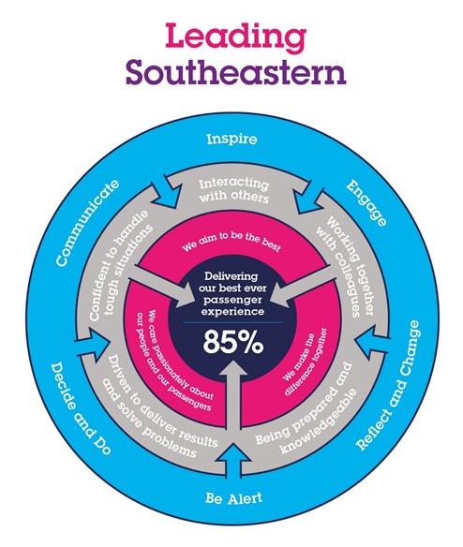

The Leading Southeastern framework details how we should be behaving in order to drive up performance to deliver 85 by 18.

All shortlisted candidates seeking promotion will be assessed against this framework.

The job demands the following blend of experience/knowledge, skills and behaviours (all are essential , unless otherwise shown and will be assessed by application and/ or interview/assessment) :

Experience, Knowledge & Qualifications (including any specific safety training requirements)

Essential
- Recognised Internal Audit or CCAB qualification.
- Demonstrable experience within a professional internal audit department,
- Excellent time management skills including the ability to manage interruptions, changing priorities and perform tasks in a high-pressure environment.
- Commercial awareness.
- Ability to influence and persuade others
- A team player approach to working
- Enthusiastic approach to a customer focused organisation and a culture of employee engagement

Desirable
- Experience of working in a government organisation or a rail environment.
- Good working knowledge of legislation relevant to a rail operator.
- Audit Committee experience
- Advanced used of O365 Products

Skills (including any specific safety critical competencies)

- Problem solving skills
- Decision making skills
- High level of communication, conflict management and relationship management skills.

H | Dimensions of role
H1 | Financial – Direct: |  | None
H2 | Financial – Other: |  | None
H3 | Staff Responsibilities – Direct: |  | None
H4 | Staff Responsibilities – Other: |  | Liaison with the Internal Control team.
H5 | Any Other Statistical Data:
I | Acknowledgement
I1 | Prepared By: | _______________ |  | Date: | ______________
I2 | Approved By (Head of Department): | _______________ |  | Date: | ______________

J | Job Description Briefing
 | The post holder has been briefed on and understands the requirements of this Job Description and other related documents:
 | Name of post holder: |  | Signature: |  | Date:
 | Name of briefing manager: |  | Signature: |  | Date:
K | Nominated Deputy for Safety requirements
 | If this is a KEY SAFETY POST (D2 in Safety Details above is YES) at least one nominated deputy must be identified. The Job Holder must ensure that the Nominated Deputy(ies) receives a copy of, and is briefed on this Job Description. If there are more nominated deputies, they should sign further copies of this Job Description.
 | The nominated deputy has been briefed on and understands the requirements of this Job Description and other related documents:
 | Name of nominated deputy: |  | Signature: |  | Date:
 | Name of briefing manager: |  | Signature: |  | Date:

