A | Post Details
 | Job Title: IT Service Team Leader |  | Function: | Engineering, IT and Major Contracts
 | Location:  Four More London |  | Unique Post Number:
 | Reports To: IT Service Manager |  | Grade: MG1
B | Purpose of the Job  Team leader role, managing a small team that makes up the larger support function. Set objectives, identify and set training paths for the team in conjunction with the IT Service Manager.  To resolve 3rd line IT incidents, requests and problems efficiently and effectively, whilst managing customer relations and expectations with great diplomacy.  Participate in the out of hours incident escalation rota, to resolve critical incidents that occur over weeknights and weekends.  Involvement in infrastructure projects relating to Services, Server and Back office Infrastructure items.  Supporting all sites on the WAN including stations and depots with Hardware or Network related faults.  Support the IT teams and the wider organisation in delivery of Southeastern’s projects and obligations.
C | Principal Accountabilities
C1  C2  C3  C4  C5  C6  C7  C8  C9  C10  C11  C12  C13  C14 | Manage and lead a team, focused on delivering against SLA’s and KPI’s.  Set training paths to for the team to develop, and maintain competence on existing, and new services coming into the organisation  Support the 2nd line, Systems Engineers and Field Engineers in covering their duties  Ensuring that Service Desk calls are actioned within timescales set and that all incidents, problems, faults and requests are logged and updated in the Service Desk Management System correctly with the correct priorities, categories and comprehensive details.  Complete daily system health checks as prescribed to ensure systems are available and operating at required levels.  Carry out regular maintenance tasks on services and servers to ensure their ongoing health, security and performance levels remain at expected levels  Perform, when necessary, all system upgrades in conjunction with, and as defined with and by other IT teams.  Lead or participate in the implementation of service changes (addition, enhancement or upgrade), including support for testing these streams.  Create or update service and software installation and upgrade documentation  Participate in an on-call escalation rota, covering nights and weekends, including bank holidays.  Ensure that the formal change and release management processes are adhered to  Support the field engineers, partnering with specific engineering and crew depots to provide support and insight  Support the department with your insight, experience and technical knowledge.  Undertake any other activity that is commensurate with the role, as requested IT management

D | Safety Responsibilities
D1 | This post is required to undertake SAFETY CRITICAL WORK | Yes |  | No
D2 | This is a KEY SAFETY POST or nominated deputy | Yes |  | No
D3 | The holder of this post is identified as a KEY SAFETY MANAGER | Yes |  | No
D4 | The job requires competence in PERSONAL TRACK SAFETY | Yes |  | No
D5 | This job has SPECIFIC SAFETY RESPONSIBILITIES (if Yes see section D6 below) | Yes |  | No
D6 | The post holder has the following specific safety responsibilities:
Carrying out Planned General Inspections of the following locations:
- [list locations or delete if not applicable]

Acting as Fire Precautions Manager for the following locations:
- [list locations or delete if not applicable]

Safety Interface with the following external parties:
- [list interfaces or delete if not applicable]

Investigation of accidents occurring at the following locations or as requested by Safety & Environment:
- [list locations or delete if not applicable]

E | Decision making Authority
E1 | As appropriate to ensure resolution of incidents, requests, problems and service requests.
F | Most Challenging and/or Difficult parts of the role
F1 | Ensuring incidents are managed and resolved in a timely manner

G | Person Specification

Southeastern aims to recruit people not just for jobs but for long term careers. We want good quality, talented people with the right attitude who will stay with us.

For these reasons we look for evidence of Southeastern values and behaviours in all potential staff and our existing staff looking for promotion along with the particular experience/knowledge, skills and behaviours relevant to the position applied for. These are

We care passionately about our people and passengers
  - we put ourselves in our passengers’ shoes to do what’s right for them
  - we support our colleagues to be, feel and do their best
  - we love the places we serve and do our bit for our communities and environment

We aim to be the best
  - we move with pace, we’re agile and learn from everything
  - we relentlessly strive to be the best
  - we are professionals with personalities

We make the difference together
  - we are answerable to each other and our passengers
  - we trust each other and do what we say we will
  - we are stronger together than we are as individuals

We also have identified behaviours required to be successful in leading Southeastern.

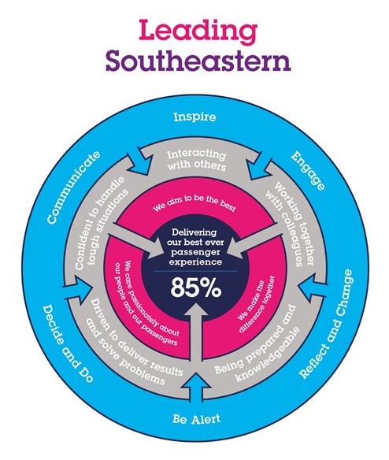

The Leading Southeastern framework details how we should be behaving in order to drive up performance to deliver 85 by 18.

All shortlisted candidates seeking promotion will be assessed against this framework.

The job demands the following blend of experience/knowledge, skills and behaviours (all are essential , unless otherwise shown and will be assessed by application and/ or interview/assessment) :

G1 | Experience, Knowledge & Qualifications (including any specific safety training requirements)  1 year experience of leading a small team  2 years experience working in 3rd line Incident, Request, Knowledge and Problem management.  Experience of supporting WINTEL operating systems.  MCSE (or equivalent)  Microsoft 365 Certified: Teamwork Administrator Associate (or equivalent – Desirable)  Citrix Certified Professional (Desirable)  ITIL Foundation certification (Desirable)
G2 | Skills (including any specific safety critical competencies)  Driven individual with a ‘CAN DO’ attitude that engenders confidence, respect and support.  Passion, enthusiasm and expertise.  Good written and verbal communication skills  Quality and transparency  Good prioritising skills and the ability to meet targets
G3 | Behaviours  Honesty  Integrity  Reliable
G4 | Other

H | Dimensions of role
H1 | Financial – Direct: DFA up to
H2 | Financial – Other:
H3 | Staff Responsibilities – Direct: Line management of 5 individuals.  Leading a team of 13 individuals
H4 | Staff Responsibilities – Other:
H5 | Any Other Statistical Data:
I | Acknowledgement
I1 | Prepared By: | _______________ |  | Date: | ______________
I2 | Approved By (Head of Department): | _______________ |  | Date: | ______________

J | Job Description Briefing
 | The post holder has been briefed on and understands the requirements of this Job Description and other related documents:
 | Name of post holder: |  | Signature: |  | Date:
 | Name of briefing manager: |  | Signature: |  | Date:
K | Nominated Deputy for Safety requirements
 | If this is a KEY SAFETY POST (D2 in Safety Details above is YES) at least one nominated deputy must be identified. The Job Holder must ensure that the Nominated Deputy(ies) receives a copy of, and is briefed on this Job Description. If there are more nominated deputies, they should sign further copies of this Job Description.
 | The nominated deputy has been briefed on and understands the requirements of this Job Description and other related documents:
 | Name of nominated deputy: |  | Signature: |  | Date:
 | Name of briefing manager: |  | Signature: |  | Date:

