A | Post Details
 | Job Title: | HR Business Partner | Function: | Human Resources
 | Location: | Head Office
 | Reports To: | Head of People | Grade: | MG2
B | Purpose of the Job  Act as a true partner to the business in implementing the people change plan. Develop deep understanding of key business drivers and priorities and provide an effective interface with the Centres of Excellence to help the achievement of these
C | Principal Accountabilities
C1  C2  C3  C4  C5  C6  C7  C8  C9 | Lead on the integration and implementation of the People Change plan within the business partner area and in support of Southeastern strategic plan  To be responsible for any organisational change plan in the respective business partner area, ensuring alignment with wider organisational change, accurate diagnosis of the functions organisational needs and the design, implementation, monitoring and review of appropriate HR interventions to meet those needs  Provide coaching and guidance to business unit managers. Contribute and lead on a multitude of HR activities to drive business performance and influence change across the business  Lead and deliver programmes of activity, overseeing all people elements of a programme to deliver to Southeastern’s strategic change agenda, realising the associated business benefits and agreed business outcomes  Effective co-ordination, communication and stakeholder management across the organisation for all people activity related to the programme and business partner area  Cost effective use of resources available (internal and external)  Identification and management of BAU and programme risks, issues and dependencies. Quantify and produce contingency plans. Facilitate complex problem solving initiatives relating to risks. This will require a high technical competence and ability to think strategic solutions from the customers' perspective  Promote and facilitate the BAU performance management cycle, talent management, engagement, job evaluation and learning & development  Provide support to and deputise for Head of People where required

D | Safety Responsibilities
D1 | This post is required to undertake SAFETY CRITICAL WORK | Yes |  | No
D2 | This is a KEY SAFETY POST | Yes |  | No
D3 | This post requires SECURITY CLEARANCE | Yes |  | No
D4 | The job requires competence in PERSONAL TRACK SAFETY | Yes |  | No
D5 | This job has SPECIFIC SAFETY RESPONSIBILITIES (if Yes see section D6 below) | Yes |  | No
D6 | The post holder has the following specific safety responsibilities:
E | Decision making Authority
E1

F | Most Challenging and/or Difficult parts of the role
F1 | Influencing change at all levels of the organisation

G | Person Specification

Southeastern aims to recruit people not just for jobs but for long term careers. We want good quality, talented people with the right attitude who will stay with us.

For these reasons we look for evidence of Southeastern values and behaviours in all potential staff and our existing staff looking for promotion along with the particular experience/knowledge, skills and behaviours relevant to the position applied for. These are

We care passionately about our people and passengers
  - we put ourselves in our passengers’ shoes to do what’s right for them
  - we support our colleagues to be, feel and do their best
  - we love the places we serve and do our bit for our communities and environment

We aim to be the best
  - we move with pace, we’re agile and learn from everything
  - we relentlessly strive to be the best
  - we are professionals with personalities

We make the difference together
  - we are answerable to each other and our passengers
  - we trust each other and do what we say we will
  - we are stronger together than we are as individuals

We also have identified behaviours required to be successful in leading Southeastern.

The Leading Southeastern framework details how we should be behaving in order to drive up performance to deliver 85 by 18.

Leading Southeastern
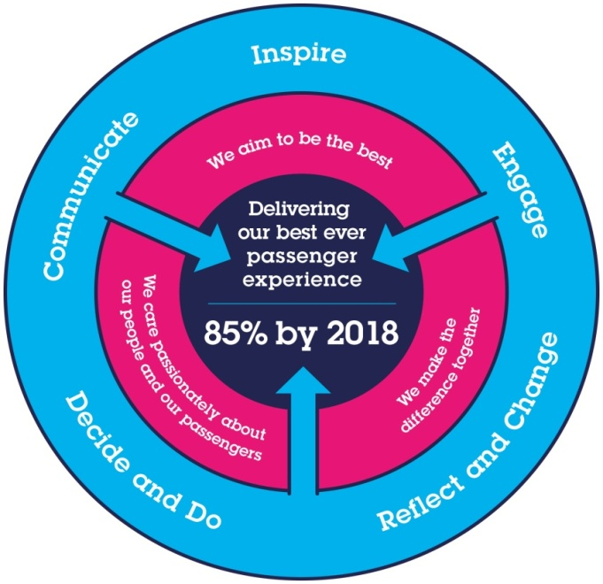

All shortlisted candidates seeking promotion will be assessed against this framework.

The job demands the following blend of experience/knowledge, skills and behaviours (all are essential, unless otherwise shown and will be assessed by application and/ or interview/assessment) :

G1 | Skills & Knowledge
- Proven track record of managing stakeholder relationships - significant experience operating at HR Manager level
- Demonstrable multi-discipline Human Resources experience
- Proven experience of significant change management/OD experience including restructure, redundancy, TUPE, Compromise agreements and redeployment
- Demonstrable experience of grasping issues quickly and delivering effective and efficient solutions
- Ability to quickly develop organisational savvy, political navigation and sensitivity
- Ability to adopt a consultant style approach to the role, partnering with senior managers, developing good relationships both within and external to the organisation
- High level of personal credibility and ability to engage with the business and to exercise sound judgement
- Well-organised and able to manage multiple projects/relationships
- Demonstrable track record of delivering value-adding HR solutions
- Familiar with relevant HR-oriented technologies and computer literate
- Able to operate and work effectively with MS Office Suite:- Outlook, Word, Excel, PowerPoint
- CIPD (or equivalent qualification) or working towards qualification

I | Dimensions of role
I1 | Financial – Direct:
I2 | Financial – Other:
I3 | Staff Responsibilities – Direct:
I4 | Staff Responsibilities – Other:
I5 | Any Other Statistical Data:
J | Acknowledgement
J1 | Prepared By: |  |  |  |  |  | Date:
J2 | Approved By (Head of Department): |  |  |  |  |  | Date:
K | Job Description Briefing
 | The post holder has been briefed on and understands the requirements of this Job Description and other related documents:
 | Name of post holder: |  |  | Signature: |  |  |  |  | Date:
 | Name of briefing manager: |  |  | Signature: |  |  |  |  | Date:
L | Nominated Deputy for Safety requirements
 | If this is a KEY SAFETY POST (D2 in Safety Details above is YES) at least one nominated deputy must be identified. The Job Holder must ensure that the Nominated Deputy(ies) receives a copy of, and is briefed on this Job Description. If there are more nominated deputies, they should sign further copies of this Job Description.
 | The nominated deputy has been briefed on and understands the requirements of this Job Description and other related documents:
 | Name of nominated deputy: |  |  | Signature: |  |  |  |  | Date:
 | Name of briefing manager: |  |  | Signature: |  |  |  |  | Date:

