A | Post Details
 | Job Title: | Finance Business Partner | Function: | Finance (Train Services)
 | Location: | 4 More London | Unique Post Number:
 | Reports To: | Head of Management Accounting and Reporting | Grade: | MG2
B | Purpose of the Job
B1  B2  B3  B4  B5 | To offer an excellent finance partnering service to business departments and to maximise profitable, value for money and commercial opportunities via effective relationships with Finance and non-finance Managers by means of strong interpersonal and technical competencies for the benefit of Southeastern.  To provide insight driven, high quality analysis to improve business performance.  To build budgets and forecasts taking into account current and future business performance, ensuring consistency with the future strategy of the business.  To actively contribute to the business management, decision making and major project monitoring through the provision of accurate, timely and relevant financial information.  To provide the Directorate with expert financial and accounting advice to enable strategic decision making.
C | Principal Accountabilities
C1  C2  C3  C4  C5  C6  C7  C8  C9  C10  C11  C12  C13 | Gain detailed knowledge of relevant business activities and cost drivers to continually develop clear, concise and relevant financial and management reporting.  Build good working relationships with directors, managers and staff and provide them with management information and analysis based on insight and enquiry.  Identification of risks and opportunities through a sound understanding of the financial profile of the business and key drivers of business value, making recommendations to maximise profitability and mitigate key risks within these constraints.  Responsible for modelling, influencing, challenging and reporting the business annual business planning (ABP) process, quarterly rolling forecasts and periodic reporting for Train Services and other respective business areas as appropriate.  Manage and provide support to managers and directors to ensure funds for budgeted activities and projects are approved and projects are delivered as planned.  Responsible for financial analysis and development of departmental initiatives and business cases. Supporting relevant capital expenditure and major project approvals and ongoing project management monitoring and reporting.  To be recognised and sought out by the business as a primary and trusted source of insight for decision making.  Act as business change agent proactively identifying and implementing process improvements within the team and across the business  Responsible for managing period and year end results, producing management analysis to required deadlines, highlighting material variances and trends, their underlying causes and impact on profitability to derive recommendations on strategic action plans.  Ensure financial records are complete and accurate and reflect underlying business activities and objectives.  Liaise closely with the Financial Accounting team to ensure reliability, accuracy and timeliness of financial information.  Provide adhoc support and analysis to the Head of Financial Planning and Analysis, Train Services Director as necessary.  Provide guidance on finance matters within relevant business area.
D | Safety Responsibilities
D1 | This post is required to undertake SAFETY CRITICAL WORK |  |  |  | Yes |  | No
D2 | This is a KEY SAFETY POST |  |  |  | Yes |  | No
D3 | This post requires SECURITY CLEARANCE |  |  |  | Yes |  | No
D4 | The job requires competence in PERSONAL TRACK SAFETY |  |  |  | Yes |  | No
D5 | This job has SPECIFIC SAFETY RESPONSIBILITIES (if Yes see section D6 below) |  |  |  | Yes |  | No
D6 | The post holder has the following specific safety responsibilities:
 | - None
E | Decision making Authority
E1  E2  E3 | Authorised to review and recommend changes to business practices, processes and new projects.  Authorised to prepare and influence budgets and forecasts and assumptions therein.  Authorised to attend meetings with external companies and organisations and represent Southeastern’s interests at those meetings.
F | Most Challenging and/or Difficult parts of the role
F1  F2  F3 | Managing conflicting business and director / commercial and financial priorities  Managing to tight deadlines and manipulating large amounts of data  Understand the technical aspect of SouthEastern Train Services Directorate and the management thereof.

G | Person Specification

Southeastern aims to recruit people not just for jobs but for long term careers. We want good quality, talented people with the right attitude who will stay with us.

For these reasons we look for evidence of Southeastern values and behaviours in all potential staff and our existing staff looking for promotion along with the particular experience/knowledge, skills and behaviours relevant to the position applied for. These are

We care passionately about our people and passengers
  - we put ourselves in our passengers’ shoes to do what’s right for them
  - we support our colleagues to be, feel and do their best
  - we love the places we serve and do our bit for our communities and environment

We aim to be the best
  - we move with pace, we’re agile and learn from everything
  - we relentlessly strive to be the best
  - we are professionals with personalities

We make the difference together
  - we are answerable to each other and our passengers
  - we trust each other and do what we say we will
  - we are stronger together than we are as individuals

We also have identified behaviours required to be successful in leading Southeastern.

The Leading Southeastern framework details how we should be behaving in order to drive up performance to deliver 85 by 18.

Leading Southeastern

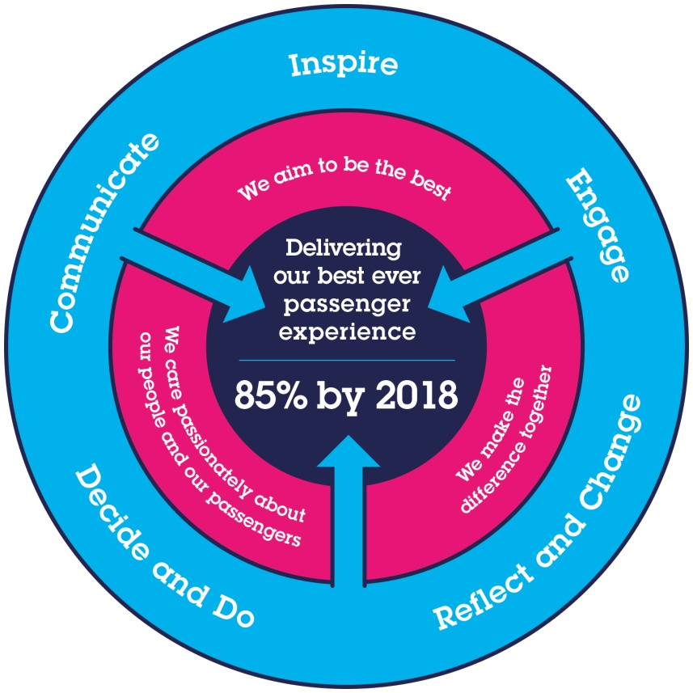
All shortlisted candidates seeking promotion will be assessed against this framework.

The job demands the following blend of experience/knowledge, skills and behaviours (all are essential , unless otherwise shown and will be assessed by application and/ or interview/assessment) :

Finance Business Partner – Team Charter

The Finance Business Partner Team are focused on providing quality service and support to their key customers (including management, Directors, DfT, ROSCOs, Network Rail and Group) and are expected to display the following attributes, striving to continually improve both individual and team performance in each of these four quadrants.
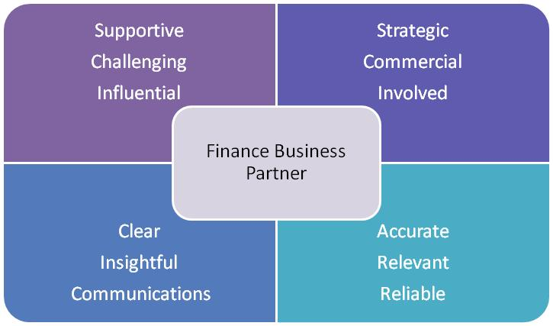

G1 | Experience, Knowledge & Qualifications  Degree or equivalent.  Qualified or part qualified in a recognised accountancy qualification (CIMA, ACA, ACCA), or equivalent.  Substantial experience in a commercial environment including some time spent in an analytical or commercial finance role.  Commercially astute with demonstrable understanding of financial aspects of a business  Experience of budgeting and forecasting at an operating company level.  Experience of rail or similar transport / franchise industry (desirable)
G2 | Skills (including any specific safety critical competencies)  Excellent analytical and financial modelling skills.  Excellent presentation skills  Oracle and iTM1 systems (desirable)
G3 | Behaviours  Ability to work efficiently, effectively and collaboratively as part of a team, contributing to a culture of continuous business improvement  Ability to influence and solve problems at all levels of the business, influencing decisions beyond the numbers.  Ability to communicate clearly and effectively (both written and oral) at all levels and explain financial issues to a non-financial audience
G4 | Other
I | Dimensions of role
I1 | Financial – Direct: |  |  | 0
I2 | Financial – Other: |  |  | Depending on relevant business areas
I3 | Staff Responsibilities – Direct: |  |  | TBC [0 or MAX 1]
I4 | Staff Responsibilities – Other: |  |  | 0
I5 | Any Other Statistical Data:
K | Job Description Briefing
 | The post holder has been briefed on and understands the requirements of this Job Description and other related documents:
 | Name of post holder: |  | Signature: |  |  | Date:
 | Name of briefing manager: |  | Signature: |  |  | Date:

