A | Post Details
 | Job Title: IT Endpoint & MDM Administrator |  | Function: | IT Department
 | Location:  Four More London |  | Unique Post Number:
 | Reports To:  IT Infrastructure Manager |  | Grade: MG1
B | Purpose of the Job  This is a key role required to manage the setup, integration, compliance, and governance of three technologies used to manage the organisations endpoints: Microsoft Endpoint Manager (Intune), VMware’s Airwatch MDM and MS SCCM. The role will work in conjunction with the IT teams, focusing on the overall provision, configuration and integration of the technologies that manage and secure the organisations desktop, laptop and mobile estate.  The role will manage the platforms, incorporating continual improvements, aimed at improving deployment, enrolment, application packaging and publishing, operating system patching and overall security through profiles and policies, as well as the provision of accurate compliance and management reports.
C | Principal Accountabilities
C1  C2  C3  C4  C5  C6  C7  C8 | Ongoing setup and management of the organisations MS Endpoint Manager platform, using policies and profiles to deliver initial setups, applications, system patching and overall security to the organisations devices  Ongoing setup and management of the organisations VMware Airwatch MDM platform, using policies and profiles to deliver initial setups, applications and security to the organisations mobile retail devices  Ongoing setup and management of the organisations MS SCCM platform, using policies and profiles to deliver security patching to the organisations server estate.  Undertake new application packaging, update existing packages, managing their approval, testing and deployment through their respective Endpoint Management Platforms. Retirement of Application packages is also required  Work collaboratively with the IT teams to create and update Autopilot images regularly  Create, review and update platform policies, in conjunction with the other IT teams, to address or improve device provision or device security, in line with industry best practices or compliance requirements.  Assist with the creation and distribution of accurate compliance and management reports from the platforms  Undertake any other activity that is commensurate with the role, as requested by IT management

D | Safety Responsibilities
D1 | This post is required to undertake SAFETY CRITICAL WORK | Yes |  | No
D2 | This is a KEY SAFETY POST or nominated deputy | Yes |  | No
D3 | The holder of this post is identified as a KEY SAFETY MANAGER | Yes |  | No
D4 | The job requires competence in PERSONAL TRACK SAFETY | Yes |  | No
D5 | This job has SPECIFIC SAFETY RESPONSIBILITIES (if Yes see section D6 below) | Yes |  | No
D6 | The post holder has the following specific safety responsibilities:
Carrying out Planned General Inspections of the following locations:
- None

Acting as Fire Precautions Manager for the following locations:
- None

Safety Interface with the following external parties:
- None

Investigation of accidents occurring at the following locations or as requested by Safety & Environment:
- None

E | Decision making Authority
E1

E2

E3
F | Most Challenging and/or Difficult parts of the role
F1

G | Person Specification

Southeastern aims to recruit people not just for jobs but for long term careers. We want good quality, talented people with the right attitude who will stay with us.

For these reasons we look for evidence of Southeastern values and behaviours in all potential staff and our existing staff looking for promotion along with the particular experience/knowledge, skills and behaviours relevant to the position applied for. These are

We care passionately about our people and passengers
  - we put ourselves in our passengers’ shoes to do what’s right for them
  - we support our colleagues to be, feel and do their best
  - we love the places we serve and do our bit for our communities and environment

We aim to be the best
  - we move with pace, we’re agile and learn from everything
  - we relentlessly strive to be the best
  - we are professionals with personalities

We make the difference together
  - we are answerable to each other and our passengers
  - we trust each other and do what we say we will
  - we are stronger together than we are as individuals

We also have identified behaviours required to be successful in leading Southeastern.

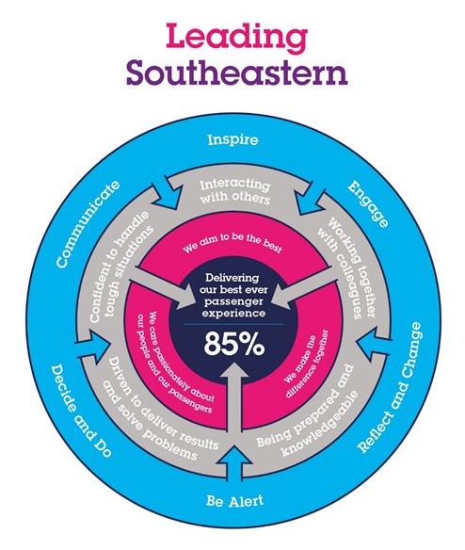

The Leading Southeastern framework details how we should be behaving in order to drive up performance to deliver 85 by 18.

All shortlisted candidates seeking promotion will be assessed against this framework.

The job demands the following blend of experience/knowledge, skills and behaviours (all are essential , unless otherwise shown and will be assessed by application and/ or interview/assessment) :

G1 | Experience, Knowledge & Qualifications (including any specific safety training requirements)  3 years experience of administering MS Endpoint Manager  2 years experience of administering Airwatch MDM  2 years experience of administering SCCM  Microsoft Certified: Security, Compliance, and Identity Fundamentals (or equivalent)
G2 | Skills (including any specific safety critical competencies)  Driven individual with a ‘CAN DO’ attitude that engenders confidence, respect and support.  Passion, enthusiasm and expertise.  Good written and verbal communication skills  Quality and transparency  Good prioritising skills and the ability to meet targets
G3 | Behaviours  Honesty  Integrity  Reliable
G4 | Other

H | Dimensions of role
H1 | Financial – Direct: None
H2 | Financial – Other: None
H3 | Staff Responsibilities – Direct: None
H4 | Staff Responsibilities – Other: None
H5 | Any Other Statistical Data:
I | Acknowledgement
I1 | Prepared By: | _______________ |  | Date: | ______________
I2 | Approved By (Head of Department): | _______________ |  | Date: | ______________

J | Job Description Briefing
 | The post holder has been briefed on and understands the requirements of this Job Description and other related documents:
 | Name of post holder: |  | Signature: |  | Date:
 | Name of briefing manager: |  | Signature: |  | Date:
K | Nominated Deputy for Safety requirements
 | If this is a KEY SAFETY POST (D2 in Safety Details above is YES) at least one nominated deputy must be identified. The Job Holder must ensure that the Nominated Deputy(ies) receives a copy of, and is briefed on this Job Description. If there are more nominated deputies, they should sign further copies of this Job Description.
 | The nominated deputy has been briefed on and understands the requirements of this Job Description and other related documents:
 | Name of nominated deputy: |  | Signature: |  | Date:
 | Name of briefing manager: |  | Signature: |  | Date:

