A | Post Details
 | Job Title: | Commercial Finance Business Partner | Function: | Finance
 | Location: | 4 More London | Unique Post Number:
 | Reports To: | Market Intelligence Manager | Grade: | MG2
B | Purpose of the Job
 | To build budgets and forecasts for the Commercial Department taking into account current and future business performance, ensuring consistency with the future strategy of the business. To provide accurate, timely and relevant financial information on which to base business decisions, with a focus on business-oriented management reporting. To strengthen links between primarily revenue-focused and primarily cost-focused roles within the Financial Planning & Analysis (FP&A) Team and also between the FP&A and Commercial teams. Emphasis on working closely with the Commercial team to provide market intelligence and expert analytic review to steer and support marketing, pricing and retail decisions. To address the needs of the DfT and other key stakeholders by liaising as required on all financial matters relating to product, retail and marketing activities that drive revenue and demand.
C | Principal Accountabilities
C1  C2  C3  C4  C5  C6  C7  C8  C9  C10  C11  C12  C13  C14  C15  C16 | Responsible for managing period and year end results for the Commercial Director, producing management analysis to required deadlines, highlighting material variances and trends, their underlying causes and impact on profitability to derive recommendations on strategic action plans.  Solely responsible for modelling, influencing, challenging, justifying and reporting the business’ 3 year corporate plan and quarterly rolling forecasts for the Commercial Department.  Responsible for financial analysis of Commercial team’s business cases and relevant GAG capital expenditure approvals; integral part of the business case process and project monitoring.  Gain detailed knowledge of relevant business activities and endogenous/exogenous demand drivers to continually develop clear, concise, and relevant financial and management reporting.  Contribute to modelling, influencing, challenging, justifying and reporting the business’ 3 year corporate plan and quarterly rolling forecasts for passenger income and demand.  Build good working relationships with directors, managers and staff and provide them with management information and analysis based on insight and enquiry.  Identification of risks and opportunities through a sound understanding of the market served by Southeastern and the strengths/weaknesses of our competitors, making recommendations to maximise profitability and mitigate key risks.  Manage and provide support to managers and directors to ensure modelled revenue/demand uplift driven by budgeted activities and projects is realistic and projects are delivered as planned.  Ensure that changes in market share, whether from timetable changes, ORCATS, Travelcard survey results or non-rail competitive activity, are accurate and in line with expectation.  Recognised and sought out by the business as a primary and trusted source of insight for decision making.  Act as business change agent proactively identifying and implementing process improvements within the team and across the business  Maintain and enhance Southeastern’s reputation with external stakeholders by timely provision of data and analytic expertise as appropriate, remaining at the same time sensitive to considerations of commercial confidentiality.  Ensure financial records are complete and accurate and reflect underlying business activities and objectives.  Liaise closely with the Financial Accounting team to ensure reliability, accuracy and timeliness of financial information.  Provide expert support to and perform user administration role for Tableau/DWH users across the FP&A Team, Commercial department and the wider business.  Provide guidance on finance matters within relevant business area.
D | Safety Responsibilities
D1 | This post is required to undertake SAFETY CRITICAL WORK |  |  |  | Yes |  | No
D2 | This is a KEY SAFETY POST |  |  |  | Yes |  | No
D3 | This post requires SECURITY CLEARANCE |  |  |  | Yes |  | No
D4 | The job requires competence in PERSONAL TRACK SAFETY |  |  |  | Yes |  | No
D5 | This job has SPECIFIC SAFETY RESPONSIBILITIES (if Yes see section D6 below) |  |  |  | Yes |  | No
D6 | The post holder has the following specific safety responsibilities:
 | - None
E | Decision making Authority
E1  E2  E3 | Authorised to review and recommend changes to business practices, processes and new projects.  Authorised to prepare and influence budgets and forecasts and assumptions therein.  Authorised to attend meetings with external companies and organisations and represent Southeastern’s interests at those meetings.
F | Most Challenging and/or Difficult parts of the role
F1  F2  F3  F4 | Managing conflicting business and director / commercial and financial priorities  Managing to tight deadlines and manipulating large amounts of data  Addressing and managing business need for data insight when periods of great change and uncertainty risk disrupting the supply of usable and relevant data.  Understanding the technical aspects of Southeastern’s revenue profile e.g. passenger income apportionment; season ticket suspense; ticketing and settlement regulations and fares regulation.

G | Person Specification

Southeastern aims to recruit people not just for jobs but for long term careers. We want good quality, talented people with the right attitude who will stay with us.

For these reasons we look for evidence of Southeastern values and behaviours in all potential staff and our existing staff looking for promotion along with the particular experience/knowledge, skills and behaviours relevant to the position applied for. These are

We care passionately about our people and passengers
  - we put ourselves in our passengers’ shoes to do what’s right for them
  - we support our colleagues to be, feel and do their best
  - we love the places we serve and do our bit for our communities and environment

We aim to be the best
  - we move with pace, we’re agile and learn from everything
  - we relentlessly strive to be the best
  - we are professionals with personalities

We make the difference together
  - we are answerable to each other and our passengers
  - we trust each other and do what we say we will
  - we are stronger together than we are as individuals

We also have identified behaviours required to be successful in leading Southeastern.

The Leading Southeastern framework details how we should be behaving in order to drive up performance to deliver 85 by 18.

Leading Southeastern

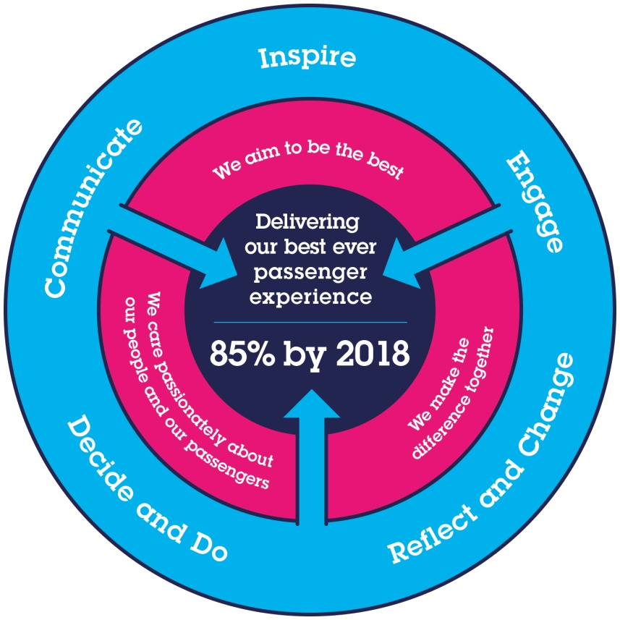
All shortlisted candidates seeking promotion will be assessed against this framework.

The job demands the following blend of experience/knowledge, skills and behaviours (all are essential , unless otherwise shown and will be assessed by application and/ or interview/assessment) :

Finance Business Partner – Team Charter

The Finance Business Partner Team are focused on providing quality service and support to their key customers (including management, Directors, DfT, ROSCOs, Network Rail and Group) and are expected to display the following attributes, striving to continually improve both individual and team performance in each of these four quadrants.
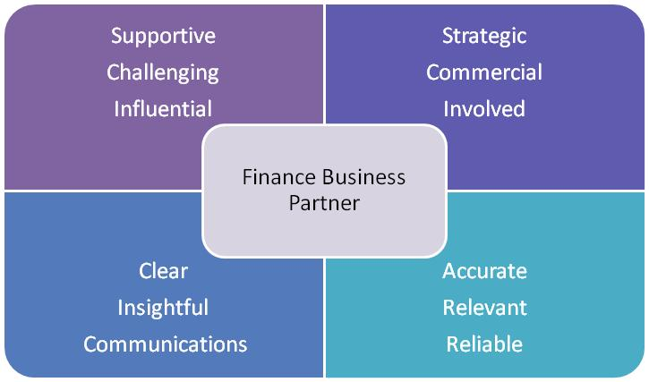

G1 | Experience, Knowledge & Qualifications  Degree or equivalent  Qualified or part qualified in a recognised accountancy qualification (CIMA, ACA, ACCA), or equivalent (desirable)  Substantial experience in a commercial environment including some time spent in an analytical or commercial finance role  Commercially astute with demonstrable understanding of financial aspects of a business  Experience of budgeting and forecasting at an operating company level  Experience of rail or similar transport / franchise industry (desirable)  Sound geographic/demographic knowledge of Kent (desirable)
G2 | Skills (including any specific safety critical competencies)  Excellent analytical and financial modelling skills  Excellent presentation skills  Tableau and/or Power BI systems (desirable)  Oracle, iTM1, EPM Planning systems (desirable)
G3 | Behaviours  Ability to work efficiently, effectively and collaboratively as part of a team, contributing to a culture of continuous business improvement  Ability to influence and solve problems at all levels of the business, influencing decisions beyond the numbers.  Ability to communicate clearly and effectively (both written and oral) at all levels and explain financial issues to a non-financial audience  Ability to manage internal and external stakeholders
G4 | Other
I | Dimensions of role
I1 | Financial – Direct: |  |  | 0
I2 | Financial – Other: |  |  | Depending on relevant business areas
I3 | Staff Responsibilities – Direct: |  |  | 0
I4 | Staff Responsibilities – Other: |  |  | 0
I5 | Any Other Statistical Data:
K | Job Description Briefing
 | The post holder has been briefed on and understands the requirements of this Job Description and other related documents:
 | Name of post holder: |  | Signature: |  |  | Date:
 | Name of briefing manager: |  | Signature: |  |  | Date:

