A | Post Details
 | Job Title: | Environment and Carbon Specialist | Function: | Safety & Environment
 | Location: | 4 More London | Unique Post Number:
 | Reports To: | Environmental Sustainability Lead | Grade: | MG1
B | Purpose of the Job
 | To assist the Environmental Team with the development of Southeastern’s environmental policies and processes. Supporting managers throughout the business to continually improve environmental performance. Delivering programmes that assist Southeastern to meet legal requirements and business objectives, goals and actions.
C | Principal Accountabilities
C1  C2  C3  C4  C5  C6  C7  C8  C9  C10  C11  C12  C13  C14  C15 | Assist the Environmental Sustainability Lead to develop and deliver energy and carbon emission reduction programmes.  Responsibility for carbon and energy accounting including data collection.  Prepare internal and external reporting to meet legal requirements such as SECR, ESOS and Science Based Targets Initiative requirements.  Maintain and continually develop the carbon trajectory tool.  Develop and deliver supplier engagement programmes in support of Southeastern’s science-based targets  Assist the Environmental Sustainability Lead to develop and deliver climate adaptation and resilience planning and associated policies and strategies.  Lead on the continual development and delivery of the Air Quality Strategy and Noise Management Strategy.  Provide secretariat support to the Sustainability Board.  Develop procedures, standards and guidance notes related to improving environmental performance.  Ensure that environmental risks are understood, and effective mitigations are put into place to reduce the company’s potential exposure to litigation and reputational damage to as low as reasonably practicable.  Assist with the development and management of Southeastern’s environmental policies, strategies, plans, targets and key performance indicators.  Provide managers and employees throughout the business with expert environmental advice and support.  Engage with industry environmental groups, representing Southeastern’s business interests as required and actively seeking good practices which can be implemented by Southeastern.  Work with regulatory bodies to identify and rectify issues in an effective manner, delivering compliance whilst protecting Southeastern’s business interests.  Monitor existing and proposed legislation, ensuring that impacts on Southeastern are identified, that representations are made where appropriate, that processes are put into place to deliver compliance as required and that suitable measurement and reviews are undertaken to confirm compliance.
D | Safety Responsibilities
D1 | This post is required to undertake SAFETY CRITICAL WORK | Yes |  | No
D2 | This is a KEY SAFETY POST or nominated deputy | Yes |  | No
D3 | The holder of this post is identified as a KEY SAFETY LEADER | Yes |  | No
D4 | The job requires competence in PERSONAL TRACK SAFETY | Yes |  | No
D5 | This job has SPECIFIC SAFETY RESPONSIBILITIES (if Yes see section D6 below) | Yes |  | No
D6 | The post holder has the following specific safety responsibilities:
 | - N/A
E | Decision making Authority
E1  E2 | Engagement of environmental consultancies and auditors.  Agreement of action plans with line managers and regulators.
F | Most Challenging and/or Difficult parts of the role
F1  F2 | Support the interpretation of often complex emerging regulatory and contractual requirements; helping to build pragmatic business solutions and responses; engaging managers to build understanding and support to meet new requirements.  Required to work through managers to deliver environmental excellence across the business. This will require both excellent facilitation and inter-personal skills and an acute understanding of business goals.  Delivering environmental excellence at a corporate level in a complex customer-focused business with many competing demands for managerial attention.

G | Person Specification

Southeastern aims to recruit people not just for jobs but for long term careers. We want good quality, talented people with the right attitude who will stay with us.

For these reasons we look for evidence of Southeastern values and behaviours in all potential staff and our existing staff looking for promotion along with the particular experience/knowledge, skills and behaviours relevant to the position applied for. These are

Take personal responsibility for our actions

Support our colleagues

Take care of our customers

Work collaboratively with stakeholders

Operate in a socially and environmentally responsible way

We also require more than competent performance against our Leadership & Management Competency Framework.
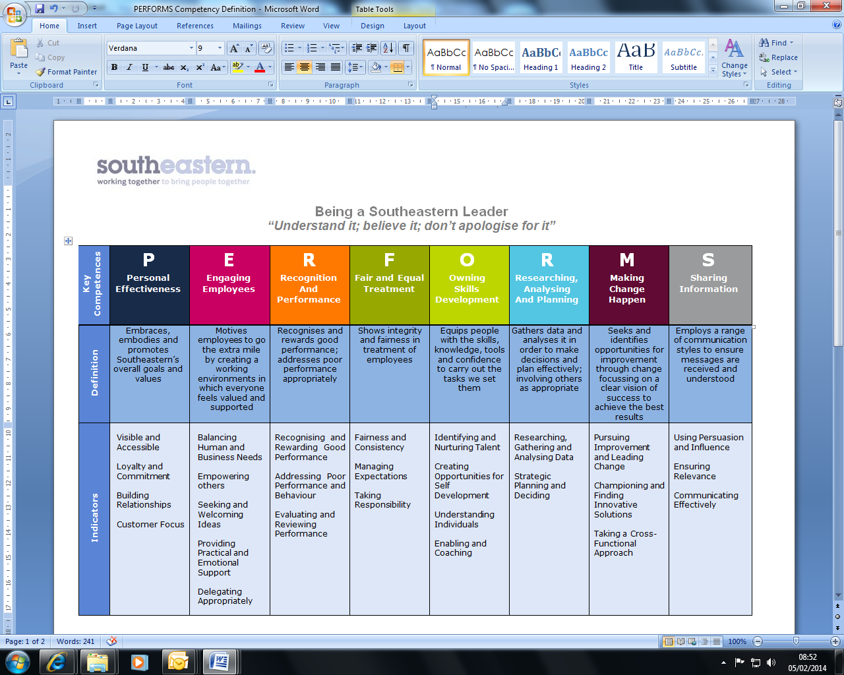
All shortlisted candidates seeking promotion will be assessed against this framework.

The job demands the following blend of experience/knowledge, skills and behaviours (all are essential , unless otherwise shown and will be assessed by application and/ or interview/assessment) :
G1 | Experience, Knowledge & Qualifications (including any specific safety training requirements)  - Educated to relevant degree level.  - Experience of developing and delivering environment/sustainability-based initiatives and programmes.  - Strong numeracy skills, including data collection, trend analysis and reporting.  - Experience of engaging, communicating with and influencing a wide range of stakeholders.  - Able to plan, execute, monitor progress, and close projects.  - Experience of working with stakeholders to develop and implement strategies.  - Good knowledge of UK environmental law.  - Good business awareness.  - Excellent standard of written and spoken English.  - Excellent standard of knowledge and application of Microsoft Word, Excel and Powerpoint applications.
G2 | Skills (including any specific safety critical competencies)  - Influencing stakeholders  - Planning and organising work  - Commercial awareness  - Adding organisational value  - Honesty and integrity  - Able to view change with both a strategic and operational perspective  - Be able to present technical matters in a clear and easily understandable format  - Pragmatic problem solver  - Ability to lead or to support a project as required  - Able to work independently and show initiative.
G3 | Behaviours  Leading by example  Team working  Coaching  Attention to detail and accuracy
G4 | Other

H | Dimensions of role
H1 | Financial – Direct: |  | None
H2 | Financial – Other: |  | Breaches of environmental legislation can expose the company to large fines and significant reputational damage. This role is key in reducing the risks of such failures.  Promoting effective resource management has potential multi-million pound benefits for the business through reduced costs.
H3 | Staff Responsibilities – Direct: |  | None
H4 | Staff Responsibilities – Other: |  | Required to engage and influence managers at all levels across the business.
H5 | Any Other Statistical Data: |  | None
I | Acknowledgement
I1 | Prepared By: | _______________ |  | Date: | ______________
I2 | Approved By (Head of Department): | _______________ |  | Date: | ______________

J | Job Description Briefing
 | The post holder has been briefed on and understands the requirements of this Job Description and other related documents:
 | Name of post holder: |  | Signature: |  | Date:
 | Name of briefing manager: |  | Signature: |  | Date:
K | Nominated Deputy for Safety requirements
 | If this is a KEY SAFETY POST (D2 in Safety Details above is YES) at least one nominated deputy must be identified. The Job Holder must ensure that the Nominated Deputy(ies) receives a copy of, and is briefed on this Job Description. If there are more nominated deputies, they should sign further copies of this Job Description.
 | The nominated deputy has been briefed on and understands the requirements of this Job Description and other related documents:
 | Name of nominated deputy: |  | Signature: |  | Date:
 | Name of briefing manager: |  | Signature: |  | Date:

