A | Post Details
 | Job Title:  IT Infrastructure Manager |  | Function: | Engineering, IT and Major Contracts
 | Location:  Four More London |  | Unique Post Number:
 | Reports To:  Head Of IT |  | Grade: MG2
B | Purpose of the Job  The role will lead the field and retail support engineers, working closely with the Service team to address incident and request tickets inline with SLA’ s.  This is a key management function, directly responsible for ongoing health, resilience, capacity, operational performance and overall effectiveness of existing infrastructure and service platforms, as well as ensuring the aspects are incorporated into new initiative introduction into the organisation. The role will also work closely with the Cyber Security team to introduce or improve the security of the platforms. Access requirements to the Datacentres and improving the physical security and access requirements to site Comms rooms and cabinets also form part of the responsibilities.  The role is also tasked with driving greater adoption of feature sets and improvements in the existing platforms, and working with other directorates and project teams to ensure that duplication of systems is avoided, and opportunities to utilise modules in existing systems, or consolidate and rationalise systems are understood and undertaken.  Supplier management also forms part of this role. Engaging with suppliers regularly to discuss contracted performance levels, address failures, engage new or upgraded services, and ensuring relationships are nurtured with the aim of continually improving the IT service provided to the organisation.  The role will also ensure that procedure, process, and standards are relevant, and updated when required to ensure they support IT policy. The role will also collaborate with the IT management structure to advise on required policy updates as circumstances and organisational improvements dictate.  This role also performs a significant function in the IT governance requirements, participating in the Design Authority panel, lifecycle Change control of service, software and hardware assets  The role also participates in the Silver command rota requirements of the department, acting as an escalation point for the on-call engineers where impacts of incidents require management involvement and wider organisational or supplier communication and involvement.
C | Principal Accountabilities
C1  C2  C3  C4  C5  C6  C7  C8  C9  C10  C11  C12  C13  C14  C15  C16  C17 | Lead the team of field and retail support engineers, focused on delivery of incident and requests inline with SLA’s and KPI’s.  Set and update training paths for the team members, to develop the individuals and ensure ongoing competence for existing and new services supported by the team.  Manage the health, performance, capacity, resilience and effectiveness of the VMWARE, HyperV, virtual and standalone Microsoft servers, including the Citrix Server Farm, Datacentre and site rack space and power provision. Ensure build templates and existing operating system configurations are updated to incorporate best practice and security requirements  Manage the health, performance and capacity aspects of the Laptop/Desktop kit selection, build templates and changes requirements for the existing kit to incorporate best practice and security requirements.  Manage the access to, and physical security requirements of the Datacentres and site Comms rooms and cabinets.  Manage the hardware and software asset licensing requirements  Manage the process to create and update site documentation regularly  Supplier engagement and management  Create and regularly review and update process, procedure and standards  Collaborate with IT management to inform on IT policy amendments where appropriate.  Participate in the IT governance requirements, including the Design Authority Panel and lifecycle Change Management Panel  Creation of Management reports  Participate in Silver command on-call rota, managing significant technical incidents when required.  Manage document lifecycle requirements within the team, ensuring creation and updates to documentation are completed during installation or upgrades  Lead the Business Continuity plan testing requirements, and working with the teams to adapt and update them  Participate in Major Incident response plan testing, and Major Security Incident response plan testing requirements, and working with the teams to adapt and update them  Undertake any other activity that is commensurate with the role, as requested by the Head of IT

D | Safety Responsibilities
D1 | This post is required to undertake SAFETY CRITICAL WORK | Yes |  | No
D2 | This is a KEY SAFETY POST or nominated deputy | Yes |  | No
D3 | The holder of this post is identified as a KEY SAFETY MANAGER | Yes |  | No
D4 | The job requires competence in PERSONAL TRACK SAFETY | Yes |  | No
D5 | This job has SPECIFIC SAFETY RESPONSIBILITIES (if Yes see section D6 below) | Yes |  | No
D6 | The post holder has the following specific safety responsibilities:
Carrying out Planned General Inspections of the following locations:
- None

Acting as Fire Precautions Manager for the following locations:
- None

Safety Interface with the following external parties:
- None

Investigation of accidents occurring at the following locations or as requested by Safety & Environment:
- None

E | Decision making Authority
E1  E2  E3 | As appropriate to ensure resolution of incidents and requests  Invocation of Business continuity and disaster recovery  Platform and Service provision
F | Most Challenging and/or Difficult parts of the role
F1 | Ensuring incidents are managed and resolved in a timely manner

G | Person Specification

Southeastern aims to recruit people not just for jobs but for long term careers. We want good quality, talented people with the right attitude who will stay with us.

For these reasons we look for evidence of Southeastern values and behaviours in all potential staff and our existing staff looking for promotion along with the particular experience/knowledge, skills and behaviours relevant to the position applied for. These are

We care passionately about our people and passengers
  - we put ourselves in our passengers’ shoes to do what’s right for them
  - we support our colleagues to be, feel and do their best
  - we love the places we serve and do our bit for our communities and environment

We aim to be the best
  - we move with pace, we’re agile and learn from everything
  - we relentlessly strive to be the best
  - we are professionals with personalities

We make the difference together
  - we are answerable to each other and our passengers
  - we trust each other and do what we say we will
  - we are stronger together than we are as individuals

We also have identified behaviours required to be successful in leading Southeastern.

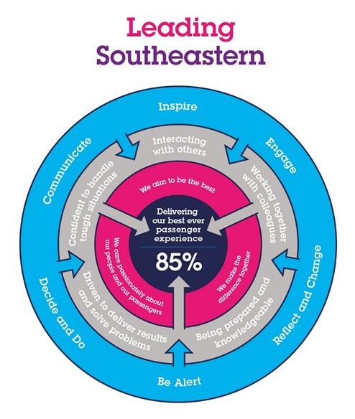

The Leading Southeastern framework details how we should be behaving in order to drive up performance to deliver 85 by 18.

All shortlisted candidates seeking promotion will be assessed against this framework.

The job demands the following blend of experience/knowledge, skills and behaviours (all are essential , unless otherwise shown and will be assessed by application and/ or interview/assessment) :

G1 | Experience, Knowledge & Qualifications (including any specific safety training requirements)  2 years experience of leading a team  MCSE (or equivalent)  Citrix Certified Professional  VMWare Professional Data Center Virtualization Certification
G2 | Skills (including any specific safety critical competencies)  Driven individual with a ‘CAN DO’ attitude that engenders confidence, respect and support.  Passion, enthusiasm and expertise.  Good written and verbal communication skills  Quality and transparency  Good prioritising skills and the ability to meet targets
G3 | Behaviours  Honesty  Integrity  Reliable
G4 | Other

H | Dimensions of role
H1 | Financial – Direct: DFA up to
H2 | Financial – Other:
H3 | Staff Responsibilities – Direct: Line management of 5 individuals.  Leading a team of 13 individuals
H4 | Staff Responsibilities – Other:
H5 | Any Other Statistical Data:
I | Acknowledgement
I1 | Prepared By: | _______________ |  | Date: | ______________
I2 | Approved By (Head of Department): | _______________ |  | Date: | ______________

J | Job Description Briefing
 | The post holder has been briefed on and understands the requirements of this Job Description and other related documents:
 | Name of post holder: |  | Signature: |  | Date:
 | Name of briefing manager: |  | Signature: |  | Date:
K | Nominated Deputy for Safety requirements
 | If this is a KEY SAFETY POST (D2 in Safety Details above is YES) at least one nominated deputy must be identified. The Job Holder must ensure that the Nominated Deputy(ies) receives a copy of, and is briefed on this Job Description. If there are more nominated deputies, they should sign further copies of this Job Description.
 | The nominated deputy has been briefed on and understands the requirements of this Job Description and other related documents:
 | Name of nominated deputy: |  | Signature: |  | Date:
 | Name of briefing manager: |  | Signature: |  | Date:

