A | Post Details
 | Job Title: IT SharePoint & M365 Administrator |  | Function: | IT Department
 | Location:  Four More London |  | Unique Post Number:
 | Reports To:  IT Infrastructure Manager |  | Grade: MG1
B | Purpose of the Job  This is a key role required to administer the setup, integration, compliance, and governance of organisations SharePoint and M365 suite. The role will work in conjunction with the IT teams, focusing on the overall provision, configuration of SharePoint, the M365 suite and MS Azure Services, and ensuring controlled access across elements is enacted and maintained to keep the organisation and its data secure and safe. The role will also liaise with Southeastern staff and external suppliers to ensure changes are carried out in compliance with the IT change and security policies.  The role will administer and support the SharePoint implementation within the organisation, incorporating the interaction with MS Teams and OneDrive sites. In conjunction with departmental owners, the role will ensure that existing sites and new sites are setup, managed and maintained inline with best practice, including the principle of least privilege access.  The role will also administer the M365 suite, focused on providing access, restricted access or removing access to components based on Organisational requirements, strategic considerations, secure development requirements or IT Change processes. This will include a focus on the M365 roadmap and its new tools and capabilities, shaping how and when the organisation could potentially trial and adopt them into the organisation.  The role will also oversee the MS Azure deployment of the organisation, incorporating design, monitoring and retirement of services within MS Azure, in conjunction with the other IT teams.
C | Principal Accountabilities
C1  C2  C3  C4  C5  C6  C7  C8  C9  C10 | Overall management of the organisations SharePoint setup, including top level permission setting, to allow business owners to perform the required site specific day to day management.  Manage the configuration and management across the MS Teams and OneDrive aspects of SharePoint  Manage integrations with SharePoint, including Webparts  Manage the M365 suite of products, limiting and removing access to components until adoption criteria are established and the organisation is ready to progress.  Ensure awareness of and support adoption of M365 roadmap and new tools and capabilities and potential use within the organisation  Assist with design and operational oversight of the MS Azure services used by the organisation  Accountable for Azure Active Directory Synch services, performing monitoring and support of that process and Conditional Access policies  Supporting the provision of Power Platform environments, working closely with the application support team  Liaise with staff and suppliers, ensuring that change requirements are carried out in compliance with the IT Change Management and IT Information Security policies.  Undertake any other activity that is commensurate with the role, as requested by IT management

D | Safety Responsibilities
D1 | This post is required to undertake SAFETY CRITICAL WORK | Yes |  | No
D2 | This is a KEY SAFETY POST or nominated deputy | Yes |  | No
D3 | The holder of this post is identified as a KEY SAFETY MANAGER | Yes |  | No
D4 | The job requires competence in PERSONAL TRACK SAFETY | Yes |  | No
D5 | This job has SPECIFIC SAFETY RESPONSIBILITIES (if Yes see section D6 below) | Yes |  | No
D6 | The post holder has the following specific safety responsibilities:
Carrying out Planned General Inspections of the following locations:
- None

Acting as Fire Precautions Manager for the following locations:
- None

Safety Interface with the following external parties:
- None

Investigation of accidents occurring at the following locations or as requested by Safety & Environment:
- None

E | Decision making Authority
E1

E2

E3
F | Most Challenging and/or Difficult parts of the role
F1

G | Person Specification

Southeastern aims to recruit people not just for jobs but for long term careers. We want good quality, talented people with the right attitude who will stay with us.

For these reasons we look for evidence of Southeastern values and behaviours in all potential staff and our existing staff looking for promotion along with the particular experience/knowledge, skills and behaviours relevant to the position applied for. These are

We care passionately about our people and passengers
  - we put ourselves in our passengers’ shoes to do what’s right for them
  - we support our colleagues to be, feel and do their best
  - we love the places we serve and do our bit for our communities and environment

We aim to be the best
  - we move with pace, we’re agile and learn from everything
  - we relentlessly strive to be the best
  - we are professionals with personalities

We make the difference together
  - we are answerable to each other and our passengers
  - we trust each other and do what we say we will
  - we are stronger together than we are as individuals

We also have identified behaviours required to be successful in leading Southeastern.

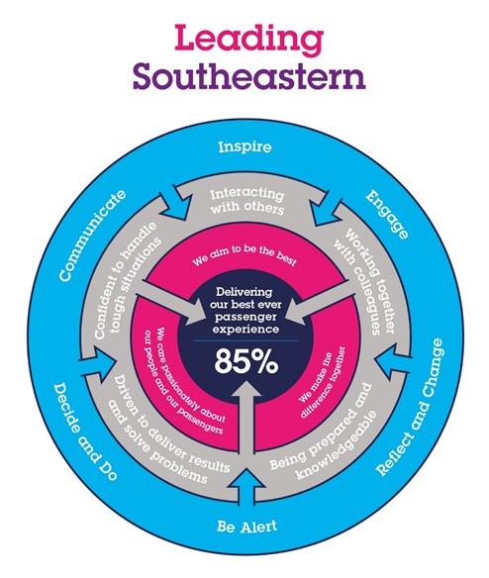

The Leading Southeastern framework details how we should be behaving in order to drive up performance to deliver 85 by 18.

All shortlisted candidates seeking promotion will be assessed against this framework.

The job demands the following blend of experience/knowledge, skills and behaviours (all are essential , unless otherwise shown and will be assessed by application and/ or interview/assessment) :

G1 | Experience, Knowledge & Qualifications (including any specific safety training requirements)  3 years experience of SharePoint and M365 Administration  MCSE: SharePoint (or equivalent)  M365 Certified Enterprise Administrator Expert
G2 | Skills (including any specific safety critical competencies)  Driven individual with a ‘CAN DO’ attitude that engenders confidence, respect and support.  Passion, enthusiasm and expertise.  Good written and verbal communication skills  Quality and transparency  Good prioritising skills and the ability to meet targets
G3 | Behaviours  Honesty  Integrity  Reliable
G4 | Other

H | Dimensions of role
H1 | Financial – Direct: DFA up to
H2 | Financial – Other:
H3 | Staff Responsibilities – Direct: Line management of 5 individuals.  Leading a team of 13 individuals
H4 | Staff Responsibilities – Other:
H5 | Any Other Statistical Data:
I | Acknowledgement
I1 | Prepared By: | _______________ |  | Date: | ______________
I2 | Approved By (Head of Department): | _______________ |  | Date: | ______________

J | Job Description Briefing
 | The post holder has been briefed on and understands the requirements of this Job Description and other related documents:
 | Name of post holder: |  | Signature: |  | Date:
 | Name of briefing manager: |  | Signature: |  | Date:
K | Nominated Deputy for Safety requirements
 | If this is a KEY SAFETY POST (D2 in Safety Details above is YES) at least one nominated deputy must be identified. The Job Holder must ensure that the Nominated Deputy(ies) receives a copy of, and is briefed on this Job Description. If there are more nominated deputies, they should sign further copies of this Job Description.
 | The nominated deputy has been briefed on and understands the requirements of this Job Description and other related documents:
 | Name of nominated deputy: |  | Signature: |  | Date:
 | Name of briefing manager: |  | Signature: |  | Date:

