A | Post Details
 | Job Title: | Service Quality Regime Manager | Function: | Commercial
 | Location: | 4 More London | Unique Post Number:
 | Reports To: | Head of Insights | Grade: | MG2
B | Purpose of the Job
Manage SQR for trains, stations and service quality measures on a timely and accurate basis maintaining high standards of service delivery, maintaining rapid resolution timescales and comprehensive reporting requirements.

Leading and delivering the Southeastern Service Quality Regime in line with DfT standards and Franchise obligations.

Manage the Audit agency and software supplier on a daily basis to encourage the maintenance and/or improvement of services across the business and ensure that no areas of the network are neglected. Ensuring that both providers collaboratively comply with the requirements outlined in their respective contracts

Work with relevant directorate to drive sustainable improvements that reduce reported errors, manage costs effectively and support excellent customer service delivery

C | Principal Accountabilities
C1  C2  C3  C4  C5  C6  C7  C8  C9  C10  C11  C12 | Ensure SQR is completed as per DFT requirements and in line with Southeastern’s customer experience model.  Responsible for creating bespoke period reports for all functions, including engineering, passenger services, train services, train presentation and facilities  To compile concise and accurate statistical information on all relevant service quality audit results  Prepare agreed reports on performance accurately and on time identifying key findings and relevant trends. Recommend improvement plans for Commercial Managers, Franchise Compliance Manager  Investigate and report any discrepancies or failings in SQ Audit findings with relevant line managers who interface with Service Quality Regime.  Effectively deal with any issues on constraints of how inspections ought to be carried out at a particular service area  Deal with any queries on the day-to-day running of the Service Quality contract, analysing reports and accounts from contractors and supervising, assessing and amending the contract where necessary.  Regularly travel across the network to observe the Auditors, ensuring that they are fully equipped and competent to fulfil their roles and work effectively in partnership with the rest of the business.  Manage the Service Quality Analyst  Meet with function managers to develop action plans resulting from SQR scores  and meet with other train operating companies to share best practise  Ensure mystery shopper reports are sent to the correct owning manager(s) creating action plans where needed  To perform any other task reasonably requested by line manager

D | Safety Responsibilities
D1 | This post is required to undertake SAFETY CRITICAL WORK | Yes |  | No
D2 | This is a KEY SAFETY POST or nominated deputy | Yes |  | No
D3 | The holder of this post is identified as a KEY SAFETY MANAGER | Yes |  | No
D4 | The job requires competence in PERSONAL TRACK SAFETY | Yes |  | No
D5 | This job has SPECIFIC SAFETY RESPONSIBILITIES (if Yes see section D6 below) | Yes |  | No
D6 | The post holder has the following specific safety responsibilities:
Carrying out Planned General Inspections of the following locations:
- [list locations or delete if not applicable]

Acting as Fire Precautions Manager for the following locations:
- [list locations or delete if not applicable]

Safety Interface with the following external parties:
- [list interfaces or delete if not applicable]

Investigation of accidents occurring at the following locations or as requested by Safety & Environment:
- [list locations or delete if not applicable]

E | Decision making Authority
E1 | To seek authority from the Head of Insights during leave/training courses etc.
F | Most Challenging and/or Difficult parts of the role
F1  F2 | Ability to meet deadlines for Front Line Managers and Senior Managers.  Working to challenging timescales.

G | Person Specification

Southeastern aims to recruit people not just for jobs but for long term careers. We want good quality, talented people with the right attitude who will stay with us.

For these reasons we look for evidence of Southeastern values and behaviours in all potential staff and our existing staff looking for promotion along with the particular experience/knowledge, skills and behaviours relevant to the position applied for. These are

We care passionately about our people and passengers
  - we put ourselves in our passengers’ shoes to do what’s right for them
  - we support our colleagues to be, feel and do their best
  - we love the places we serve and do our bit for our communities and environment

We aim to be the best
  - we move with pace, we’re agile and learn from everything
  - we relentlessly strive to be the best
  - we are professionals with personalities

We make the difference together
  - we are answerable to each other and our passengers
  - we trust each other and do what we say we will
  - we are stronger together than we are as individuals

We also have identified behaviours required to be successful in leading Southeastern.

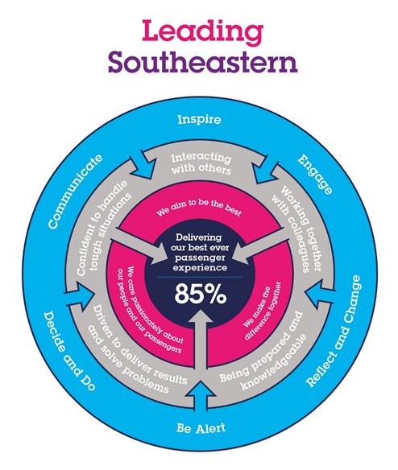

The Leading Southeastern framework details how we should be behaving in order to drive up performance to deliver 85 by 18.

All shortlisted candidates seeking promotion will be assessed against this framework.

The job demands the following blend of experience/knowledge, skills and behaviours (all are essential , unless otherwise shown and will be assessed by application and/ or interview/assessment) :

G1 | Experience, Knowledge & Qualifications (including any specific safety training requirements)  Strong administration skills including use of Word, Excel, PowerPoint and report writing.  Experience in auditing and the ability to work assess information impartially.  Numerate, organised, logical, attention to detail.  Knowledge of Service Quality requirements  High level of personal integrity  Desirable  Previous SQR involvement for another TOC
G2 | Skills (including any specific safety critical competencies)  Committed to company values and code of conduct.  Ability to work to timescales
G3 | Behaviours
G4 | Other  Training needs will be established during one-to-one meeting with line manager and subject to personal and company needs.

H | Dimensions of role
H1 | Financial – Direct:
H2 | Financial – Other:
H3 | Staff Responsibilities – Direct: |  | Southeastern employees 1
H4 | Staff Responsibilities – Other:
H5 | Any Other Statistical Data:
I | Acknowledgement
I1 | Prepared By: | _Howard Tarr_ |  | Date: | _30th March 2021__
I2 | Approved By (Head of Department): | _______________ |  | Date: | ______________

J | Job Description Briefing
 | The post holder has been briefed on and understands the requirements of this Job Description and other related documents:
 | Name of post holder: |  | Signature: |  | Date:
 | Name of briefing manager: |  | Signature: |  | Date:
K | Nominated Deputy for Safety requirements
 | If this is a KEY SAFETY POST (D2 in Safety Details above is YES) at least one nominated deputy must be identified. The Job Holder must ensure that the Nominated Deputy(ies) receives a copy of, and is briefed on this Job Description. If there are more nominated deputies, they should sign further copies of this Job Description.
 | The nominated deputy has been briefed on and understands the requirements of this Job Description and other related documents:
 | Name of nominated deputy: |  | Signature: |  | Date:
 | Name of briefing manager: |  | Signature: |  | Date:

